
DEPARTMENT OF CIVIL ENGINEERING
ENGINEERING MECHANICS-IMPORTANT QUESTIONS
PART-A
1. Distinguish the following system of forces with a suitable sketch. a) Coplanar b) Collinear

2. Define Kinetics and Kinematics

3. State Lami’s theorem with a sketch.

4. State parallelogram law and triangle law of forces.

5. State Varignon’s theorem

6. What is a couple? What is a moment of a couple?

7. A force vector F has the components Fx = 150N, Fy= -200N and Fx = 300N. Determine the magnitude F and the angle made by the force with coordinate axes.

8. Sketch the different types of supports.

9. State parallel axis theorem

10. State perpendicular axis theorem

11. Find the polar moment of inertia of a hollow circular section of external diameter ‘D’ and internal diameter ‘d’

12. Define principal axes and principal moment of inertia

13. Define D’Alembert’s principle

14. Write down the equations of motion of a particle under gravitation

15.A car accelerates uniformly from a sped of 30 Km/Hr to a speed of 75 Km/Hr in 5secs. Determine the acceleration of the car and the distance traveled by the car during 5secs.

16. Explain dynamic equilibrium

17. Define friction and classify its types.
18. State coulomb’s laws of dry friction.
19. What us general plane motion? Give some examples.
20. What is coefficient of rolling resistance?

PART-B
1. A force P is applied at ‘O’ to the string AOB as shown in fig. If the tension in each part of string is 50 N, find the direction an magnitude of force P for equilibrium conditions.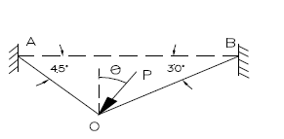
2. Two identical rollers each of weight 50N are supported by an inclined plane and a
vertical wall as shown in fig. Find the reactions at the points of supports A, B, and C.
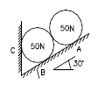

3.Four coplanar non concurrent non parallel forces act on a square plate of side 2m as shown in fig. Locate the resultant force.
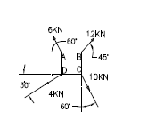

4.In figure below, two forces act on a circular disc as shown. If the resultant moment of all these forces about point D on the disc is zero, determine: a) Magnitude of force P (b) Magnitude of the resultant of two forces (c) The point on the Y-axis through which the line of action of the resultant passes through.


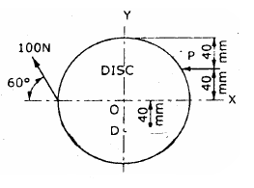

5. Find reactions at points A & B

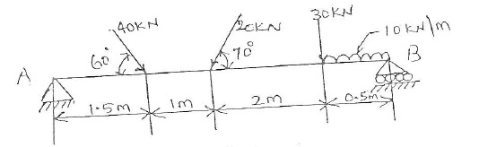

6.Find the moment of inertia of the section shown in the figure about its horizontal centroidal
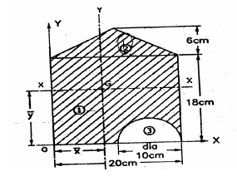
axis.

7.The position of the particle is given by the relation S=1.5t3-9t2-22.5t+60, where S is expressed in meters and t in seconds. Determine (i) the time at which the velocity will be zero (ii) the position and distance traveled by the particle at that time (iii) the acceleration of the particle at that time and (iv) the distance traveled by the particle from t = 5s to t = 7s.

8.Two blocks of weight 150 N and 50 N are connected by a string and passing over a frictionless pulley as shown in figure. Determine the acceleration of blocks A and B and the tension in the spring.
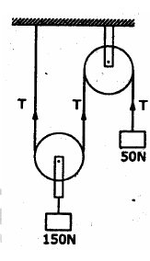

9. Two Blocks A and B of weight 100 N and 200 N respectively are initially at rest on a 30° inclined plane as shown in figure. The distance between the blocks is 6 m. The co efficient of friction between the block A and the plane is 0.25 and that between the block B and the plane is 0.15. If they are released at the same time, in what time the upper block (B)
reaches the Block (A).

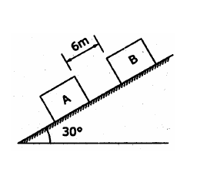

10. Block (2) rests on block (1) and is attached by a horizontal rope AB to the wall as shown in fig. What force P is necessary to cause motion of block (1) to impend? The co-efficient of friction between the blocks is ¼ and between the floor and block (1) is 1/3. Mass of blocks (1)and(2) are 14kg and 9 kg respectively
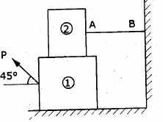

11. A 7m long ladder rests against a vertical wall, with which it makes an angle of 45° and on a floor. If a man whose weight is one half that of the ladder climbs it, at what distance along the ladder will he be, when the ladder is about to slip? Take coefficient of friction between the ladder and the wall is 1/3 and that between the ladder and the floor is ½.
