Gurukul Science Classes
Aptitude Test

Maths Section
- A student was asked to find the arithmetic mean of the numbers 3,11,7,9,15,13,8,19,17,21,14, and x. He found the mean to be 12.What should be the number in place of x.
A) 3 B) 7 C) 17 D) 31
- The product of two numbers is 120 and the sum of their squares is 289. The sum of the numbers is
A) 20 B) 23 C) 169 D) 199
- Find a number such that when 15 is subtracted from 7 times the number the result is 10 more than twice the number
A) 1 B) 3 C) 5 D) 9
- A man buys a cycle for Rs. 1400 and sells it at a loss of 15%. What is the selling price of the cycle?
A) Rs.1090 B) Rs.1160 C) Rs.1190 D) Rs.1202
- A sum of Rs.12,500 amounts to Rs.15,500 in 4 years at the rate of simple interest then what is the rate of interest
A) 3% B) 4% C) 5% D) 6%
- How many pieces of 85cm length can be cut from a rod 42.5 meters long?
A) 30 B) 40 C) 60 D) 50
- A person crosses a 600m long street in 5 minutes. What is his speed in km per hour?
A) 7.2 B) 3.6 C) 8.4 D) 10
- A man is 24 years older than his Son. In two years, his age will be twice the age of his Son then the present age of Son is
A) 14 years B) 18 years C) 20 years D) 22 years
- The value of $\frac{{(0.137+0.098)}^{2}{ - (0.137-0.098)}^{2}}{0.137×0.0198}$ is
A) 0.039 B) 0.235 C) 4 D) 0.25
- In a single throw of a die, what is the probability of getting a number greater than 4
A) $1/2$B)$1/3$ C) $2/3$ D) $1/4$
Science section
11.Power of lens measured in ………..
A) Joules B) Dioptre C) watt D) Pascal
12.Physical quantity which can be completely specified by its magnitude
only, is called………
A) Scalars B) Magneto C) Quantifiers D) Vectors
13.Newton – Meter is SI unit of ……….
A) Acceleration B) work C) Force D) power
14.The most electronegative element among the following is ………………
A) sodium B)Fluorine C) Bromine D) Oxygen

15.The most soluble substance in water is …………………
A) sulphur B) salt C) camphor D) sugar
16.The main active constituent of tea and coffee is ……….
A) chlorophyll B) caffeine C) Nicotine D) Aspirin
17.The most electropositive element among the following is ………………
A) Na B)Cs C) K D) Ca
18.Which of the following is most malleable metal……………
A)Silver B) Gold C) Platinum D)Iron
19.Which of the following is assumed to hold the nucleons
together……………..
A) Mesons B) Electrons C) Neutrons D) Positrons
20.Organic substances which control growth and development called………
A)Hormones B) Enzymes C) vitamins D) Fat

LOGICAL REASONING

21. Which number completes the puzzle?
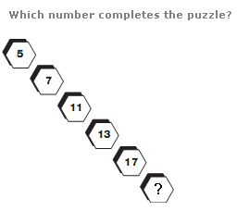

A) 19 B) 14 C)4 D) 18

22. Which number replaces the question mark?
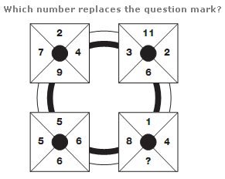
A) 8 B) 1 C)9 D) 7

23. What time should the last watch show?
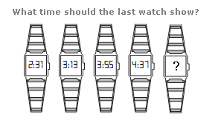
A) 5.19 B) 5.14 C)5.18 D) 5.13

In each of the following questions find out the alternative which will replace the
questions mark.

24. 8: 28: :: 27 : ?
A) 28 B) 8 C) 64 D) 65

Complete the series in following questions:

25. CMM, EOO, GQQ, _____, KUU
A) GRR B) GSS C) ISS D) ITT
26. B₂CD, _____, BCD₄, B₅CD, BC₆D
A) B₂C₂D B) BC₃D C) B₂C₃D D) BCD₇

27.
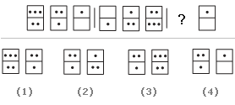
A) 1 B) 2 C) 3 D) 4

28.
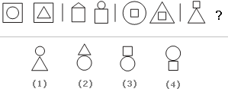
A) 1 B) 2 C) 3 D) 4

29. In the year 2008, Maharashtra Day fell on Thursday. On which day did it fall
in the year 2007?
A) Tuesday B) Wednesday C) Friday D) Saturday

30.
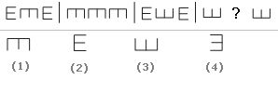
A) 1 B) 2 C) 3 D) 4

ALL THE BEST

ROUGH WORK

