Under the banner of West Bengal State Council of Technical Education & Training Published on behalf of syllabus committee

Question Bank on Mechanics of Structure

For Semester 3 of Diploma in CIVIL Engineering (based on new syllabus effective from 2014 onwards)

**Details of Evaluation system: divided in two segments – A. Theoretical subjects and B. Sessional/practical subjects.**

**Disclaimer**

The question bank has been developed with an aim to make it an exhaustive one so that a student, while going through a standard text book reading between the lines, feels the question bank a handy one to strengthen his/her acumen on subject concerned thus sharpening his/her profession skill. But it is to be mentioned categorically on behalf of the syllabus committee that this question bank is a barest minimum so far practicing is concerned. It is also to be highlighted that student should not expect that the questions in the semester examination(s) will be from this question bank.

1. **Theoretical subject:**

Every theoretical subject having 100 marks in its credit consists of two parts – 1. **internal assessment part bearing 30 marks** and 2. **External assessment part bearing 70 marks.**

Internal assessment part – comprised of two parts namely,

**CT (class test)** – bearing 20 marks. Two class test are to be conducted department wise at a time suitable for individual case on 20 marks. Average of two will be regarded as the marks for CT. this is to be done to give importance on both the class test as it is observed from the current trend that if a student used to get a good score in the 1st internal assessment he/she care a fig for the 2nd one. The syllabus for each class test should not be more than 5 and it should be declared at least 7-10 days in advance. However under special circumstances like prolonged illness, inadvertently missing the exam etc third class test may be taken for the student who has otherwise attended the class regularly

**Number distributions for the subjects like ‘Mechanics of Structure’, ‘Hydraulics’, SDD I and II will be as follows**:

* 3 to 4 questions bearing marks 1 or 2 – question should be given such a way student have to write one or two sentences.
* 1 or 2 question bearing marks 6 or greater – this requires to accommodate problems of structural analysis, designing, theoretical derivation, etc.

**Number distributions for the other subjects of Civil Engineering like ‘Irrigation’, Transportation Engg, Environmental Engg. etc excluding drawing will be as follows:**

* 3 – 4 number of questions bearing mark of 1 (question should be given such a way student have to write one or two sentences)
* 2 - 4 questions each having 2 to 3 marks
* 1 or 2 questions having 4 to 5 marks for accommodating question on problems, regarding wh question? (excluding why type)

**Number distribution for Civil Engineering Drawing will be as follows** –

* It has been proposed that there will no objective type question. Two question carrying 20 marks each will be set – one between them will have to be answered in 1 (one ) hour examination.

ii. **TA (Teachers’ s assessment)** – it also consists of two parts namely a. Attendance and quizzes – 6 (in pursuance with AICTE)

**Attendance part** – will contribute 3 out of 6 and will be in accordance with the following norms:

1. Below 60% - should be awarded 0
2. Above 60% to below 70% - 1
3. Above 70% to below 80% - 2
4. Above 80% - 3

**Quizzes** – for remaining 3 – to be decided by the subject teacher depending on the class performance of the students.

iii. **Assignment & Group Discussion** – 4 marks. Some topics have been given for assignment purpose at the end of course content. Subject teachers may also suggest alternatives if he/she thinks fit.

**External assessment part**

To be conducted on the question, having full marks 70, supplied by Council for which distribution of marks will be as follows:

|  |  |  |  |  |  |  |
| --- | --- | --- | --- | --- | --- | --- |
| GROUP | TOPICS | OBJECTIVE QUESTIONS | SUBJECTIVE QUESTIONS | | | |
|  | TO BE SET | TO BE ANSWERED | MARKS PER QUESTION | TOTAL MARKS |
| All | All | Objective part will carry total marks of 20. Should be set in such a fashion that students will have to write one or more sentences. No question will carry options or true/false nature   1. 10 questions to be answered from a list of 12-13 questions each carrying mark 1 – total marks will be 1 x 10 = 10 2. 5 questions to be answered from a set of 7-8 questions, each carrying marks 2; total marks will be 2 x 5 = 10 3. There will not be any objective in the Civil Engineering Drawing | Nine | Five | Ten | 50 |
| All the question should be comprised of 2(Two) to 4(four) parts – each part will carry marks ranging from 2 to 5. As there is no grouping all parts of a question will have to be from different units of the concerned curriculum so as to compel the students to cover the whole syllabus.  Exception subjects   1. like ‘Mechanics of Structure’, ‘Hydraulics’, SDD I and II where number of parts in a question may be decreased vis-à-vis increase in marks of a part just for accommodating problems on designing, structural analysis, derivation etc etc. 2. like Civil Engineering Drawing, as there will not be any objective, each of the five questions to be answered will carry a marks of 14 **or** there may be 4 (four) questions carrying 17 marks each and 2 marks may be allotted for draughtsmanship and neatness.   **NB: schedule time for WBSCTE examination for all theoretical subjects except drawing will be 3 hours whereas that for the drawing examinations will be 4 hours.** | | | |

1. Sessional/practical subjects:

In the draft curricular structure it has been proposed that assessment for sessional/practical subjects be divided into two heads named i. Term Work (TW) and ii. Practical (PR). In the draft syllabus it had been shown that the weightage for Term work and Practical will be in 1:3 proportion. But in a meeting of council we are indirectly directed to incorporate a change in the ratio under reference. According to the last modification as suggested, the weightage of the two will be equal i.e. in 1:1 proportion).

Term work (TW) – to be evaluated by a board of faculty members/teachers of the Civil Engineering department of the institution concerned. Subject Teacher will be member of the said board by default. Marks will be given on the basis of regular evaluation of his/her attendance in the sessional class, his/her conception on the tasks, his/her involvement in the tasks assigned to him/her/their group, leadership quality for successful completion of the task assigned, against the submission of laboratory notebook in complete/ drawing sheets/project evaluation notebook/ etc. instrument handling, collection of data, necessary calculation, performance in the viva-voce. This can be done on the basis of his/her overall performance in the subject in the particular semester as well as by giving his/her a particular portion of the whole task.

*The distribution of marks for Internal Assessment in practical subjects shall be made as per the following guidelines:*

1. 60% marks shall be awarded for performance in practical.
2. 20% marks shall be given for Report/Practical book and punctuality in equal proportion.
3. 20% marks shall be for Viva-voce conducted during the practical.

Practical (PR) – to be evaluated by an external teacher from other polytechnic. 50% weightage has to be given on the laboratory notebook and 50% weightage has to be given for his/her performance of external sessional examination through experiments or parts of assignments or otherwise.

NB :

1. Evaluation of professional industrial training report through viva-voce/presentation aims at assessing students of understanding of materials, industrial process, practices, industry/field organization and their ability to engage in activities related to problem solving in industrial setup as well as understanding of application of knowledge and skills learnt in real life situations. The formative and summative evaluation may comprise of weightage to performance in testing, general behaviour, quality of report and presentation during viva-voce examination. It is recommended that such evaluations may be carried out by a team comprising of concerned HOD, teachers and representative from industry.
2. The distribution of mark for internal assessment in drawing subjects including AutoCAD (Sessional) shall be as per following guidelines:-

* 60% marks for sheets
* 40% marks for tests

**Unit 1**

**PROBLEMS FOR EXERCISE**

1. A bar of rectangular cross-section 20 mm × 50 mm is 400 mm long and is subjected to an axial tensile load of 80 kN. If modulus of elasticity and modulus of rigidity of the material of bar are 1 × 105 N/mm2 and 0.4 x 105 N/mm2, find the bulk modulus and changes in dimensions and volume. **[Ans:** *K =* 0.6667 × 105 N/mm2, Δ*x =* 0.32 mm, Δ*y* = -0.004 mm, Δz = -0.010 mm and Δ*v* = 160 mm2]

2. A bar 600 mm long is having a cross-section of size 50 mm × 50 mm. If the bar is subjected to an axial tensile force of 20 kN and lateral compressive forces of 600 kN on the faces of 50 mm × 600 mm, find the changes in its dimensions and in the volume.

[**Ans:** Δ*x* = 0.18 mm, Δ*y =* Δ*z =* - 0.0071 mm and Δ*v* = 24 mm3]

3. A bar of 25 mm diameter is tightly fitted into a tube. Find the stresses in the bar and change in volume due to an axial compressive force of 60 kN in the bar, if the tube restrains 50 percent of expansion in diameter. Take length of bar = 400 mm, *E* = 2 × 105 N/mm2 and *µ* = 0.3.

**[Ans:** *px =* 122.231 N/mm2, *py = pz =* 26.192 N/mm2, Δ*v* = 68.525 mm3]

4. A point in a strained material is subjected to two mutually perpendicular tensile stresses of 200 N/mm2 and 100 N/mm2. Determine the intensities of normal, tangential and resultant stresses on a plane inclined at 30° anticlockwise to the axis of the minor stress.

[Note: Axis of minor stress means the plane of major stress]

**[Ans:** *px* = 175 N/mm2, *pt* = 43.3 N/mm2, *p* = 180.28 N/mm2 and is inclined at 106.30° to the plane of 200 N/mm2 stress]

5. The state of stress at a point in a strained material is as shown in Fig. below. Determine the normal, tangential and resultant stress on plane *DE.* Determine the direction of resultant stress also.

[**Ans:** *pn* = 9.58 N/mm2, *pt* = 59.09 N/mm2, *p* = 59.86 N/mm2 at 59.21° to the plane of 80 N/mm2 stress]

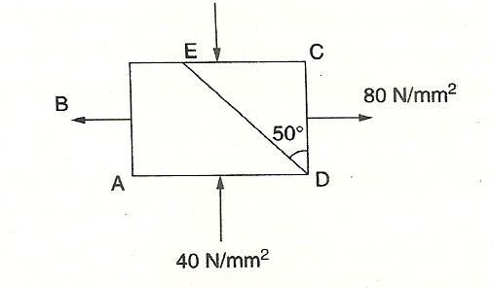

6. The stresses acting at a point in a two-dimensional stress system is shown in Fig. below. Determine the principal stresses and the stresses acting on the plane *AB.* Verify the results graphically.

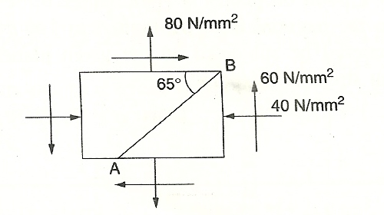

[Note: *px* = -40 N/mm2, *py* == 80N/mm2, *q =* 60 N/mm2, *θ* = - 25° to the plane of *px*]

[**Ans:** *p*1 = 104.85 N/mm2, *p*2 = 64.85 N/mm2, *pn =* - 64.53 N/mm2, *pt* = 7.395 N/mm2]

7. The State of stress in a two dlmensionally stressed body is as shown in Fig. 2.13. Determine principal stresses, principal planes and maximum shear stress. Determine also the normal and tangential stresses on plane *AC.* Verify the results by drawing Mohr’s circle.

[Note: *px* = -90 N/mm2, *py* = -60 N/mm2, *q =* - 60 N/mm2, *θ* = - 60° (inclination to the plane of *px*)]

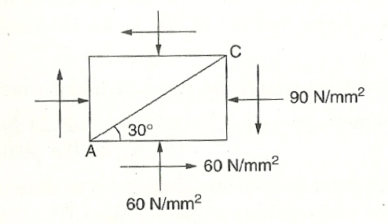

[**Ans:** *p*1 = -13.15 N/mm2, *p*2 *=* -136.85 N/mm2, *q*max = 61.85 N/mm2, *θ* = - 37.98° to the plane of 60 N/mm2 stress, *pn* = -15.54 N/mm2 *pt* = -17.00 N/mm2]

8. At a point in a beam the longitudinal tensile stress is 80 MN/m2 and the shear stress is 45 MN/m2. Find the magnitude and direction of principal stresses at the point. What is the magnitude and direction of the greatest shear stress?

[Note: 1 MN/m2 - 1 N/mm2]

**[Ans:** *p*1 = 100.21 N/mm2, *p*2 = -20.21 N/mm2, *θ* = 24.18°, and *θ*2 = 114.18°; *qmax* = 60.2 lN/mm2, at 69.18° to the plane]

9. At a point in beam the bending stress is 80 N/mm2. The greatest principal stress is’ to be limited to 90 N/mm2. What is the greatest shearing stress that can be applied on the given planes? Determine the minimum principal stress and direction.

**[Ans:** *q =* 30 N/mm2, *p*2 = -10N/mm2, *θ* = 108.435 N/mm2]

10. Direct stress of 80 N/mm2 tension and 60 N/mm compression are applied to an elastic material at a point on planes at right angles to one another. The maximum principal stress in the material is to be limited to 100 N/mm2. To what shearing stress may the material be subjected on the given planes and what will then be maximum shearing stress at the point?

**[Ans:** *q* = 56.77 N/mm2, *qmax =* 90 N/mm2]

**QUESTIONS**

**I. Descriptive type questions**

1. Explain the terms volumetric strain and bulk modulus.

2. Prove that volumetric strain is equal to sum of the strain in three mutually perpendicular direction by taking the examples of (a) bar of rectangular cross-section; (b) bar of circular cross-section.

3. Prove that, if algebraic sum of stresses acting on a body in three mutually perpendicular directions is zero, there will not be any volumetric change in the material.

4. Define Poisson’s ratio, Modulus of Elasticity, Modulus of Rigidity and Bulk Modulus.

5. Derive the relationship between

(a) Modulus of Elasticity and Modulus Rigidity.

(b) Modulus of Elasticity and Bulk Modulus.

6. In a biaxial stress system subject to the direct stresses *px* and *py*, and sheer stress *'q'* determine the normal and tangential stresses on a plane at anti-clockwise angle *θ* to the plane of *px* -stresses.

7. Define the terms principal planes and principal stresses. If normal and tangential stresses on a plane at *θ* to the plane of *px* forces are



and , determine the principal planes and principal stresses.

7. Show that in case of uni-axial stress shear stress is maximum at 45° to the axis,

8. Prove that the principal planes are the planes of maximum/minimum stresses. Given, normal and tangential stresses in a biaxial system as



and 

9. Explain with a neat sketch, the method of constructing Mohr’s circle for stresses.

**II. Fill in the blanks type questions**

1. The ratio of change in volume to the original volume is known as ___________.

2. The ratio of identical stress *p* acting on a body in all direction to the volumetric strain is known as ___________.

3. If a bar is subjected to uni-axial stress *‘p*’ volumetric strain will be ___________.

4. If a body is subjected to stresses *px, pv* and *pz* the volumetric strain in terms of Poisson’s ratio *µ* and modulus of elasticity *E* is given by ___________.

5. The relationship between modulus of elasticity and modulus of rigidity in terms of Poisson’s ratio is ___________.

6. The relationship between modulus of elasticity and bulk modulus in terms of Poisson’s ratio is ___________.

7. The relationship among the three moduli of material in terms excluding Poisson’s ratio is ___________.

8. In case of uni-axial stress, shear stress is maximum at _______ to the axis.

9. The principal plane is the one on which shearing stress is __________.

10. If maximum principal stress is 40 N/mm2 and the minimum is 10 N/mm2, maximum shearing stress is _____________.

11. If a material is subjected to general biaxial stress system of *px*, *py* and *q*, the centre of Mohr’s circle is _____________.

12. The radius of Mohr’s circle is given by _____________. .

13. The direction of principal plane *θ* in a two dimensional stress system is given by _____________.

14. The direction of maximum shear stress makes angle _____________ to the direction of principal planes.

ANSWERS

1. Volumetric strain 2. Bulk modulus

3.  4. 

5. *E* = 2*G*(1 + 2*µ*). 6. *E* = 3*K*(1 – *µ*).

7.  or

8. 45° 9. Zero 10. 15 N/mm2

11. 12. 

13. tan 2*θ* =  14. 45°

**III. State whether the following statement are true or false**

1. The ratio of hydrostatic stress to volumetric strain is known as bulk modulus.

2. If a body is subjected to uni-axial stress *p* and volumetric strain is *ev* then  is known as bulk modulus.

3. If the sum of stresses in three mutually perpendicular direction acting on a body is zero, volumetric strain is zero.

4. The relationship between modulus of elasticity and bulk modulus is *E* = 3*K*(1 – *µ*).

5. The relations among the three moduli of a material are 

6. In case of uni-axial stress, shear is maximum at 45° to the axis.

7. Principal plane is defined as the plane on which normal stresses are maximum/ minimum.

8. Maximum shear stress in a biaxial system is equal to half the difference between the principal stresses.

9. Maximum shear stress occurs at 60° to the plane of maximum principal stress.

10. Centre of Mohr’s circle is at .

11. Radius of Mohr’s circle in equal to the maximum shear stress.

12. If *px* and *q* exist but *py* is zero, maximum and minimum principal stresses are always having opposite signs.

ANSWERS

1. True 2. False

3. True 4. False

5. False

6. True 7. False

8. True 9. False

10. False 11. True

12. True

**IV. Multiple Choice Questions**

1. If a body is subjected to tensile stress of 25 N/mm2 in *x*-direction, 10 N/mm' compressive stress in *y*-direction and 15 N/mm2 compressive stress in *z*-direction and Poisson’s ratio is 0.3, volumetric strain is equal to

(a)  (b)  (c) Zero (d) None of the above

2. If a bar is subjected to axial stress of 25 N/mm2 and Poisson’s ratio is 0.3, then volumetric strain is

(a)  (b) 

(c)  (d) None of the above

3. If Young’s modulus is 2 × 105 N/mm2, and Poisson’s ratio is 0.3, modulus of rigidity is

(a) 1.667 × 105 N/mm2 (b) 1.536 × 105 N/mm2

(c) 1.425 × 105 N/mm2 (d) 0.769 × 105 N/mm2

4. The relationship between modulus of elasticity and bulk modulus is (a) 

(b)  (c)  (d) 

5. The relationship among *E, G, K* is

(a)  (b) 

(c)  (d) 

6. In case of a two dimensional stress system with *px* , *py* as direct stresses and *q* as the shear stress, normal stress on a plane at *θ* is

(a)  (b) 

(c)  (d) 

7. In the above case tangential stress *pt* is given by

(a)  (b) 

(c)  (d) 

8. Inclination of principal plane *θ* to the plane of *px* is given by (a) tan *θ* = , (b) tan *θ* = , (c) tan 2*θ* = , (d) tan 2*θ* = .

9. Centre of Mohr's circle is at

(a) , (b) , (c) , (d) 

10. Radius of Mohr’s circle is given by (a) , (b) 

(c) , (d) 

ANSWERS

1- c 2 - c 3-d 4 - b 5-c

6 – a 7 – c 8-a 9 – b 10-b

**Chapter 2**

**PROBLEMS FOR EXERCISE**

1. Draw shear force and bending diagrams for the cantilever beam shown in Fig. (a)

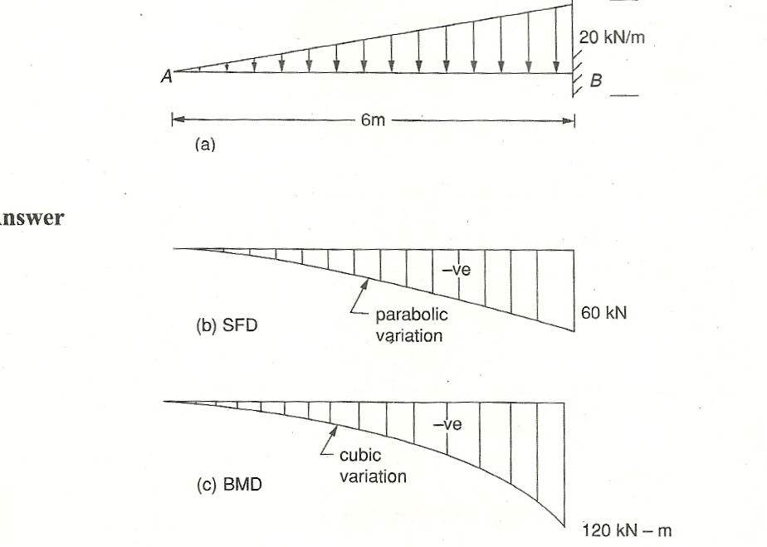

2. Draw *SFD* and *BMD* for simply supported beam shown in Fig. (a)

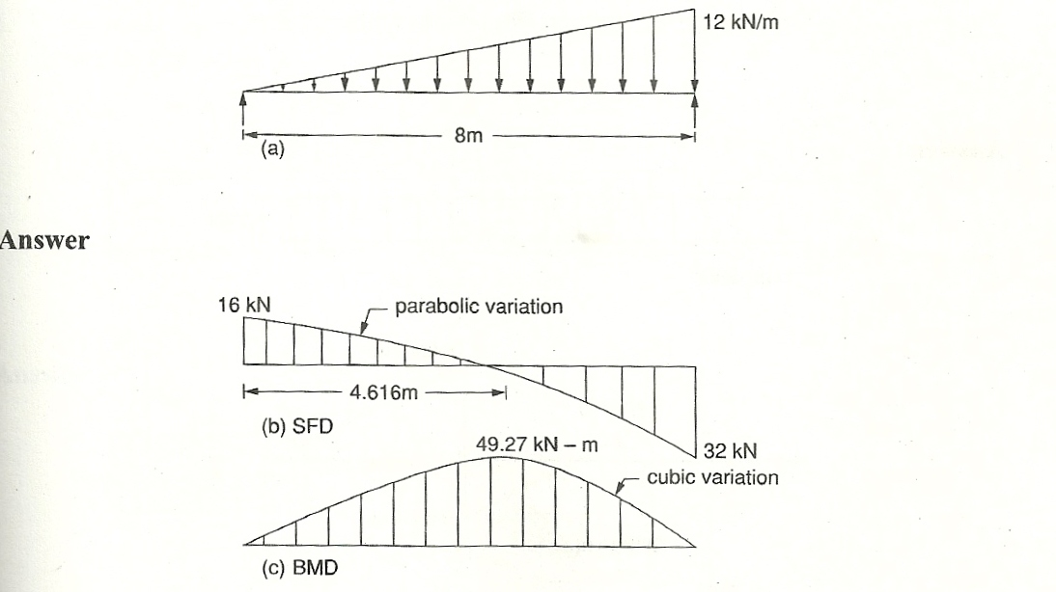

3. Draw *SFD* and *BMD* for simply supported beam shown in Fig. (a)

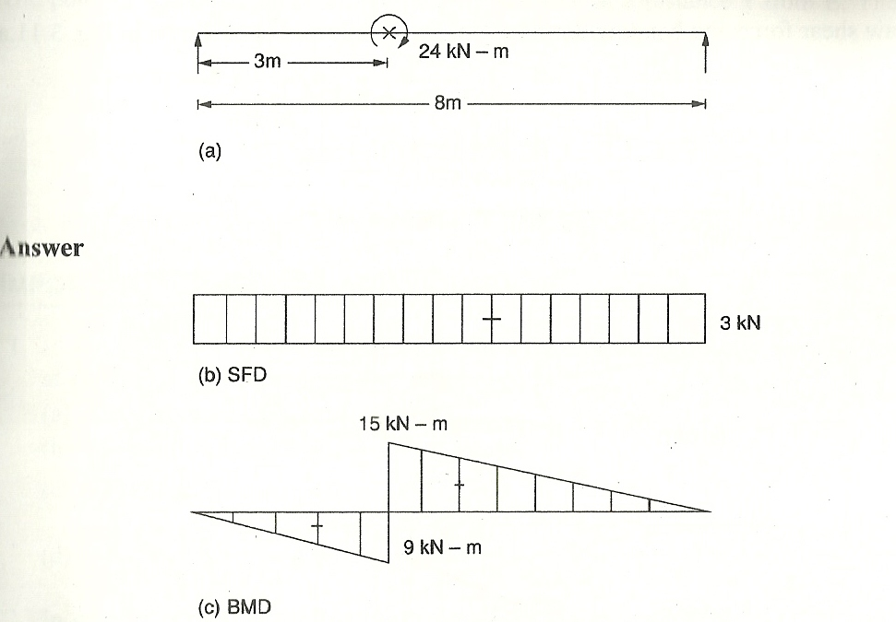

4. Draw *BMD* and *SFD* for the simply supported beam shown in Fig. (a)

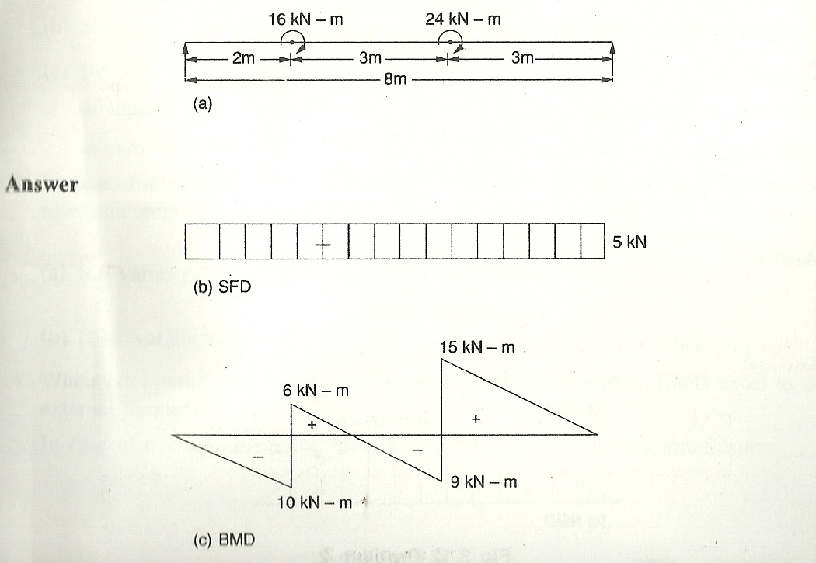

5. Draw shear force and BMD for the cantilever shown in Fig. (a)

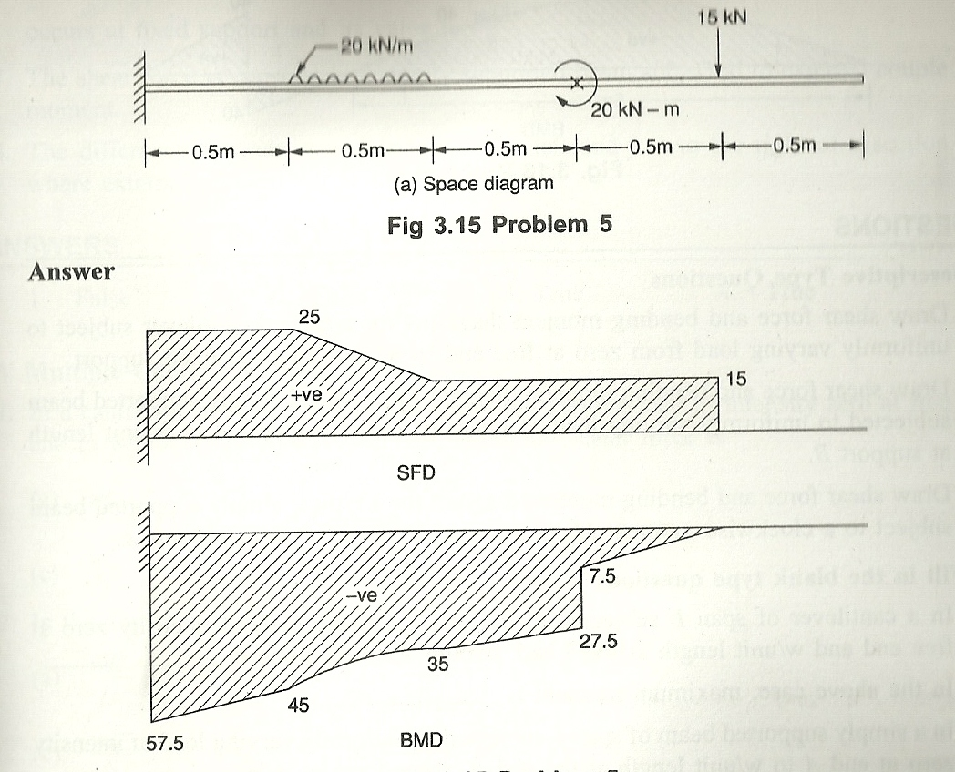

6. Draw shear force and bending moment diagrams for the simply supported beam shown in Fig. (a)

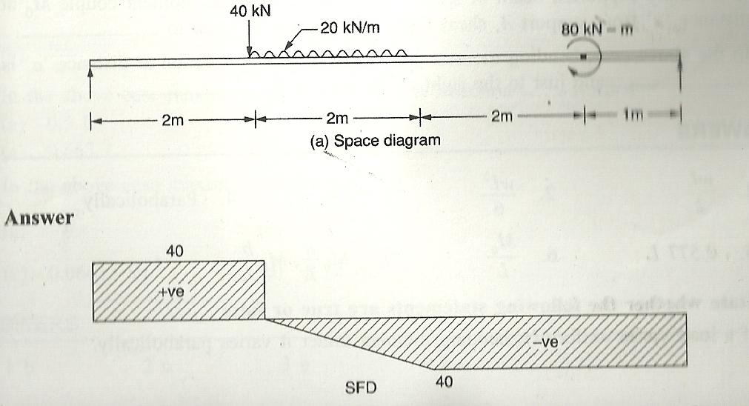

**QUESTIONS**

**I. Descriptive Type Questions**

1. Draw shear force and bending moment diagrams for a typical cantilever subject to uniformly varying load from zero at free end to w/unit length at fixed support.

2. Draw shear force and bending moment diagram for a typical simply supported beam subjected to uniformly varying load of intensity zero at support *A* to w/unit length at support *B.*

3. Draw shear force and bending moment diagram for a typical simply supported beam subject to a clockwise moment *M0* at a point, distance *‘a’* from support *A.*

**II. Fill in the blank type questions**

1. In a cantilever of span *L* subjected to uniformly varying load of intensity zero at free end and *w*/unit length at fixed end, maximum shear force is __________.

2. In the above case, maximum moment is __________.

3. In a simply supported beam of span *L* subjected to uniformly varying load of intensity zero at end *A* to *w*/unit length at the end *B,* shear force at *A* is __________.

4. In the above case shear force varies __________.

5. In the above case maximum moment occurs at _________ from end *A.*

6. In a simply supported beam of span *L* subjected to external moment couple *M0* at distance *‘a’* from support *A,* shear force at any point is equal to __________.

7. In the above case, bending moment just to the left of the section at distance ‘*a*’ is __________ and just to the right of the section is __________.

**Answers**

1.  2.  3.  4. Parabolically

5. 0.577 *L* 6.  7. 

**III.** **State whether the following statements are true or false**

. If a load varies uniformly, bending moment under it varies parabolically.

2. In cantilever of span /, lubjlit In uniformly distributed load, maximum moment occurs at fixed support and its value is

3. The shear force is constant in a simply supported beam subjected to external couple moment.

4. The difference between moments just to the left and just to the right of a section where external moment *M*0 is acting is *M*0*.*

**ANSWERS**

1. False 2. False 3. True 4. True

**IV Multiple Choice Questions**

1. In a cantilever of span *L,* subject to uniformly varying load of intensity zero at free end to w/unit length at fixed support, maximum shear force is

(a)  (b)  (c)  (d) 

2. In the above case maximum bending moment is (a) (b)  (c)  (d) 

3. In a simply supported beam of span *L* subjected to uniformly varying load of intensity zero at support *A* to *w*/unit length at support *B,* maximum shear force is

(a)  (b) (c) (d) 

4. In the above case maximum moment occurs at a section ________ from *A.*

(a) 0.5*L* (b) 0.577*L* (c) 0.667*L* (d) 0.75*L*

5. In the above case maximum moment is I /a\ *wL2 wl?*

(a)  (b)  (c) 0.06415 *wL2* (d) 0.72 *wL2*

**ANSWERS**

l-b 2-c 3-b 4-b 5-c

**Model Question Paper on**

**Mechanics of Structure**

**Chapter 3**

**PROBLEMS FOR EXERCISE**

**BENDING STRESS:**

1. A steel plate of width 60 mm and of thickness 10 mm is bent into a circular arc of radius 10 m. Determine the maximum stress induced and the bending moment which will produce the maxi­mum stress. Take *E =* 2 × 105 N/mm2.[**Ans.** 100 N/mm2 ; 100 N-m.]

2. A cast iron pipe of external diameter 60 mm, internal diameter of 40 mm, and of length 5 m is supported at its ends. Calculate the maximum bending stress induced in the pipe if it carries a point load of 100 N at its centre.[**Ans.** 7.34 N/mm2]

3. A rectangular beam 300 mm deep is simply supported over a span of 4 m. What uniformly distributed load per metre, the beam may carry if the bending stress is not to exceed 120 N/mm2? Take *I* = 8 × 106 mm4. [**Ans.** 3.2kN/m]

4. A cast iron cantilever of length 1.5 metre fails when a point load *W* is applied at the free end. If the section of the beam is 40 mm × 60 mm and the stress at the failure is 120 N/mm2, find the point load applied.[**Ans.** 1.92 kN]

5. A cast iron beam 20 mm × 20 mm in section and 100 cm long is simply supported at the ends. It carries a point load W at the centre. The maximum stress induced is 120 N/mm2. What uniformly distributed load will break a cantilever of the same material 50 mm wide, 100 mm deep and 2 m long ?[**Ans.** 5 kN per m run]

6. A timber beam is 120 mm wide and 200 mm deep and is used on a span of 4 metres. The beam carries a uniformly distributed load of 2.8 kN/m run over the entire length. Find the maximum bending stress induced.[**Ans.** 7 N/mm2]

7. A timber cantilever 200 mm wide and 300 mm deep is 3 m long. It is loaded with a*u.d.l.* of 3 kN/m over the entire length. A point load of 2.7 kN is placed at the free end of the cantilever. Find the maximum bending stress produced.[**Ans.** 7.2 N/mm2]

8. A timber beam is freely supported on supports 6 m apart. It carries a uniformly distributed load of 12 kN/m run and a point load of 9 kN at 3.5 m from the right support. Design a suitable section of the beam making depth twice the width, if the stress in timber is not to exceed 8 N/mm2. [**Ans.** 230 mm× 460 mm]

9. A timber beam of depth 300 mm and symmetrical section is simply supported over a span of 10 m. What uniformly distributed load (including self-weight of the beam) can it carry if the maximum permissible stress is 750 N/cm2. The moment of inertia of the section of the beam about its neutral axis is 45 × 107 mm4.

Find the maximum bending stress and the radius of curvature at a section 1 m from the right hand support. Take for timber *E* = 12.6 kN/mm2.

[**Ans.** *w* = 1.8 kN/m ; *f* = 270 N/cm2; *R* = 700 m.]

10. A steel channel has the following dimensions: Depth = 100 mm, flange width = 50 mm, flange thickness = 10 mm, web thickness = 5 mm. The channel is to be used as a beam over a span of 2.5 m. The allowable stress in bending is 1.4 kN/cm2. Find the safe concentrated load that the beam may carry at the mid-span. [**Ans.** 10.07 kN.]

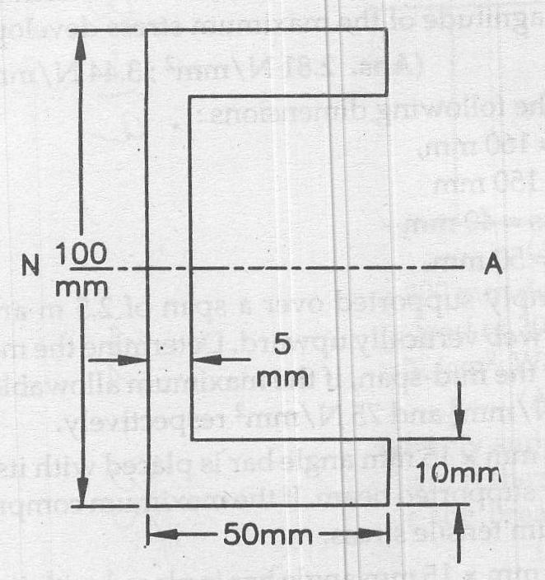

**Fig. Problem 3.10**

11. A beam of symmetrical section has a depth of 500 mm and M.I. of 30,000 cm4 about the neutral axis. Find the maximum possible span for this beam, if simply supported at the ends, it has to carry a uniformly distributed load of 28 kN per metre run without exceeding the bending stress of 14 kN/cm2.[**Ans.** 6.928 m.]

12. Determine the dimensions of a rectangular steel joist, 6 m long to carry a brick wall 250 mm thick and 3 m high, if the weight of the brick work is 19.2 kN per cum and the maximum permissible bending stress is 800 N/cm2. The depth of the joist is 1½ times its width.

[**Ans.** 278.5 mm × 417.8 mm]

13. A strip of metal 50 mm thick is bent round a circular drum of 3 m diameter. Calculate the maximum stress set up due to bending. Take *E* = 200 kN/mm2. [**Ans.** 327.8 kN/cm2.]

14. A floor has to carry a load of 18.3 kN per square metre. The joists are 30 cm deep and 12 cm wide and have a span of 4.2 m. How far apart may the centre lines of the joists be placed if the bending stress is not to exceed 8 kN per sq cm. [**Ans.** 3.569 m.]

15. A T-beam, overall depth 200 mm, flange width 150 mm, flange thickness 10 mm, web thickness 15 mm, is simply supported over a span of 6 metre. It carries a uniformly distributed load of 3 kN per metre run including its own weight, over its entire span, together with a load of 6 kN at the mid-span. Find the maximum tensile and compressive stresses induced in the beam.

[**Ans.** *fc* = 8.588 kN/cm2; *ft* = 15.78 kN/cm2.]

16. A R.S.J. (rolled steel joist) 4.5 m long having *I*-section 300 mm deep, is to support a load of 5 kN at points distant 1 m from each support. If M.I. about the neutral axis = 8100 cm4, find the maximum bending stress in the joist.[**Ans.** 0.9258 kN/cm2.]

17. A 150 mm × 100 mm × 15 mm angle bar is placed with its longer leg vertical and is used as a joist freely supported at the ends. Find what uniformly distributed load should be carried by the joist over a span of 4 m if the skin stress is not to exceed 2.5 kN per sq cm. What is the nature of this maximum stress ? [**Ans.** 1.03 kN/m; tensile]

18. A simply supported beam of 4 m span, carries a*u.d.l.* on the entire span. If the allowable tensile stress does not exceed 18 MPa, find the safe uniformly distributed load that the beam can carry. The section of the beam is *I*-section having the following data:

Top flange and bottom flange : 80 mm × 10 mm

Web thickness : 20 mm

Overall depth : 250 mm [**Ans**. 3.12 kN/m]

**SHEAR STRESS:**

1. Show that the ratio of maximum shear stress to mean shear stress in a solid circular section is equal to 4/3 when it is subjected to a transverse shearing force.

2. If a hollow circular beam, whose external diameter is twice the internal diameter, is subjected to a shear force, show that the maximum shear stress is 1.866 times the average shear stress.

3. A I-section beam of wide-flange shape with *b* = 165 mm, *t* = 7.5mm, *h* = 320 mm (total depth), and *h*1 (depth of web) = 290 mm is subjected to a vertical shear force *V* = 45 kN; determine *τmax*, *τmin* and total shear force in the web. [**Ans.** *τmax* = 21.0 MPa, *τmin* = 17.4 MPa and *Vweb* = 43 kN]

4. For a beam having a *T*-shaped cross section with *b* = 100 mm, *t* = 24 mm, *h* = 200 mm, vertical shear force acting is *V* = 45 kN, determine shear stress developed at the top of the web and *τmax*.

[**Ans.** 10.9 MPa; *τmax* = 13.2 MPa]

5. In the *I*-beam shown in Fig. below, *t* is small with respect to *b*. Show that the maximum shear stress is, 3.2 times the mean.

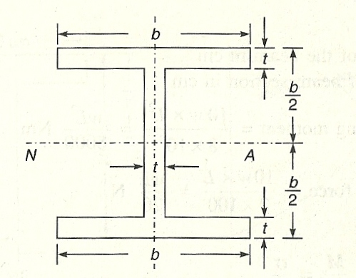

6. A timber beam having a rectangular cross-section is loaded with a uniform load of 10 *w* N/m. If the allowable design stresses are 8.5 MPa in bending and 0.85 MPa in shear, what will be the span to depth ratio so that the allowable flexural and shear stresses occur simultaneously? [**Ans.** *L/h* = 10]

7. A beam *AB* supported at its ends has a span of 2 metres and carries a uniformly distributed load of 20 kN/m over the entire span. The cross-section of the beam is a *T*-section having flange width of 125 mm, flange thickness of 25 mm, web thickness of 25 mm and overall depth of 200 mm. Calculate the maximum shear stress in the beam. Also draw the shear stress distribution diagram indicating the principal values. [**Ans.** 986.2 kN/m2 (in flange at junction); 4931.1 kN/m2 (in web at junction); *τmax* = 5640.786 kN/m2.]

8. A beam of *I*-section, 50 cm deep and 19 cm wide, has flanges 2.5 cm thick and web 1.5 cm thick. It carries a shearing force of 400 kN at a section. Calculate the maximum intensity of shear stress in the section, assuming the moment of inertia to be 64500 cm4. Also calculate the total shear force carried by the web and sketch the shear stress distribution across the section. [**Ans.** *τmax* = 62.3385 MPa, *Vweb* = 382202.84 N.]

9. A rolled steel joist, simply .supported across a span of 4 m and carrying a uniformly distributed load of 80 kN/m, has the following dimensions: Overall depth 35 cm, each flange 150 mm × 25 mm and web 300 mm × 12 mm. Determine the magnitude of bending and shearing stresses at the junction of the web with the top flange at a section 1 m away from the support. [**Ans.** *σ* = 79844.74 kN/m2 (compressive); *τ* = 1441641.3 kN/m2 (in flange at junction), 18020.516 kN/m2 (in web at junction).]

10. A cast iron bracket subjected to bending has a cross-section of *I*-shape with unequal flanges [Overall depth 35 cm, top flange 25 cm × 5 cm; bottom 15 cm × 5 cm and web 25 cm × 5 cm]. If the tensile stress in top flange is not to exceed 17.5 MPa, what is the bending moment the section can take? If the section is subjected to a shear force of 100 kN, draw the shear stress distribution diagram over the depth of the section. [**Ans.** *τ* from top to bottom level = 1264.0376; 6320.1882; 7354.4887 (*τmax*); 1724.231; 5172.693 kN/m2.]

**TORSION:**

1. A solid circular shaft is to transmit 300 kW at 100 r.p.m. If the shear stress is not to exceed 80 N/mm , find the diameter of the shaft. What percentage in saving would be obtained, if this shaft is replaced by a hollow one, whose internal diameter is equal to 0.8 of the external diameter, the length, the material and the allowable maximum shear stress being the same? [**Ans.** *ds* = 122.173mtn, *d*1 = 145.638, *d*2 = 116.510, % saving = 48.94]

2. A solid circular shaft is to be designed to transmit 22.5 kW power at 200 r.p.m. If the maximum shear stress is not to exceed 80 N/mm2 and the angle of twist is not to exceed 1° per metre length, determine the diameter of the shaft. Take modulus of rigidity 80 kN/mm2. [**Ans** *d =* 52.91]

3. A hollow circular shaft 12 m long is required to transmit 100 kW power when running at a speed of 300 rpm. If the maximum shearing stress allowed in the shaft is 80 N/mm2 and the ratio of inner diameter to the outer diameter is 0.75, find the dimensions of the shaft and also the angle of twist of one end of the shaft relative to the other end. Modulus of rigidity of the material is 85 kN/mm2.

[**Ans** *d*1 = 66.67 mm, *d*2 = 50 mm, *θ* = 0.3389 rad.]

4. A solid shaft of 200 mm diameter is proposed to be replaced by a hollow shaft of external diameter *D* and internal diameter *DU.* If the same power is to be transmitted at the same speed and at the same level of shear stress, determine the diameter *D.* [**Ans** *D =* 204.35 mm]

5. A hollow shaft is 2 m long and has outer and inner diameters 200 mm and 150 mm respectively. If the angle of twist must not exceed 0.5° in 2 m and the maximum shearing stress is not to exceed 50 N/mm2 find, the maximum power that can be transmitted at 200 rpm. Take modulus of rigidity of die material as 84 kN/mm2. [**Ans** 824.27 kW]

**QUESTIONS**

**I. Descriptive type questions**

1. Write down the assumptions made in the theory of simple bending.

2. Deduce the equation  with their usual notations.

3. What do you mean by neutral plane and neutral axis of a beam?

4. What is flexural strength of a beam section?

5. Write down the factors on which the flexural strength of a section depends.

6. Explain what moment of resistance is.

7. What do you mean by section modulus of a section?

8. Explain the difference between Pure Bending & Ordinary Bending.

9. Give the expression for finding shearing stress in a beam. Explain each term used.

10. Derive the expression for shear stress across a rectangular section subjected to shear force *F* and show that the maximum shear stress is 1.5 times the average shear stress.

11. Derive the expression for shear stress across a circular section subjected to shear force *F* and show that the maximum shear stress is  times the average shear stress.

12. State the assumption made in the theory of torsion.

13. Give torsion equation and explain each term in it. Given the units used for each of them.

14. Explain the term polar modulus of section.

15. Explain the terms torsional rigidity and power transmitted by a shaft. Give expressions for them.

**II. Fill in the blanks type questions**

1. In a simply supported beam, the maximum compressive bending stress will develop at the ______ fibre.

2. A cantilever carries an uniformly distributed load throughout, the nature of bending stress at the bottom most layer will be ________.

3. If the cross-section of a beam is symmetrical about the neutral axis the magnitude of the stress at the top most and bottom most layer will be ________.

4. The strength of a beam depends on __________.

5. In a cantilever beam, the maximum compressive stress will develop at the ______ most layer of the loaded beam.

6. The bending stress in a beam is directly proportional to ____________.

7. The bending stress in a beam is ________ proportional to bending moment.

8. In a simply supported beam, the maximum tensile stress will occur at the _____________.

9. The magnitude of the bending stress at any layer is ________ proportional to the distance of the layer from the neutral axis.

10. The magnitude of bending stress is ________proportional to the moment of inertia of the cross-section of the beam about neutral axis.

11. A sagging B.M. induces tensile stress at the _______________ of the beam.

12. Unit of section modulus of a section is __________.

13. The section modulus of a circular section having diameter ‘*d*’ about its centroidal axis is ________.

14. Section modulus of a rectangular beam is ______.

15. With their usual notation *I/Y* is called ___________ of a beam.

16. One of the assumptions in the theory of bending is that, Young’s Modulus for the material is ______ for tension and compression.

17. Whatever be the magnitude of B.M., the stress at neutral plane is ______ zero.

18. Radius of curvature of a beam is the radius of _____________ of the beam.

19. The flexural strengths of two sections of same moment of inertia are _____ always equal.

20. The stress on neutral axis of a beam is ______.

21. Neutral axis of a section always passes through the ___________ of the section.

22. One of the assumptions generally made in the theory of pure bending is the value of ____________ is same in tension as well as in compression.

23. Section modulus is the ratio of the moment of inertia of area and __________________.

24. If section modulus of a beam is increased, the bending stress will _________.

25.In a rectangular section subjected to shear force *F,* maximum shear stress is _______ times the average shear stress.

26. In a circular section subjected to shear force *F,* maximum shear stress is_______ times the average shear stress.

27. Shear stress is _________ in extreme fibre and ___________ at neutral axis.

28. Torsion formula with usual notations is ________________.

29. If *J* is polar modulus of section, *R* is radius modulus of rigidity, polar modulus of section is ____________ and torsional rigidity is ________________.

ANSWERS

1. top ; 2. compressive; 3. same or equal (but opposite in nature); 4. Section Modulus; 5. Bottom; 6. distance from N.A.; 7. directly; 8. bottom-most fibre; 9. directly;

10. inversely; 11. portion below neutral plane; 12. mm3 or cm3 (generally);

13. ; 14. *bd*2/6; 15. Section Modulus (*Z*); 16. same; 17. always;

18. neutral plane/longitudinal axis; 19. not; 20. zero; 21. Centroid or C.G.;

22. Modulus of Elasticity; 23. maximum fibre distance from neutral axis; 24. decrease.

25. 1.5. 26. . 27. Zero, maximum 28.  29. 

**III. State whether the following statement are true or false**

1. The radius of gyration of an area is the square root of the moment of inertia divided by area.

2. The unit of section modulus and area are same.

3. The stress intensity in any fibre is inversely proportional to the distance of the fibre from the neutral axis.

4. The bending stress developed at neutral axis is maximum tensile in nature.

5. The section modulus of a circular section of diameter‘d’ is.

6. Neutral axis of a beam in the axis at which SF is zero.

7. Bending stress is zero at neutral axis.

8. The strength of the beam mainly depends on bending moment.

9. The intensity of bending stress of any point in a beam varies directly with the distance of point from the neutral axis.

10. The shear force in a beam is zero under pure bending case.

11. The variation of bending stress is linear from top to bottom fibre in elasto-plastic action on a beam.

12. The moment of inertia of a composite figure is equal to the sum of the moments of inertia of its separate parts.

13. *Z* for *I* section 30 cm × 15 cm having 2 cm thick flanges and 1.25 cm thick web is 900 cm3.

14. Bending into a circular arc may occur if the beam has constant cross-section throughout its length and bending moment is also not varying.

15. The stiffness of the beam, which is inversely proportional to the deflection, is the second criterion of beam design.

16. The variation of shear stress in a beam across the section is parabolic.

17. In a beam of circular cross-section, the maximum shear stress due to shear force *F* is 1.5 times the average shear stress.

18. In torsion formula , θ should be in degrees.

19. Shear stress due to torsion is maximum at the centre of circle.

**Ans.** 1. – T; 2. – F; 3. – F; 4. – F; 5. – T; 6. – F; 7. – T; 8. – F; 9. – T; 10.–T; 11. – T; 12. – T; 13. – T; 14. – T; 15. – T; 16. – T; 17. – F; 18.- F; 19. – F.

**IV. Multiple Choice Questions**

1. The designing of a beam based on bending and shear stress considerations is known as __________ criterion.

(a) stiffness, (b) toughness, (c) strength, (d) None of the above.

2. A beam is said to be loaded in pure bending if

1. shear force and bending moment are uniform throughout
2. shear force is zero and bending moment is uniform throughout
3. shear force can vary but bending moment is uniform throughout
4. None of the above.

3. The moment of inertia of rectangular lamina of side *d* and *b* about centroidal axis parallel to side *d* is (a) *bd*3/12*,* (b) *bd*3/36 *,* (c) *db*3/12*,* (d) (c) *db*3/36.

4. Neutral axis in a beam carries _________ bending stress.

(a) maximum (b) minimum (c) zero (d) None of the above.

5. In simple bending of beams, the stress in the beam

(a) is constant (b) varies linearly (c) varies parabolically, (d) None of the above.

6. In a transversally loaded beam, the maximum tensile stress occurs at the

(a) top edge (b) bottom edge (c) neutral axis (d) none of these

7. In a transversally loaded beam, the maximum compressive stress occurs at the

(a) top edge (b) bottom edge (c) neutral axis (d) none of these

8. The relation governing the simple bending of beam is

(a) , (b) , (c) , (d) .

9. The stress in a beam is less if its section modulus is

(a) high (b) low (c) zero (d) None of the above.

10. Bending stress means

(a) tensile stress (b) compressive stress

(c) both tensile and compressive stress (d) shear stress.

11. The main difference between bending stress and direct stress is that

1. bending stress is constant anywhere in the section, but direct stress varies from top to bottom or vice versa of the section
2. bending stress increases as we proceed more and more from the neutral axis either above or below it
3. nature of bending stress is not the same above and below neutral axis whereas the nature of direct stress is the same anywhere in the section of the beam
4. both (b) and (c).

12. In case of simply supported beam, compressive stress is set up

(a) at the neutral layer (b) above the neutral layer

(c) below the neutral layer (d) none of the above.

13. In case of a cantilever, compressive stress is set up

(a) at the neutral layer (b) above the neutral layer

(c) below the neutral layer (d) none of the above.

14. Bending stress is nil at

(a) the neutral axis (b) top layer of the beam

(c) bottom layer of the beam (d) middle layer of the beam.

15. Pure bending is that bending where (a) shear stress is maximum, (b) bending stress is maximum, (c) bending stress is nil, (d) shear stress is nil.

16. Neutral axis passes through

(a) the top layer of the beam (b) the bottom layer of the beam

(c) the C.G. of the section of the beam (d) none of the above.

17. For safe design of a beam, moment of resistance is (a) always equal to the B.M., (b) may be less than the B.M., (c) may be greater than the B.M., (d) greater than or equal to the B.M.

18. Relation among bending stress *f*, moment of resistance *M* and section modulus *Z* is

(a) *M* =*f*×*Z* (b)*f*=*M*×*Z*

(c) *Z* = *M* ×*f* (d) none of the above.

19. A beam can be made of uniform strength by

1. varying the depth of the beam but maintaining constant width
2. varying the width of the beam but maintaining constant depth
3. varying both width and depth
4. any one of the above.

20. For circular section of diameter ‘*d*’, the section modulus is given by

(a) , (b) , (c) , (d) .

21. For a rectangular section of width ‘*b*’ and depth ‘*d*’, the section modulus is given by

(a) , (b) , (c) , (d) 

22. If section modulus of a beam is increased, the bending stress will

(a) increase (b) decrease

(c) remain unchanged (d) none of the above.

23. For a beam, subjected to pure bending

(a) all fibres experience uniform stress

(b) the nature of stress in all fibres is the same

(c) the stress intensity in any fibre is proportional to the distance of the fibre from the neutral axis

(d) the stress intensity in any fibre is proportional to the distance of the fibre from the supports.

24. The strength of a beam section depends upon

1. its sectional area
2. its sectional modulus
3. distance of its base from N. A.
4. its length.

25. In a simply supported beam, along the neutral axis

1. (a) fibres do not undergo strain
2. (b) fibres get twisted
3. (c) fibres undergo maximum strain

(d) fibres undergo minimum strain

26. Two beams carrying identical loads, simply supported, are having same width but beam *A* has double the depth as compared to that of beam *B*. The ratio of elastic strength of beam *A* to that of *B* will be (a) 2, (b) 4, (c) 1/2, (d) 1/4.

27. The bending moment at a section tends to bend or deflect the beam and the internal stresses resist its bending. The resistance offered by the internal stresses, to the bending, is called (a) compressive stress (b) shear stress (c) bending stress (d) elastic modulus.

28. In a simple bending theory, one of the assumption is that the plane sections before bending remain plane after bending. This assumption means that

1. stress is uniform throughout the beam
2. strain is uniform throughout the beam
3. stress is proportional to the distance from the neutral axis
4. strain is proportional to the distance from the neutral axis.

29. In a beam there is a layer which is neither stretched nor compressed during bending operations. This layer is known as (a) compressive layer (b) tensile layer (c) neutral layer (d) the middle layer

30. In a rectangular section, shear stress due to transverse shear F, the ratio of maximum stress to average stress is

(a) 1.25 (b) 

(c) 1.5 (d) 2

31. Out of the following mild steel sections, the most economical section is

(a) I-section (b) circular section

(c) rectangular section (d) channel-section

32. In a beam of circular section, shear stress due to shear force *F,* the ratio of maximum shear stress to average stress is

(a) 1.25 (b) 

(c) 1.5 (d) 2.0

33. Two beams of equal cross-sectional area are subjected to equal bending moments. If one beam has square cross-section and the other has circular section, then

1. circular section will be economical
2. square section will be economical
3. both beams will have equal strength
4. in shear the square section will be stronger.

34. Three beams of circular, square, rectangular (with depth twice the width) sections and of same length are subjected to the same maximum bending moment. If allowable stress is the same then the section which will require maximum weight of the same material will be

(a) rectangular, (b) square, (c) circular, (d) none of the above.

35. For the question 34, the section which will require minimum weight of the same material will be

(a) rectangular (b) square

(c) circular (d) none of the above.

36. For the question 34, the ratios of weight of circular beam, weight of rectangular beam and weight of square beam is

(a) 1: 0.7938 : 1.118 (b) 0.7938 : 1: 1.118

(c) 1.118 : 0.7938 : 1 (d) 0.7938 : 1.118 : 1.

37. The ratio of moment of inertia about the neutral axis to the distance of the most distance point of the section from the neutral axis is called

(a) moment of inertia (b) section modulus

(c) polar moment of inertia(d) modulus of rigidity.

38. Choose the correct statement

(a) Section modulus of a hollow circular section of external diameter *‘D’* and internal diameter *‘d’* is equal to 

(*b*) Section modulus of a circular section of diameter *‘D’* is 

(c) Section modulus of a rectangular section is .

(d) Section modulus of a square section *b* × *b* is .

39. In a beam of rectangular section at a depth , the shear stress is

(a) Zero (b)  × max. shear stress

(c) ½ × max. shear stress (d) None of the above.

40. Due to torsional moment, shear stress at distance  in a shaft of radius *R is*

(a) Zero (b) ½ × max. shear stress

(c) ¼ × max. shear stress (d) None of the above.

41. Power transmitted by a shaft of length *L* subjected to torque *T* and rotating at *N* rpm is

(a)  (b) 

(c)  (d) 

***Answers to M.C.Q.***

1. (c), 2. (b), 3. (c), 4. (c), 5. (b), 6. (b), 7. (a), 8. (d), 9. (a), 10. (c), 11. (d),

12. (b), 13. (c), 14. (a), 15. (d), 16. (c), 17. (d), 18. (a), 19. (d), 20. (c), 21. (d), 22. (b),

23. (c) 24. (b) 25. (a) 26. (b) 27. (c) 28. (d), 29. (c) 30. (c) 31. (a) 32. (b) 33. (b)

34. (c) 35. (a) 36. (c) 37. (b) 38. (c) 39. (d) 40. (b) 41. (a)

**Chapter 4**

**PROBLEMS FOR EXERCISE**

1. Find the forces in each of the members of the king post truss loaded as shown in Fig. below.

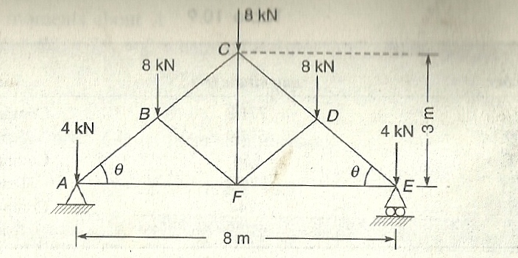

*Ans. AB* = 20 kN Compression; *BC =* 12.96 kN Compression; *CD* = 12.96 kN Compression;

*DE* = 20 kN Compression; *EF* = 16 kN Tension; *FA* = 16 kN Tension; *BF* = 6.667 kN Compression; *DF* = 6.667 kN Compression; *CF* = 8 kN Tension.

2. Find the forces in all the members of the cantilever truss as shown in Fig.

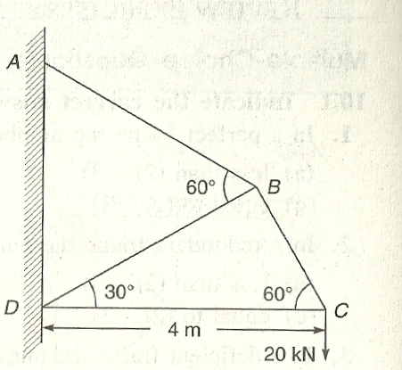

*Ans. AB* = 26.6 kN Tension; *BC* = 23.1 kN Tension; *CD =* 11.55 kN Compression; *BD* = 13.3 kN Compression.

3. Determine the forces in all the members of the saw tooth truss as shown in Fig.

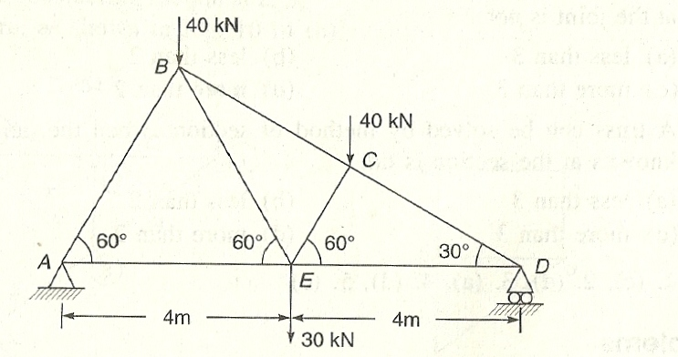

*Ans. AB* = 69.2 kN Compression; *AE =* 34.6 kN Tension; *BE =* 69.2 kN Tension; *BC* = 80 kN Compression; *CE =* 34.6 kN Compression; *DE =* 6.5 kN tension; *CD* = 100 kN Compression.

4. Find the forces in the members *CD, DE, BC, CF* and *EF* of the braced cantilever as shown in Fig.

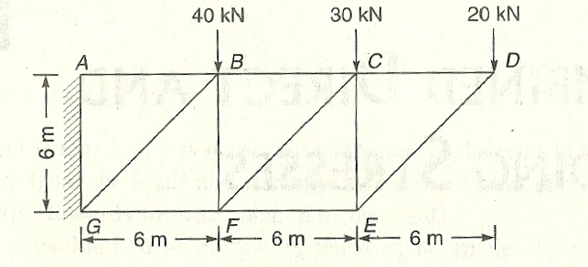

*Ans. CD* = 20 kN Tension; *DE* = 28.2 kN Compression; *BC* = 70 kN Tension; *EF* = 20 kN Compression; *CF =* 70.7 kN Compression

5. For the Simple frame shown below determine forces in members. Only the support B is hinged. Also determine support reaction.

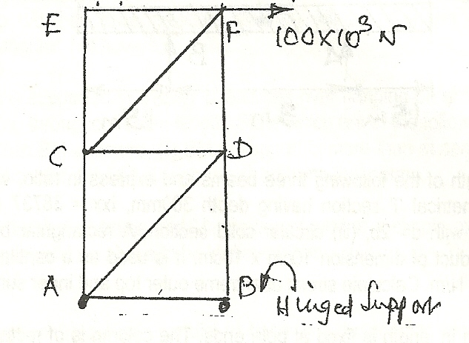

*Ans. AB =* 100 kN; *CA* = 100 kN (T); *CD* = 100 kN (C); *DA* = 141.42 kN (T); *DB* = 200 kN (C); *CF* = 141.42 kN (T); *FD* = 100 kN (C); *CE = CF* = 0 kN

***Reactions*:** *HA* = 0; *VA* = 200 kN (↓) *HB* = 100 kN (←); *VB* = 200 kN (↑)

6. *ABCDEF* is a pin jointed frame with *DA, AB, BE* and *ED,* forming a square of sides 3.6 metres and diagonal *DB.* The frame is suspended from *A* and *B* and is extended on either side by horizontal bars *DC* (3.6 metres) and *EF* (4.8 metres) and inclined members *AC, BF.* The frame carries loads of 20, 5, 15 and 10 kN at the joints *C, D, E* and *F* respectively. Using the ***method of sections***, determine the forces in the members *CD, DA*, *BA* and *BD* indicating those in compression and tension. Neglect the weight of members. *AB* is hori­zontal.

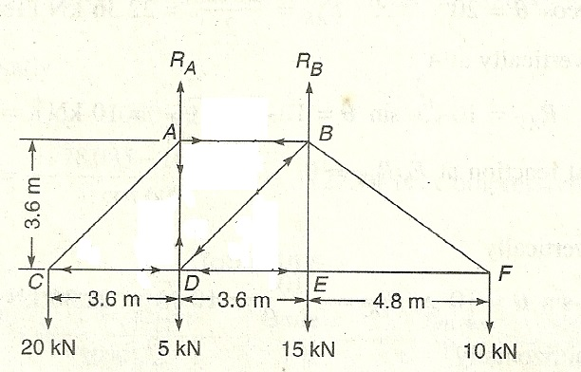

*Ans.*

|  |  |  |  |
| --- | --- | --- | --- |
| *SL No.* | *Member* | *Force in kN* | *Nature* |
| 1 | *CD* | 20 | Compressive |
| 2 | *DA* | 11.67 | Tensile |
| 3 | *AB* | 20 | Tensile |
| 4 | *BD* | 9.43 | Compressive |

7. Determine the forces in the various members of a pin jointed framework shown in Fig. ***by Graphical method*** of solution; tabulate the forces stating whether they are in tension or compression.

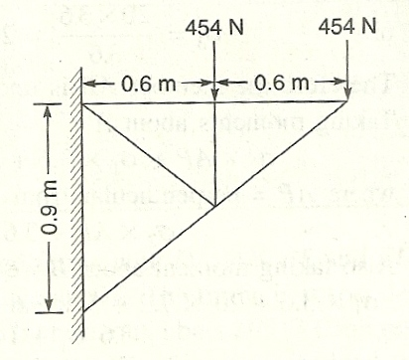

*Ans.*

|  |  |  |
| --- | --- | --- |
| *Member* | *Force* | |
| *magnitude (N)* | *Nature* |
| *RU* | 771.8 | Compression |
| *UQ* | 612.9 | Tension |
| *UT* | 954 | Compression |
| *TS* | 376.8 | Tension |
| *SR* | 1144 | Compression |
| *PT* | 612.9 | Tension |

**QUESTIONS**

**I. Descriptive Type**

1. Define the terms: Truss, perfect truss, deficient truss, redundant truss.

2. List the assumptions made in the analysis of pin jointed frames.

3. When do you prefer to go for method of section for the analysis of trusses?

4. What are the advantages and disadvantages of graphical method for the analysis of trusses?

**II. Fill in the blank type of questions**

1. The truss in which all members are in a single plane is known as _______________.

2. A pin-jointed frame which has got just sufficient number of members to resist the load applied at any joint in any direction, without undergoing appreciable change in shape is known as _______________.

3. At any joint, the axes of all members meeting at a joint pass through _______________.

4. In __________ type of truss, forces in all the members of truss can be found without finding the support reactions.

**ANSWERS**

1. Plane truss 2. Perfect truss

3. a single point 4. Cantilever.

**III. State whether the following statements are true or false**

1. A truss with more number of members than that required for a perfect truss is known as deficient truss

2. In a perfect truss, the relationship between number of joints ‘*j*’ and number of members *m*, is *m* = 2*j* – 3.

3. In the analysis of trusses loads are assumed to act only at joints.

4. In the method of section, the section line should not cut more than 2 members to separate the truss into two parts.

5. Graphical method is very accurate method of analysis the trusses.

**ANSWERS**

1. False; 2. True; 3. True; 4. False; 5. False

**IV. Multiple choice questions**

**Indicate the correct answer from the given alternatives.**

1. In a perfect frame the number of members are

(a) less than (*2j* – 3) (b) equal to (*2j* – 2)

(c) equal to (*2j* – 3) (d) more than (*2j* – 3)

2. In a redundant frame the number of members are

(a) less than (*2j* – 3) (b) equal to (*2j* – 2)

(c) equal to (*2j* – 3) (d) more than (*2j* – 3)

3.In a deficient frame the number of members are

(a) less than (*2j* – 3) (b) equal to (*2j* – 3)

(c) equal to (*2j* – 2) (d) more than (*2j* – 3)

4. A truss can be solved by method of joints when the number of unknowns at the joint is not

(a) less than 3 (b) less than 2

(c) more than 3 (d) more than 2

5. A truss can be solved by method of sections when the number of un­knowns at the section is not

(a) less than 3 (b) less than 2

(c) more than 3 (d) more than 2

6. The assumptions made in the analysis of truss is

1. The ends of the members are having perfect pin connections.
2. The weights of the members are negligible
3. Loads act at joints only
4. All the above

7. Which member of the truss shown in Fig is zero member?

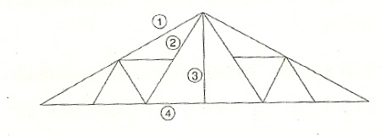

(a) 1 (b) 2

(c) 3 (d) 4.

ANSWERS

1. (c); 2. (d); 3. (a); 4. (d); 5. (c); 6. – (d); 7. – (c)

**Chapter 5**

**PROBLEMS FOR EXERCISE**

1. Compare the strain energy stored in bar *A* with that of bar *B* (Fig. 6.8) when

(a) Same load *P* acts on them.

(b) When the maximum stress produced is the same.

Assume both are made up of same material.

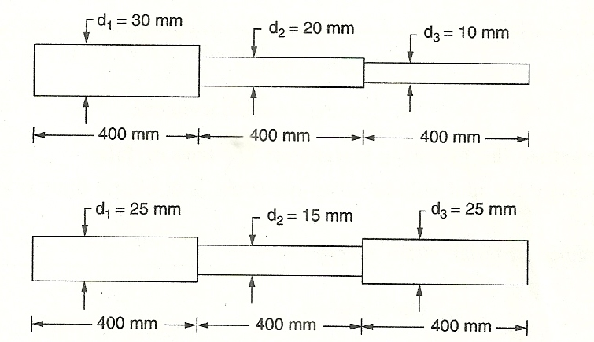

[Ans: (a)  = 1.7805, (b)  = 0.3517. ]

2. A steel rod 20 mm diameter and 400 mm long has a collar at lower end and is fixed at top. A load of 60 N falls freely along the rod and strikes the collar. If the instantaneous stress does not exceed 250 N/mm2, find the maximum height from which the load can be allowed to strike the collar. How much is the stress produced, if the load falls from a height of 200 mm? Take *E* = 2 × 105 N/mm2.

[Ans: *h* = 326.75 mm, *p* = 195.63 N/mm2]

3.Calculate the strain energy in a bar 2.5 m long and 5 cm in diameter when it is subjected to a tensile load of 10000 kg. What will then be modulus of resilience of the material of the bar? Take *E* = 2.0 × 105 N/mm2.[Ans: 0.272 N/mm2.]

4. Compute the amount of strain energy stored for the bar having circular cross-section as shown in Fig.

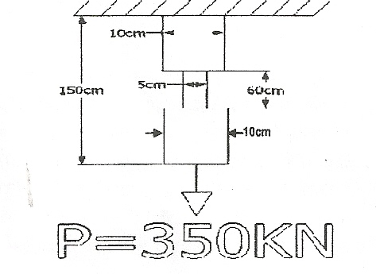

[Ans.: 128.6 kN/mm2.]

**QUESTIONS**

**I. Descriptive type questions**

1. Define the terms strain energy, Resilience and Proof resilience.

2. Derive the expression for strain energy due to direct stress.

3. Show that stress developed due to sudden load is twice the stress developed due to the same load applied gradually.

4. A load *W* freely falls on the collar of a bar of cross section area *A* and Length *L*, from a height *h.* If Young’s modulus of the material of the bar is *E*, derive the expression for the stress developed.

5. If U units of shock load is applied to a bar of length *L*, cross section *A*, find the stress developed. Take Young’s modulus of the material of the bar as *E*.

**II. Fill in the blanks type questions**

1. Strain energy per unit volume is defined as _____________.

2. Strain energy per unit volume when the stress is at elastic limit is known as _____________.

3. Instantaneous stress developed in a bar when load is suddenly applied is ___________ times that due to the same load applied gradually.

4. Strain energy stored in a material due to stress *p* is equal to _____________.

**ANSWERS**

1. Resilience 2. Proof resilience 3. 2 4. ½ × stress × strain × volume

**III. State whether the following statements are true or false**

1. Strain energy per unit volume when the stress is at elastic limit is known as proof resilience.

2. In a strained material, strain energy = ½ × stress × strain

3. If the load is applied suddenly the instantaneous stress produced is 3 times the stress produced, if the load applied is gradual.

4. On the collar of a bar a load *W* falls freely and produces instantaneous stress *p*1*.* If a load of 2*W* falls from the same height on the same bar, stress produced will be 2*p*1*.*

ANSWERS

1. True 2. True 3. False 4. False

**IV. Multiple choice questions**

1. If *p* is the stress and *E* the modules of elasticity, resilience is equal to

(a)  (b)  × volume (c)  (d) × volume

2. A suddenly applied load on a bar of cross-section *A* produces instantaneous stress

(a)  (b)  (c)  (d) 

(c)

3. If a weight *W* falls on a collar of bar of length *L* and cross-sectional area *A.* From a height *h,* the instantaneous stress produced is

(a)  (b)  (c)  (d) 

where *E* is Young’s modulus

4. If a shock energy *U* is applied to a bar of length *L,* cross-sectional area *A*, young’s modulus *E*, the instantaneous stress is

(a)  (b)  (c)  (d) 

ANSWERS

1-a 2-b 3-a 4-c

**Model Question Paper on**

**Mechanics of Structure**

**Chapter 5**

**PROBLEMS FOR EXERCISE**

1. Compare the strain energy stored in bar *A* with that of bar *B* (Fig. 6.8) when

(a) Same load *P* acts on them.

(b) When the maximum stress produced is the same.

Assume both are made up of same material.



[Ans: (a)  = 1.7805, (b)  = 0.3517. ]

2. A steel rod 20 mm diameter and 400 mm long has a collar at lower end and is fixed at top. A load of 60 N falls freely along the rod and strikes the collar. If the instantaneous stress does not exceed 250 N/mm2, find the maximum height from which the load can be allowed to strike the collar. How much is the stress produced, if the load falls from a height of 200 mm? Take *E* = 2 × 105 N/mm2.

[Ans: *h* = 326.75 mm, *p* = 195.63 N/mm2]

3.Calculate the strain energy in a bar 2.5 m long and 5 cm in diameter when it is subjected to a tensile load of 10000 kg. What will then be modulus of resilience of the material of the bar? Take *E* = 2.0 × 105 N/mm2.[Ans: 0.272 N/mm2.]

4. Compute the amount of strain energy stored for the bar having circular cross-section as shown in Fig.



[Ans.: 128.6 kN/mm2.]

**QUESTIONS**

**I. Descriptive type questions**

1. Define the terms strain energy, Resilience and Proof resilience.

2. Derive the expression for strain energy due to direct stress.

3. Show that stress developed due to sudden load is twice the stress developed due to the same load applied gradually.

4. A load *W* freely falls on the collar of a bar of cross section area *A* and Length *L*, from a height *h.* If Young’s modulus of the material of the bar is *E*, derive the expression for the stress developed.

5. If U units of shock load is applied to a bar of length *L*, cross section *A*, find the stress developed. Take Young’s modulus of the material of the bar as *E*.

**II. Fill in the blanks type questions**

1. Strain energy per unit volume is defined as _____________.

2. Strain energy per unit volume when the stress is at elastic limit is known as _____________.

3. Instantaneous stress developed in a bar when load is suddenly applied is ___________ times that due to the same load applied gradually.

4. Strain energy stored in a material due to stress *p* is equal to _____________.

**ANSWERS**

1. Resilience 2. Proof resilience 3. 2 4. ½ × stress × strain × volume

**III. State whether the following statements are true or false**

1. Strain energy per unit volume when the stress is at elastic limit is known as proof resilience.

2. In a strained material, strain energy = ½ × stress × strain

3. If the load is applied suddenly the instantaneous stress produced is 3 times the stress produced, if the load applied is gradual.

4. On the collar of a bar a load *W* falls freely and produces instantaneous stress *p*1*.* If a load of 2*W* falls from the same height on the same bar, stress produced will be 2*p*1*.*

ANSWERS

1. True 2. True 3. False 4. False

**IV. Multiple choice questions**

1. If *p* is the stress and *E* the modules of elasticity, resilience is equal to

(a)  (b)  × volume (c)  (d) × volume

2. A suddenly applied load on a bar of cross-section *A* produces instantaneous stress

(a)  (b)  (c)  (d) 

(c)

3. If a weight *W* falls on a collar of bar of length *L* and cross-sectional area *A.* From a height *h,* the instantaneous stress produced is

(a)  (b)  (c)  (d) 

where *E* is Young’s modulus

4. If a shock energy *U* is applied to a bar of length *L,* cross-sectional area *A*, young’s modulus *E*, the instantaneous stress is

(a)  (b)  (c)  (d) 

ANSWERS

1-a 2-b 3-a 4-c

**Chapter 6**

**PROBLEMS FOR EXERCISE**

1. A steel flat section 150 mm wide and 20 mm thick is subjected to a pull of 20 kN. Find the maximum and minimum stress intensities set up in the section when the pull is acting at a distance of 4 mm in the plane bisecting the thickness. [*Ans.* 113 N/mm2, 56 N/mm2]

2. A hollow circular column having external and internal diameters of 40 cm and 30 cm, respectively, carries a vertical load of 150 kN at the outer edge of the column. Calculate the maximum and minimum intensities of stress in the section.[*Ans: f*max = 971.3 N/cm2 (comp); *f*min = 425.62 N/cm2 (tension)

3. A rectangular section 16cm by 12 cm (shown below) is subjected to a compressive load of 200 kN acting at 6 cm from 12 cm side and 3 cm from 16 cm side. Find the maximum tensile and com­pressive stresses. [*Ans*. 3.13 kN/cm2, 1.3 kN/cm2]

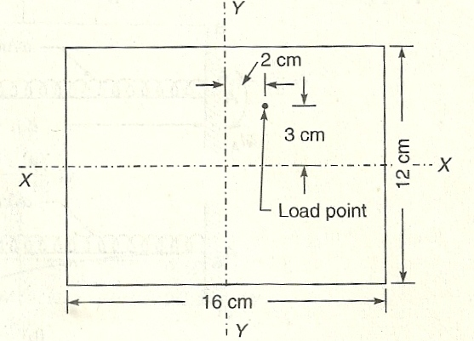

4. Determine the normal stresses developed at the four comers of a short column shown in Fig. due to direct load 200 kN acting at the point shown.

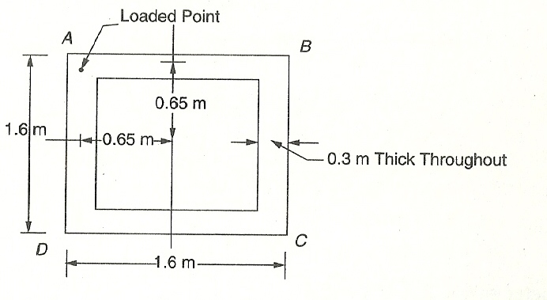

*Answer: fA =* 934.407 kN/m2 (comp)

*fB —*128.21 kN/m2 (comp)

*fC* = 684.294 kN/m2 (tension)

*fD* = 128.21 kN/m2 (comp)

5. A free standing brick chimney is having hollow circular section of external diameter 4.0 m and wall thickness 1.0 m. Determine the stresses developed at base, if the height of chimney is 30m and wind pressure is 1.2 kN/m2. Take coefficient of wind pressure as 0.9 and unit weight of brick masonry 20 kN/m3.

*Ans: f*max = 931 kN/m2 (comp) *f*min = 269 kN/m2 (comp)

**QUESTIONS**

**I. Descriptive type questions**

1. Show that if a load acts within middle one third of base width, there will not be in tension at any point.

2. Find the expressions for minimum and maximum stresses in case of a free standing wall of height *h,* thickness *‘b’* subjected to horizontal wind pressure *p*.

3. Explain the term shape factor for wind pressure.

**II. Fill in the blanks type questions**

1. An eccentric load *‘P’* may be replaced by an axial load ____________ and a moment __________ where *‘e’* is eccentricity.

2. If eccentric load is within __________ of base there will not be any tension at base level.

3. If wind pressure is ‘*p*’ horizontal, the moment at the base per unit length of a wall of height *h* is __________.

**ANSWER**

1. *P*,*P×e*

2. Middle one third

3. *p* *×h*2/2

**III. True or False type questions**

1. If eccentric load on a column is within middle one third portion, there is no tension at any point in the column.

2. Due to self weight, the direct pressure on a column is *γH* where *γ* is unit weight of the material of column and *H* is the height of the column of uniform cross-section.

3. Due to horizontal wind pressure ‘*p*’, the maximum bending stress induced in a wall of width *b* is  where *h* is height of wall.

**ANSWERS**

1. True 2. True 3. False

**IV. Multiple choice questions.**

1. In a wall subjected to at eccentric load, stress produced is always compressive, if the load is in

a. Outer one third portion b. Middle one third portion

c. Inner one third portion d. None of the above

2. The bending moment at the base due to horizontal wind pressure *p*on a wall per unit length is

(a)  (b)  (c)  (d) .

where *h* is height of wall and *Z* is modulus of section.

3. The bending stress at the base of the wall of height *h* and thickness *b,* due to horizontal wind pressure *p* (a)  (b)  (c)  (d) 

where *b* is thickness, *h* is height and Z is modulus of section per unit length of wall.

ANSWERS

1 – b 2 – b 3 – b

**Chapter 7**

**PROBLEMS FOR EXERCISE**

1. For the beam loaded as shown in Fig below, determine the deflection at loaded points and at mid span. Also show that the ratio of mid span deflection to deflection at loaded point is 1.375. *EI* is constant throughout. [Ans.: ,  ]

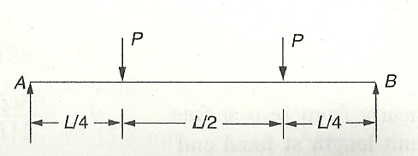

2. Determine the deflection at point *B* in the beam shown in Fig. below. Take *E* = 200kN/mm2 and *I =* 200 × 106 mm4. [Ans.: *yB* = 41.25 mm]

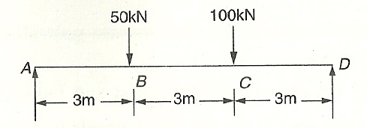

3. A beam of 3 m span is loaded as shown in Fig below. Calculate the deflection at and *Q* and slope at *A.* Take the value of *EI* = 840 kN-m2. (Ans) [*yP* = 12.555 mm, *yQ =* 5.015 mm, *θA* = 0.015 rad]

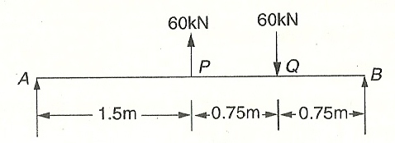

4. Determine the maximum deflection and its location in the beam shown in Fig. below. The beam has a rectangular cross section 50 mm wide and 100 mm deep. Take *E* = 200 kN/mm2.

(Ans) [*y*max =20.16 mm at 1.84 m from *A*]

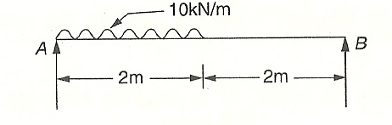

5. Find the slope and deflection at the free end of the cantilever shown in Fig. below. Take *E* = 200 kN/mm2, *I* = 40 × 106 mm4. (Ans) [Slope = 0.0275 × 10– 3 rad., Deflection = 100.83 mm]

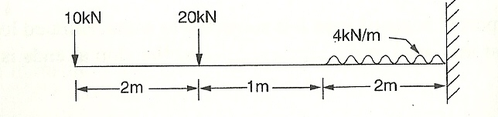

6. Find the slope and deflection at the free end of the cantilever shown in Fig. below. Take *EI* = 1 × 1010 kN-mm2 (Ans) [Slope = 4.4 × 10– 3 rad., Deflection = 16.038 mm]

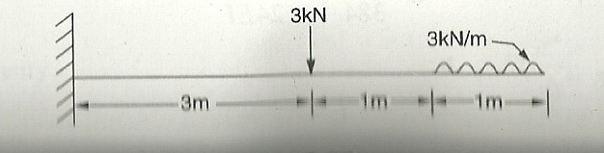

7. Determine the deflection at the free end in the cantilever shown below using moment area theorem.

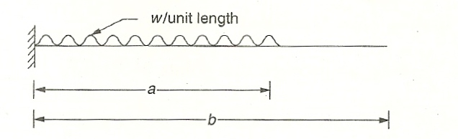

*Ans.:* 

8. Using moment area method, determine the deflection at free end of the beam shown in Fig. below.

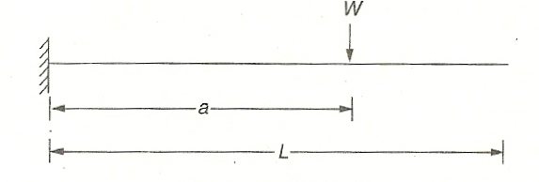

Ans: 

9. Determine the mid-span deflection of the beam shown in Fig. below. Use moment area method

Ans: 

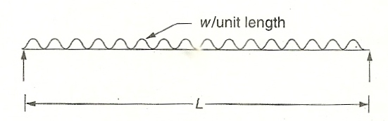

10. Using moment area theorem, determine the slope and deflection at free end of a cantilever of span *L* subject to external moment *M* at the free end. [Ans.  clockwise; downward]

**I. Descriptive type questions.**

1. State the relationship between slope, deflection and radius of curvature.

2. Prove that the differential equation of elastic curve is *EI*(*d*2*y / dx*2) *= M.*

3. Deduce the equation of slope and deflection of a cantilever of length ‘*l*’ which carries an *u.d.l.* of ‘*w*’ per unit length over the entire span. Also find the magnitude and position of maximum deflection and maximum slope.

4. State the boundary conditions at the following points in terms of defection and slope:

1. Simply supported end.
2. Fixed end.
3. Point of symmetry.

5. Find the deflection at free end of a typical cantilever subject to

1. Moment *M* at free end.
2. Concentrated load *w* at free end.
3. UDL over entire span.

6. Determine the expressions for defection at mid span and rotation at end in a simply supported beam of span *L*,subjected to

1. Concentrated load *W*at mid span.
2. UDL over entire span.

7. A cantilever beam of span *L*is subjected to a concentrated load *w*at a distance ‘*a*’ from fixed end. Find the deflection at free end.

8. State and explain moment area theorem 1.

9. State and explain moment area theorem 2.

**II. Fill in the blanks type questions**

1. If *y*is the deflection at distance *x*from a support, the radius of curvature is given by _________.

2. If *EI* is flexural rigidity of beam, *M* is sagging moment then *,*the *y*value obtained is___________ deflection.

3. Thedeflection at free end in a cantilever of span *L,*flexural rigidity *EI,* subject to concentrated load *W*at free end is _________.

4. Inthe above case if the load is *w*/unit length over entire span, the deflection at free end is ________ and slope is _________.

5. If a simply supported beam of span *L*is subjected to a concentrated load *w*at midspan, the deflection at mid-span is __________ and the slope at ends is _________.

6. The area of  diagram between two points is equal to _________.

7. The moment of diagram between two points gives the _________ between the tangents between those two points.

**ANSWERS**

1.  2. Upward 3.  4. , 5. ,

6. Change in slope between the tangents 7. Deflection

**III. State whether the following statements arc True or False**

1. If *M* is sagging moment, *y* is downward deflection, then 

2. The relationship between defection and the magnitude of shear force is 

3. The relationship between load intensity *\*q\** and deflection^ is of the form 

4. When a cantilever of span *L* is subjected to a concentrated load *w* at free end, the deflection at free end is 

5. When a cantilever of span *L* is subjected to UDL over entire span, the maximum deflection is , downward.

6. In case of a simply supported beam of span *L* subjected to UDL over entire span, maximum deflection is .

ANSWERS

1. True 2. True 3. False 4. False 5. True 6. False

**IV. Multiple choice questions**

1. The expression  at a section of a member represents — (a) shearing force, (b) rate of loading, (c) bending moment, (d) slope.

2. The maximum deflection of a cantilever beam of length *L* with a point load *W* at the free end is

(a) , (b) , (c) , (d) .

3. The maximum deflection of a cantilever beam of length *L* with a uniformly distributed load of *w* per unit length is

(a) , (b) , (c) , (d) .

4. The maximum deflection for a simply supported beam when a concen­trated load *W* is applied at the centre of the beam is

(a) , (b) , (c) , (d) .

5. The slope at the free end of a cantilever of length *L* carrying a concentrated load *W* at the free end is

(a) , (b) , (c) , (d) .

6. The maximum slope for a simply supported beam of length *L* carrying a concentrated load *W* at the centre is

(a) , (b) , (c) , (d) .

7. The maximum slope for a simply supported beam of length*L* carrying a *u.d.l.* of *w* per unit length is

(a) , (b) , (c) , (d) .

8. The maximum slope of a cantilever of length L carrying a *u.d.l.* of *w* per unit length is

(a) , (b) , (c) , (d) .

9. The maximum deflection for a simply supported beam of length *L* carrying a *u.d.l.* of *w* per unit length is

(a) , (b) , (c) , (d) .

10. Slope and deflection of a beam can be determined by

(a) double integration method, (b) moment area method,

(c) Macaulay's method, (d) any one of the three.

11. The expression  at a section of a member represents — (a) shearing force, (b) rate of loading, (c) bending moment, (d) slope.

***Answers to M.C.Q.***

1. (b), 2. (a) 3. (b) 4. (c) 5. (d) 6. (c) 7. (c)

8. (b) 9. (b) 10. (d) 11. (a)

**Chapter 8**

**PROBLEMS FOR EXERCISE**

1. A fixed beam of span 5 m is loaded with U.D.L. 10 × 103 N/m. Draw B.M. and SF diagram indicating important values. Also determine point of contraflexure (DO not use any formula). The beam may be taken to be of same section through out. [Ans. SF = ± 25 kN at two ends; *MA* & *MB* = – 20.83 kN-m; *M*at mid-pt. = 10.42 kN-m; Pt. of contraflexure = 3.94 m from *A* ]

2. *AB* is a 2 metre long fixed beam and is fixed at its ends *A* and *B*. It is carrying a point load of 100 kN at its centre. Find out the fixed end moments and draw the SF and BM diagrams. Use area-moment theorem or any other method. [Ans. *VA* = *VB* = 50 kN; FEM at both *A* and *B* = 25 kN-m & *M*at mid-pt. = 25 kN-m.]

3. A fixed beam *AB* is restrained at ends *A* and *B*. It is 5 m long and carries a point load of 10 kN at a distance of 3 m from *A*. Find support reactions and draw the SF and BM diagrams showing the salient values. Use area moment method. [Ans. *VB* = 6.28 kN; *VA* = 3.72 kN; FEM at *A* and *B* = 4.8 kN-m & 6.2 kN-m.]

4. Determine the fixed end moment at end *A* in the propped cantilever beam shown in Fig. below.

[Ans: 64.444 kN-m (hogging)]

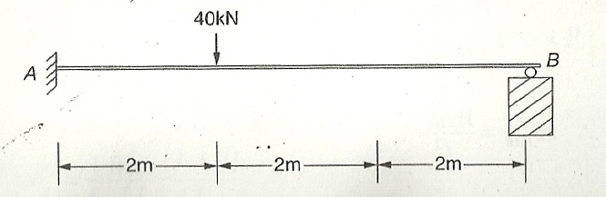

5. Determine the fixed end moment is a typical fixed beam subjected to central concentrated load *w* as shown in Fig below. Find moment at mid span also.

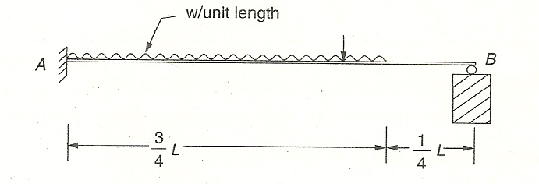

[Ans: *RA*= 0.82334 *wL*; *MAB* = 0.10459 *wL*2; *RB* = 0.17666 *wL*]

6.Determine end reactions in the beam shown in Fig. below.[Ans: (hogging), (sagging)]

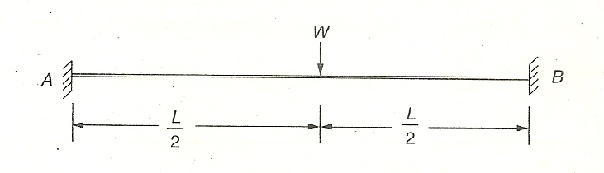

7. A Fixed beam of 6 m span is subjected to a couple 120 kN-m at a point 2 m from the left support. Draw the SF and BM diagrams. [Ans. SF = – 26.67 kN at any section; *MA* = 0 & *MB* = – 40 kN-m; at 2 m from *A*, *M* = 40 & 80 kN-m respectively. Pt. of contraflexure = 0.67 m from *B* ]

QUESTIONS

**I. Descriptive type questions**

1. Explain the concept of fixity.

2. What are the advantages and disadvantages of making ends of beam fixed?

3. Derive the expression for end reactions in a propped cantilever subjected to *u-d-l* *w* unit length over entire span.

4. Derive the expressions for end reactions in a fixed beam subjected to *u-d-l*.

5. State the law of superposition.

**II. Fill in the blanks type questions**

1. In a typical propped cantilever subjected to *u-d-l* *w*/unit length, the vertical reaction at propped end will be ______________.

2. In a typical propped cantilever of span *L,* subjected to *u-d-l* *w*/unit length, fixed end moment is ______________.

3. In a fixed beam subjected to *u-d-l* *w*/unit length, fixed end moment is ______________.

4. In a fixed beam of span *L,* subjected to central concentrated load *W,* the fixed end moments are ______________ and central moment is ______________.

**ANSWERS**

1.  2.  3.  4. , .

**III. State whether the following statements are true or false.**

1. In a propped cantilever subjected to *u-d-l* over entire span, moment at propped end is where *w* is *u-d-l* and *L* is span.

2. In a propped cantilever of span *L,* subjected to *u-d-l* *w* over entire span *L,* the fixed end moment is *.*

3. In a fixed beam of span *L,* subjected to *u-d-l* *w* /unit length fixed end moment developed is .

4. In a fixed beam of span *L,* subjected to central concentrated load *W,* fixed end moment developed is .

**ANSWERS**

1. False 2. False 3. True4. False

**V. Multiple choice questions**

1. In a propped cantilever of span *L,* subjected to *u-d-l* *w*/unit length over entire span, reaction at propped end is (a)  (b)  (c)  (d) 

2. In a propped cantilever of span *L* subjected to *u-d-l* *w*/unit length fixed end momeflj development is equal to (a)  (b)  (c)  (d) 

3. In a fixed beam of span *L,* subjected to *u-d-l* *w*/unit length fixed end moment developed are

(a)  (b)  (c)  (d) 

4. At fixed end

(a) Deflection is zero; (b) Slope is zero; (c) Deflection and slope are zero; (d) Moment is zero.

5. In a fixed beam of span *L,* if a concentrated load *W,* acts at distance ‘*a*’ from support *A,* the fixed end moment developed *MFAB* is

(a)  (b)  (c)  (d), where *b* = *L — a*

ANSWER:

1 - c 2 - b 3 - c 4 - c 5 - b

**Chapter 9**

**PROBLEMS FOR EXERCISE**

1. Analyse the continuous beam shown in Fig. below and draw BMD*.* Assume same cross section throughout

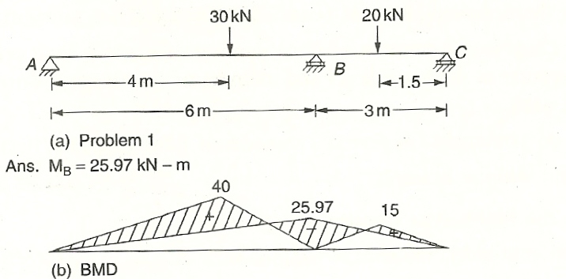

2. Analyse the continuous beam shown in Fig. below and draw BMD*.* Assume moment of inertia of the section is the same throughout.

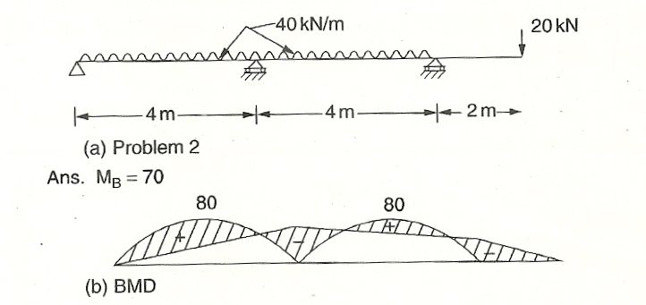

3. Analyse the beam *ABC* shown in Fig. below and draw the bending moment diagram. Flexural rigidity is constant throughout.

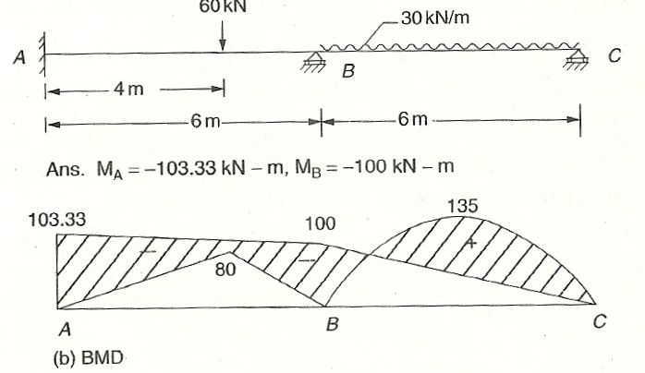

4. Analyse the continuous beam shown in Fig. below and draw bending moment diagram.

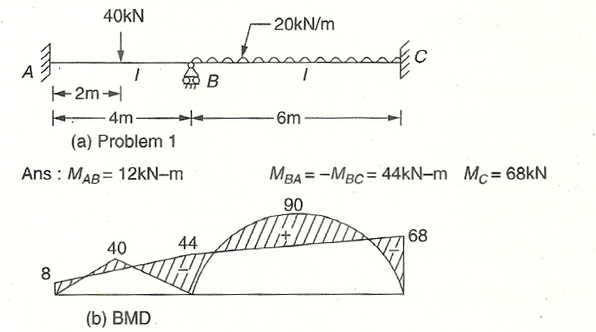

5. A beam of length 8 m is placed over with simple support on two equal span *AB* & *BC*. It is subjected to UDL of 2 kN/m on entire span. Determine BM and SF at each support joint and also BM at mid span. Draw SF & BM diagram. [Ans. *MA* & *MC* = 0 & *MB* = – 4 kN-m; *M*at mid-span = 2 kN-m. sagging (each *AB* & *BC*); *RA*= *RC* = 3 kN; *RB* = 10kN]

6. Apply moment distribution method to determine BM and SF for the following beam at mid spans and at supports—(i) beam continuous on two equal spans BC & CD each equal to 4m, (ii) loading UDL 4 kN/m on *BC* and 6 kN/m on *CD*. Also draw BM & SF diagram. [Ans. *MB* & *MD* = 0 & *MC* = – 10 kN-m; *RB*= 5.5 kN; *RC* = 25 kN (SF varying from – 10.5 to + 14.5 kN at *C*); *RD* = 9.5 kN]

7. Analyse the continuous beam shown in Fig. below by moment distribution method and draw bending moment diagram.

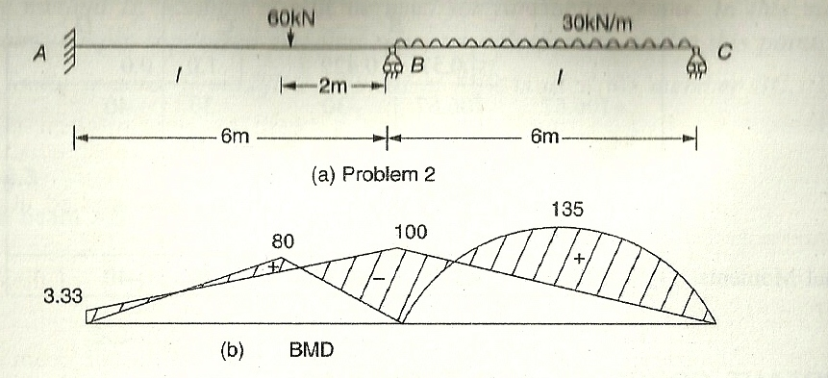

8. Analyse the continuous beam shown in Fig. below by moment distribution method and draw bending moment diagram.

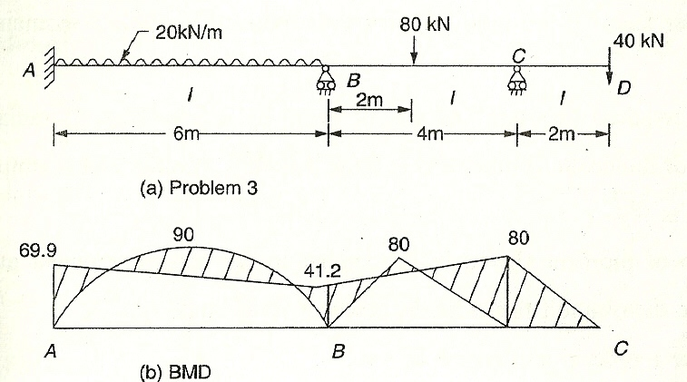

9. *ABCD* is a portal frame fixed at lower ends *A* and *D* as shown in the figure. The beam portion which is 4 m long is carrying a *u-d-l* of 15 kN/m-run. Draw the BM diagram for the portal frame and horizontal reactions at *A* and *D*. Other details have been given in the figure, use moment distribution method.

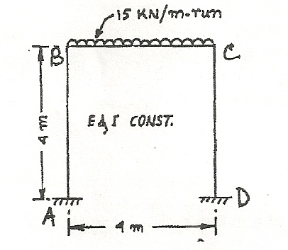

[Ans. *HA =* – *HD* = 7.34 kN; Vertical reaction at *A* & *D* = 30 kN; *MA* = +9.66 kN-m; *MB* = *MC* = 19.68 kN-m; & *MD* = – 9.66 kN-m ]

10. *ABCD* is a portal frame hinged at *A* and *D*. The beam portion is subjected to a load of 100 kN at the centre. Draw the SF and BM, use moment Distribution method.

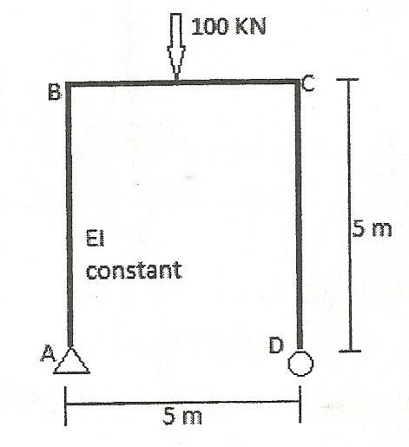

[Ans. *MA* & *MD* = 0 & *MB* = *MC* = – 37.35 kN-m; *RB*= 5.5 kN; *HA =* – *HD* = 7.49 kN; Vertical reaction at *A* & *D* = 50 kN]

**QUESTIONS**

**I. Descriptive type questions**

1. Explain the effect of continuity and nature of moments induced.

2. Draw the deflected shape of beam shown in excercise problem 2.

3. State Clapeyron’s theorem of three moments for a two span continuous beam with all supports at the same level and moment of inertia same throughout. Explain the terms used.

4. How do you apply Clapeyron’s theorem of three moments if end *A* is fixed? Explain with an example.

5. Define the terms

a. Carry over moment, b. Carry over factor.

c. Stiffness factor of a beam. d. Distribution factor.

6. Derive the expressions for (i) Carry over factor; (ii) Distribution factor.

7. Show that stiffness of a beam is (i) if the other end is fixed and (ii)  if the other end is simply supported.

**II. Fill in the blank type questions**

1. Due to continuity, moment at support is ___________ for download loads.

2. Area of parabolic moment diagram over a span *L* with maximum ordinate *M* is _____________.

3. In a triangle with maximum ordinate at *x* = *a* from end *A,* centroid is at *a*1 = _______ from support *A* where *L* is span.

4. In case of overhang of length 2 m subjected to concentrated load 20 kN, moment m support near free end is ____________.

5. Moment required to rotate the end of a beam by unit rotation is termed as ____________.

6. The ratio of moment shared by a member to the moment applied at the joint is known as ____________.

7. If the other end of a beam is fixed, stiffness of a beam in terms of flexural rigidity El and length *L* is ____________.

8. If the other end of a beam is simply supported the stiffness of beam in terms of flexural rigidity *El* and length is ____________.

ANSWERS

1. Hogging; 2. ; 3. ; 4. 40 kN-m (hogging);

5. stiffness 6. Distribution factor 7.  8. 

**III. State whether the following statements are true or false**

1. Due to continuity, sagging moment in the beam due to loading is reduced.

2. In case of triangular shaped bending moment diagram, the centroid is at a distance  from support *A,* where *L* is span and *b* is distance of point of maximum moment from end *B.*

3. Area of free moment diagram of parabolic shape over a span of 4 m with maximum ordinate 30 kN-m is 60 kN-m.

4. In case of fixed end *A* in continuous beam, three moment equation can be used by introducing an imaginary beam of flexural rigidity infinity.

5. If moment *M* is applied at one end the moment developed at other end, if it is fixed, *M* is 

6. If ‘*n*’ number of members are meeting at a joint, the distribution factor for *i*-th member is .

7. If the other end is simply supported, moment required to rotate the end of a beam by unit rotation is.

ANSWERS

1. True 2. False 3. False 4.True 5. True 6. True 7. False.

**IV. Multiple choice quoitlonn**

1. For continuous beam *ABC,* free moment diagram of area *A*1 on *AB* and *A*2 on *BC* Clapeyron’s theorem of three moments is

(a) 

(b) 

(c) 

(d)  where *a*1 is distance of centroid of *A*1 from end *A, a*2 distance of centroid of*A*2from end *C, AB = L*1 and *BC* = *L*2.

2. Area of a symmetric parabola over a span *L* and maximum ordinate *M* is

(a)  (b)  (c)  (d) *ML*.

3. Referring to the figure 11.13, the centroid is at a distance ________ from end *A*,

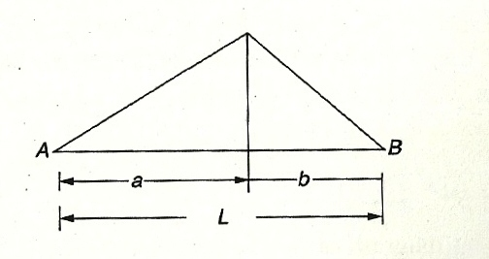

(a)  (b)  (c) (d) 

4. Carry over factor in a beam is (a) ¼ (b) ½ (c) – ¼ (d) – ½

5. If end *B* is simply supported and stiffness of *AB* is modified as ——, carry over factor is

(a) – ½ (b) Zero

(c) ½ (d) none of the above.

ANSWERS

1 – a; 2 –c; 3 – a; 4 - b; 5 - b

CHAPTER 10

Subjective type Questions

1. Distinguish between short column, medium column and long column.

2. (i) What is buckling or crippling or critical load? (ii) Explain “buckling factor”.

3. What are the assumptions made in the Euler's theory of column?

4. Explain the term effective length of a column.

5. What are the end conditions of columns?

6. Write down the effective length for the column having different end conditions.

7. Write down the Rankine’s formula and mention each term with their proper unit.

.

Problems

1. A solid round bar of 50 mm and diameter 1.5 m long is used as a strut. Find the safe compressive load it can carry using Euler’s formula when (i) both ends are hinged, (ii) both ends are fixed, (iii) one end fixed other end free and (iv) one end fixed other end hinged. Take modulus of elasticity 2 × 105 N/mm2 and factor of safety 3.

[**Ans.** (i) 89.717 kN; (ii) 358.867 kN; (iii) 22.249 kN; (iv) 179.434 kN]

2. Compare the buckling strengths of a solid circular column of diameter ‘*D*’ and that of a hollow circular column having same cross-sectional area but internal diameter being rd of external diameter. The columns have same length and same end condition. [**Ans.** Solid: hollow = 5:13]

3. Compare the slenderness ratios of (i) a solid circular column, (ii) a square column and (iii) a rectangular column having one side of its cross-section double of the other. All three columns have same cross-sectional area and same length.

[**Ans.** Solid circular : Square : Rectangular = 1 : 0.977 : 1.382]

4. Find the Euler’s crippling load of a Channel Section having depth of channel (overall depth) (*h*) = 100 mm, width of flange (*b*) = 45 mm, thickness of web (*tw*) = 3 mm and thickness of flange (*tf*) = 5 mm when used as a column of length 3 m. Both ends of the column are maintained restrained against rotation and translation (*i.e*., fixed). Take modulus of elasticity of channel material (*E*) = 210 GPa. [**Ans.** 138.689 kN]

5. The external and internal diameter of a hollow cast iron column are 5 cm and 3 cm respectively. If the length of this column is 4 m and both of its ends are fixed, determine the crippling load using Rankine’s formula. Take the value of σc = 550 N/mm2 and in Rankine’s formula. [**Ans.** 540.09 kN]

6. A hollow cylindrical cast iron column is 6 m long with both ends fixed. Determine the minimum diameter of the column if it has to carry a safe load of 300 kN with a factor of safety of 4. Take the internal diameter as 0.7 times the external diameter. Takeσc = 550 N/mm2 and in Rankine’s formula. [**Ans.** *D =* 9.53 cm, *d* = 6.67 cm]

7. A 2.0 m long column has a circular cross-section of 6 cm diameter. One of the ends of the column is fixed in direction and position and other end is free. Taking factor of safety as 3, calculate the safe load using *(i)* Rankine's formula take yield stress σc = 550 N/mm2 andfor pinned ends, *(ii*) Euler’s formula, Young’s modulus for *C.I.* = 1.3 × 105 N/mm2.

**[Ans.** *(i)* 11.4 kN and *(ii)* 170 kN]

8. Find the Euler crushing load for a hollow cylindrical cast iron column 15 cm external diameter and 25 mm thick if it is 6 m long and is hinged at both ends. Take *E =* 8 × 104 N/mm2. Compare the load with the crushing load as given by the Rankine’s formula, taking σc = 550 N/mm2 and ; for what length of the column would these two formulae give the same crushing load ? **[Ans.** 665 kN, 260.77 kN, 507 cm]

9.A mild steel tube is 7.5 cm in diameter and 0.25 cm thick. A short length of this tube is tested in compression and is found to yield at 500 N/mm2. The modulus of elasticity of the material of the tube is 2 × 105 N/mm2. A length of 2 m when tested as a strut with free ends failed with a load of 180 kN force. Assuming the failing stress in Rankine formula to be the yield stress of the mate­rial, find the value of Rankine’s constant *‘*α’. Find also the crushing load as by the Euler’s formula. [**Ans.** and *P* = 225 kN]

10. An alloy steel tube is 7.5 cm external diameter and 0.25 cm wall thickness. A very short length of this tube was tested in compression and found to yield at a load of 320 kN. A length of 2 meters when tested as a strut with hinged ends buckled at a load of 170 kN. Assuming the failing stress in Rankine formula to be the yield stress of the material, find the value of Rankine’s constant *‘*α’. [**Ans.** ]

11. A 1.5 m long column has a circular cross-section of 0.5 cm diameter. One of the ends of the column is fixed in direction and position and the other end is free. Taking factor of safety as 3, calculate the safe load using: (*i*) Rankine formula with σc = 560 N/mm2 and  for pinned ends and (*ii*) Euler’s formula with *E* for C.I. = 1.2 × 105 N/mm2.

**[Ans.** (i) 9.9 kN and (ii) 13.45 kN]

12. Determine the external diameter and internal diameter of a hollow circular cast iron column, which carries a load of 1000 kN. The length of the column is 6 metre. The internal diameter is to be one half that of outer diameter. Use Rankine’s formula with σc = 560 N/mm2 and . Take a factor of safety 4. One end is fixed and the other end is free.

**[Ans.** *D* = 35.4 cm, *d* = 17.7 cm]

Objective type Questions

**A. Multiple Choice Type:**

1. Column is defined as a

(a) member of a structure which carries a tensile load

(b) member of a structure which carries an axial compressive load

(c) vertical member of a structure which carries a tensile load

(d) vertical member of a structure which carries an axial compressive load.

2. A strut is a

(a) vertical member subjected to compressive load

(b) an inclined member subjected to tensile load

(c) an inclined member subjected to compressive load

(d) none of the above.

3. A column or strut is subjected to

(a) only compressive stress

(b) only bending stress

(c) both direct compressive stress and bending stress

(d) none of the above.

4. A column is said to be a short column, when

(a) its length is very small

(b) its cross-sectional area is small

(c) the ratio of its length to the least radius of gyration is less than 80

(d) the ratio of its length to the least radius of gyration is more than 80

5. Long column means

(a) a column which is very long

(b) a column whose length is large compared to its cross-sectional area

(c) a column which is subjected mainly to bending stress

(d) both (b) and (c).

6. Columns used for construction of a building are

(a) short columns

(b) long columns

(c) medium columns

(d) in building construction no column is used.

7. A column is subjected to a load which is

(a) greater than the critical load (b) equal to the critical load

(c) less than the critical load (d) both (b) and (c).

8. The slenderness ratio is the ratio of

(a) area of column to least radius of gyration

(b) effective length of column to least radius of gyration

(c) least radius of gyration to area of column

(d) least radius of gyration to length of column

9. For long columns, the value of buckling load is ___________ crushing load.

(a) equal to, (b) less than, (c) more than, (d) none of the above.

10. Euler’s formula holds good only for

(a) short columns (b) long columns

(c) medium columns (d) both short and long columns

11. To determine critical load, Rankine’s formula is applicable only when

(a) short columns (b) long columns

(c) medium columns (d) all of the above.

12. The maximum axial compressive load which a column can take without failure by lateral deflection is called

(a) critical load (b) buckling load

(c) crippling load (d) any one of the above.

13. Slenderness ratio is defined as the ratio of

(a) equivalent length of the column to the minimum radius of gyration

(b) length of the column to the minimum radius of gyration

(c) length of the column to the area of cross-section of the column

(d) minimum radius of gyration to the area of cross-section of the column.

14. Buckling factor is defined as the ratio of

(а) equivalent length of a column to the minimum radius of gyration

(b) length of the column to the minimum radius of gyration

(c) length of the column to the area of cross-section of the column

(d) none of the above.

15. A loaded column is having the tendency to deflect. On account of this tendency, the critical load

(а) decreases with the decrease in length

(b) decreases with the increase in length

(c) first decreases then increases with the decrease in length

(d) first increases then decreases with the decrease in length.

16. A loaded column fails due to

(a) stress due to direct load (b) stress due to bending

(c) both (a) and (b) (d) none of the above.

17. The crippling load, according to Euler’s theory of long columns, when both ends of the column are hinged, is equal to

(a) , (b) ,

(c) , (d) .

18. If *l* = actual length of a column, the Euler’s formula is applicable to determine critical load for a column having both ends hinged only if

(a) 80, (b) 80,

(c)  100, (d) none of the above.

where *l* = actual length of the column and *K* = least radius of gyration of the column section.

19. The crippling load, according to Euler’s theory of long column when one end of the column is fixed and other end is free, is equal to

(a) , (b) ,

(c) , (d) .

20. A column with maximum equivalent length has

(a) both ends hinged

(b) both ends fixed

(c) one end fixed and the other end hinged

(d) one end fixed and the other end free

21. Compression members always tend to buckle in the direction of the (a) axis of the load, (b) perpendicular to the axis of load, (c) minimum cross-section, (d) least radius of gyration.

22. A column that fails due to direct stress, is called (a) short column, (b) long column, (c) medium column, (d) none of the above

23. According to Euler’s column theory, the crippling load for a column of length ‘*L*’ fixed at both ends is ____________ the crippling load of a similar column hinged at both ends

(a) equal to (b) two times (c) four times (d) eight times.

24. A bar which carries an axial compressive load is called - (a) struts, (b) tie, (c) shaft, (d) none.

25. The ratio of equivalent length to original length of a column, having one end fixed and other end free is – (a) √2 , (b) 2, (c) , (d) ½ .

26. Slenderness ratio of a vertical column of square cross-section of 2.5 cm side and 3 m long is - (a) 550, (b) 416, (c) 240, (d) 120.

27. For a short column the slenderness ratio should be (a) equal to 32, (b) less than 32, (c) more than 32, (d) equal to nearly zero

28. For a long column the slenderness ratio should be (a) less than 80, (b) equal to 80, (c) more than 120, (d) less than 120.

29. If one end of a hinged column is made fixed and the other end free, the critical load shall

(a) increase by 2 times, (b) decrease by 4 times,

(c) decrease by 2 times. (d) increase by 4 times.

30. Secant formula is used for

(a) short columns under eccentric loading,

(b) long columns under eccentric loading,

(c) short columns under axial loading,

(d) long columns under axial loading.

31. If the end conditions of a column are changed from both ends hinged to both ends fixed, the critical load shall

(a) increase by 4 times, (b) increase by 2 times,

(c) decrease by 2 times, (d) decrease by 4 times.

32. The ratio of equivalent length to the actual length of a column having both ends hinged is

(a) 1:1, (b) 2:1, (c) 1:2, (d) 1:  .

33. The ratio of equivalent length to the actual length of a column having one end fixed and the other end free is

(a) 1:1, (b) 2:1, (c) 1:2, (d) 1:  .

34. For a column having one end fixed and the other end free, Euler’s formula for critical load will be applicable, if

(a) 80, (b) 80,

(c)  100, (d) none of the above.

where *l* = actual length of the column and *K* = least radius of gyration of the column section.

35. For a column having both ends fixed, Euler’s formula for critical load will be applicable, if

(a) 80, (b) 80,

(c)  100, (d) none of the above.

36. For a column having one end fixed and the other end hinged, Euler’s formula for critical load will be applicable, if

(a) 80, (b) 80,

(c)  100, (d) none of the above.

37. To determine critical load, Rankine’s formula is applicable only for (a) column, (b) strut, (c) both column and strut, (d) Rankine’s formula is not used to determine critical load.

38. For cast iron column, Rankine’s constant is given by (a) , (b) , (c) , (d) .

39. For mild steel column, Rankine’s constant is given by (a) , (b) , (c) , (d) none of the above.

40. The ratio of crippling load to working load is called

(a) factor of safety (b) buckling factor

(c) critical factor (d) all of the above.

41. Rankine’s formula is based on (a) direct compressive stress, (b) buckling stress, (c) both direct compressive stress and buckling stress, (d) none of the above.

42. A column having one end fixed and the other end free is capable of carrying a safe load of 100 kN. Then the safe load carried by the same column when one end fixed and the other end hinged will be (a) 100 kN, (b) 800 kN, (c) 50 kN, (d) 75 kN.

43. Constant in Rankine’s formula for hinged ends is for the material of - (a) M.S., (b) C.I., (c) W.I., (d) Wood.

44. The crippling load, according to Euler’s theory of long column when both ends of the column are fixed, is equal to

(a) , (b) ,

(c) , (d) .

45. The crippling load, according to Euler’s theory of long column when one end of the column is fixed and the other end is hinged, is equal to

(a) , (b) ,

(c) , (d) .

46. The ratio of crippling load, for a column of length (*l*) with both ends fixed to the crippling load of the same column with both ends hinged, is equal to (a) 2.0, (b) 4.0, (c) 0.25, (d) 0.50.

47. The ratio of crippling load, for a column of length (*l*) with both ends fixed to the crippling load of the same column with one end fixed and other end free, is equal to (a) 2.0, (b) 4.0, (c) 8.0, (d) 16.0.

48. The ratio of crippling load, for a column of length (*l*) with both ends fixed to the crippling load of the same column with one end fixed and other end hinged, is equal to (a) 2.0, (b) 4.0, (c) 8.0, (d) 16.0.

49. The equivalent length is equal to actual length divided by  for a column with (a) one end fixed and other end free, (b) both ends fixed, (c) one end fixed and other end hinged, (d) both ends hinged.

50. Choose the wrong statement:

(a) Column is a vertical member of a structure which carries an axial compressive load.

(b) The ratio of length of a column to its minimum radius of gyration is called slenderness ratio.

(c) A column tends to buckle in the direction of the minimum moment of inertia.

(d) The equivalent length of a column with one end fixed and other end free is half of its actual length.

51. Choose the correct statement:

(a) Euler’s formula holds good only for short columns.

(b) A short column is one which has the ratio of its length to least radius of gyration more than 100.

(c) A column with both ends fixed has minimum equivalent (or effective) length.

(d) The equivalent length of a column with one end fixed and other end hinged is half of its actual length.

52. The crippling load by Rankine’s formula is

(a) , (b) ,

(c) , (d) .

where *A* = area of cross-section of the column, σc = crushing stress, α = Rankine’s constant, *r* = least radius of gyration, *l* = actual length of column *le* = equivalent length of column.

53. The Rankine’s constant (α) in Rankine's formula is equal to (a) , (b) , (c), (d) .

54. The Rankine’s constant(α) for a given material of a column depends upon the (a) length of column (b) diameter of the column (c) length and diameter (d) none of the above.

55. The expression  is known as (a) Rankine’s formula, (b) Gordon’s formula, (c) Straight line of formula, (d) Johnson’s parabolic formula,

where *d* = least diameter or width of the section β = constant and *le* = equivalent length.

56.The strength of a column depends on which of the following factor? - (a) slenderness ratio, (b) end conditions, (c) both (a) & (b), (d) none of these.

***Answers to M.C.Q.***

1. (d), 2. (c), 3. (c), 4. (c), 5. (d), 6. (c), 7. (c), 8. (b), 9. (b), 10. (b), 11. (d),

12. (d), 13. (b), 14. (a), 15. (b), 16. (c), 17. (b), 18. (b), 19. (c), 20. (d), 21. (d), 22. (a),

23. (c) 24. (a) 25. (b) 26. (b) 27. (b) 28. (c), 29. (b) 30. (b) 31. (a) 32. (a) 33. (b)

34. (d) 35. (b) 36. (a) 37. (c) 38. (d) 39. (a) 40. (a) 41. (c) 42. (b)

43. (c) [Note: W.I. stands for Wrought Iron & C.I. stands for Cast Iron] 44. (a), 45. (d)

46. (b) 47. (d) 48. (a) 49. (c) 50. (d) 51. (c) 52. (b) 53. (d) 54. (d) 55. (b) 56. (c)

**B. State whether the following statements are true (t) or false (f)**

1. Rankine’s formula for medium columns is semi-empirical formula.

2. Rankine’s constant for CI is 1/1600.

3. Short columns are those whose length is less than 8 times the diameter or least side or whose slenderness ratio is less than 32.

4. Rankine constant for mild steel is 1/750.

5. Euler’s buckling formula is applicable for columns which is initially straight and subjected to thereby axial load.

6. Columns which have 8 times their diameter are called short columns.

7. Euler’s formula is not valid for mild steel column when slenderness ratio is less than 30.

**Ans.** 1. – T; 2. – T; 3. – T; 4. – F; 5. – T; 6. – T; 7. – F.

**C. Fill in the blanks with appropriate words :**

1. A column of length ‘*l*’ is fixed at one end and hinged at the other. The equivalent length of the column will be ________.

2. In Euler’s formula the moment of inertia of the cross-section of the column is _________moment of inertia.

3. Euler’s formula for column is applicable only for _____ column.

4. For column the effective length is twice the actual length when _____ end(s) of column is fixed.

5. A column with maximum equivalent length has ________________ .

6. The Rankine’s constant for mild steel is ______.

7. The slenderness ratio of a vertical column of square cross-section of 2.5 cm sides and 600 cm long is ______.

8. The columns are usually made of ____ material.

9. Rankine’s formula for medium columns is _______ formula.

10. Long columns are those columns, whose length is more than 30 times the least dimension of the column or the slenderness ratio should be more than _____.

ANSWERS

1. ; 2. the minimum; 3. Long; 4. one; 5. one end fixed, other end free;

6. 1/7500; 7. 831.4; 8. C.I. (Cast Iron); 9. semi-empirical; 10. 120.