Reg. No: …..………………….
Name: …….………………...
M.TECH. DEGREE EXAMINATION
Model Question Paper - II
Second Semester
Branch: Electrical and Electronics Engineering
Specialization: Power Electronics and Power Systems
MEEPP-201 – POWER ELECTRONIC SYSTEM CONTROL
[Regular/Supplementary - 2011 Admission onwards]
Time: Three Hours Maximum: 100 Marks

- (a) Discuss about SVM and explain its various modulation schemes (10 marks)
(b) With necessary waveforms explain the principle of hysteresis-band current control. Draw the control block diagram for hysteresis-band PWM. (10 marks)
(c) What are the various methods of current control (5 marks)
Or
- (a) Briefly explain on Hysteresis Control. (10 marks)
(b) What is distortion factor in SPWM? Derive an expression for the r.m.s value of output voltage in SPWM. (10 marks)
(c) Explain sinusoidal pulse width modulation technique & its advantages? (5 marks)

- (a) Discuss the discontinuous conduction mode of Buck Converter? Also derive expression for voltage conversion ratio (12 marks)
(b) In a step-up converter, the duty ratio is adjusted to regulate the output voltage V_{o} at 48V. The input voltage varies in a wide range from 12V to 36V. The maximum power output is 120W. For stability reasons, it is required that the converter always operate in discontinuous –current-conduction mode. The switching frequency is 50 kHz. Assuming ideal components and C as very large, calculate the maximum value of L that can be used. (8marks)
(c) Draw the circuit of a buck-boost converter and explain its working principle.
(5 marks)
Or

- (a) Explain the operation of the basic CuK converter. What are its main advantages?
(10 marks)
(b) Describe the state-space modeling of buck and buck boost DC-DC converters (5 marks)
(c). In a buck-boost regulator the following parameters are given:
The input voltage = 24 V, operating frequency = 20 kHz, Inductance = 200 μH, Capacitor = 500 μF, Average load current = 5 A, Duty ratios are (i) 0.2 and (ii) 0.7.
Find out the following:
Average output voltage, peak-to-peak inductor current, peak-to-peak ripple voltage, average input current (assume the circuit is loss free) and the minimum current at which load current is just discontinuous. (10 marks)

- (a) Draw the circuit diagram and explain the working of a push pull converter with the help of relevant waveforms. (8 marks)
(b) In a isolate converter of figure below E₁ = 170 V, Switching frequency = 20 kHz=Hz,
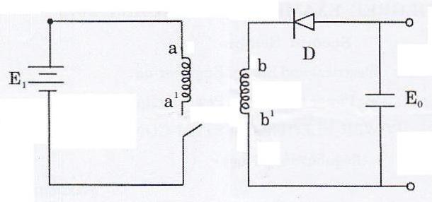

Duty cycle = 75%, Number of turns naa¹ = 100 number of turns nbb¹ = 25. Assume ideal components and respective conditions. Also consider continuous current through Diode, D during OFF switch period. Calculate E₀ and plot the waveform of voltage Vaa¹ and Vbb¹ considering relative magnitudes and time intervals. (10 marks)

(c) Explain the working principle of forward converter with the help of relevant waveforms
(7 marks)
Or
- (a). A full bridge converter with rectified load operates from a dc power supply of 120V. The transformer has a step down ratio of 8.33:1 and a leakage reactance of 20.4μH. At a switching frequency of 20 kHz the converter delivers a load current of average value 40A. What is the average output voltage
(10 marks)
.
(b). Explain the principle of operation of fly back converter and derive the expression for the inductor current and voltage across the switch during OFF intervals.
(10 marks)
(c) Draw the block schematic diagram of a Uninterruptable Power Supply. (5 marks)

- (a) What are resonant converters? How they are classified? (7 marks)

(b) Explain varies modes of operation of series loaded resonant converter with relevant waveform. (10 marks)
(c) Compare zero voltage and zero current switching? (8 marks)
Or
8. (a) Write a short note on resonant d.c. link inverters? (8 marks)
(b Explain the principle and operation of ZCS Converters (10 marks)
(c) Write a short note on series resonant circuits? (7 marks)
[4 x 25 = 100 marks]

