M.TECH. DEGREE EXAMINATION
Model Question Paper - II
Second Semester
Branch: Civil Engineering
Specialization: Geomechanics and Structures
MCEGS 206- 4 EARTHQUAKE ANALYSIS AND DESIGN OF STRUCTURES (Elective IV)
(Regular – 2011 Admission onwards)
Time: 3 Hrs Max Marks: 100
Answer all questions
- (a) Write a short note on Epicenter, Hypocenter, and Earthquake Waves.
(10 marks)
(b) A standard torsion seismograph records a trace amplitude of 8.5 mm long in N-S direction and 6.1 mm in E-W direction. The distance of the epicenter is estimated as 112 km. The station correction is +0.2. Determine the magnitude of the earthquake. The distance correction for 112 km is 3.1.
- marks)
OR
- (a) Differentiate between Magnitude and Intensity.
(b) Explain modified Mercalli’s scale of intensity of earthquake.
(c) Describe various factors considered in preparing earthquake zone map of our country.
(d) What are the causes of earthquakes?
(e) Explain the process of liquefaction of soil, its causes and effect on structures resting on them. (25 marks)

- (a) Explain the seismic coefficient method of analysis in detail. (10 marks)
(b) Derive a solution for equation of motion for an undamped free vibration case. Also
plot the displacement response for different conditions. (15 marks)
OR
- (a) Explain the concept and practical application of lumped mass model of multi storeyed building (5 marks)
(b) Derive the equation of motion for a cantilever beam, carrying a weight W sustained from a spring at its free end as shown, given the following data.

[P.T.O]
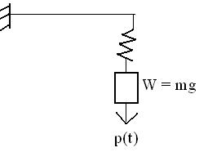 (20 marks)

- (a) What are the principles of earthquake resistant design of RCC buildings?
(5 marks)
(b) Design a rectangular beam for 8m span to support a DL of 10 kN/m and a LL of 12
kN/m inclusive of its own weight. Moment due to earthquake load is 100kNm and
shear force is 80kN. Use M20 grade concrete and Fe415 steel. (20 marks)
OR

- Plan of five storeyed building is shown below. Total dead load can be assumed as 5 KN/m² and live load as 4 KN/m² on each floor and as 1.5 KN/m² on the roof. Determine the lateral forces and shears at different storey levels. Assume, zone factor = 0.24, I = 1, response reduction factor, R = 5, soil type = 2, storey height = 3.5 m.
(25 marks)
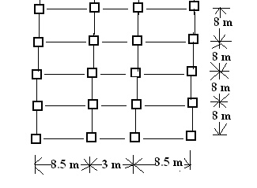

- (a) Explain the principle of base isolation of building. (5 marks)
(b) Explain in detail the concept of capacity design. (10 marks)
(c) Discuss the principles and applications of Tuned Mass Dampers. (10 marks)
OR
- (a)Write short note on Mechanical dampers for buildings. (10 marks)
(b) Explain briefly the mathematical modeling of multistoreyed RC building.
(15 marks)

