M.TECH. DEGREE EXAMINATION
Model Question Paper - I
Second Semester
Branch: Civil Engineering
Specialization: Geomechanics and Structures
MCEGS 206- 4 EARTHQUAKE ANALYSIS AND DESIGN OF STRUCTURES (Elective IV)
(Regular – 2011 Admission onwards)
Time: 3 Hrs Max Marks: 100 Marks
Answer all questions
- (a) Explain how measurement of ground motion is done by seismologists and design engineers. (10 marks)
(b) An earthquake causes an average of 2.6 m strike-slip displacement over a 75 km long, 22 km deep portion of a transformed fault. Assuming the average rupture strength along the fault as 180 KPa, estimate the seismic moment and moment magnitude of the earthquake.
(15 marks)
OR
- (a) Explain the Elastic Rebound Theory for the formation of earthquakes.
(b) Write a short note on seismic zoning.
(c) Explain the process of liquefaction of soil, its causes and effect on structures resting on them. (25 marks)

- (a) Explain the seismic coefficient method of analysis in detail. (10 marks)
(b) Derive a solution for equation of motion for an undamped free vibration case. Also plot the displacement response for different conditions. (15 marks)
OR
- (a) Explain the concept and practical application of lumped mass model of multistoreyed building. (5 marks)
- Figure shows the frame of a RC building to be constructed in Kerala. The spacing of frames is 3.6 m c/c. The floor beams support 120mm thick masonry wall. Compute the seismic forces.
Data: Size of column = 230mm x 400mm
Size of beam = 230mm x 500mm
Slab thickness = 120mm
Weight of concrete = 24 kN/m³
Weight of masonry = 19 kN/m³
LL on roof = 1.5 kN/m²
LL on floors = 5 kN/m²
Assume relevant data, if required.

[P.T.O]
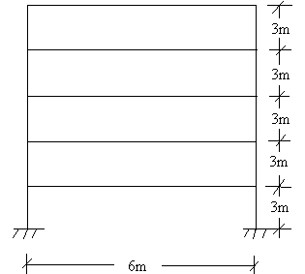 (20 marks)
- (a) What are the principles of earthquake resistant design of RCC buildings?(5 marks)
(b) Design a rectangular beam for 8m span to support a DL of 10 KN/m and a LL of 12 kN/m inclusive of its own weight. Moment due to earthquake load is 100kN-m and shear force is 80kN. Use M20 grade concrete and Fe415 steel. (20 marks)
OR
- The plan of a three-storeyed R.C.C school building is shown below. The building is located in seismic zone V. The type of soil encountered is medium stiff and it is proposed to design the building as a moment-resisting frame. The intensity of the dead load is 10 KN/m2 and the floors are to cater to an imposed load of 3 KN/m2. Determine the design seismic loads on the structure by static analysis. Storey height of each floor is 3.5 m. (25 marks)
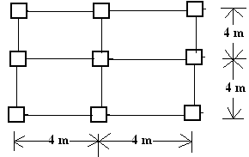

- (a) Explain the principle of base isolation of building. (5 marks)
(b) Explain in detail the concept of capacity design. (10 marks)
(c) Discuss the principles and applications of Tuned Mass Dampers. (10 marks)
OR
- (a) What are the main Code-based procedures for seismic analysis? (10 marks)

(b) Define ‘Shear Walls’. How are these classified? (15 marks)

