(Pages: 2)

M. TECH. DEGREE EXAMINATION, MODEL QUESTION PAPER - II
First Semester

Branch: Mechanical Engineering
Specialisation: Production and Industrial Engineering / Advanced Manufacturing and Production Management / Computer Integrated Manufacturing
MMEPI 104 / MMEMP 104 / MMECM 106.3 QUALITY ENGINEERING AND MANAGEMENT
(Regular – 2013 Admissions)
Time: Three Hours Maximum: 100 Marks
(Answer all questions)

- a. How are quality costs measured and collected in an organization (10 marks)
b. What are the four components of cost of quality? Explain. (15 marks)
OR
- a. Select a problem in one of the process of your daily life and use the problem solving method to solve it. (15 marks)
b. Explain traditional and emerging model of cost of quality (10 marks)
- a. Tensile strength of a material is tested and expressed in Kg/cm with five values for each of the 20 samples is recorded as shown below
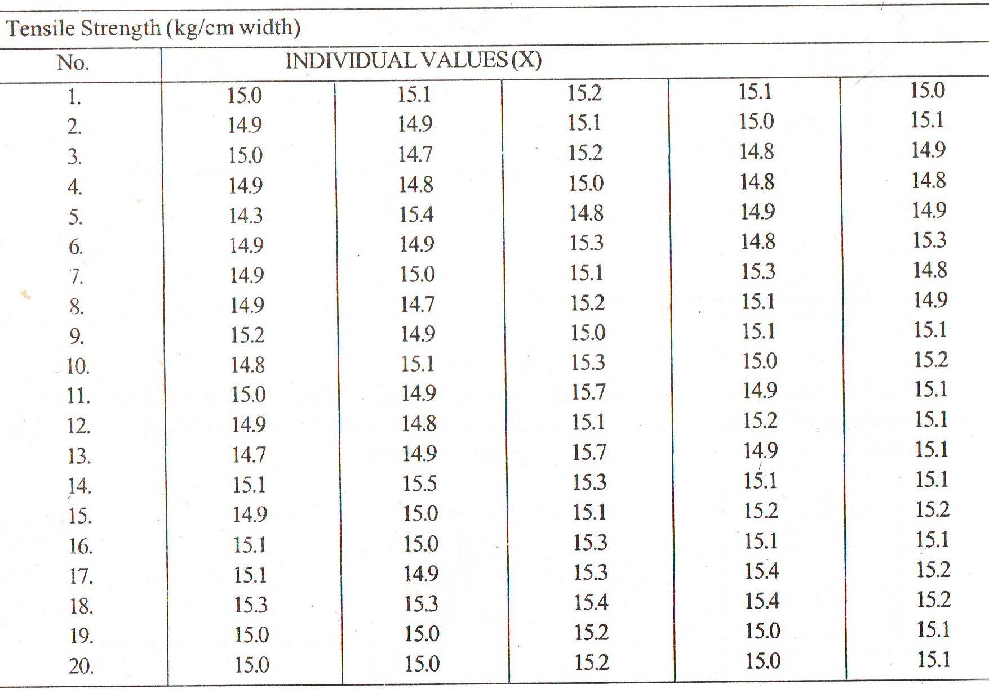
Set up X bar and R charts and comment on the state of the process (15 marks)
b. Determine the equation for the OC curve for the sampling plan N = 10,000, n₁ = 200, c₁ = 2, r₁ = 6, n₂ = 350, c₂ = 6, and r₂ = 7. Construct the curve using about 5 points. (10 marks)
OR

- a. “Six sigma is a statistical measure used to ensure quality of products and services” Discuss. (5 marks)
b. Distinguish between defect and defective. (5 marks)
c. A real estate firm evaluates incoming selling agreement forms using the sampling plan N = 1500, n = 110, and c = 3.
- Construct the OC curve using about 7 points.
- Determine the AOQ curve and the AOQL. (15 marks)

- a. Explain the various steps involved in building house of quality by selecting suitable example. (15 marks)
b. Describe the concept of Taguchi’s loss function with the help of an example.
(10 marks)
OR
- a. Using the existing design, the lives of three AA batteries are 20, 22 and 21 hours. An experimental design produces batteries with values 17, 21 and 25 hours .Which is the better design and by how much. (5 marks)
b. Explain the procedure to determine appropriate Orthogonal Array. (10 marks)
c. Describe the QFD process with the help of a flow diagram (10 marks)

- a. Which of the elements in ISO 9001 are similar to ISO 14001? (5 marks)
b. “Application of TQM in manufacturing and service industry” – Discuss (10 marks)
c. Define TQM. What are the Pillars of TQM? (10 marks)

OR
- a. What are the problems that are encountered during implementation of TQM and explain how would you tackle them? (5 marks)
b. List five benefits that could be realized by implementing an ISO 9000 quality system (5 marks)
c. What is six sigma methodology? Describe the DMAIC problem solving methodology. (15 marks)

