(Pages: 3)

M. TECH. DEGREE EXAMINATION, MODEL QUESTION PAPER – II
First Semester

Branch: Mechanical Engineering
Specialisation: Advanced Manufacturing and Production Management
MMEMP 103 - COMPUTER INTEGRATED MANUFACTURING
(Regular – 2013 Admissions)
Time: Three Hours Maximum: 100 Marks
(Answer all questions)

1. a) Define rasterisation. (3 marks)
b) Write note on Direct View Storage Tube? (5 marks)
c) What are the various LAN configurations? (7 marks)
d) Explain the midpoint circle algorithm. (10 marks)

OR

2. a) What you meant by the term windowing in computer graphics? (3 marks)
b) Explain the term CAD database. (5 marks)
c) What are the various types of coordinate systems employed in CAD?
(7 marks)
d) What is clipping? Explain Cohen Sutherland line clipping algorithm. (10 marks)
.
3. a) List the various wireframe modeling entities. (3 marks)
b) Explain briefly about the characteristics of B-Spline curves. (5 marks)
c) Explain the various curve manipulation techniques. (7 marks)
d) Explain the properties of Bezier surfaces. (10 marks)

OR

4. a) Differentiate between the geometry & topology of an object. (3 marks)
b) What are the various entities used in solid modeling technique in CAD?
(5 marks)
c) Explain the concept of half spaces in solid modeling. (7 marks)
d) Explain constructive solid geometric scheme to create the solid models in CAD.
(10 marks)

5.a) What are the factors to be considered for testing the performance of a CNC machine? (3 marks)
b) Write the syntax for five basic movement blocks with example. (5 marks)
c) What are the factors affecting the tooling for CNC machines?
(7 marks)
d) Write a part program for milling operations on the following job. Take suitable feed and speeds and diameter of cut .Thickness of job as 5mm.Assume single pass.
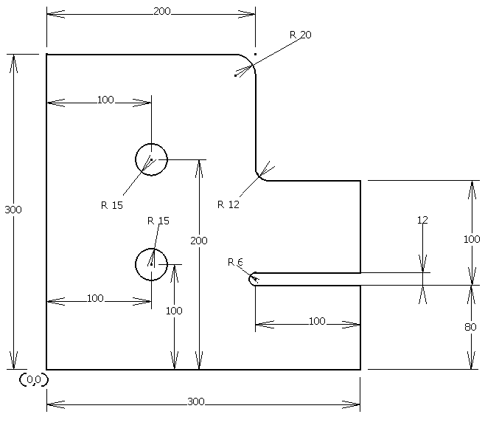
(10 marks)
OR

6. a) What is the need for computer aided part program? (3 marks)
b) What is the concept of macro statements in APT? (5 marks)
c) Explain the various tape programming formats in NC. (7 marks)
d) Explain operation of developing a program in APT. (10 marks)

7.a) Briefly explain the of computer aided process planning. (3 marks)
b) Explain retrieval type CAPP? (5 marks)
c) Explain the various types of configurations for computer aided process monitoring system. (7 marks)
d) How the selection of optimal machining parameters done in CAPP?
(10 marks)

OR
8. a) List the benefits of computer aided process control. (3 marks)
b) What you meant by online search strategy in process control ? (5 marks)
c) Explain supervisory computer process control method. (7 marks)
d) What are the various process control strategies employed in process control?
(10 marks)

