CE6303-MECHANICS OF FLUIDS
DEPARTMENT OF CIVIL ENGINEERING
PART-A-TWO MARKS

- What is the difference between an ideal and a real fluid?
- Define Control volume
- How do solid and a fluid respond to the deformation when a constant shear force is applied
- How Fluids classified based on Newtons law of viscosity/Give any 1 example for any two types of fluid
- Differentiate between specific weight and specific gravity of an oil
- Define Compressibility
- Define Surface Tension
- What is specific gravity
- What is Absolute pressure; Gauge Pressure and vacuum pressure
- Define centre of pressure and centre of buoyancy.
- Will the centre of pressure and centre of gravity ever coincide?
If so, under what conditions?

- What is the cause of Viscosity in liquids and in gases
- What is the effect of temperature on viscosity of water and that of air
- Write the equation of surface tension of liquid jet;LiquidDroplet;Soap Bubble
- Mention the units for
  - Viscosity
  - 1 stoke is equal to
- Explain the effect of property of capillarity
- Calculate the capillary rise in a glass tube of 1.8mm diameter when immersed vertically in water. Take surface tension of water as 0.073 N/m.
- For what range of contact angle of a fluid the following will occur (i) capillary rise and (ii) capillary fall.
- Estimate the pressure inside a water droplet of size 0.3mm. Assume surface tension=0.0728 N/m.
- A soap bubble 50mm diameter has inside pressure of 20 N/m2 above atmosphere. Calculate the tension in soap film.
- Determine the viscosity of oil having kinematic viscosity 6 stokes and specific gravity 2.0

PART-B-16 Marks

1. Two large plane surfaces are 120mm apart. The space between the surfaces is filled with oil of viscosity 0.92 Ns/m2. A flat thin plate of 0.6m2 area moves through the oil at velocity of 0.5 m/s. Calculate the drag force
(i) When the plate is in the middle of the two plane surfaces
(ii) When the thin plate is at a distance of 30mm from one of the planes.
2. Calculate the capillary rise in millimeters in a glass tube of 4mm diameter.When immersed in
a)water and b). mercury.The temperature of the liquid is 20 degcel and the values of surface tension of water and mercury at 20 deg c in contact with air are 0.0735 N/M and 0.51N/M respectively.The contact angle of water θ =0 deg and for mercury = 130 deg.Take Specific weight of water at 20 degcel as equal to 9790 N/m³.
3. A 400mm diameter shaft is rotating at 200 rpm in a bearing of length 120mm. If the thickness of oil film is 1.5mm and the dynamic viscosity of the oil is 0.7 Ns/m2. Determine the torque required and power lost

4. i) Determine the bulk modulus of elasticity of a liquid, if as the pressure of the liquid is increased from 7 MN/m2 to 13 MN/m2 the volume of liquid decreased by 0.15%.
ii) Distinguish between dynamic and kinematic viscosity. State their units

5. Explain the following terms a. Dynamic Viscosity b. Kinematic Viscosity c.Specific volume
d Specific Density

6. The left limb of a U tube manometer is connected to a pipe in which a fluid of specific gravity 0.8 is flowing. The right limb is open to atmosphere and manometric fluid is mercury. The difference in mercury level between the two limbs is 20cm and the center of the pipe is 12cm below the mercury level in the right limb. Find the fluid pressure in the pipe.

7. Derive an expression for the force exerted and centre of pressure for a completely submerged inclined plane surface.

8. Derive an expression for the force exerted and centre of pressure for a completely submerged inclined plane surface.
9. 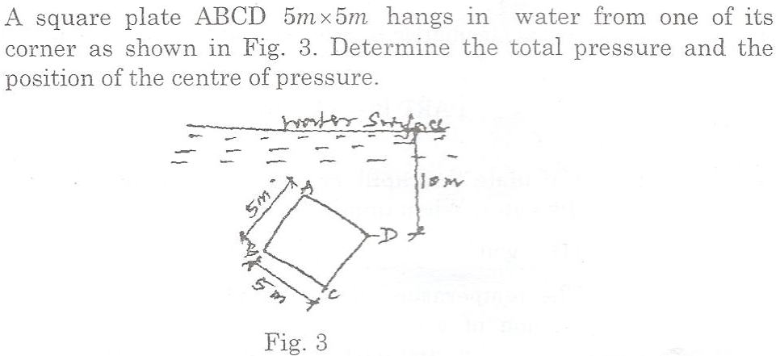

10. 