DEPARTMENT OF ELECTRICAL AND ELECTRONICS ENGINEERING
Subject: EE6303- Linear Integrated Circuits & Applications
UNIT I IC FABRICATION
PART A
- Write the chemical reaction in the epitaxial growth process of pure Silicon
- What are the advantages of Integrated circuits over discrete component circuits?
- Explain why Inductors are difficult to fabricate in IC’s
- List out the reaction compounds and doping hydrides used in Chemical Vapour Deposition?
- What is Ion Implantation? Why it is preferred over diffusion process?
- What are the different levels of Integration?
- Give classification of Integrated circuits.
- What do you mean by monolithic process?
- Explain importance of SiO₂ layer.
- Name the parameters which govern the thickness of the film in the oxidation process
- Compare Dry oxidation and Wet oxidation
- What is the step taken to avoid material defect in Ion Implantation?
- What is meant by dielectric isolation in IC fabrication?
- Name different types of IC packages
- What is the need of buried layer in fabrication of monolithic integrated transistor?
- What is meant by parasitic capacitance in an IC?
- Name different methods used in fabrication of Integrated Resistors?
- Define an Integrated circuit
- What is Epitaxial growth?
- What is meant by Planar technology?
- What are the limitations of Integrated circuits
- Differentiate thin film and thick film technology in IC fabrication
- What are the different linear IC packages?

PART B
- Describe in detail any two isolation technique used to provide isolation between various components in IC fabrication with illustrations?
- Explain in step by step basis, the fabrication of Planar P-N Junction Diode with neat illustrations
- Describe the Epitaxial growth process and photolithography process with neat diagram
- Give the various ways for making Integrated Resistor
- Explain in detail about the processing steps involved in the fabrication of monolithic Integrated Circuit
- Describe in detail about the Oxidation process of IC fabrication
- Explain the process of Crystal growth and Wafer preparation in detail
- Describe in detail about the diffusion process of IC fabrication
- Explain in detail about Ion Implantation and Metallization in detail
- Discuss the methods used for fabricating IC Resistors, Capacitors and Inductors
- Completely describe in detail the various stages involved in the fabrication of R, C and transistor in a single chip
- Explain the basic Planar processes in IC fabrication with neat diagrams
- Explain the fabrication process of Transistors and FET’s

UNIT II CHARACTERISTICS OF OPAMP
PART A
- What is the input impedance of a non-inverting amplifier?
- What are the different kinds of packages of IC 741?
- Mention the important ideal characteristics of an OP AMP.
- Draw the frequency response characteristic of an AC Integrator and indicate the part where it behaves as a True Integrator?
- State the causes for Slew rate in an operational amplifier? How it is indicated?
- Define CMRR? State its ideal value
- What is an operational amplifier?
- What is input offset voltage?
- What is input bias current and input offset current?
- What is PSRR? What should be its ideal value?
- What is slew rate? What causes the slew rate? State slew rate equations.
- Draw the typical frequency response of the op-amp
- Why frequency compensation is required?
- Mention linear and non-linear applications performed by an operational amplifier
- Compare inverting and non-inverting amplifiers
- What is an unity follower? Give its schematic and applications.
- How to obtain the average circuit from the inverting summer?
- Draw the integrator circuit using op-amp. Give its output equation.
- List the applications of Integrator circuit
- Draw the circuit diagram of an ideal differentiator. Write expression for its output.
- Why Integrators are preferred over differentiators in analog computers
- Determine the output voltage of a differential amplifier having differential gain 2000 and the CMRR 100 dB
- Give the four differential amplifier configurations
- An input of 3V is fed to the non-inverting terminal of an operational amplifier. The amplifier has R_{i} of 10kΩ and R_{f}of 10kΩ. Find the output voltage

PART B
- Explain the operation of a basic differential amplifier.
- List the six characteristics of an ideal op-amp and explain in detail. Give the practical op-amp equivalent circuit
- Explain in detail about DC characteristics of op-amp
- With a neat circuit diagram and equations, discuss the operation of summer and differentiator using operational amplifier
- Explain the AC characteristics of an operational amplifier
- Briefly explain different types of frequency compensation techniques applied to op-amp circuits
- Deduce the expression for a closed loop voltage gain of a inverting and non-inverting amplifier
- Explain the working of non-inverting summer with neat circuit diagram
- Draw and explain the circuit of a V to I and I to V converter
- Explain the working of Integrator and Differentiator
- Design an op-amp circuit to give an output voltage Vo=3V₁-2V₂+5V₃, where V₁,V₂,V₃ are inputs
- Design a practical differentiator circuit that will differentiate an input signal with maximum frequency 150 Hz
- For the non-inverting op-amp shown in Fig., find the output voltage Vo
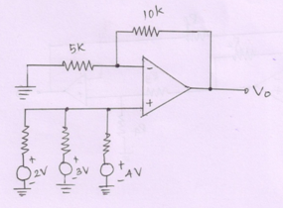

- Determine the output voltage for the following circuit
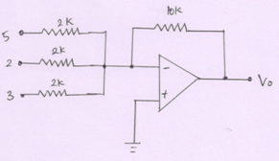

- Determine the output voltage Vo and the current Io in the circuit as shown below
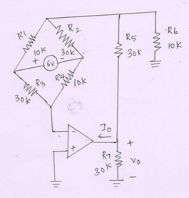

- Obtain the closed loop voltage gain Vo/Vi of the circuit shown below
