JEM FOUNDATION SCHOOLS
SUMMATIVE ASSESSMENT I
SESSION 2016-17
SUB: SCIENCE TIME: 2 Hrs.
CLASS: IV MM: 60
Instruction : Read the question paper carefully and answer them neatly and correctly.
_________________________________________________________________________________
SECTION A 50 Marks
I) Very short answers
A. Name the following:- 1X5 =5marks
- A plant like organism without chlorophyll
- The hardest substance in our body
- The method by which food items like idli and dhokla are cooked
- The hardest substance in our body
- The process that destroys vitamins and minerals of food

II) Short Answer Type I
A . Give two examples of each 2x5=10 marks
- 2 rich sources of vitamin c
- 2 types of sharp permanent teeth
- 2 types of microbes
- 2 common protozoa
- Rakiya’s mother is preparing cake for her birthday which she will have with her friends at school. Name the method of preparing cake and what is the value shown by Rakiya?
B. Give reasons 2x5=10 marks
- Why should we eat lots of vegetables and fruits?
- Why is milk boiled before use?
- Why do athletes need more carbohydrates and proteins than a common man?
- Why do pickles and jams stay fresh for a long time?
- Why a cut or wound should not be left open?

III) Short answer Type II
A. Complete the web diagram 3X5 = 15 marks
2

Different shapes of bacteria

1
3

B. State the way of cooking
- Roasting –
- Boiling –
- Steaming –
C. Label the structure of a tooth.
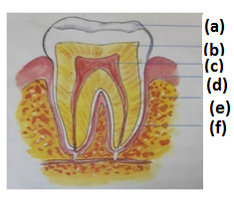
D. Circle the odd one out and give reason for your choice:-
- Chicken pox, typhoid, pneumonia, tetanus
- Fish, milk, egg, potato.
- Footpath, Zebra crossing, traffic light, mobile phones
E. Fill in the blanks:-
- The ______________ hold the teeth in place.
- A nutrient that help us in the repair of body tissues is _________________.
- Medicine should be kept in ________________ bottles.

IV) Long answers
I) A) Label the digestive system 5X2 = 10 marks
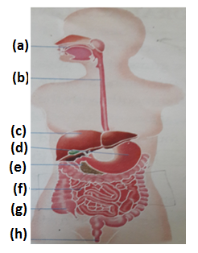

B) 2 ways of food preservation
II) Write the names of causing agent in each of the following:-
i) Fluffines in dough for making bhatura
ii) Ringworm –
iii) Dysentry –
iv) Typhoid –
v) Chicken pox –

SECTION B 10 Marks
I) Multiple Choice Questions:-
1This is not a microbe
a) fungi b) bacteria
c) virus c)ant
2) This disease is caused by virus
a) malaria b) tetanus
c) polio d) tuberculosis
3) Sealing foods in air tight can for protection against microbes is called
a) dehydration b) salting
c) canning d) freezing
4) The component of food that gives instant energy to the body is
a) carbohydrate b) fat
c) protein d) water
5) A food rich in fiber is
a) oil b) milk
c) potato d) carrot
6) The set of 16 teeth each in the two jaws are called
a) baby teeth b) milk teeth
c) permanent teeth d) wisdom teeth
7) The number of teeth in the mouth of one month old child is
a) 0 b) 10
c) 2 d) 4
8) These clothes catch fire easily
a) wollen b)synthetic
c) cotton d) jute
9) Accidents are caused due to
a) carelessness b) precaution
c) safety d) cautious
10) This should be used to extinguish an electric fire.
a) sand b) water
c) blanket d) rug

