JEM FOUNDATION SCHOOLS
SUMMATIVE ASSESSMENT I 2016-2017
SUBJECT : EVS
CLASS : I SECTION : ____
Name : _____________________ Date : ____________

Roll No. : ______ M.M. : 60
Invigilator’s Sign : ___________ Time : 2 hrs
60
Corrected By : ______________ Remarks : ________

Instruction : Read the questions carefully and answer the questions.
Section A 50 marks
- VERY SHORT ANSWERS
- Fill in the blanks by choosing the correct word. 1 X 5 = 5 marks
- Bees live in a ___________. (coop/hive)
- Curd is made from _________. (milk/water)
- We read a story book with our_______. (nose/eyes)
d. Grown up people are called __________. (adults/children)
- ____________ is a plant eating animal. (Cow/Lion)
II) SHORT ANSWERS TYPE I
- What do you do with your legs? 2 X 8 = 16 marks

Ans. ________________________________________________________
_______________________________________________________
- Why do we need to sleep?

Ans. ________________________________________________________
_______________________________________________________
- Name two flesh eating animals.
Ans. ________________________________________________________
____________________________________________________________
- What makes our body strong?
Ans. ________________________________________________________
- Name two food items that we get from animals.
Ans. ________________________________________________________
_______________________________________________________
- Name two food items that protect us from diseases.
Ans. ________________________________________________________
_______________________________________________________
- Write true or false.
- Sita smells a perfume bottle with her nose. _________
- Mini listens to the radio with her tongue. ___________
- Simran sees the black board with her eyes. __________
- Atul touches his puppy with his eyes. ____________

- Match the animals with their homes.
Animals Homes
- Fish Stable

- Horse Shed

- Hen Aquarium

- Cow Coop

- SHORT ANSWERS TYPE II
- Unscramble the letters to find the names of eatable things. 3 X 7 = 21 marks
- ZAZIP _________
- BRUERG __________
- TFOFEE __________
- Cross the odd one.
- Apple Banana Meat
- Milk Egg Rice
- Egg Burger Pizza
- How can we keep our teeth clean?
Ans. ________________________________________________________
_______________________________________________________
_______________________________________________________
- Find and circle the names of any three works that you can do with your hands.
H | N | E | K | A | L | S
O | W | R | I | T | E | D
L | E | E | D | R | A | W
D | P | A | I | N | T | P

- Write any three games that you play with your friends.
Ans. ________________________________________________________
_______________________________________________________

______________________________________________________

- Complete the word web.

Keeping fit

- Identify and name these animals.
c
b
a
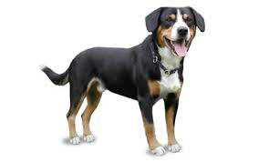
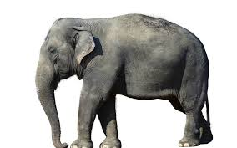
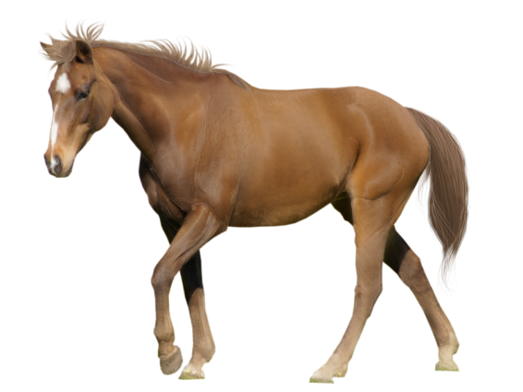

_________________ ________________ ________________
- LONG ANSWERS 8 marks
- Unscramble the names of food of these animals. 4 marks
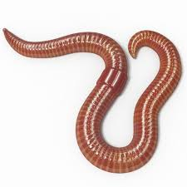
- Sparrow ORWM _____________
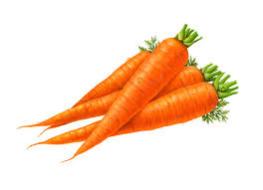
- Rabbit ARCRTO _____________

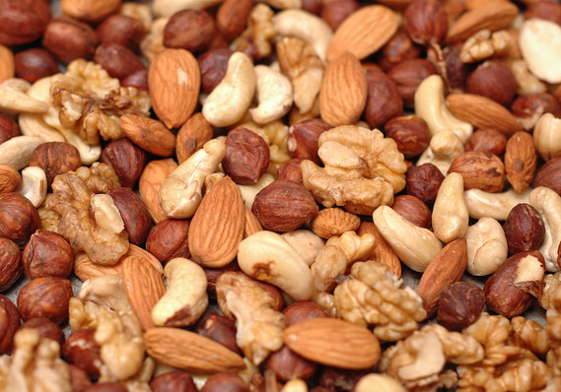
- Squirrel TNUS ______________
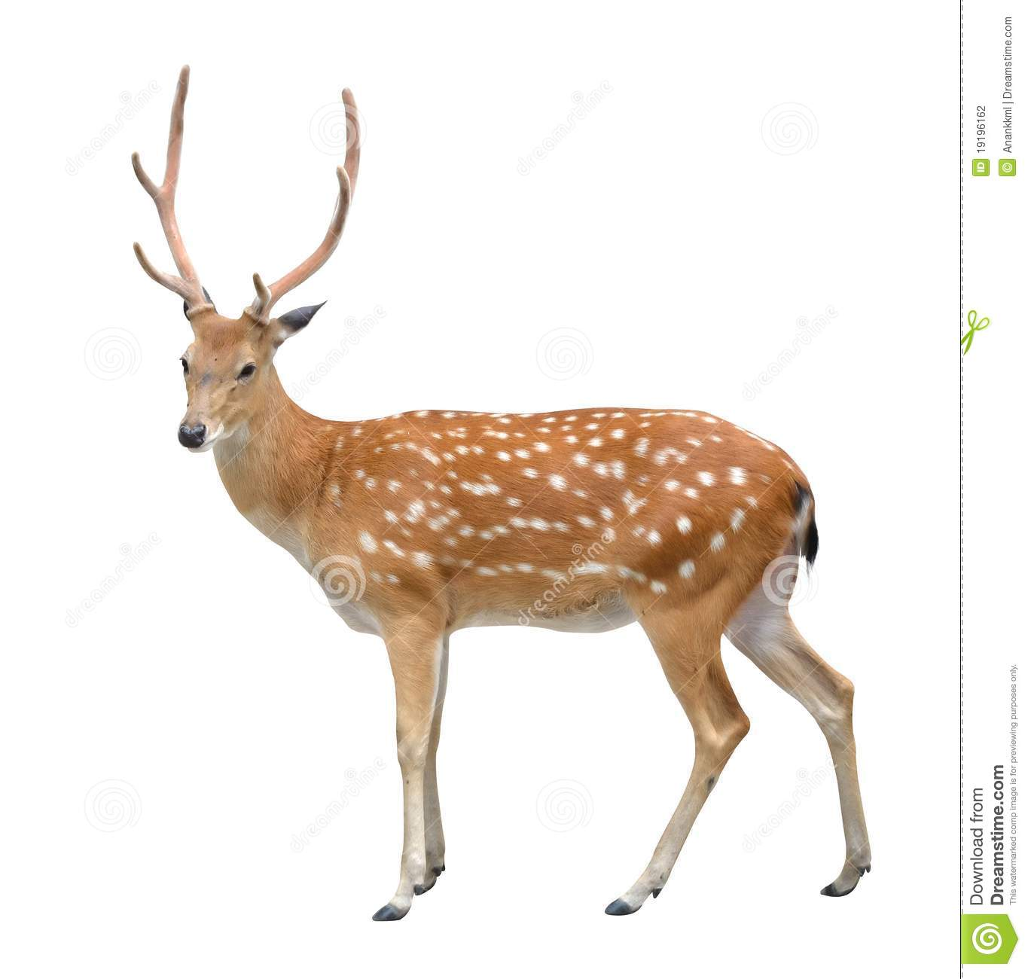
- Tiger EDER ______________

- Draw and name any four sense organs. 4 marks

Section B 10 marks
MULTIPLE CHOICE QUESTIONS 1 X 10 = 10 marks
Choose the correct answer.
- _____________ is a home of a dog.
  - kennel b. burrow c. coop d. web

- Snake lives in a __________________.
  - den b. hole c. shed d. stable

- Eyes help us to __________________.
  - see b. smell c. taste d. feel

- We write with our __________________.
  - head b. mouth c. legs d. hand

- Curd and paneer are __________________ products.
  - milk b. bread c. wheat d. rice

- Chips are called __________________ food.
  - healthy b. junk c. fresh d. stale

- We should eat __________________ meals a day.
  - two b. three c. five d. four

- __________________ keeps us fit and healthy.
  - standing b. talking c. sitting d. exercise

- We should get up early in the __________________.
  - morning b. night c. evening d. afternoon

- __________________ gives us rest.
  - singing b. dancing c. standing d. sleeping

