JEM FOUNDATION SCHOOLS
SUMMATIVE ASSESSMENT I 2016 - 2017
SUBJECT- ENGLISH
CLASS – I SECTION A B C

Name :________________________ Date :___________________

60

Roll No. :_____ M.M.: 60
Invigilator’s Sign :___________ Time : 2hrs
Corrected by:______________ Remarks:_______________

Instruction: Read the questions carefully and write the answers neatly and correctly.

Section A- READING 15 Marks

Q1. Read the passage carefully and answer the following questions.
My uncle has a new airplane. It is yellow with blue stripes. The wings have stars on them. It flies high. He took me on a trip in his new plane. I enjoyed the ride very much. The name of his plane is “Yellow Bird”.
a ) Answer the following questions. (2 x 2 =4 marks)

i ) What was the colour of the airplane ?

______________________________________________________________________________

______________________________________________________________________________

ii ) Who has a new airplane ? What is the name of the airplane?

______________________________________________________________________________

______________________________________________________________________________

b ) Fill in the blanks. (1x 2 = 2 marks)
- The wings have ______________ on them.
- The airplane flies _________________ .

c )Write True / False. (1 x 2 = 2 marks)

- He took me on a trip in his new plane.

- My uncle has a new Helicopter.

Q2. Read the passage carefully and answer the following questions.

The kangaroo is found in Australia. It is nearly as tall as a man. Its front legs are very short. It does not use them for walking. It uses them to hold things and to carry food to its mouth. The kangaroo’s hind legs are long. It uses its hind legs to make long leaps. The kangaroo’s head is like that of a deer. The mother kangaroo has a pocket on its belly and carries its baby. It likes to eat grass and leaves.
- Tick the correct answer. (7 x 1 = 7 marks)

i )The kangaroo is as tall as a _______.

- woman
- man
- tree

ii )The kangaroo is found in _________.

- India
- China
- Australia

iii )The opposite of tall x __________ is

- short
- thin
- long

iv ) The head of a kangaroo is that of a ______

- bear
- deer
- snake

v) The kangaroo eats _______ and leaves

- grass
- apple
- snake

(B) Underline the naming word in the sentence.

Kangaroo is nearly as tall as man

(C) Underline the describing word in the sentence given below.

The kangaroo’s hind legs are long.

Section–B (WRITING & GRAMMAR) 25 Marks
Q3.Describe a house with the words given in the help box. (5x1=5 marks)
drawing room, live, kitchen, clean, welcome

A house is a place where we ______________________ happily.It consists of __________________,

bedroom, hall, kitchen and washroom. We _____________________ our guests and make them
sit in the drawing room.. Mother cooks in the _________________________.We should keep
our house neat and___________________.
Q4. Observe the picture carefully and write five sentences about it. (5 marks)
cupboard, bed, table, chair, ball, bat, shoes, wall picture, bags, door

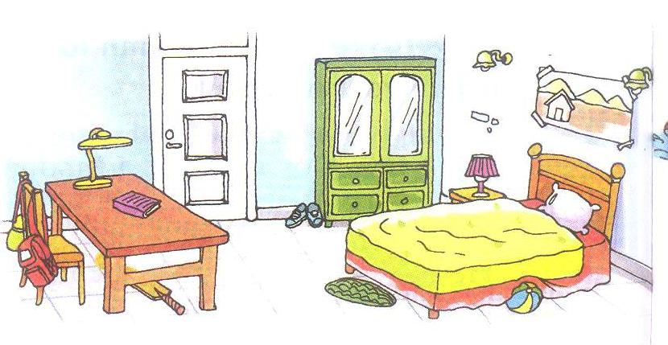
______________________________________________________________________________

______________________________________________________________________________

______________________________________________________________________________

______________________________________________________________________________

______________________________________________________________________________

Q5. Do as directed.

I. Fill the blanks with articles (a/an). (1 x4 = 4marks)

- Anya is drawing ____________ doll in her drawing book.

- ____________ orange is a juicy fruit.
- Rohan has _____________ new pencil box in his bag.
- I had ______________ egg and toast for the breakfast.
II. Choose the correct word to complete the sentence. (1 x 4 = 4 marks)

- Harsh does not play cricket.____________________________ plays hockey. (She / He)
- There is a park near our house. ___________________play there in the evening. ( We / He)
- ___________________ is a good girl. (It / She)
- The cat is useful. ______________catches mice. ( She / It)
III.Circle the describing words in the following sentences. (1x3=3=3 marks)
- We live in a huge house.
- The ball has a round shape.
- Mother cooks tasty food.
IV. Write singular or plural forms of the nouns given below. (1x2=2=marks)
- Mohan sleeps in a small _________________. (beds / bed )

- ______________________ are making noise in the classroom. ( Child / Children)
V.Arrange these words to form sentences. (1x2=2 marks)
- over the jumped wall fox the

_____________________________________________________________
- pretty a girl is salma
____________________________________________________________

SECTION C (LITERATURE)
20 Marks

Q6. Refer to the context and answer the following questions.
A. “ Uncle Vivek shows us the lions first. We hear the lions roar. Uncle tells us that the lions roar to speak to other lions.” (1x5=5marks)
- Who shows the lions to the children?

__________________________________________________________________________

- Why do the lions roar?

__________________________________________________________________________

- What did the children hear?

_________________________________________________________________________

- Make a sentence with the following word.

zoo- __________________________________________________________________

- Write the opposite of last x ____________

B.“Pretty little children
Smart and bright”

i) Name the poem. (1 x 2 =2 marks)

_______________________________________________________________

ii) Who were pretty in the poem?

_______________________________________________________________

iv) Give the opposite of the following words. (1 x 2 = 2 marks)

dull x _______________ stupid x _______________

iv) Give one rhyming word for. (1 x 1= 1mark)

write ______________

Q7. Answer the following questions: (4 x 2 = 8 marks)

- What did Ravi’s mother meant by ‘C’ and ‘S’ game?

___________________________________________________________________________

___________________________________________________________________________

- How many chicks came out from the eggs?

______________________________________________________________________________

- Why was Mother Hen tired?

______________________________________________________________________________

- Who is in a pink dress and silver shoes?

______________________________________________________________________________

Q8.Value Based Question: (2 x 1 =2 marks)

Why should we take care of animals?

______________________________________________________________

______________________________________________________________

