(Pages: 2)

M. TECH. DEGREE EXAMINATION, MODEL QUESTION PAPER – I
First Semester

Branch: Mechanical Engineering
Specialisation: Computer Integrated Manufacturing / Advanced Manufacturing and Production Management
MMECM 104 /MMEMP 105-3 FINITE ELEMENT METHOD
(Regular – 2013 Admissions)

Time: Three Hours (Answer all Questions) Maximum:100 Marks

- (a) With a suitable example explain the general procedure for obtaining solution of a continuum problem using finite element method. (15 marks)
(b) Write a brief note on the history of FEM (10 marks)
OR
- (a) Make a comparison between FDM and FEM (10 marks)
(b) Explain the various types of elements used in FEM (15 marks)

- For the assembly given below find the element stifness matrix and the global stifness matrix ,nodal displacements and force in each element. Assume K1 =1000N/mm, k2 = 2k1, K3 = 3K1, K4 = 4K1, K5=5, K1K6 =6K1 , P = 10000N (25 marks)
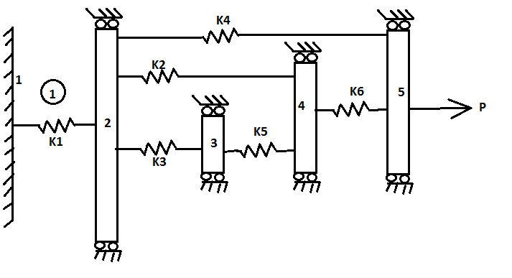
OR
- For the beam loaded as shown , determine (a) the global stifness natrix, (b) the vertical displacement at the right end,(c) the nodal rotations, (d)nodal reactions, (e) forces in shear elements (25 marks)
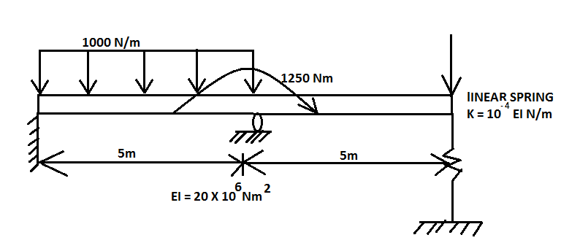

- Consider the different equation + 600 = 0 ; 0 ≤ x ≤ 1 with the boundary conditions Find the solution to problem using galerkin method and trial solution is rotating at constant angular velocity 32rad/s. determine the axial stress distribution in the rod using 2 quadratic elemnts. Consider only the centrifugal force,ignore the bending of the rod. Assume A= 100mm² , E= 210 Gpa, density = 7800Kg/m³ (25 marks)
OR
- (a) Derive the mass metrix for a CST element (10 marks)
(b) With suitable example, explain any to weighted residual methods (15 marks)

- (a) Derive the mass matrix for an axisymmetric triangular element. (10 marks)
(b) Two steel plates of size 100mm X 50mm X 3mm are but welded. Explain the steps involved in analyzing the temperature distribution in the plate using finite element package (15 marks)
OR
- (a) Explain the terms (a) Mesh generation (b) Node number generation. (c) Element assembly. (d) Post processing (10 marks)
(b) Temperature distribution during orthogonal turning is to be analyzed using a finite element package. Explain the steps involved. (15 marks)

