NATIONAL TEACHERS COUNCIL

ALL INDIA TALENT SEARCH EXAMINATION

MODEL QUESTION PAPER
AITSE 0910

CLASS IX

Duration: 1¹/₂ hours Maximum Marks: 100

General Instructions to Candidates

1. This question paper contains 100 multiple choice questions each of one mark.

2. The question paper is divided into two sections A and B

3. Section A is Scholastic Ability Test (SAT), contains 50 questions. This section covers Science, Mathematics and Social Science.

4. Section B is Mental Ability Test (MAT), Computer Awareness and General Knowledge, contains 50 questions.

5. There will be no negative marks for wrong answer.

6. A separate answer sheet is provided for answering the questions. Each question should be answered by darkening the appropriate circle (A, B, C, or D) with a blue or black ball pen.

7. Answer recorded once in the answer sheet cannot be altered.

8. All rough works should be done only in the space provided for rough work in this question paper.

9. Calculator is not permitted in the examination hall.

10. Candidate should write his / her name in the space provided for the purpose.
Name

SECTION A

1. A simple pendulum hangs from the roof of a train. The string is inclined towards the rear of
the train. What is the nature of motion of the train?
A) Uniform B) Accelerated
C) Retarded D) At rest
2. Two objects of unequal masses are dropped from a cliff. At any instant they have equal
A) Momentum B) Acceleration
C) Potential energy D) Kinetic energy
3. Identify the correct statement about the definition of work
A) A force always does work on the body on which it is acting
B) A force does work only when the body is moving
C) A force does work only when the body moves under the action of force
D) None of these
4. For the same kinetic energy, the momentum shall be maximum for
A) Electron B) Proton
C) Deuteron D) Alpha particles
5. A source of frequency 500Hz emits waves of wavelength 0.2m. The time the wave
takes to travel a distance of 300m is
A) 3 seconds B) 12 seconds
C) 60 seconds D) 75 seconds
6. A train is moving towards east and a car is along north, both with same speed.
The observed direction of the car to the passenger in the train is
A) South –East direction B) North-East direction
C) North-West direction D) None of these
7. When a body of mass ‘m’ revolves with uniform speed of ‘V’ on a circular path of radius ‘r’,
the work done by the body in one complete rotation is
A) ½ mv² B) 2πrmv²
C) (2π -1/2) mv² D) Zero
8. A pendulum of a clock takes less than a second for one swing. It means that the clock is
A) Running fast B) Running slow
C) Giving correct time D) Loosing time

9. A car starts from rest and moves on a straight road with a uniform acceleration of 10m/s²
for the first 10 seconds. During the next 10 seconds the car moves with the velocity it has attained.
What is the total distance covered by the car in 20 seconds?
A) 500 m B) 1000 m
C) 1500 m D) 2000m

10. A ball is thrown vertically up in. It goes up and falls down on the earth.
Which of the given figure represents its true velocity – time graph?

Velocity Velocity Velocity Velocity

A) B) C) D

Time Time Time Time
11. When a gold sheet is bombarded by a beam of alpha-particles, only a few of them get deflected
where as most go straight undeflected. This is because:
A) The force of attraction exerted on the alpha particles by the oppositely charged
electrons is not sufficient.
B) A nucleus has much smaller volume than that of an atom.
C) The force of repulsion acting on the fast moving alpha particle is very small.
D) The neutrons in the nucleus do not have any effect on the alpha particle.
12. The atomic mass and atomic number of an element ‘X’ are 238 and 92 respectively. Y is an isotope of x with atomic mass 234. The number of neutrons in the nucleus of X and Y is respectively:

A) 92 and 146 B) 92 each
C) 238 and 234 D) 146 and 142
13. A solution contains 50 gram of sugar mixed with 150 gram of water.
The concentration of the solution is
A) 25 % B) 50 %
C) 75 % D) 60 %
14. How many moles of water are present in 0.9 gram of water?
A) 2 B) 20 C) 0.5 D) 0.05
15. The chemical formula of lead nitrate is
A) PbNO₃ B) Pb(NO₃)₂ C) Pb₂NO₃ D) PbN₂

16. Read the given statements and answer:
Statement: 1 Alloys are homogeneous mixture.
Statement: 2 All compounds are pure substances.
A) Both statements 1 and 2 are true.
B) Both statements 1 and 2 are false.
C) Statement1 is true and Statement 2 is false.
D) Statement 1 is false and Statement 2 is true.
17. Ammonia is a
A) Fire extinguisher B) Fertilizer
C) Refrigerant D) Fungicide
18. One of the phenomenon which cannot be described as combustion is
A) Oxidation of coal in air B) Burning of magnesium in nitrogen
C) Reaction of antimony in chlorine D) Lighting of an electric lamp
19. A solution of ‘X’ is translucent, appears to be homogeneous but actually heterogeneous,
and leaves a residue on filter paper. The particles do not settle down due to gravity. ‘X’ is a
A) True solution B) colloidal solution
C) Suspension Solution D) Coloured Solution.
20. Water in a container is heated from -10º C to 100ºC. Then the volume of water
A) Increases Continuously
B) Decreases Continuously
C) Decreases up to 4ºC and then increases
D) Increases up to 4ºC and then decreases
21. To prepare a mount of human cheek cell, the sample is collected from
A) Outer side of cheek with a blade B) Inner side of cheek with blade
C) Outer side of cheek with a tooth pick D) Inner side of cheek with a tooth pick
22. Test for starch is performed by
A) Adding a few drops of iodine solution to food sample
B) Boiling food sample with NaOH and adding iodine solution
C) Boiling a mixture of iodine solution, conc. HCl and food sample
D) Any of the above
23. Which of the following tissues includes bone and cartilage?
A) Muscle Tissue B) Nervous Tissue
C) Epithelial Tissue D) Connective Tissue
24. Plants that live on the cost of other plants
A) Symbiotic B) Parasitic
C) Saprophytic D) Epiphytic
25. A herbarium is a
A) Collection of herbs in dried form
B) Garden with a varied collection of herbs
C) Garden with a collection of medicinal herbs
D) Centre for preservation of dried specimen of plants
26. The arithmetic mean of 6, 8, 5, 7, x and 4 is 7. The value of x is
A) 12 B) 6
C) 8 D) 4
27. An exterior angle of a triangle is 110º and the two interior opposite angles are equal.
Each of these angles is
A) 110o B) 35º
C) 55º D) 70º
28. √10 X √15 is equal to

A) 6√5 B) 5√6
C) √25 D) 10√5
29. The flowers in basket become doubles in every minute. In 30 minute, the basket is filled with
flowers. The basket filled half in
A) 15 minute B) 20 minute
C) 25 minute D) 29 minute
30. The value of √ (-1)² is
A) -1 B) 1
C) ±1 D) none of these
31. The percentage increase in the area of a triangle, if its each side is doubled is
A) 200% B) 300%
C) 400% D) 500%
32. The ratio of the ages of A and B ten years before was 3: 5. The ratio their present ages is 2: 3.
Their ages are respectively
A) 30, 50 B) 20, 30
C) 40, 60 D) 16, 24
33. If x² +1 = 7 then the value of x² + 1 is
x x²
A) 49 B) 47
C) 46 D) 48
34. The area of a rhombus is 28cm² and of its diagonals is 4cm. its perimeter is
A) 4 √53 cm B) 36cm
C) 2√53 cm D) none

35. The probability that a vowel selected at random in English language is an “i” is
A) 1 B) 1
26 6
C) 1 D) None
5
36. Which of the following state has boundaries with three countries?
A) Arunachal Pradesh B) Jammu and Kashmir
C) Assam D) Mizoram
37. What is the epic centre of an earth quake?
A) The point at which earth quake originates
B) The point which is prone to the earth quakes
C) The point from which the intensity of seismic waves declines
D) The point on the earth’s surface vertically above the seismic focus
38. Which of the following is an inland river port?
A) Kolkata B) Mumbai
C) Chennai D) Tuticorin
39. Which of the following is correctly matched?
A) Bandipur - Orrissa
B) Manas - Uttar Pradesh
C) Tekkadi - Karntaka
D) Simlipal - Bihar

40. The term fourth estate is used for:
A) Legislature B) Press and News paper
C) Judiciary D) Executive

41. A day is added when one crosses
A) The equator from South to North B) 180⁰ longitude from east to West
C) The equator from North to South. D) 180⁰ longitude from North to South
42. Which one of the following is the part of executive?
A) Sub inspector of Police B) Member of Rajya Sabha
C) Chief justice of High court D) Member of legislative assembly
43. Article 1 of the constitution declares India as:
A) Federal State B) Quasi federal State
C) Unitary states D) Union of States

44. Which one of the following is not correctly matched?
A) White Revolution - Diary
B) Green Revolution - Agriculture
C) Blue Revolution - Fishery
D) Red Revolution - Wool
45. Which symbol has the India Government adopted from Maurya Dynasty?
A) The national Bird B) The National Calendar
C) Lion capital C) National Song
46. Who considered as the first Citizen of India.
A) Prime minister B) President
B) Defence Minister D) Governor
47. The seat of Supreme Court at:
A) New Delhi B) Mumbai
C) Bangalore D) Jaipur
48. The largest Pensular River is
A) Mahanadi B) Godavari
C) Krishna D) Cauvery
49. At the time of independence of India in 1947, the Prime Minister of England was:
A) Lord Mount Batten B) Winston Churchill
C) Clement Atlee D) None of These
50. The second most populous country in the world.
A) China B) India
C) USA D) France

SECTION B

DIRECTIONS: (Q. No 51 to 53) In each of these questions, a related pair of word is followed by
four pairs of word. Select the pair that best expresses a
relationship similar to the one expressed in the original pair.
51. Filter : Water :: ___________.
A) Curtail : Activities B) Edit : Text
C) Expunge : Book D) Censor : Play

52. Coconut : Shell :: Letter : _________.
A) Mail B) Letter Box
C) Stamp D) Envelope
53. A B Z : 1 :: D E W
26
A) 9 B) 92
4 5
C) 20 D) 9
23 23

DIRECTIONS: (Q. No 54 to 56) some of the letters or numbers are missing in the given sequence.
Find out the one correct answer among the given alternatives.
54. 257, 226, 197, ___.
A) 153 B) 165
C) 170 D) 180
55. M 4, T 7, P 7, Q 10, S 10, N 13, ___, K 16
A) V 4 B) K 7
C) T 13 D) G 15
56. C, ___, H, L, C, P, ___, L.
A) C L B) D Q
C) H P D) P H
57. Mohan travels 3 Km in the east, then he turns to south and moves 4 Km. How far is he
now from the starting point?
A) 2 Km B) 4 Km
C) 5 Km D) 6 Km
DIRECTIONS: (Q. No. 58 to 60) In the following questions insert the missing number in place of
question mark from the given alternatives.
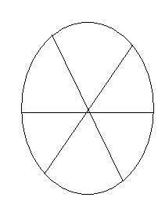
58.
4
3 8

2 27
?

A) 36 B) 16
C) 64 D) 1

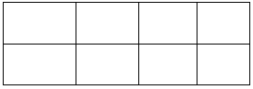
59. 4 7 3 2

416 749 309 ?

A) 204 B) 104
C) 404 D) 401

60.
3 4 5

3 7 12

3 ? 22

A) 11 B) 10
C) 9 D) 8

61. If A + B means A is the sister of B; A – B means A is the brother of B; A X B means A is the
daughter of B. Which of the following shows the relation that E is the maternal uncle of D?
A) D + F X E B) D – F X E
C) D X F + E D) D X F – E
62. If + means X, ÷ means -, X means ÷ and – means +,
What will be the value of 4 + 11÷ 5 – 55?
A) 94 B) 91
C) 79 D) -11
63. Seen through a mirror, the arms of a clock show 11:50. What is the actual time?
A) 1:50 B) 12:50
C) 12:10 D) 1:10

64. A man goes up hill with an average speed of 24 Km/h and comes down with an average speed of
36 Km/h. The distance traveled in both the case being the same. The average speed (in Km/h)
for the entire journey is
A) 30 B) 28.8
C) 32.6 D) 30.8
65. The sum of two numbers is 100 and their distance is 50. The ratio between them is
A) 2: 1 B) 3: 1
C) 4: 1 D) 5: 1
DIRECTIONS: (Q. No. 66 to 75). Choose one out of the four small squares A, B, C and
D that makes the complete pattern in the bigger figure.

66

67

68

69

71
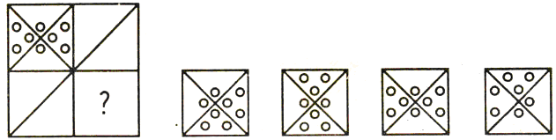

A B C D

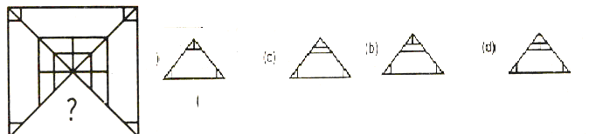
A B C D

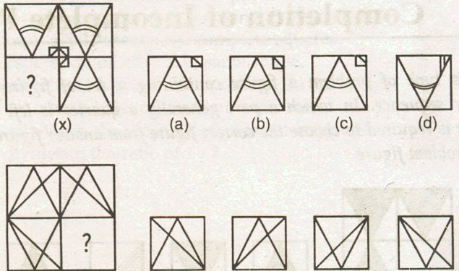

69

70

71

75
A B C D
A B C D
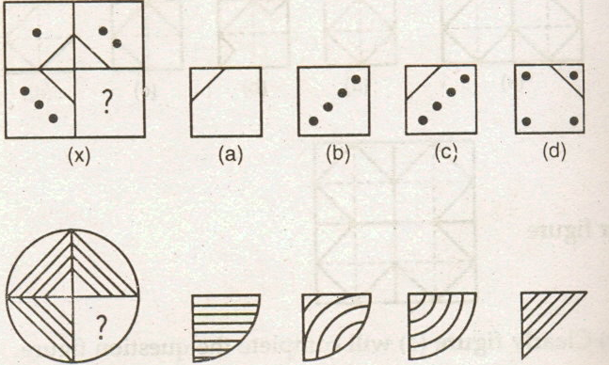
A B C D
A B C D
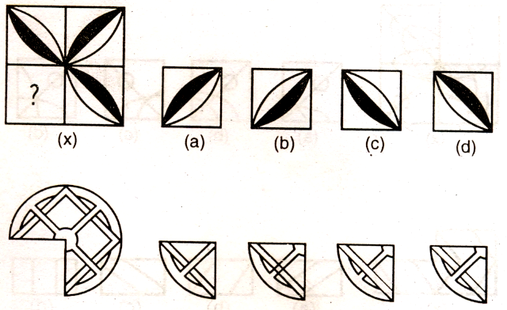
A B C D

72

73

74

75
A B C D
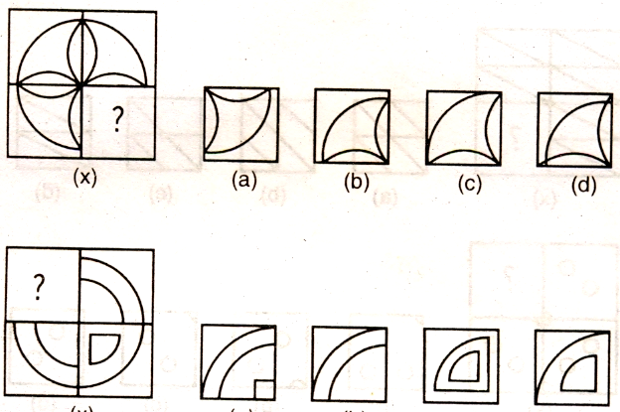
A B C D
A B C D

76. Which one of the following is not a Dravidian Language?
A) Urdu B) Telugu
C) Kannada D) Tamil
77. In the year 1948 two important two very important freedom fighters died:
A) Mahatma Gandhi and Sardar Patel
B) M. A Jinnah and Sardar Patel
C) Mahatma Gandhi and M. A Jinnah
D) Tagore and M. A Jinnah
78. Which of the following is a web browser?
A) Fire fox B) Power Point
C) Visual Basic C) All of the above
79. Sakthi Sthal is the Samadhi of:
A) Rajeev Gandhi B) Indira Gandhi
C) Sanjay Gandhi D) Mahatma Gandhi
80. Which wild life sanctuary has the project to conserve the Rhinos in India?
A) Bandipur B) Kaziranga
C) Gir D) Periyar
81. Area drained by river is called:
A) Valley B) Basin
C) Plateau D) Flood plain

82. Which one of the following environment supports the growth of Mangrove swamps:
A) Tidal Flat B) Monsoon
C) Equatorial D) None of these
83. Which amongst the following state has the highest population density as per 2001 census?
A) Kerala B) Tamilnadu
C) West Bengal D) Maharashtra
84. The state which stands first in per capita income:
A) Kerala B) Maharashtra
C) Punjab D) Gujarat
85. Which of the following is not a computer language?
A) C B) C++
C) COBOL D) Microsoft
86. A program designed to destroy data on your computer which can travel to “affect” other
computer is called:
A) Torpedo B) Virus
C) Corrupted file D) None of these
87. Which of the following is not a famous operating system?
A) Windows Vista B) Mac OS X
C) Linux D) Virtual Box
88. E commerce allows companies to:
A) Issues important business reports
B) Conducts business over internets
C) Support decision making process
D) None of these
89. What is an Email attachment?
A) A receipt sent by the recipient
B) A list of CC or BCC
C) A separate document from another program sent along with an E mail message.
D) None of these
90. Something which has easily understood instruction is said to be:
A) User friendly B) Information
C) Word processing D) Icon
91 Which country won the Gold medal for Hockey in XIX Commonwealth Games?
A) India B) Australia
C) England D) Canada
92. The footballer who was declared ‘Best Player’ in FIFA World Cup 2010 is
A) Chritiano Ronaldo B) Diego Forlan
C) David Beckham D) Cheema Okery.

93. The first Italian woman to win French Open Tennis Championship 2010 is:
A) Francesca Shiavone B) Klara Zakopalova
C) Kim Klijster D) Caroline Wozniacki
94. Which country secured the maximum number of Gold medals in XIX commonwealth Games 2010?
A) Australia B) India
C) Canada D) England
95. Who is selected for the Best Actor, in 57th National Film Awards?
A)Amitabh Bachchan B) Mammooty
C) Rajanikant D) Kamalahasan
96. The first Indian to receive the Nobel Prize in Economics:
A) Rajagopalachari B) Amrtya Sen
C) P. Chidambaram D) None of these
97. Potomology is the study of:
A) Maps B) Roads
C) Rivers D) Mountains
98. The leaning tower of Pisa is located in which country?
A) France B) Italy
C) Greece D) India
99. Recently with the help of which country Iran loaded its first nuclear power plant:
A) India B) U S A
C) Germany D) Russia
100 Which Bollywood actress has been appointed UNICEF National Ambassador
for promoting child rights and adolescents?
A) Priyanka Chopra B) Aiswary Rai
B) Hemalatha D) Rani Mukharjee

SPACE FOR ROUGH WORK

