NATIONAL TEACHERS COUNCIL

ALL INDIA TALENT SEARCH EXAMINATION

MODEL QUESTION PAPER

AITSE 0510

CLASS V

Duration: 1¹/₂ hours Maximum Marks: 100

General Instructions to Candidates

1. This question paper contains 100 multiple choice questions each of one mark.

2. The question paper is divided into two sections A and B

3. Section A is Scholastic Ability Test (SAT), contains 50 questions. This section covers Science, Mathematics and Social Science.

4. Section B is Mental Ability Test (MAT), Computer Awareness and General Knowledge, contains 50 questions.

5. There will be no negative marks for wrong answer.

6. A separate answer sheet is provided for answering the questions. Each question should be answered by darkening the appropriate circle (A, B, C, or D) with a blue or black ball pen.

7. Answer recorded once in the answer sheet cannot be altered.

8. All rough works should be done only in the space provided for rough work in this question paper.

9. Calculator is not permitted in the examination hall.

10. Candidate should write his / her name in the space provided for the purpose.
Name

SECTION A

1. A device used to measure atmospheric pressure
A) Hydrometer B) Barometer
C) Lactometer D) Thermometer
2. The normal range of haemoglobin in our blood
A) 12 to 16 gm/dl B) 8 to 12 gm/dl
C) 10 to 12 gm/dl D) 6 to 10gm/dl
3. Which one of the following diseases is not spread by mosquitoes?
A) Malaria B) Dengue
C) Chikungunya D) Typhoid
4. An animal without external ear
A) Tiger B) Human
C) Snake D) Monkey
5. A carnivorous plant
A) Nepenthes B) Cactus
C) Water Lily D) Orchid
6. The prominent bright coloured part of a plant
A) Sepal B) Petal
C) Stamen D) Pistil
7. The largest animal on the planet earth
A) Dolphin B) Elephant
C) Blue Whale D) Giraffe
8. Many flowers bloom in night. The most common colour of such flowers is
A) Black B) White
C) Red D) Yellow
9. The total number of bones in an adult man
A) 196 B) 200
C) 206 D) 212
10. Which one of the following does not dissolve in water?
A) Salt B) Vinegar
C) Kerosene D) Oxygen
11. A communicable disease
A) Anaemia B) AIDS
C) Scurvy D) Night blindness
12. Which one of the following statement is not true?
A) Water vapour is present in the air
B) The change of water to water vapour is called evaporation
C) Water is a colourless liquid
D) Ice sinks in water
13. The full form of LPG
A) Liquefied Petroleum Gas B) Liquefied Petroleum Gas
C) Low Petroleum Gas D) Liquid Propellant Gas
14. The smallest planet of the solar system
A) Mercury B) Pluto
C) Jupiter D) Mars
15. ORS which is used for the treatment of Diarrhoea stands for
A) Oral Recharging Solution B) Oral Reducing Solution
C) Oral Replenishing Solution D) Oral Rehydration Solution
16. Which one is not a petroleum product?
A) Kerosene B) Natural Gas
C) Petroleum Gas D) Petrol
17. Pulses are mainly rich in
A) Carbohydrates B) Fats
C) Protein D) Vitamins
18. The major component of air is
A) Nitrogen B) Oxygen
C) Carbon dioxide D) None of these
19. A desert plant
A) Water Lily B) Rose
C) Cactus D) Pine
20. The shaking of earth is called
A) Tsunami B) Flood
C) Earthquake D) Volcano
21. One thousand less than 641234 is
A) 640234 B) 631234
C) 64100 D) 640123
22. Two lines which never meet each other are called
A) Perpendicular lines B) Parallel lines
C) Intersecting lines D) Converging lines
23. Sum of the place values of 5 in 56255 is
A) 50055 B) 50000
C) 15 D) 55500
24. The time, quarter past 12 midnight is
A) 12:15 pm B) 12: 15 am
C) 11: 45 pm D) 11: 45 am
25. The largest four digit number is divided by largest two digit number. The quotient is
A) 11 B) 111
C) 101 D) 100
26. The product of the place values of 7 and 8 in 48673 is.
A) 56 B) 5600
C) 56000 D) 560000
27. A plane figure is made of three line segments. It has three corners. It is a
A) Rectangle B) Square
C) Triangle D) Angle
28. Two tens + 3 ones + 5 hundredths + 6 thousands can be written as
A) 2 X 10 + 3X1 + 0.5 + 0.006 B) 20 + 3 + 0.05 + 0.6
C) 20 + 3 + 0.05 + 0.006 D) 23.56
29. In the following figure measure of one side is missing.
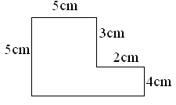
What is the measure of missing side?
A) 10 cm B) 9 cm
C) 5 cm D) 7 cm
30. 8 km 8 m is equal to
A) 8.8 km B) 80.8 km
C) 8.08 km D) 8.008 km

31. Rani purchased a laptop computer for Rs. 24200 and sold it for Rs. 23950. What is her loss?
A) Rs. 1250 B) Rs. 250
C) Rs. 750 D) Rs. 200
32. The smallest four digit number that can be formed by using 8, 0, 1, 4 is
A) 1048 B) 0148
C) 8410 D) 1084
33. The measure of an obtuse angle is always
A) 120⁰ B) 90⁰
C) Greater than 90⁰ D) Less than 90⁰
34. L C M of 5, 10 and 15 is
A) 15 B) 20
C) 30 D) 60
35. A and B are two squares. The perimeter of B is twice that of A. If the area of A is 25cm², then the area of B is
A) 50 cm² B) 10.0 cm²
C) 12.5 cm² D) None of these
36. If is equal to 0.2 then

+ + + is

A) 3.2 B) 0.8
C) 1.6 D) 4
37. Find the perimeter of the following figure.
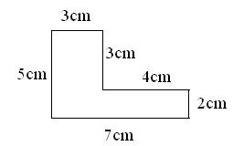
A) 24cm B) 24cm
C) 21cm D) 21cm²
38. The sum of 2 ³/₈ and 3 ¹⁰/₁₆ is
A) 5 ¹³/₁₀ B) 6
C) ⁷⁷/₁₆ D) 7
39. If a family of 4 requires 38kg of cereals in a month, how much cereal will be required
for a family of 5?
A) 47.5kg B) 47kg
C) 43kg D) 42.5kg
40. If ³/₇ of a number is 300, what is the number?
A) 600 B) 660
C) 700 D) 720
41. The region around South Pole is known as.
A) Arctic B) Equator
B) Antarctic D) Capricorn
42. Flora is the:
A) Animal life of a region B) Plant life of a region
C) Study of Physics D) Study of Oceanography
43. Bauxite is an ore of:
A) Iron B) Lead
C) Aluminum D) Magnesium
44. Land of rising sun is:
A) Vietnam B) Australia
C) Japan D) China
45. Indian Ocean is:
A) The largest B) Second largest
C) Third largest D) None of these
46. Shantivan is associated with:
A) Gandhiji B) Jawaharlal Nehru
C) Rajiv Gandhi D) Lalbahadur Sastri
47. Children’s day is celebrated every year on:
A) 14th November B) 15th November
C) 14th December D) 15th December
48. The head of our country:
A) President B) Prime minister
C) Military General D) None of these
49. The famous slogan “Do or die” inspired millions of Indian people during the freedom struggle, this slogan is associated with famous:
A) Quit India Movement B) Salt Satygraha
C) Non Co operation movement D) Civil Disobedience movement.
50.

SECTION B

DIRECTION: - (QNo.51 to 59). In each of these questions some number or letter is missing.
Find out the correct answer:-
51. 0, 1, 3, 6, 10, 15, __
A) 21 B) 20
C) 22 D) 23

52. ½, ¼, ¹/₈, ¹/₁₆, ¹/_{32 ,} __
A) ¹/₆₀ B) ¹/₃₆
C) ¹/₆₄ D) ¹/₉₆
53. 1536, 384, 96, 24 __
A) 6 B) 8
C) 12 D) 16
54. U, O, I, __ , A
A) C B) E
C) F D) H
55. AB, DE, HI, MN, __ .
A) OP B) PQ
C) RS D) ST
56. If P = 64 + 36 and Q = 124 – 26, then P – Q = ?
A) 0 B) 2
C) 10 D) 36
57. In a class there are 45 students. If one more boy joins in the class, the number of boys and girls become equal. What is the present strength of boys in the class?
A) 25 B) 24
C) 23 D) 22
58. 3 X 6 ÷ 9 + 9 – 5 = ?
A) 13 B) 6
C) 10 D) 5
59. If ÷ means X , + means -, X means + and – means ÷, then
5 ÷ 8 – 2 + 10 = ?
A) 4 B) 8
C) 10 D) 12

DIRECTION: - (QNo.60 & 61):- Odd one out.

60. A) 6 B) 12 C) 44 D) 48

61. A) Circle B) Square C) Rectangle D) Triangle

62. Ankit is facing towards North. He turns left and walks 5m and then turns right.
In which directions he is walking?
A) South B) West
C) East D) North
63. Which one of the following has only one surface?
A) Cube B) Cuboid
D) Sphere D) Cylinder
64. Which one of the following cannot be a mobile phone number?
A) 0943645715 B) 9635468790
C) 9483641831 D) 09876543213
65. If x X x X x X x X x = 32 and x X x X x = 8 then the possible value of x is
A) 4 B) 6
C) 2 D) 1
DIRECTION: - (Q. NO. 66 to 68) Complete the series:
66. A, E, I, M, Q …?
A) T B) V
C) U D) W
67. A, E, I, O ….?
A) J B) U
C) K D) C
68. ABC, BCD, CDE, ….?
A) DEF B) EFG
C) CEF D) DEC

DIRECTION: - (Q. No. 69 to 75) Three of the following four are alike in certain way and so form a group which is the one that does not belong to that group:

69. A). Thiruvanandapuram B) Hyderabad C). Delhi D) Lucknow

70. A) Bhagavat Gita B) Bible C) Koran D) Iliad

71. A) Father B) Mother C) Sister D) Grand Mother

72. A) Gandhiji B) Bhagat Singh C) Subhash Chandra Bose D) Tipu Sultan

73.

A) B) C) D)

74

A) B) C) D)

75

A) B) C) D)

DIRECTION: - (Q. No. 76 & 77) Raju has a banner which includes the following alphabets

A B K R M T N I D H P E S

With the help of above letters he made the names of the following states, but he made one mistakes in each group. Your task is to find the name of the state which he made by using alphabets other than mentioned in banner.

76. A) ANDHRAPRADESH B) KARNATAKA C) KERALA D) BIHAR

77. A) MAHARASHTRA B) ASSAM C) MAHARASHTRA D) MANIPUR

78. The symbol of WWF is:
A) Tiger B) Giant Panda
C) Lion D) Elephant
79. Who is known as ‘The prince of Mathematics’?
A) Euclid B) Carl Frederic Gauss
C) Pythagoras D) Charles Babage

DIRECTION: - (Q. No. 80 to 83) Identify the personalities
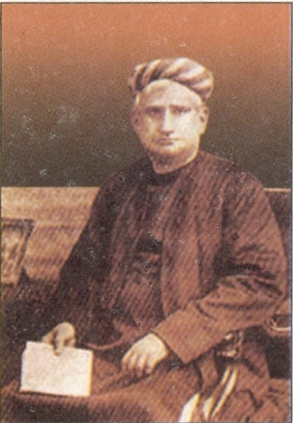
A) Bankim Chandra Chattarjee

B) Motilal Nehru

C) C. Rajagopalachari

D) None of these
80)

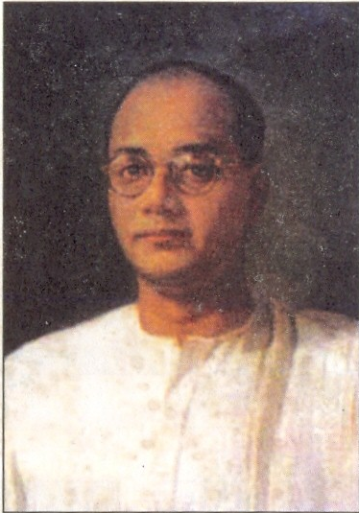
A) Bhagat Singh

B) Lala Lajpat Rai

C) Mangal Pandey

D) Subash Chandra Bose

81

A) Abraham Lincoln

B) George Washington

C) Roosevelt

D) Woodrow Wilson

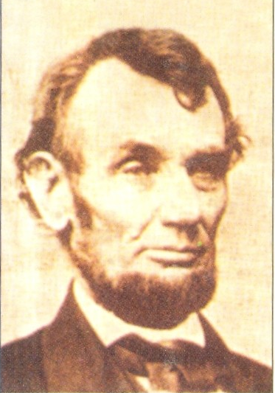

82

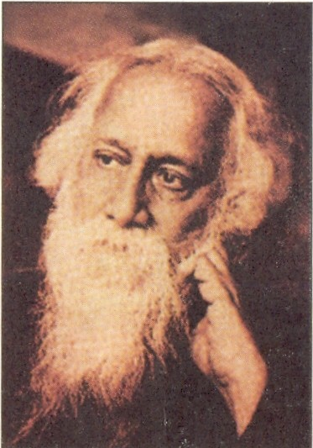
A) Bankim Chandra Chattarjee

B) Motilal Nehru

C) C. Rajendra Prasad

D) Rabindra Nath Tagore
83

84. Who is the captain of Indian Cricket team?
A) Mahendar Singh Dhoni B) Sachin Tendulkar
C) Virendar Sewag D) Anil Kumble
85. What is the duration of a football match?
A) 90 minutes B) 95 minutes
C) 60 minutes D) 120 minutes
86. How many playing members required in a hockey team?
A) 10 B) 9
C) 11 D) 12
87. Which on of the following is not a permanent member of UN Security Council?
A) France B) Italy
C) USA D) Italy
88. Name the king who invaded Delhi and plundered the ‘Kohinoor Diamond’
A) Nadir Shah B) Firuz Shah
C) Mohammad Ghori D) Mohammad Gazni
89. Who is the father of Indian constitution?
A) Dr. B R Ambedkar B) Rajendra Prasad
C) Jawaharlal Nehru C) Sardar Patel

90. An ‘Automatic Teller Machine’ (ATM) represents:
A) An online Banking System B) A fast Internet System
C) A voice recognition system D) None of these
91. The collection of numbers, alphabets, or some facts and numbers are called
A) Information B) Data
C) Values D) Numbers
92. First electronic computer was:
A) ENIAC B) EDSAC
C) Intel Pentium D) Apple
93. Which one of the following is not an input device?
A) OMR B) Joystick
B) Monitor D) Mouse
94. What is the expansion of WWW?
A) World Wide Web B) World Watch Web
C) World Wild Web D) None of these
95. What are the two epics of India
A) Rig-Veda, Bhagavat Gita B) Vedas, Upanishads
B) Ramayana and Mahabharata D) Ramayana and Bhagavat Gita
96. Who was the first prime minister of India?
A) Jawaharlal Nehru B) Rajendra Prasad
C) Sardar Patel D) V P Menon
97. Adolph Hitler was the ruler of which country?
A) Germany B) France
C) Italy D) Poland
98. Golden Temple situated in:
A) Jammu and Kashmir B) Assam
C) Delhi D) Himachal Pradesh
99. Which state of India is often called the heart of India?
A) West Bengal C) Uttar Pradesh
C) Madhya Pradesh D) Karnataka

100. Every year Teachers Day celebrated on
A) 5th October B) 5th November
C) 5th August D) 5th September

SPACE FOR ROUGH WORK

