NATIONAL TEACHERS COUNCIL

ALL INDIA TALENT SEARCH EXAMINATION

MODEL QUESTION PAPER

AITSE 0310

CLASS III

Duration: 1¹/₂ hours Maximum Marks: 100

General Instructions to Candidates

1. This question paper contains 100 multiple choice questions each of one mark.

2. The question paper is divided into two sections A and B

3. Section A is Scholastic Ability Test (SAT), contains 50 questions. This section covers Science, Mathematics and Social Science.

4. Section B is Mental Ability Test (MAT), Computer Awareness and General Knowledge, contains 50 questions.

5. There will be no negative marks for wrong answer.

6. A separate answer sheet is provided for answering the questions. Each question should be answered by darkening the appropriate circle (A, B, C, or D) with a blue or black ball pen.

7. Answer recorded once in the answer sheet cannot be altered.

8. All rough works should be done only in the space provided for rough work in this question paper.

9. Calculator is not permitted in the examination hall.

10. Candidate should write his / her name in the space provided for the purpose.
Name

SECTION A

1. Green plants prepare their own food in presence of sunlight. This process is called
A) Cooking B) Transpiration
C) Photosynthesis D) Self preparation
2. An instrument used to measure the amount of rain fall.
A) Rain guard B) Rain gauge
C) Thermometer D) Water gauge
3. The largest animal on the land
A) Blue Whale B) Elephant
C) Giraffe D) Lion
4. Birds like duck and swan can swim on water because they have
A) Streamlined body B) Light body
C) Webbed feet D) Flat beak
5. The part of the plant under the soil
A) Stem B) Leaf
C) Shoot D) Root
6. The inventor of Telephone
A) Graham Bell B) Alfred Nobel
C) Thomas Edison D) Issac Newton
7. Select the odd one
A) Deer B) Tiger
C) Rabbit D) Elephant
8. An ice cube is placed in a beaker containing water. The ice cube will
A) Float B) Sink
C) Evaporate D) None
9. Which is not a source of fresh water?
A) Pound B) Well
C) Bore well D) Ocean
10. Diseases spread from person to person in different ways. A disease spread by mosquitoes
A) Typhoid B) Swine flue
C) Dengue D) Cholera

11. Air is mixture of different gases. Which one is the major component of air?
A) Nitrogen B) Hydrogen
C) Oxygen D) Carbon dioxide
12. Various human activities bring down the quality of air. This is called air pollution.
` Which one of the following is a cause of air pollution?

A) Transport vehicles cause air pollution
B) Forest fire causes air pollution
C) Factories and industries cause air pollution
D) All the above
13. The top soil contains various substances needed for the growth of plants. But various natural
and man made activities removes this top soil. This process of removal of top soil is called
A) Soil formation B) Soil erosion
C) Soil flow D) Weathering
14. Our body has different organ system. Each one of them has a particular function to perform.
Which one of the organ system removes waste from our body?
A) Circulatory System B) Digestive System
C) Excretory System D) Nervous System
15. All living things breathe. We breathe through nose. Breathing organ of a fish is
A) Mouth B) Nose
C) Skin D) Gills
16. The natural satellite of the earth
A) Moon B) Sun
C) Aryabhatta D) Mars
17. Which one of the following is not a common characteristic of living things?
A) Living things reproduce B) Living things breathe
C) Living things move D) Living things grow
18. The largest gland in human body
A) Liver B) Kidney
C) Heart D) Typhoid
19. Select the unit of mass
A) Kilogram B) Gram
C) Milligram D) All these
20. The number of sense organ in our body
A) 3 B) 4
C) 5 D) 6
21. The place value of 5 in 625264 is
A) Five thousand B) Five thousand two hundred sixty four
C) Five hundred D) Thousand
22. 1 + 11 + 111 + 1111 =?
A) 11111 B) 4321
C) 1234 D) 1134
23. Write the fraction that is shaded
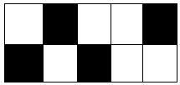

A) ⁴/₆ B) ¹⁰/₄
C) ⁶/₁₀ D) ²/₅
24. Ravi leaves for office at 9:30 am reaches home at 5:30 pm. How many hours he is away
from home?
A) 9 hrs B) 8 hrs
C) 4 hrs D) 5 hrs
25. The expanded form of 74806 is
(A) 70000 + 4000 + 80 + 6 B) 700000 + 4000 + 800 + 6
(C) 70000 + 4000 + 800 + 6 D) 70000 + 4000 + 8000 + 6

26. 14 + (6 + 18) = ( 14 + -------) + 18

A) 0 B) 18
C) 14 D) 6

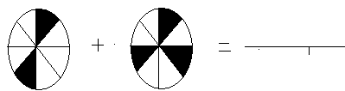27.

A) ⁵/₈ B) ¹¹/₈
C) ²/₈ D) ³/₈

28. A garden has 1300 herbs, 1640 shrubs and 200 trees. What is the total number of trees in the garden?
A) 2940 B) 3140
C) 3410 D) 3104
29. In a School there are 990 students. The number of boys in the school is 430. On a particular day 10 girls were absent in the school. The number of girls present in the school on that day is

A) 420 B) 550
C) 560 D) 980

30. Which is not the same as 6 X 4?
A) 6 + 6 + 6 + 6 B) 4 + 4 + 4 + 4 + 4 + 4
C) 8 x 3 D) 4 + 6
31. There are 196 marbles in a packet. These marbles are equally divided among 7 students. How many marbles each student get?
A) 28 B) 18
C) 1372 D) 189
32. One less than smallest 5 digit number
A) 99999 B) 9999
C) 9998 D) 10000
33. Which one is in order from smallest to greatest?

A) ¹/₈, ¹/₇, ¹/₆, ¹/₅, ¼ B) ¼, 1/₅, ¹/₆, ¹/₇, ¹/₈
C) ⁵/₈, ⁴/₈, ³/₈, ²/₈, ¹/₈ D) None of these
34. How many surfaces the following object has?

A) 1 B) 2
C) 3 D) Many
35. A closed figure made up of three line segments.
A) Circle B) Square
C) Rectangle D) Triangle
36. Rekha had Rs. 200 with her. She purchased a geometry box for Rs. 75.50, a pen for Rs. 22 and a
pencil for Rs. 3.25. How much money is left with her?
A) Rs. 110.25 B) Rs. 100.25
C) Rs. 99.25 D) Rs. 99.75
37. How many metres make 1 kilometre?
A) 1000 m B) 100 m
C) 10 m D) 0.001 m
38. 1241 X ………… = 1241
A) 0 B) 1
C) 1241 D) 0.1
39. A box of pencil has 12 pencils. What is the total number of pencils in 12 such boxes?
A) 12 B) 24
C) 144 D) 44
40. The difference between two numbers in zero. Then
A) One number is zero B) One number is zero
C) Both numbers are equal D) One is the reciprocal of other.
41. Who is the father of our country?
A) Gandhiji B) Subash Chandra Bose
C) Jawaharlal Nehru D) None of these
42. Jawaharlal Nehru also known as:
A) Chachaji B) Mahatma
C) Guruji D) Rajaji
43. Vande Mataram is India’s
A) National Anthem B) National Song
C) National Prayer D) None of these
44. Who is the Prime Minister of India
A) Sonia Gandhi B) Manmohan Singh
D) L K Advani C) Mira Kumar Sen
45. Which among the following is not an Indian river?
A) Krishna B) Ganga
C) Satlaj D) Nile
46. Which sea or ocean touches the coast of India?
A) Arabian Sea B) Pacific Ocean
C) Atlantic Ocean D) Red Sea
47. What do you see in the center of National Flag?
A) White colour B) Ashok Chakra
C) Charka D) Father of our Nation
48. What was the old name of Chennai
A) Madras B) Bangalore
C) Culcutta D) Sennai
49. The highest waterfalls in the world
A) Angel falls B) Jog falls
C) Niagara falls D) Jorhat
50. Lumbini is the sacred place of:
A) Muslims B) Christians
C) Hindus D) Buddhists

SECTION B

DIRECTIONS: (Q. No. 51 & 52) Find the odd one from the group.

51. A) Book B) Pen C) Pencil D) Watch

52. A) Second B) Minute C) Milligram D) Hour

53. The following table gives the price list of a cool bar. Name the items having highest
and lowest price.
Items | Ice-cream | Apple juice | Orange Juice | Lemon Juice | Fruit Salad
Cost | Rs. 10 | Rs. 16 | Rs. 14 | Rs. 6 | Rs. 18

A) Apple Juice & Lemon Juice B) Fruit Salad & Lemon Juice
C) Ice-Cream & Fruit Salad D) Fruit Salad & Orange Juice
54. Pinku is shorter than Anku and Anku is taller than Rinku. The tallest persons is
A) Anku B) Pinku
C) Rinku D) Both
55. After completing evening snakes, Tintu looked at clock. He saw hour hand between
4 and 5 and minute hand on 6. The time is
A) 4:30 am B) 5:30 am
C) 4:30 pm D) 5:30 pm
56. 22 + 22 + 22 = ------ X 22
A) 3 B) 2
C) 1 D) 0
57. If a mean +, b mean – and c mean X, then 8 c 5 a 10 b 4 is equal to
A) 116 B) 46
C) 50 D) 88

58. When a number passes through a box, a different number comes out. If 2 goes in
5 comes out, if 3 goes in 6 comes out, if 4 goes in 7 comes out.
If 5 go in, which number comes out?
A) 10 B) 9
C) 8 D) None of these.
59. 0 1, 1 2, 2 3, 3 4, ___.
A) 45 B) 56
C) 35 D) 36
60. 2, 12, 22, ___, 42
A) 30 B) 32
C) 34 D) 40

61. 4, 8, 16 ___, 64
A) 18 B) 24
C) 32 D) 36
62. AB, CD, EF, GH, ___, KL
A) IJ B) HI
C) GI D) JK
63. Z, X, V, T, R, ___.
A) Q B) P
C) S D) O
64. Boy walks 20m towards east and turns right and walks. In which direction he is walking?
A) East B) West
C) North D) South
65. The cost of one geometry box is equal to cost of four (4) pens. If cost of one pen is Rs.15. What is the cost of one geometry?

A) Rs. 15 B) Rs. 60
C) Rs. 40 D) Rs. 30
DIRECTIONS (Q. NO. 66 to 68) complete the series:

?
66.

?
67.

?
68.

DIRECTIONS (Q. No. 69 to 71) Identify the games/events

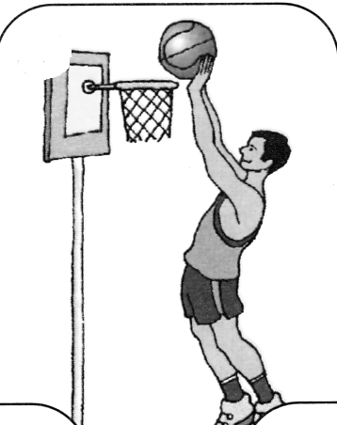
A) Volleyball

B) Basketball

C) Handball

D) Football

69.

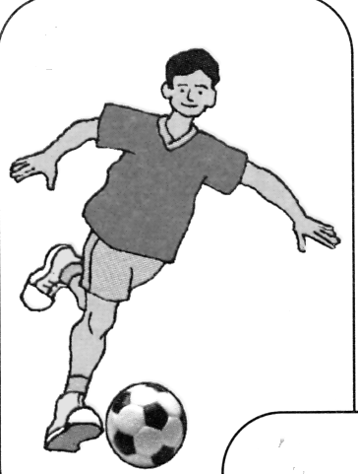
A) Volleyball

B) Basketball

C) Handball

D) Football

70

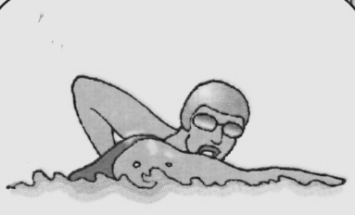
A) Swimming

B) Beach volleyball

C) Cycling

D) Basketball

71.

DIRECTIONS (Q. No. 72 to 74) Identify the flags
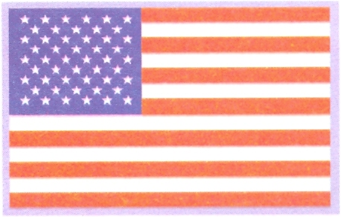
A) U S A
B) Britain
C) Canada
D) Australia

72

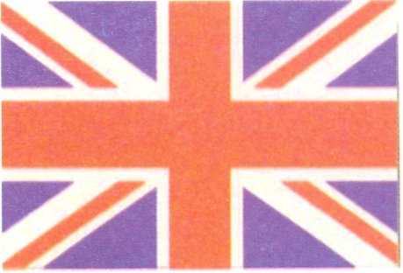
A) Sri Lanka
B) Britain
C) U S A
D) Singapore

73

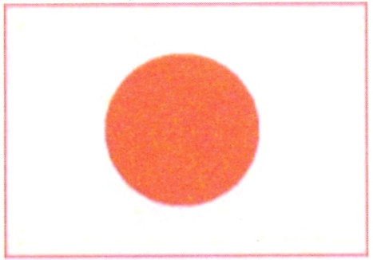
A) Pakistan
B) Malaysia
C) Spain
D) Japan

74

DIRECTIONS (Q. No. 75 to 77) identify the freedom fighters
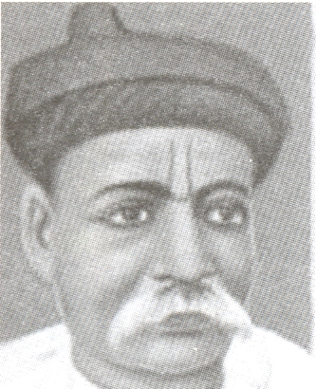
A) Bala Gangadhar Tilak
B) Lal Bahadur Shastri
C) Lala Lajpat Rai
D) Jawaharlal Nehru

75

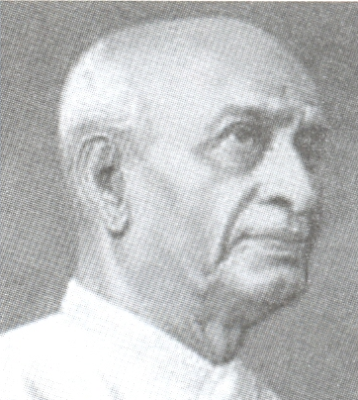
A) Rajendra Prassd
B) V K Menon
C) Raja Gopalachari
D) Sardar Patel

76

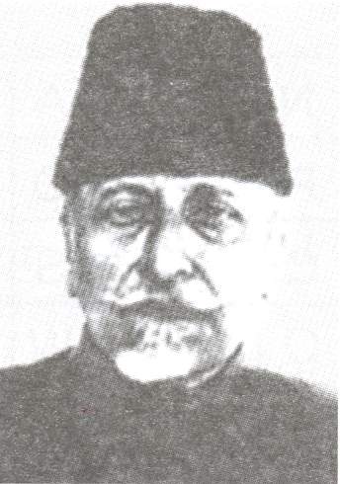
A) Andul Kalam Azad
B) Abdul Khan
C) Ali Brother
D) Bhagat Singh

77

DIRECTIONS (Q. No. 78 to 80) Identify the classical dances:
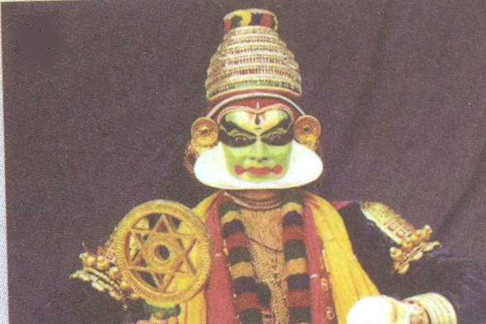
A) Krishnanattam
B) Mohiniattam
C) Kathakali
D) Kuchupudi

78.

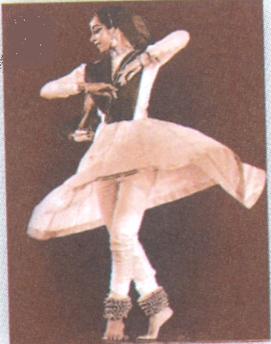
A) Mohiniattam
B) Kathak
C) Kuchupudi
D) Manipuri

79.

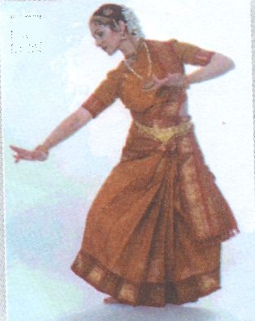
A) Krishnanattam
B) Mohiniattam
C) Bharatanatyam
D) Kuchupudi

80.

81. B. S. F stands for
A) Boarder Security Force B) Bharat Securty Force
C) Bharat Standard Force D) Bharat Seva Force
82. Anand Math is written by
A) Bakim Chandra Chatarjee B) Rabindra Nath Tagore
C) Arundati Roy D) Salman Rushdi
83. Which is the official language of Sri Lanka?
A) Hindi B) English
C) Sinhala D) Tamil
84. If you want to draw a picture in your computer you will draw in:
A) Paint B) Excel
C) Power Point D) Page Maker
85. In a computer system ‘monitor’ is
A) An input unit B) An out put unit
C) A central Processing Unit D) A software unit

86. Chennai Super Kings, Mumbai Indians, and Royal Challengers Bangalore are:
A) Cricket Teams B) Football Teams
B) Golf Clubs C) Volleyball Teams
87. Who is popularly known as ‘Master Blaster’?
A) Anil Kumble B) Rahul Dravid
C) Sachin Tendulkar D) Virendar Sewag
88. I M Vijayan was a famous:
A) Volleyball Player B) Football Player
C) Singer D) Film Star
89. The famous Tennis player Maria Sharapova represents
A) Australia B) Russia
C) Argentina D) Brazil
90. The prestigious award given annually by the academy of motion pictures.
A) Film fare B) Oscar
C) Star Film fare D) None of this
91. Who is known as father of English poetry?
A) Geoffrey B) Chaucer
C) Shakespeare D) Wordsworth
92. Which of the following is man made thing?
A) Coal B) Wood
C) Gold D) Plastic
93. The smallest Indian state
A) Goa B) Sikkim
C) Tripura D) Manipur
94. Who is the defense minister of India?
A) A K Antony B) P Chidambaram
C) Mamata Banarjee D) S M Krishna
95. Who is known as father of Indian Cinema?
A) Satyajit Ray B) Dada Saheb Phalke
C) Adoor Gopalakrishnan D) G. Aravindan
96. The Eiffel Tower is situated in which country?
A) France B) Germany
C) America D) Russia

97. The first woman prime minister of India.
A) Indhira Gandhi B) Sarojini Naidu
C) Sujeda Kripalini D) Jayalalita
98. Which is the largest planet in the Solar System?
A) Jupiter B) Venus
C) Saturn D) Neptune
99. Who is known as father of computers?
A) Edison B) Charles Babbage
C) Bill Gates D) James Watt

100. Teachers Day is celebrated on:
A) 5th September B) 5th November
C) 7th September D) 7th November

