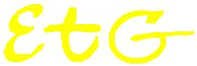
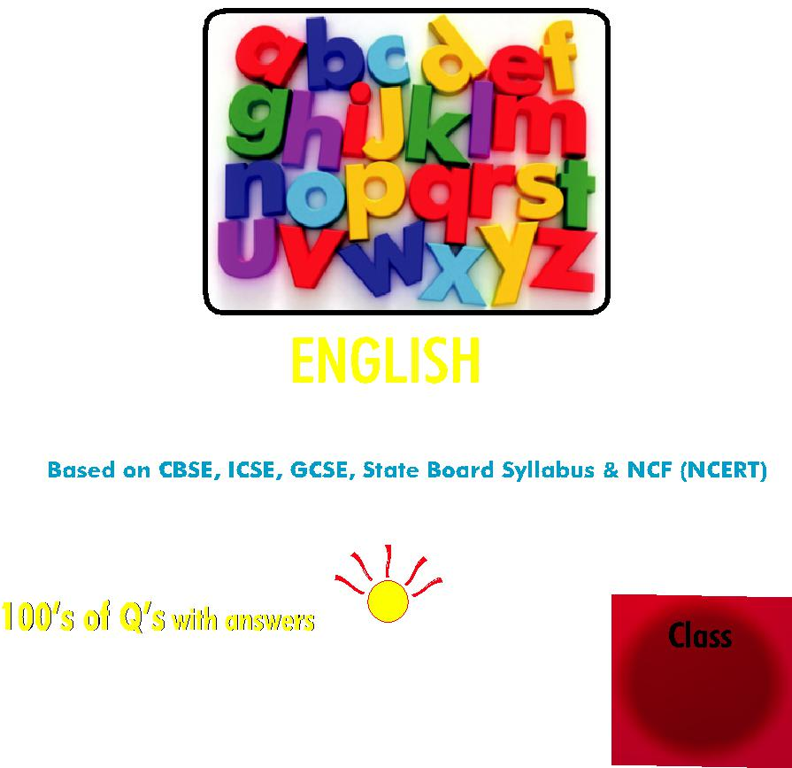

5
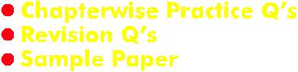

Contents

S.No. Chapters Page No.

1. Revision Questions 1

2. Correct Word 15

3. Preposition 24

4. General Questions 28

5. Tense 29

6. Odd One 39

7. Singular Plural 42

8. Pronoun 46

9. Noun 50

10. Conjunction 54

11. Adverb 58

12. Article 60

13. Synonyms 64

14. Antonyms 68

15. Comprehension 72

16. IEO Sample Paper 77

☺☺☺

^{iv} Olympiad Explorer

Based on CBSE, ICSE & GCSE Syllabus

& NCF guidelines devised by NCERT

Section I.

Comprehension l General topic l Story based.

Section II.

Knowledge l Classification l Analogy l Distinguishing between

real and imaginary l Distinguishing between fact and opinion l

Distinguishing through definition and example.

Section III.

Grammar l Sentences l Noun l Pronoun l Verb l Articles l

Preposition l Conjunction l Voice l Direct and indirect speech l

Antonym / Synonym l Elementary Idea of tenses l Jumbled

sentences.

Section IV.

Writing Skills l Story Construction l Essay Construction.

☺☺☺

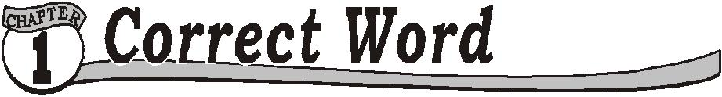
Use the correct word.
Q.1. | These ___ my books.
 | (a) | are | (b) | is
 | (c) | am | (d) | none of these
Q.2. | That __ a girl.
 | (a) | am | (b) | is
 | (c) | are | (d) | none of these
Q.3. | They __ coming on Sunday.
 | (a) | am | (b) | are
 | (c) | is | (d) | none of these
Q.4. | This __ my own book.
 | (a) | is | (b) | are
 | (c) | am | (d) | none of these
Q.5. | These ___ your boxes.
 | (a) | are | (b) | am
 | (c) | is | (d) | none of these
Q.6. | This__ my inkpot.
 | (a) | is | (b) | are
 | (c) | am | (d) | none of these
Q.7. | Those__ girls.
 | (a) | is | (b) | are
 | (c) | am | (d) | none of these
Q.8. | These ___ my boxes.
 | (a) | is | (b) | are
 | (c) | am | (d) | none of these
Q.9. | That __a black car.
 | (a) | was | (b) | were
 | (c) | am | (d) | none of these
Q.10. That__ my cat.
 | (a) | were | (b) | was
 | (c) | am | (d) | none of these
Q.11. | This ___my building.
 | (a) | were | (b) | is
 | (c) | am | (d) | none of these
Q.12. That__ a good decision taken by him.
 | (a) | were | (b) | was
 | (c) | am | (d) | none of these

2 |  |  | Olympiad Explorer
Q.13. They__ having a large bungalow.
(a) | were | (b) | was
(c) | am | (d) | none of these
Q.14. This __ my inkpot.
(a) | are | (b) | is
(c) | were | (d) | none of these
Q.15. They __ enjoying the food.
(a) | are | (b) | were
(c) | am | (d) | both (a) and (b)
Q.16. This___ an old car.
(a) | is | (b) | are
(c) | am | (d) | none of these
Q.17. This __ a tiger.
(a) | is | (b) | are
(c) | am | (d) | none of these
Q.18. That __ not a difficult phase.
(a) | are | (b) | am
(c) | was | (d) | none of these
Q.19. She __ a beautiful girl.
(a) | was | (b) | is
(c) | am | (d) | both (a) and (b)
Q.20. That __ a beautiful house.
(a) | is | (b) | was
(c) | were | (d) | both (a) and (b)
Q.21. These __boys.
(a) | are | (b) | am
(c) | is | (d) | none of these
Q.22. That___ a boy.
(a) | were | (b) | was
(c) | am | (d) | none of these
Q.23. That __ a car.
(a) | are | (b) | am
(c) | was | (d) | none of these
Q.24. There __ many boys in the class.
(a) | are | (b) | is
(c) | am | (d) | none of these
Q.25. These__ keys of my house.
(a) | is | (b) | are

Class ­ 5 |  |  | 3
(c) | am | (d) | none of these
Q.26. That __ not a tiger.
(a) | was | (b) | are
(c) | am | (d) | none of these
Q.27. They ___not in a position to handle it.
(a) | are | (b) | is
(c) | am | (d) | non of these
Q.28. That ___ not an aeroplane.
(a) | were | (b) | was
(c) | am | (d) | none of these
Q.29. Gold ___ a precious metal.
(a) | was | (b) | is
(c) | am | (d) | none of these
Q.30. There __ many islands.
(a) | are | (b) | is
(c) | am | (d) | none of these
Q.31. There ___ many reasons to celebrate this day.
(a) | am | (b) | are
(c) | is | (d) | none of these
Q.32. There ___ a little hope for this.
(a) | was | (b) | were
(c) | am | (d) | none of these
Q.33. There__ many women who were interested in cooking.
(a) | are | (b) | am
(c) | is | (d) | none of these

Q.34. There __ few important decisions which will be taken by me.

(a) | are | (b) | is
(c) | were | (d) | none of these
Q.35. They ___ very stingy.
(a) | am | (b) | are
(c) | is | (d) | none of these

Q.36. They ___ surprised when we reached to their place.

(a) was (b) were

(c) am (d) none of these

4 |  |  | Olympiad Explorer
Q.37. There __ much noise in the class.
(a) | were | (b) | are
(c) | was | (d) | none of these
Q.38. There are___ bags in the house.
(a) | much | (b) | many
(c) | was | (d) | none of these
Q.39. There was ___ work to do.
(a) some |  | (b) much
(c) | many | (d) | none of these
Q.40. There are ___ girls in the class.
(a) | many | (b) | much
(c) | some | (d) | both (a) and (c)
Q.41. He has ___ people who will be there in the distress.
(a) | much | (b) | many
(c) | few | (d) | none of these
Q.42. There was __ scope for improvement.
(a) many |  | (b) much
(c) | few | (d) | none of these
Q.43. There were ___ bags of sugar.
(a) much |  | (b) many
(c) | some | (d) | none of these
Q.44. Everyday she drank__ liters of milk.
(a) many |  | (b) much
(c) | more | (d) | none of these
Q.45. There are __ people in the house.
(a) much |  | (b) many
(c) | any of these | (d) | none of these
Q.46. There are __ books in the shelf.
(a) many |  | (b) much
(c) | more | (d) | none of these
Q.47. There is __ sugar in the pot.
(a) many |  | (b) more
(c) | much | (d) | none of these
Q.48. ___ a boys visited the temple.
(a) | Much | (b) | Many
(c) | More | (d) | None of these

Q.49. There are __ boys in the class.

Class ­ 5 |  |  | 5
(a) | many | (b) | much
(c) | more | (d) | none of these
Q.50. There is ___ milk in the tea­pot.
(a) | many | (b) | much
(c) | more | (d) | none of these
Q.51. There are___ people around her all the time.
(a) | much | (b) | many
(c) | more | (d) | none of these
Q.52. He has to take ___ sleep.
(a) | many | (b) | much
(c) | more | (d) | none of these
Q.53. I have ___ doubts in my mind.
(a) | many | (b) | much
(c) | more | (d) | none of these
Q.54. He has given____ pieces of advice.
(a) | many | (b) | much
(c) | more | (d) | none of these
Q.55. There are ___ pairs of sandals in the room.
(a) | many | (b) | much
(c) | more | (d) | none of these
Q.56. She will become____ independent now.
(a) | more | (b) | much
(c) | many | (d) | none of these
Q.57. She has ___commonsense.
(a) | more | (b) | much
(c) | many | (d) | none of these
Q.58. There are __ animals in the zoo.
(a) | many | (b) | more
(c) | much | (d) | none of these
Q.59. There was __ rain last night.
(a) | much | (b) | more
(c) | many | (d) | none of these
Q.60. He has done ___ acts of bravery.
(a) | much | (b) | more
(c) | many | (d) | none of these

6 |  |  | Olympiad Explorer
Q.61. I needed ___ sleep.
(a) | much | (b) | many
(c) | more | (d) | none of these
Q.62. There was__ fun last night.
(a) | many | (b) | more
(c) | much | (d) | none of these
Q.63. The utensil broke and there fell ___ grains.
(a) | many | (b) | much
(c) | more | (d) | none of these
Q.64. There are ___ clothes lying on the floor.
(a) | much | (b) | more
(c) | many | (d) | none of these
Q.65. There was ___ disturbance last night.
(a) | many | (b) | much
(c) | more | (d) | none of these
Q.66. There are __ birds in the cage.
(a) | much | (b) | more
(c) | many | (d) | none of these
Q.67. There were __ bottles in the freeze.
(a) | much | (b) | more
(c) | many | (d) none of these
Q.68. We ___ two scooters.
(a) | have | (b) | has
(c) | had | (d) both (a) and (c)
Q.69. This farmer ___ two bulls.
(a) | has | (b) | have
(c) | had | (d) both (a) and (c)
Q.70. I ____ two pencils.
(a) | has | (b) | have
(c) | had | (d) both (b) and (c)
Q.71. They __ three dresses.
(a) | have | (b) | had
(c) | has | (d) | both (a) and (b)
Q.72. I ___ two brothers.
(a) | had | (b) | has
(c) | have | (d) | none of these

Class ­ 5 |  |  | 7
Q.73. They ___ two brothers.
(a) | has | (b) | had
(c) | have | (d) | none of these
Q.74. They will ___ a house by now.
(a) | had | (b) | have
(c) | has | (d) | none of these
Q.75. They do ___ a right to say this.
(a) | has | (b) | have
(c) | had | (d) | none of these
Q.76. They ___ all the valuables with them.
(a) | has | (b) | have
(c) | had | (d) | none of these
Q.77. She ___ all the right to say this.
(a) | has | (b) | have
(c) | had | (d) | both (a) and (c)
Q.78. They all ___ a light arrangement.
(a) | has | (b) | have
(c) | had | (d) | none of these
Q.79. I ___ brought my book today
(a) | has | (b) | have
(c) | had | (d) | none of these
Q.80. She __a pencil.
(a) | has | (b) | have
(c) | had | (d) | both (a) and (c)
Q.81. I __ a pen but it is broken now.
(a) | has | (b) | have
(c) | had | (d) | none of these
Q.82. He ___black hair.
(a) | has | (b) | have
(c) | had | (d) | both (a) and (c)
Q.83. I ___ two uncles.
(a) | has | (b) | have
(c) | had | (d) | none of these
Q.84. The beggar ___ one leg.
(a) | has | (b) | have
(c) | had | (d) | none of these

Q.85. She ___ a car, but now she doesn’t have.

8 |  |  | Olympiad Explorer
(a) | has | (b) | have
(c) | had | (d) | none of these
Q.86. I___ no sister.
(a) | has | (b) | have
(c) | had | (d) | none of these.
Q.87. Do you___ a stole.
(a) has |  | (b) | have
(c) | had | (d) | none of these
Q.88. The blind doesn’t ___ eyes.
(a) has |  | (b) | have
(c) | had | (d) | none of these
Q.89. She ___ no complaints about this function.
(a) | has | (b) | have
(c) | had | (d) | none of these
Q.90. They ___ no electricity at home.
(a) has |  | (b) | have
(c) | had | (d) | none of these
Q.91. She ___ big eyes.
(a) has |  | (b) | have
(c) | had | (d) | none of these
Q.92. I____ two eyes and one nose.
(a) has |  | (b) | have
(c) | had | (d) | none of these.
Q.93. They do not ___ a large bungalow.
(a) has |  | (b) | have
(c) | had | (d) | none of these
Q.94. They will ___ a big garage by next month.
(a) | has | (b) | have
(c) | had | (d) | none of these
Q.95. This is a table. It ____ a large bridge.
(a) has |  | (b) | have
(c) | had | (d) | none of these
Q.96. They will not___ a drum.
(a) | has | (b) | have
(c) | had | (d) | none of these
Q.97. Our cow will ____ a big shelter.
(a) | has | (b) | have
(c) | had | (d) | none of these

Class ­ 5 |  |  | 9
Q.98. They ___ two cars.
(a) | has | (b) | have
(c) | had | (d) | both (a) and (c)
Q.99. They ___ a large piece of land, now they don’t have.
(a) | has | (b) | have
(c) | had | (d) | none of these
Q.100.She ___ a big jewellery box at home.
(a) | has | (b) | have
(c) | had | (d) | none of these
Q.101.He doesn’t____any friend.
(a) | have | (b) | has
(c) | had | (d) | none of these
Q.102.They ___ many toys at home.
(a) | have | (b) | has
(c) | had | (d) | none of these
Q.103.She ___ too many qualities to describe.
(a) | have | (b) | has
(c) | had | (d) | none of these

☺☺☺

ANSWERS

1. | (a) | 2. | (b) | 3. | (b) | 4. | (a) | 5. | (a) | 6. | (a) | 7. | (b) | 8. | (b)
9. | (a) | 10. | (b) | 11. | (b) | 12. | (b) | 13. | (a) | 14. | (b) | 15. | (d) | 16. | (a)
17. | (a) | 18. | (c) | 19. | (d) | 20. | (d) | 21. | (a) | 22. | (b) | 23. | (c) | 24. | (a)
25. | (b) | 26. | (a) | 27. | (a) | 28. | (b) | 29. | (b) | 30. | (a) | 31. | (b) | 32. | (a)
33. | (a) | 34. | (a) | 35. | (b) | 36. | (b) | 37. | (c) | 38. | (b) | 39. | (b) | 40. | (d)
41. | (b) | 42. | (b) | 43. | (b) | 44. | (a) | 45. | (b) | 46. | (a) | 47. | (c) | 48. | (b)
49. | (a) | 50. | (b) | 51. | (b) | 52. | (b) | 53. | (a) | 54. | (a) | 55. | (a) | 56. | (a)
57. | (b) | 58. | (a) | 59. | (a) | 60. | (c) | 61. | (a) | 62. | (c) | 63. | (a) | 64. | (c)
65. | (b) | 66. | (c) | 67. | (c) | 68. | (d) | 69. | (d) | 70. | (d) | 71. | (d) | 72. | (c)
73. | (c) | 74. | (b) | 75. | (b) | 76. | (b) | 77. | (d) | 78. | (b) | 79. | (b) | 80. | (d)
81. | (c) | 82. | (d) | 83. | (b) | 84. | (a) | 85. | (c) | 86. | (b) | 87. | (b) | 88. | (b)
89. | (a) | 90. | (b) | 91. | (a) | 92. | (b) | 93. | (b) | 94. | (b) | 95. | (a) | 96. | (b)
97. | (b) | 98. | (d) | 99. | (c) | 100.(a) |  | 101.(a) |  | 102.(a) |  | 103.(b)

☺☺☺

Use the correct preposition:
Q.1. | I will come___ Sunday.
 | (a) | on | (b) | in
 | (c) | during | (d) none of these
Q.2. | We came here___2003.
 | (a) | in | (b) | on
 | (c) | at | (d) | none of these
Q.3. | He met many people ___ her stay here.
 | (a) | in | (b) | during
 | (c) | on | (d) | none of these
Q.4. | She was sitting __ her room.
 | (a) | in | (b) | at
 | (c) | on | (d) | none of these
Q.5. | She went ___ the room.
 | (a) | into | (b) | on
 | (c) | at | (d) | none of these
Q.6. | He lives__ England.
 | (a) | at | (b) | in
 | (c) | on | (d) | none of these
Q.7. | He went___ the classroom.
 | (a) | into | (b) | to
 | (c) | at | (d) | none of these
Q.8. | My brother lives___ R.K. Puram.
 | (a) | at | (b) | or
 | (c) | in | (d) | none of these
Q.9. | I reached home__ 20 minutes.
 | (a) | at | (b) | on
 | (c) | within | (d) | none of these
Q.10. They live___ a bungalow.
 | (a) | at | (b) | or
 | (c) | in | (d) | none of these
Q.11. I go to school __ bus.
 | (a) | by | (b) | in
 | (c) | at | (d) | none of these
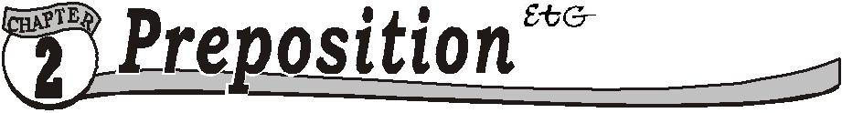

Q.12. The ball fell___ the well.

Class ­ 5 |  |  | 11
(a) | by | (b) | into
(c) | on | (d) | none of these
Q.13. He went__ Delhi to Nagpur.
(a) | for | (b) | from
(c) | to | (d) | none of these
Q.14. He got___ his horse.
(a) | of | (b) | off
(c) | in | (d) | none of these
Q.15. He got ___ his bicycle.
(a) | on | (b) | in
(c) | onto | (d) | none of these
Q.16. The child fell ___his scooter.
(a) | for | (b) | from
(c) | in | (d) | none of these
Q.17. I am looking ___ my book.
(a) | to | (b) | for
(c) | from | (d) | none of these
Q.18. Please listen___ me.
(a) | to | (b) | for
(c) | from | (d) | none of these
Q.19. Please keep this book __ the almirah.
(a) | in | (b) | on
(c) | at | (d) | none of these
Q.20. He had no place__ go.
(a) | to | (b) | at
(c) | in | (d) | none of these
Q.21. I agreed __ his proposal.
(a) | at | (b) | on
(c) | to | (d) | none of these
Q.22. The pen is __ write with.
(a) | to | (b) | on
(c) | at | (d) | none of these
Q.23. He had __ go home early.
(a) | at | (b) | on
(c) | to | (d) | none of these
Q.24. ___ what were you talking?
(a) | At | (b) | About
(c) | On | (d) | None of these

12 |  |  | Olympiad Explorer
Q.25. The cow is ___ the tree.
(a) | behind | (b) | at
(c) | on | (d) | none of these
Q.26. My uncle left __ noon.
(a) | in | (b) | on
(c) | at | (d) | none of these
Q.27. I agreed__ his idea.
(a) | to | (b) | in
(c) | at | (d) | none of these
Q.28. Please listen__ me.
(a) | at | (b) | in
(c) | to | (d) | none of these
Q.29. I thought ___ his proposal.
(a) | at | (b) | in
(c) | over | (d) | none of these
Q.30. I agreed __ his view.
(a) | to | (b) | on
(c) | at | (d) | none of these
Q.31. They made fun___ the poor old man.
(a) | on | (b) | in
(c) | of | (d) | none of these
Q.32. I have to write ___ a pen.
(a) | at | (b) | with
(c) | to | (d) | none of these
Q.33. He had no idea ___ convey.
(a) at |  | (b) | on
(c) | to | (d) | none of these
Q.34. She had nothing ___ fall upon.
(a) | to | (b) | at
(c) | on | (d) | none of these
Q.35. He has great desire ___ fame.
(a) | at | (b) | on
(c) | for | (d) | none of these
Q.36. This book is __ much use.
(a) | of | (b) | at
(c) | in | (d) | none of these
Q.37. My mother has great pity ___ poor.
(a) | of | (b) | for

Class ­ 5 |  |  |  |  |  |  |  |  |  |  |  |  |  |  | 13
 |  |  | (c) | in |  |  |  |  | (d) | none of these
Q.38. My aunty will be coming ___ the afternoon.
 |  |  | (a) | at |  |  |  |  | (b) | in
 |  |  | (c) | of |  |  |  |  | (d) | none of these
Q.39. Don’t be a slave __ your body.
 |  |  | (a) | to |  |  |  |  | (b) | on
 |  |  | (c) | at |  |  |  |  | (d) | none of these
Q.40. Ria had no taste__ music.
 |  |  | (a) | in |  |  |  |  | (b) | into
 |  |  | (c) | for |  |  |  |  | (d) | none of these
Q.41. He is no match __ me.
 |  |  | (a) | at |  |  |  |  | (b) | in
 |  |  | (c) | for |  |  |  |  | (d) | none of these
Q.42. I have great respect ___ my parents.
 |  |  | (a) | at |  |  |  |  | (b) | in
 |  |  | (c) | for |  |  |  |  | (d) | none of these
Q.43. I use to come here ___my work.
 |  |  | (a) | at |  |  |  |  | (b) | on
 |  |  | (c) | for |  |  |  |  | (d) | none of these
Q.44. Hard work is the key__ success.
 |  |  | (a) | in |  |  |  |  | (b) | at
 |  |  | (c) | to |  |  |  |  | (d) | none of these
 |  |  |  |  |  |  |  | ☺☺☺
 |  |  |  |  |  |  | ANSWERS
1. |  | (a) | 2. | (a) | 3. | (b) | 4. | (a) | 5. | (a) | 6. | (b) | 7. (a) | 8. | (a)
9. |  | (c) | 10. (c) |  | 11. | (a) | 12. | (b) | 13. | (b) | 14. | (b) | 15.(c) | 16. | (b)
17. (b) |  |  | 18. (a) |  | 19. | (a) | 20. | (a) | 21. | (c) | 22. | (a) | 23.(c) | 24. | (b)
25. (a) |  |  | 26. (c) |  | 27. | (a) | 28. | (c) | 29. | (c) | 30. | (a) | 31.(c) | 32. | (b)
33. (c) |  |  | 34. (a) |  | 35. | (c) | 36. | (a) | 37. | (b) | 38. | (b) | 39.(a) | 40. | (c)
41. (c) |  |  | 42. (c) |  | 43. | (c) | 44. | (c)

☺☺☺

Time : 40 min Question : 25

Direction: Read the passage and answer the Q.1 to Q.5

One day a kind butcher gave a large piece of bone to a hungry dog.

As he was passing by a bridge, he looked into the stream. He saw a

dog with a large piece of bone in his mouth in the stream. He was

not aware that it was his own reflection. He thought that it was

another dog with a piece of bone. He became greedy and thought

of taking it from that dog, with such thoughts the dog barked loudly.

There was no reply to his barking only a loud splash. He lost his

bone in the water, so he became sad and hungry.

Q.1. | What should be the correct title for the story?
 | (a) greed is curse. | (b) | the dog in the stream
 | (c) reflection | (d) | none of these
Q.2. | What is the correct moral of the story?
- be contented with what you have.

- greed is curse.

- if you have one you should not ask for more.

- none of these

Q.3. From where did the dog get the bone?

(a) | road | (b) | jungle
(c) | a kind butcher | (d) none of these
Q.4. What did he saw in the stream?
(a) | his own reflection. | (b) | another dog
(c) | a cat | (d) none of these
Q.5. Tick the antonym of ‘danger’.
(a) | safety | (b) | annual
(c) | begin | (d) none of these

Q.6. Who is this famous personality?
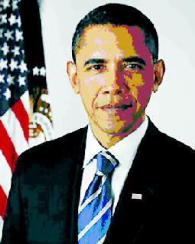

(a) Abdul Kalam (b) Barrack Obama

(c) Manmohan Singh (d) none of these

78 Olympiad Explorer

Q.7. Tick the right synonym for the word ‘accuses’.

(a) blame (b) afraid

(c) certain (d) none of these

Q.8. Fill with the right articles. “___iron is more useful than __gold”.

- the, an

- an, the

- a, an

- none of these

Q.9. What is the opposite gender for ‘madam’?

(a) madam (b) sir

(c) mistress (d) none of these

Q.10. What is the name of the famous building?
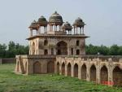

(a) Taj Mahal (b) Hawa Mahal

(c) Jal Mahal (d) none of these

Q.11. Fill in with the right preposition “I prefer milk __ tea.”

(a) | than | (b) | from
(c) | to | (d) | none of these
Q.12. What is the masculine of ‘lady’?
(a) | gentleman | (b) sister
(c) | girl | (d) | none of these
Q.13. What is the singular form of ‘bodies’?
(a) | lady | (b) | baby
(c) | body | (d) none of these

Q.14. The name of a person, thing or place is called­

(a) noun (b) collective noun

(c) verb (d) none of these

Q.15. Tick the word that does not belong to the group­

(a) building (b) mountain

(c) Delhi (d) none of these

Q.16. A group of words that makes sense, but not complete sense is called a ­

(a) sentence (b) phrase

(c) verb (d) none of these

Class ­ 5 | 79

Q.17. Put the abstract noun to fill in the blanks­ “We get useful ___from books.”

(a) knowledge |  | (b) laughter
(c) | seen | (d) none of these
Q.18. What is the correct rhyming word for” near”?
(a) | dear | (b) | mall
(c) | tall | (d) | none of these

Q.19. ‘I will buy some mangoes.’ Here some indicates­

(a) an adjective (b) verb

(c) noun (d) pronoun

Q.20. Solve the riddle

“The poor have two, the rich have none,

Millions have one, and you too have one, what am I?

(a) money (b) alphabet “o”

(c) property (d) none of these

 |  |  | INTERACTIVE SECTION
Answer questions based on the figure.
Here is Sir Isaac |  |  |  |  |  | He is sitting ___Q.21__ ____
Newton, the great |  |  |  |  |  | apple tree.
man of science. Newton had |  |  |  |  |  | It is the year 1666.
a great mind.
 |  |  |  |  |  | ___Q.22___ are apples which
 |  |  |  |  |  | are _____ his head.
 |  |  |  |  |  | The seat has three legs.
Here is an apple __Q.23____ |  |  |  |  |  | The apple came down the
was _____ his head. |  |  |  |  |  | branch.
The apple was_Q.24_ a
branch of the tree.
 |  |  |  |  |  | It came down _Q.25_
 |  |  |  |  |  | Newton’s head
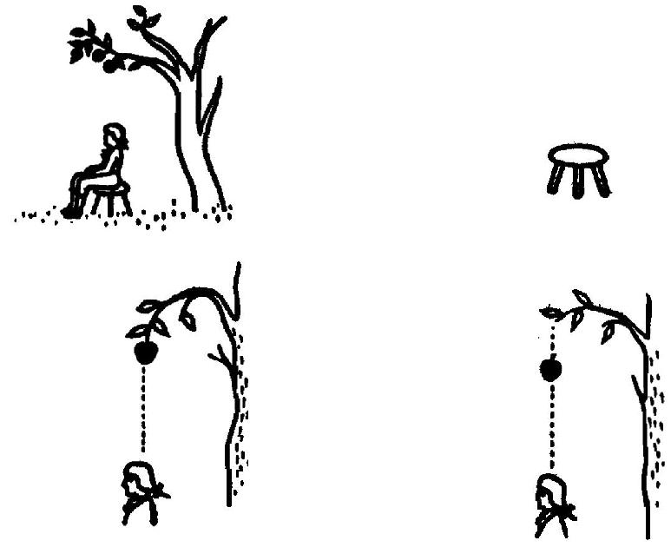

80 |  |  | Olympiad Explorer
Q.21. He is sitting ________ apple tree.
(a) | Beside, a | (b) | Under, an
(c) | Under, a | (d) | None of these
Q.22. _________ are apples which are _________ his head.
(a) | That, above | (b) | This, over
(c) | Those, over | (d) | None of these
Q.23. Here is an apple ______ was ______ his head.
(a) | That, below | (b) | Which, over
(c) | Which, below | (d) | None of these
Q.24. The apple was _________ a branch of a tree.
(a) | On | (b) | Off
(c) | Over | (d) | None of these
Q.25. It came down _________ Newtons head.
(a) | On | (b) | Off
(c) | Over | (d) | None of these

☺☺☺

ANSWERS

1. (a) 2. (a) 3. (c) 4. (a) 5. (a) 6. (b) 7. (a) 8. (b)

- (b) 10. (c) 11. (a) 12. (a) 13. (c) 14. (a) 15. (d) 16. (b)

- (a) 18. (a) 19. (a) 20. (b) 21. (b) 22. (c) 23. (b) 24. (a)

- (a)

☺☺☺

