NATIONAL TEACHERS COUNCIL

ALL INDIA TALENT SEARCH EXAMINATION

MODEL QUESTION PAPER

AITSE 1010

CLASS X

Duration: 1¹/₂ hours Maximum Marks: 100

General Instructions to Candidates

1. This question paper contains 100 multiple choice questions each of one mark.

2. The question paper is divided into two sections A and B

3. Section A is Scholastic Ability Test (SAT), contains 50 questions. This section covers Science, Mathematics and Social Science.

4. Section B is Mental Ability Test (MAT), Computer Awareness and General Knowledge, contains 50 questions.

5. There will be no negative marks for wrong answer.

6. A separate answer sheet is provided for answering the questions. Each question should be answered by darkening the appropriate circle (A, B, C, or D) with a blue or black ball pen.

7. Answer recorded once in the answer sheet cannot be altered.

8. All rough works should be done only in the space provided for rough work in this question paper.

9. Calculator is not permitted in the examination hall.

10. Candidate should write his / her name in the space provided for the purpose.
Name

SECTION A

1. An instrument used for measuring electric current
A) Ammeter B) Voltmeter
C) Galvanometer D) Manometer
2. How many 110ohm resistors in parallel are required to carry 10A on a 220V?
A) 22 B) 11
C) 10 D) 5
3. Critical angle of light passing from glass to air is maximum for
A) Red B) Violet
C) Yellow D) Green
4. Signals of danger are made in red because
A) Scattering is minimum for red B) Scattering is maximum for red
C) Our eye is most sensitive to red colour D) Red colour is internationally accepted for
danger
5. An electric bulb is rated 220V and 100W. Power consumed by it when operated on 110V is
A) 90 W B) 75 W
C) 50 W D) 25 W
6. A man going on straight road covers half distance with velocity V₁ and rest half distance with
velocity V₂. The average will be
A) V₁ + V₂ B) 2 V₁ V2
2 V₁ + V₂
C) √ V₁ V2 D) √ V₁ V2
7. Resistance of a wire of uniform thickness is ‘R’. The wire is cut in five equal pieces and
connected in parallel. Ratio of initial and final resistance will be
A) 1 : 25 B) 5 : 1
C) 1 : 5 D) 25 : 1
8. At the time of sun set the sun seemed to be
A) Lower than its actual position B) At its actual position
C) Higher than its actual position D) None of these
9. Four resistors of resistance 6.4 ohms, 0.8 ohms, 1.2 ohms and 0.6 ohms are connected in
series with 9 V battery. The current through 1.2 ohm resistor is
A) 1 A B) 0.1 A
C) 7.4 A D) 0.74 A

10. The heater element in an electric iron is made of
A) Copper B) Tungsten
C) Iron D) Nichrome

11. The gas used in the manufacture of Vanaspati from vegetable oil is
A) Hydrogen B) Oxygen
C) Nitrogen D) Carbon dioxide
12. In the following reaction which one is precipitate?
Na₂SO₄ + BaCl₂ 2 NaCl + BaSO₄
A) Na₂SO₄ _{B)} BaCl₂
C) NaCl D) BaSO₄
13. Which of the following can be used to test the P^{H} of a neutral solution?
A) Red litmus B) Blue litmus
C) Universal indicator D) Phenolphthalein
14. Two or more compounds which have the same number of the same kind of atoms are called
A) Isomers B) Isotopes
C) Isobars D) Polymers
15. The number of electrons present in the outermost shell of the halogen is
A) 4 B) 0
C) 7 D) 2
16. Which one of the following compounds gives oxygen on heating?
A) Mercuric Oxide B) Copper Oxide
C) Zinc Oxide D) Aluminium Oxide
17. The formula of oxide and chloride of an element ‘X’ is X₂O and XCl respectively.
Then which one of the following compound is not formed by the element X?
A) XHCO₃ B) X (OH) ₂
C) X₂CO₃ D) X₂SO₄
18. A select a sweet smelling compound from the following.
A) CH₃CH₂CH₂OH B) CH₃CH₂X
C) CH₃CH₂COOH D) CH₃COOC₂H₅
_{19.} Choose the odd element out.
A) Calcium B) Potassium
C) Strontium D) Magnesium
20. Which of the following is produced in pure form in reaction of sugar with Sulphuric acid?
A) Carbon B) Water
C) Oxygen D) Hydrogen
21. People are likely to suffer a cerebral hemorrhage if they have:
A) Nervous Weakness B) Low blood pressure
C) High blood pressure D) Weak bones
22. In the experiment demonstrating respiration in germinating seeds KOH is used to
A) Absorb CO₂ produced by seeds B) Absorb O₂ present in flask
C) Absorb water vapour released by the seeds D) LiberateO₂ to be used by the seeds
23. All of the following diseases are caused by Virus except
A) Jaundice B) Influenza
C) Typhoid C) Mumps
24. The transgenic animals are those which have
A) Foreign DNA in some of their cells B) Foreign DNA in all of their cells
C) Foreign RNA in all of their cells C) Both (A) and (C)
25. During the process of photosynthesis the weight of the plants
A) Does not change B) Increases
C) Decreases D) None of the above
26. A circle is inscribed in an equilateral triangle and a square is inscribed in the circle.
The ratio of the area of triangle to that of the square is
A) √3: 1 B) √3: √2
C) 3√3: 2 D) 3√3: √2
27. A coin is tossed 100 times and head appears 72 times. The probability of getting a tail is
A) 18 B) 7
25 25
C) 14 D) 1
50
28. The value of k for which both the equations x² + kx + 64 = 0 and x² – 8x +k = 0
have equal roots is
A) 4 B) 8
C) 12 D) 16
29. The diameter of a wheel of a bus is 140cm. The number of revolutions the wheel will
make in one minute to keep the speed of the bus 66 Km/h is
A) 300 B) 250
C) 125 D) 100
30. Which of the following is not a rational number?
A) √2 B) √4
C) √9 D) √16
31. A toy train moving with constant speed crosses 210m and 122m long tunnels in 25 and
17 seconds respectively. The length of the train is
A) 11m B) 65m
C) 332m D) 88m
32. The number of numbers which have 2, 3, 4, 5, 6 as factors between 1 and 1000 is
A) 200 B) 50
C) 36 D) 16
33. The point (2, -3) belong to quadrant
A) Q1 B) Q2
C) Q3 D) Q4
34. The angle of depression of an object from a tower of height 150m is 30º.
Then the distance of the object from the tower is
A) 50√3 m B) 100√3 m
C) 150 √3 m D) None
35. Two participant in Olympic shooting competition, A and B can hit a target 3 times in 6 shorts
and 2 times in 6 shorts respectively. When both A and B aim the targets, what is the
probability that both of them hit this target?
A) 1/3 B) 5/6
C) 1/6 D) 3 / 4
36. In India population density is defined as the number of person:
A) Per square kilometer
B) Per ten thousand kilometer
C) Per thousand square kilometer
D) Per lakh square kilometer

37. Who gives recognition to Political parties in India
A) Parliament B) Election Commission
C) President D) None of these

38. Out of the following statement which is correct related to World Bank
i. It is also known as IBRD
ii. It is established in 1944
iii. America has a strong influence in this Bank
iv. It is established in Britain

A) i ii, iii B) I, iii, iv
C) I, ii D) All are correct

39. Who is known as father of modern economics?
A) John Maynard Keynes B) Adam Smith
C) Ricardo D) None of this

40. The two persons who played a vital role in the integration of princely states were:
A) Sardar Patel and Jawaharlal Nehru
B) Sardar Patel and V.P. Menon
C). Sardar Patel and Rajendra Prasad
D) Sardar Patel and K M Munshi

41. President of India Cannot:
A) Summon the Parliament B) Dissolve the Parliament
C) Address the Parliament D) Be a member of Parliament

42. January 26 selected as the date for the implementation of the constitution, because
- It was considered as auspicious day
- On that day Quit India movement was started
- The congress had observed it as the independence day
- On that day constitution assembly was appointed

43. Chocolate can be bad for health because of a high content of:
A) Cobalt B) Nickel
B) Zinc D) Lead

44. . Which of the following industries is most developed in the Great lakes of North America?
A) Cement and Paper B) Steel and Engineering
C) Film Industry D) Textile and Chemical Industry

45. What is the population density of a district which has 50 lakh people and 25 thousand
Sq. km. areas?
A) 50 person per sq. km. B) 100 person per sq. km.
C) 150 person per sq. km. D) 200 person per sq. km.

46 . For the production of wheat there should be:
A) Cool and wet climate during its growing period,
B) Sufficient heat and heavy rainfall
C) Hot climate during growing period
D) None of these

47. . The Panama canals shorten the distance between:
A) The Atlantic Ocean and the Mediterranean Sea
B) The Red sea and Arabian Sea
C) The Pacific and Atlantic Ocean
D) The Atlantic Ocean and Indian Ocean

48. Who is regarded as political Guru of Gandhiji?
A) Rabindra Nath Tagore B) Gopal Krishna Gokhale
C) Auraabindo D)Vinoba Bhave

49. Which one of the following Article provide ‘Right to Equality’
A) Article 14 B) Article 15
B) Article 15 C) Article 16

50. What was the real objective of the partition of the Bengal:
A) Create division among the ranks of Indian nationalist
B) Stop the tide of nationalism in Bengal
C) Better administration in Bengal
D) None of these

SECTION B

DIRECTIONS: (Q. No 51 to 53) In each of these questions, a related pair of word is followed by
four pairs of word. Select the pair that best expresses a relationship similar
to the one expressed in the original pair.
51. Steam : Locomotive ::
A) Water : Boat B) Sea : Ship
C) Petrol : Car D) Alcohol : Man
52. Company : Department ::
A) Sea : Ocean B) Hub : Wheel
C) Milk : Butter D) Book : Chapter
53. Kilometer : Distance ::
A) Weight : Kilogram B) Thermometer : Temperature
C) IQ : Intelligence D) Time : Hour

DIRECTIONS: (Q. No 54 to 56) some of the letters or numbers are missing in the given sequence.
Find out the one correct answer among the given alternatives.
54. - - a a b – a – a – ba
A) bbaba B) ababa
C) bbabb D) baaaa
55. DGK 0, GKP 3, - - - -, PVC 15
A) GKV 5 B) KPV 8
C) PVZ 9 D) PPU 11
56. 0, 3, 8, 15, 24, 35, 48, ___
A) 63 B) 56
C) 55 D) 51
57. If MATHEMATICS is coded as 12345123678, then MAHATHMA = _____________.
A) 12423412 B) 12345123
C) 12422412 D) 12425341
58. In a certain code EVEREST is coded as TSEREVE then REDFORT is coded as
A) TOFRDER B) TDERF
C) TROFDER D) FOTRDR

59. Reshmi is Ram’s mother’s daughter’s daughter. What is her relationship to Ram?
A) Aunt B) Daughter in law
C) Friend D) Niece

60. See through a mirror, the arms of a clock show 9:30. What is the actual time?
A) 3:30 B) 6:30
C) 2:30 D) 6:10

DIRECTIONS: (Q. No 61 to 63) Find out the odd one from the given set of four alternatives
61. A) Stop B) Red
C) Break D) Phone

62. A) London B) New York
C) Delhi D) Dhaka

63. A) 144 B) 289
C) 312 D) 625

64. Four boys A, B, C, and D are upon the ladder. A is further up the ladder than B. B is between
A and C. If D is further up than A, Who is the third from the bottom?
A) Boy B B) Boy C
C) Boy A D) Boy D
65. How many 5 are such in the following series which are followed by 4 but 6 should not come
before them?
A) One B) Two
C) Three D) Four

DIRECTIONS ( Q. No.97 to 71): Study the following table and answer the questions given below it
Number of students appeared and qualified in five subjects over the year

Year | English |  | Mathematics |  | Geography |  | History |  | Science
 | Appeared | Qualified | Appeared | Qualified | Appeared | Qualified | Appeared | Qualified | Appeared | Qualified
2001 | 196 | 84 | 250 | 35 | 160 | 42 | 140 | 30 | 150 | 40
2002 | 212 | 34 | 160 | 30 | 212 | 50 | 150 | 40 | 160 | 35
2003 | 160 | 40 | 180 | 45 | 115 | 35 | 210 | 60 | 170 | 45
2004 | 190 | 35 | 250 | 60 | 180 | 60 | 240 | 70 | 185 | 50
2005 | 200 | 47 | 300 | 140 | 200 | 70 | 260 | 80 | 190 | 55

67. In which subject was there a continuous increase in both number of students appeared and
qualified over the years:
A) English B) Geography
C) Science D) History

68. In Which year the number of students qualified in mathematics was 25% of the number of
students appeared in the same subject.
A) 2003 B) 2002
C) 2001 D) 2005

69. What was the percentage increase in number of students appeared from 2001 to 2005
A) 25 B) 50
C) 20 D) 40

70. What was the percentage of qualified students to those appeared in English in the year 2003
A) 40 B) 25
C) 30 D) 20

71. In which year the number of student in History was to honored percentage of the n umber
of students qualified in English in the same year.
A) 2001 B) 2002
C) 2003 D) None of these

Directions ( Question number 72 to 76 ) Find the related figure from given alternatives

Problem figure Answer figure

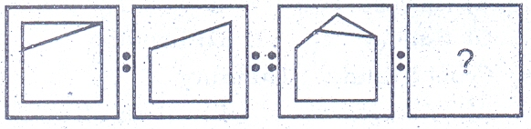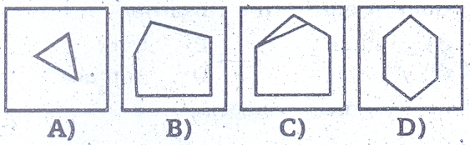
72

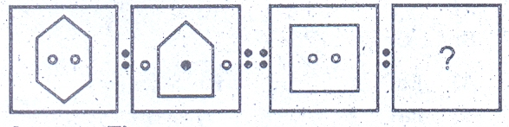
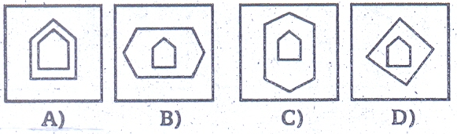
B
A
D
C
73

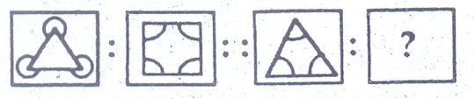
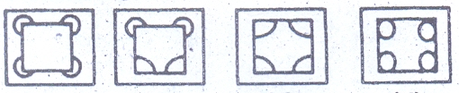
B
C
D
A
74

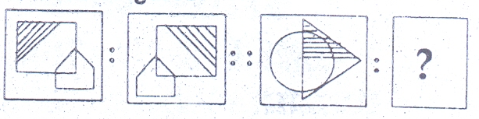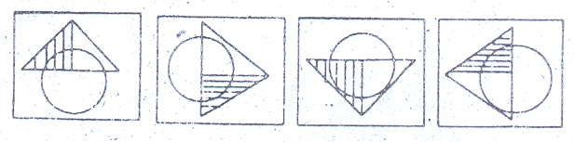
75
D
C
B
A

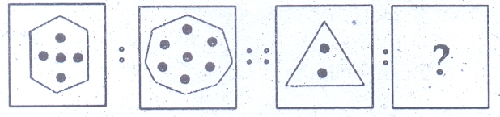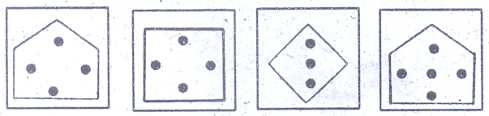
76
D
C
B
A

Directions( ) choose one out of the four small squares A,B,C and D that makes the complete pattern in the bigger square.

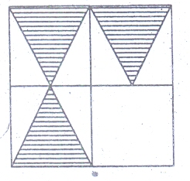
77
A
B
C
D
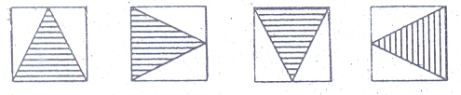

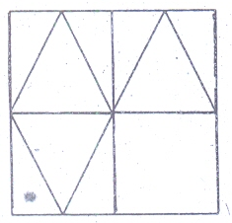
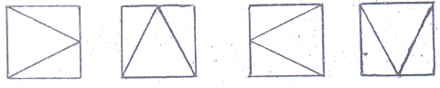
78
B
A
D
C

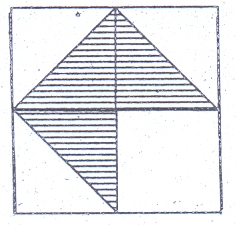
79
D
B
A
C
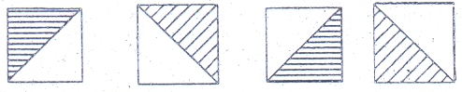

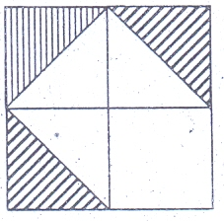
A
C
D
B
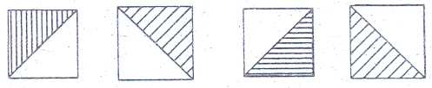
80

81. Who adopted the constitution of India on 26th November, 1949?
A) People of India B) Parliament of India
C) Constituent assembly D) President of India

82. What is the full form of USB as used in the computer related activities?
A) Universal Security block
B) Ultra Serial Block
C) Universal Serial Bus
D) None of these

83. . ‘CD’ computer abbreviation usually means.
A) Change Data B) Copy data
C) Compact Disc D) Command Description

84. ‘JPG’ extension refers usually to what kind of file?
A) System File B) Animation file
C) Audio File D) Image file

85. A form of audio broadcasting using the internet is called:
A) Pod Casting B) Telecasting
C) Audio broadcasting D) None of these

86. . In computer, by information we mean:
A) Any output coming out from the computer
B) A report that is given by computer
C) Processed data put in an intelligent form.
D) None of these

87. How many countries are participating in XIX Commonwealth games?
A) 71 B) 72
C) 73 C) 74

88. Who was crowned as Miss Universe 2010?
A) Stefina Fernandez B) Jimena Navarrete
B) Lupita Jones D) None of these

89. Tejaswini Sawant scripted history by becoming the first Indian woman to clinch gold at
world championship of:
A) Long Jump B) Wrestling
C) Shooting D) None of these

90. Who is the present chairman of ISRO?
A) K. Radhakrishnan B) G. Madhavan Nair
C) Gita Gopinath D) Dr. APJ Abdul Kalam

91. Which country has become No. 2 in world economy replacing Japan
A) India B) China
C) Singapore D) Germany

92. Next to Hindi, the language spoken by the largest number of people in the Indian sub continent is:
A) Urdu B) Bangla
C) Telugu D) Tamil

93. Telangana has been in news in December 2009 for grant of separate statehood. In which part of
the Andra Pradesh is Telangana located:
A) Coastal region in the east B) North Western region
C) Southern region D) None of these

94. As per news reports MTNL launched its 3G services and it is available in almost all part of
India. What is the full form of ‘G’ in 3G
A) Global B) Growth
C) Generation D) Gravity

95. Which was the first news paper in India:
A) Culcutta Chronicle B) Madras News
C) Bengal Gazette D) Mysore Patrika

96. Minimum age required for election as Vice president in India
A) 25 Years B) 30 Years
C) 35 Years D) 40 Years

97. The Vindya - Satpura mountains run west to east parallel to the
A) Narmada Valley B) Western Ghats
C) Malwa Plateau D) Tapti Valley

98. The head quarter of OPEC is:
A) Lyons B) Vienna
B. Geneva D) Brussels

99. Which animal never drinks water in its life:
A) Boa Snake B) Rat Kangaroo
C) Peacock D) Bee
100. The smallest continent in the world:
A) Asia B)Europe
C) Australia D) Antarctica

SPACE FOR ROUGH WORK

SPACE FOR ROUGH WORK

