/hNATIONAL TEACHERS COUNCIL

ALL INDIA TALENT SEARCH EXAMINATION

MODEL QUESTION PAPER

AITSE 0810

CLASS VIII

Duration: 1¹/₂ hours Maximum Marks: 100

General Instructions to Candidates

1. This question paper contains 100 multiple choice questions each of one mark.

2. The question paper is divided into two sections A and B

3. Section A is Scholastic Ability Test (SAT), contains 50 questions. This section covers Science, Mathematics and Social Science.

4. Section B is Mental Ability Test (MAT), Computer Awareness and General Knowledge, contains 50 questions.

5. There will be no negative marks for wrong answer.

6. A separate answer sheet is provided for answering the questions. Each question should be answered by darkening the appropriate circle (A, B, C, or D) with a blue or black ball pen.

7. Answer recorded once in the answer sheet cannot be altered.

8. All rough works should be done only in the space provided for rough work in this question paper.

9. Calculator is not permitted in the examination hall.

10. Candidate should write his / her name in the space provided for the purpose.
Name

SECTION A

1. Pitch of sound depends upon its:
A) Wave length B) Frequency
C) Amplitude D) Periodicity and Regularity
2. A paper wrapped tightly around the joint of a brass tube and its wooden handle is
put in a flame. The paper will
A) Catch fire immediately B) Burns around the brass tube
C) Burns around the wooden handle D) Not burn at any place
3. In which of the following medium the velocity of sound will be maximum.
A) Water B) Steel
C) Wood D) Air
4. The image formed on the retina is
A) Inverted and diminished B) Inverted and enlarged
C) Erect and Diminished D) Erect and enlarged
5. Alnico is widely used to prepare permanent magnets due to its:
A) High retentivety and low coercivity B) High retentivety and high coercivity
C) Low retentivety and high coercivity D) Low retentivety and low coercivity
6. The negative electrode of lead acid storage cell is
A) Lead B) Sulphuric acid
C) Copper oxide D) Lead oxide
7. One Cosmic year is equal to
A) 225 X 10⁶ years B) 2. 25 X 10⁶ years
C) 24 days D) 365 days
8. The maximum value of static friction is called
A) Dynamic friction B) Sliding friction
C) Limiting friction D) Rolling friction
9. Fish can survive inside a frozen lake because
A) Fishes are cold blooded animal B) fishes can breathe when embedded in ice
C) Fishes move to the bottom of the lake D) Fishes move to the top of the lake
10. Astronomical unit is the unit of
A) Time B) Distance
C) Mass D) Acceleration

11. Which one of the following can be beaten into thin sheets?
A) Zinc B) Phosphorus
C) Sulphur D) Graphite
12. Cellulose is a component in
A) Nylon B) Polythene
C) Rayon D) Polyester
13. The calorific value of a fuel is 50000KJ / Kg. The mass of fuel required to produce
500KJ of heat is
A) 0.1 Kg B) 0.01 Kg C) 0.001 Kg D) 100g
14. Aqua –regia is mixture of conc.HNO₃ and conc. HCl in the ratio of
A) 3 : 1 B) 1 : 3 C) 1 : 4 D) 4 : 1
15. Which of the following change produces highest amount of energy?
A) Formation of water molecules B) Burning of bio gas
C) Burning of L P G D) Burning of coke
16. An element ‘P’ urns in air and the oxide produced turns wet blue litmus to red. The element P is
A) Sodium B) Iron
C) Sulphur D) None of these.
17. Which one of the following statement is wrong?
A) Blue flame produces maximum heat B) Yellow flame is luminous
C) Middle zone of a flame is yellow in colour. D) None of the above.
18. Acid rain is caused by the pollutants
A) CO and CO₂ B) CO₂ and O₃
C) N₂ and CO₂ D) N₂O and SO₂
19. Metals are used for making bells because they are
A) Hard B) Ductile
c) Sonorous D) Malleable
20. Which one of the following is an example of displacement reaction?
A) CuSO₄ + Fe FeSO₄ + Cu
B) C + O₂ CO₂
C) CaCO₃ CaO + CO₂
D) H₂ + Cl₂ 2HCl

21. Azotobacter is a
A) Curd producing bacteria B) Nitrogen fixing bacteria
C) Immunizing bacteria D) Bacteria used for making alcohol
22. In the production of test tube babies
A) Fertilization is external and foetus formation internal
B) Fertilization is internal and foetus formation external
C) Fertilization and foetus formation are external
D) Fertilization and foetus formation are internal
23. A farmer sows beans in his field after harvesting a crop of wheat.
The agricultural practice he is following is
A) Crop rotation B) Multiple cropping
C) Fallow field D) Mixed cropping
24. B C G is used against
A) Measles B) Hydrophobia
C) Typhoid D) Tuberculosis
25. A term that may be applied to all diseases producing micro organism is
A) Saprophytic B) Staptococci
C) Pathogenic D) Virus
26. The least perfect square which is divisible by each of the numbers 6, 9, 15 and 20 is
A) 3600 B) 900
C) 400 D) 225
27. A rational number between ½ and ¼ is
A) 5/16 B) 7/16
C) 3/8 D) All the above
28. The ages of Ramesh and Reshmi are in the ratio 4:5. 12 years before the ratio of their
ages were 2:3. The present ages of Ramesh and Reshmi are respectively
A) 30 years & 24 years B) 18 years & 24 years
C) 24 years & 30 years D) 24 years & 18 years
29. The length of a rectangle is 4 times its breadth. The area of the rectangle is equal to
the area of a square of side 12cm. the length of the rectangle is
A) 6cm B) 12cm
C) 24cm D) 36cm

30. The measure of each of the exterior angle of a regular polygon is 36º.
The number of sides of the polygon is
A) 10 B) 12
C) 5 D) 8
31. There are two mixtures of honey and water. One contains 25% of honey and the other
contains 75% of honey. If 2 litres of first type is mixed with 3 litres of the second type,
the percentage of honey in the new mixture is
A) 65% B) 45%
C) 55% D) 75%
32. The value of 25x² + 16y² + 40xy at x = 1 and y = -1 is
A) -49 B) 1
C) 81 D) -81
33. A cycle is sold for RS.2800 at a loss of 20%. For how much should it be sold to gain 15%
A) Rs. 3320 B) Rs. 3500
C) Rs. 3780 D) Rs. 4025
34. The smallest number by which 2560 must be multiplied so that the product is a perfect cube is
A) 5 B) 25
C) 10 D) 15
35. One of the diagonals of a rhombus is equal to a side of the rhombus.
The angles of the rhombus are
A) 60º and 80º B) 60º and 120º
C) 120º and 240º D) 100º and 120º
36. How many members participated during first session of the congress in 1885 at Bombay?
A. 72 Members B. 75 Members
C. 172 Members D. 85 Members
37. What was meant by the Secretary of state for India during British period?
A. An official who worked as the secretary to the viceroy of India
B. A. Secretary level official appointed in each presidency of India
C. British cabinet minister full control over the India
D. None of These.
38. Who was the chairman of constituent assembly in India?
A. B. R. Ambedkar B. Rajendra Prasad
C. Jawaharlal Nehru D. C. Rajagopalachari
39. The Ozone layer situated at a distance between.
A. 10 – 30 km. B. 15 – 30 km
C. 50 – 90 km. D. 15 – 60 km
40. Which planet is the most similar to earth in respect to size, gravity and escape velocity?
A. Mars B. Mercury
B. Venus D. Jupitar
41. Largest fresh water lake in the world.
A. Lake Superior B. Wular Lake
C. Caspian Sea D. Sambar Lake
42. Which Country is the largest producer of natural diamond?
A. India B. Brazil
C. South Africa D. Germany
43. Who has the right to make law on India?
A. Parliament B. President
D. Supreme Court D. Prime Minister
44. Who gave the slogan “Dilli Chalo”
A. Bhagat Singh B. Gandhiji
C. Jawaharlal Nehru D. Subash Chandra bose
45. ‘Sunrise industry’ implies
A. Petroleum and electronic industry
B. Sun flower Oil Industry
C. Information Technology
D. Film industry
46. Consider the following statement:
i. The Prime Minister of India is the ex - officio chairman of the planning commission.
ii. the union Finance minister is the ex – officio chairman of the finance commission.
Which of the statement given above is/are correct?
A) 1 only B) 2 only
C) Both 1 and 2 D) Neither 1 nor 2
47. The first Indian ruler accepted Subsidiary Alliance.
A) Nizam of Hydarabad B) Nawab of Carnatic
C) Marathas D) Nawab of Awadh
48. The union of India consists of:
i.. States
ii. Union territories
iii. Acquired territories
A) i. only B) i. and ii
C) ii only D) i.,

49. The first president of America was:
A) George Washington B) Abraham Lincon
C) Woodrow Wilson D) Roosevelt
50 Who was the last Governor General of Independent India?
A) C. Raja Gopalachari B) Mount Baten
C) Jawaharlal Nehru D) Rajendra Prasad

SECTION B

DIRECTIONS: (Q. No 51 to 53) Find the correct answer out of the four alternatives given
below each question.

51. Ice : Coolness :: Earth : ?
A) Forest B) Weight
C) Gravitation D) Ocean
52. Gujarat : Gandhi Nagar :: Assam : ?
A) Dispur B) Guwahati
C) Kavarati D) Champa
53. ADE : EGI :: LMP : ?
A) LMO B) PST
C) PPT D) OMS
54. A and B are brothers. C and D are sisters. A’s son is D’s brother. How is B related to C?
A) Father B) Brother
C) Grand father D) Uncle
55. Study the diagram given below and identify the region representing youth who are
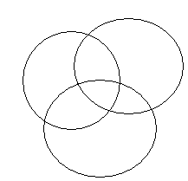employed but not educated.

Youth 1 2 3 Educated

5 6
4

- Employed

A) 4 only B) 1, 4, 7
C) 4, 7 D) 4, 5, 7

56. If Rohit finds that he is twelfth from the right in line of boys and fourth from the left, how many
boys should be added to the line such that there are 28 boys in a line?
A) 12 B) 13
C) 14 D) 20

57. Which of the following will be the middle digit of the middle number after reversing
the digits of the following numbers?
389, 675, 493, 728, 536
A) 3 B) 2
C) 8 D) 9
DIRECTIONS: (Q No. 8 to 10) some of the letters or numbers are missing in the given sequence.
Find out the one correct answer among the given alternatives.
58. 3, 5, 7, 11, 13, 17, 19, ?
A) 21 B) 23
C) 27 D) 29
59. 36, 49, 64, 81, 100,? 144
A) 110 B) 120
C) 121 D) None of these
60. 110, 99, 86, ? 54, 35
A) 81 B) 79
C) 67 D) 71
DIRECTIONS :( Q No. 11 & 12). What should come in place of question mark (?)?
61. 4² = √?
√16
A) 4 B) 8
C) 12 D) 16
62. ? X 9 X 4 = 1
9 20 9 9

A) 45 B) 9
C) 45 D) 5
9 18

63. Which expression is equivalent to the number 8006425?
A) (8 X 10⁷) + (6 X 10⁶) + (4 X 10³) + (2 X 10²) + (5X10¹)
B) (8X10) + (6X10) + (4X10) + (2X10) + (5X10)
C) (8X10⁶) + (6X10⁵) + (4X10⁴) + (2X10³) + (5X10²)
D) (8X10⁶) + (6X10³) + (4X10²) + (2X10) + (5X10⁰)

64. If cook is called butter, butter is called manager, manager is called teacher, teacher is called
clerk and clerk is called principal, who will teach in the class?
A) Principal B) Clerk
C) Teacher D) Manager
65. I am facing east. I turn 260⁰ in the clock wise direction and then 125⁰ in the anticlockwise
direction. Which direction am I facing now?
A) East B) North-East
C) North D) South-west

DIRECTIONS (Q. No. 66 to 70) It consist problem figures and Answer figures. The problem figures form a series. You are to find which of the answer figures would be the next one in the given series.

Problem figure Answer figure
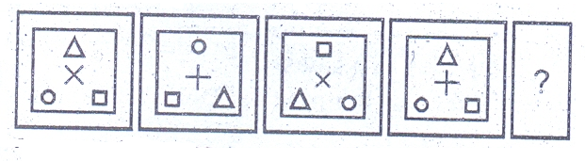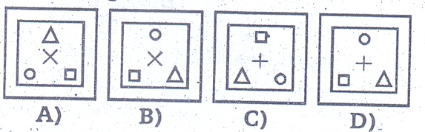
C
D
A
B
66

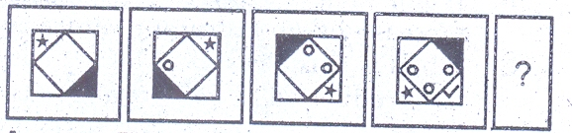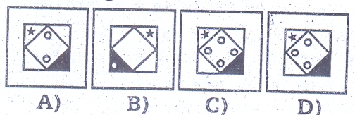
D
C
B
A
67

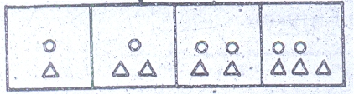
D
C
B
A
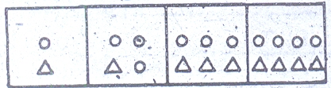
68

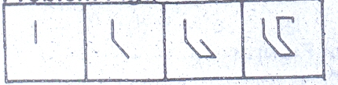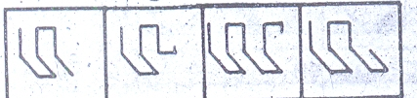
D
C
B
A
69

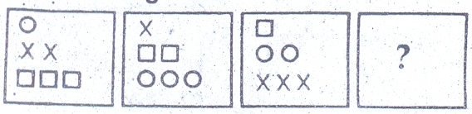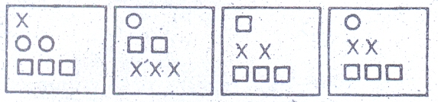
C
B
A
D
70

DIRECTIONS (Q. No. 71 to 75 ) Which one answer figure is related to figure 3 in same way as figure 2 is related to figure 1
71
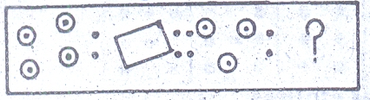
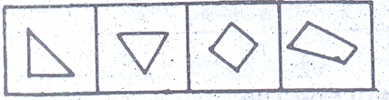
2
1
4
3
B
A
C
D
3
2
1
71

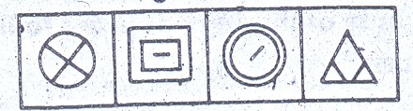
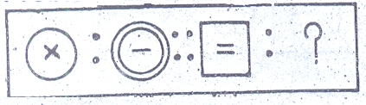
C
B
A
D
72
72
1
3
4
2

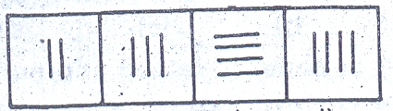
B
A
D
C
73
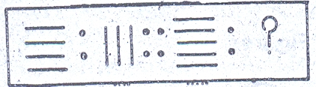
73
1
3
2
4
3
1
2
74

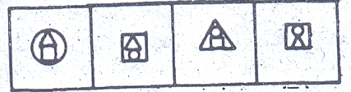
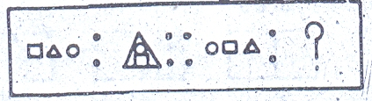
74
D
C
B
A
1
3
4
2
48
50

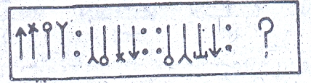
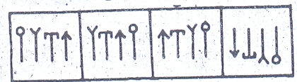
75
A
C
1
3
4
2
D
B

76. Which day is celebrated as National Teachers day?
A. September B. August 5
C. October 5 D. November 5

77. Name the Game or Tournament for which the following trophies awarded.
i. Aga Khan cup
ii. Durand Cup
iii. Irani Trophy

A. Hockey, Football, Cricket B. Hockey, Badminton, Chess
C. Cricket, Football Volley Ball D. Football, Cricket, Badminton
78. Which place in India is known for its circus artists?
A. Chennai B. Kolkota
C. Tellicheri C. Nagpur
79. The memory that stores programs and data instruction which are lost when power is
switched off.
A. RAM B. ROM
C. Hard Disk C. Floppy Disk
80. The collection of programme that are designed to operate, control and extend the
processing capabilities of the computes.
A. System software B. Software
C. Programs C. Hardware

81. Who is the author of ‘Panchatantra’:
A) Vedavyasa B) Vishnu Sharma
C) Banabhatta D) Kalidasa
82. A place through which data can enter or leave through:
A) Bus B) Key Board
C) Mouse D) Port
83. Binary codes as used in computer sciences are codes made up of which of
the following two numbers:
A) 0 and 9 B) 1 and 3
C) 0 and 1 D) 9 and 1

84. Windows 98 is:
A) An operating system B) A compiler
C) A character user interfere C) An interpreter
85. In a supermarket, which of the following will be found in use in its computerized system?
A) Scanner B) Printer
C) Bar code Reader D) OMR\
86. The first electronic computer was:
A) ENIAC B) Param Computer
C) Foxpro D) EDSAC
87. Which Word Processing tool is used to find and correct spelling errors?
A) Thesaurus B) Spell Check
C) Word Count D) Word Art
88. What is the motto of XIX Commonwealth games recently held at Delhi?
A) Come out and play B) Let’s go and play
C) This time for India C) None of these

89. Every Year which date is observed as National Sports Day which is birthday anniversary
of Major Dhyan Chand
A) 21 August B) 29 August
C) 3 September D) 5 June
90. The national game of U S A:
A) Football B) Baseball
C) Judo D) None of these
91. The observation of National Youth day is related to:
A) Subash Chandra Bose B) Bhagat Singh
C) Swami Vivekananda D) None of these
92. The colour of ‘black box’ kept in aircraft:
A) Black B) Red
C) Orange D) White
93. ‘A violent mob attacked a famous jail and released all the prisoners in the
year 1789’. The above statement is related to:
A) French revolution B) Cuban Revolution
C) Russian revolution D) None of these

94. Which one of the following is called ‘Ring of fire, area
A) Circum pacific belt B) Indian Ocean belt
C) Mediterranean belt D) Atlantic ocean belt

95. The state which is known as the “Granary of India” is:
A) Kerala B) Tamilnadu
C) Uttar Pradesh D) Punjab

96. The former name of ‘Reserve Bank of India”;
A) Imperial Bank of India B) Central Bank of India
C) National Bank of India D) None of these

97. ‘Telegraphic code was’ was introduced by;
A) Thomas Moore B) Samuel Morse
C) Thomas Alva Edison D) Graham bell

98. Science of studies of coins and metals is known as;
A) Numismatics B) Philology
C) Lexicography D) None of these

99. The last supper is painted by
A) Leonardo da Vinci B) Raphael
C) Michael Angelo D0 None of these

100. The main feature of Great depression:
A) Catastrophic decline in production, employment, consumption and trade
B) Decline in supply and demand
C) Decline in the price of essential things.
D) Increase in the export and import

SPACE FOR ROUGH WORK

