NATIONAL TEACHERS COUNCIL

ALL INDIA TALENT SEARCH EXAMINATION

MODEL QUESTION PAPER

AITSE 0710

CLASS VII

Duration: 1¹/₂ hours Maximum Marks: 100

General Instructions to Candidates

1. This question paper contains 100 multiple choice questions each of one mark.

2. The question paper is divided into two sections A and B

3. Section A is Scholastic Ability Test (SAT), contains 50 questions. This section covers Science, Mathematics and Social Science.

4. Section B is Mental Ability Test (MAT), Computer Awareness and General Knowledge, contains 50 questions.

5. There will be no negative marks for wrong answer.

6. A separate answer sheet is provided for answering the questions. Each question should be answered by darkening the appropriate circle (A, B, C, or D) with a blue or black ball pen.

7. Answer recorded once in the answer sheet cannot be altered.

8. All rough works should be done only in the space provided for rough work in this question paper.

9. Calculator is not permitted in the examination hall.

10. Candidate should write his / her name in the space provided for the purpose.
Name

SECTION A

1. The basic unit of speed is
A) Km / min. B) m / min.
C) Km / h C) m / s
2. The circuit symbol of a battery is
A) B)
C) ( ) D)
3. The filament of an electric bulb is generally made with
A) Tungsten B) Copper
C) Aluminium D) Alnico
4. The mirror used by a dentist
A) Concave mirror B) Convex mirror
C) Plane mirror D) None of these
5. The period of a simple pendulum depends upon its
A) Mass of its bob B) Length
C) Both A and B D) None of these
6. To an astronaut, the outer space appears
A) Dark blue B) White
C) Black D) Dark red
7. The numerical value of charge on an electron is
A) 1.6 X 10 ⁻¹⁸ C B) 1.6 X 10 ⁻¹⁹ C
C) 3.6 X 10 ⁻¹⁹ C D) 1.6 X 10 ⁻¹⁰ C
8. A magnetic material
A) Attract other magnetic material B) Does not attract other magnetic material
C) Repels a magnet D) Neither attract nor repel a magnet.
9. Reflection of light is the cause for
A) Day and night B) Summer and winter
C) Twinkling of stars D) Light from planet
10. The range of a clinical thermometer is
A) – 10 º C to 110 º C B) 0 º C to 100 º C
C) 35 º C to 42 º C D) 0 º C to 45 º C

11. A synthetic fibre is
A) Cotton B) Polyester
C) Silk D) Wool
12. Sanju Singh tested unripe mango juice with blue litmus and red litmus. She observed that
A) Red litmus turned to blue
B) No change for red litmus
C) Blue litmus turned to red and red litmus remains unchanged
D) Red litmus turned to blue and blue litmus remains unchanged.
13. A method to prevent the rusting of iron.
A) Galvanization B) Crystallization
C) Distillation D) Calcinations
14. The water holding capacity is the highest in
A) Sandy Soil B) Clayey Soil
C) Loamy Soil D) Mixture of Sand and Loam
15. The formation of mixture
A) Absorb Energy B) Release Energy
C) Does not involve any energy change D) Either absorb or release energy
16. The foul substance added to detect leakage of LPG is
A) Alcohol B) Ether
C) Ethyl mercapton D) Acetone
17. An antacid contains
A) Weak base B) Weak acid
C) Strong base D) Strong acid
18. Which one of the following is not responsible for water shortage?
A) Rapid growth of industries B) Increasing population
C) Heavy rain fall D) Mismanagement of water resources
19. The instrument that measures the wind speed
A) Ammeter B) Anemometer
C) Seismograph D) Odometer
20. The gas used in the aerated drinks is
A) Oxygen B) Carbon dioxide
C) Carbon monoxide D) Nitrogen

21. Microbes act upon the dead plants to produce
A) Sand B) Mushrooms
C) Humus D) Wood

22. Glucose + Oxygen Carbon dioxide + Water + Energy
This chemical equation represents which one of the following
A) Respiration B) Photosynthesis
C) Combustion D) Digestion
23. In many plants, though stamens and ovules are produced by the same flower self pollination
does not occur because
A) Stamen is not compatible with the pistil
B) The DNA of pollen grain and the ovule belong to different species
C) Anther and ovules mature at different times
D) Stigma does not hold the gametes belong to the same flower

24. Which of the given nutrient is used in minute quantity by plants?
A) Potassium B) Iron
C) Calcium D) Nitrogen
25. Which one of the following helps in blood clot?
A) R B C B) W B C
C) Haemoglobin D) Platelet
26. A fraction ª / _{b} can be expressed as a terminating decimal if b has no prime factors other than
A) 2, 3, 5 B) 2, 3
C) 2, 5 D) 3, 5
27. The ratio of two numbers is a: b. If one of them is x, then other is
A) ab B) b
x ax
C) b x D) bx
a + b a

28. 35% population of a town is men and 25% are children. If the number of women are 32000,
then the number of children will be

A) 20000 B) 2000
C) 80000 D) 28000

29. The surface area of a cube is 24 cm². What is its volume?
A) 576 cm³ B) 8 cm³
C) 144 cm³ D) 48 cm³

30. Read the statements P and Q
P → All integers are rational numbers
Q → Every rational number is an integer
Which one of the following is correct?
A) P is true and Q is false B) P is false and Q is true
C) Both P and Q is true D) Both P and Q is false
31. The distance between A and B is 260 km. A car running at a speed of 40 km/h start from A at 8 am.
At what time will it reach B?
A) 1:30 pm B) 2:00 pm
C) 2:15 pm D) 2:30 pm.
32. The value of x and y respectively in the figure are

130º

y

60º
x

A) 40º, 80º B) 70º, 50º
C) 50º, 60º D) 55º, 65º

33. 2 ^{2.06} X 3 ^{3.94} = ?
A) 16 B) 32
C) 64 D) 4096

34. The perimeter of a circle of diameter 14cm is equal to that of a square. The side of the square is
(Take ¶ = ²²/₇)
A) 11cm B) 11cm²
C) 44cm D) 44 cm²

35. The expanded form of 634.015 is

A) 6 X 100 + 3 X 10 + 4 X 0 + 0 X 1 + 1 X 1 + 5 X 1
10 100 1000

B) 6 X 1000 + 3 X 100 + 4 X10 + 0 X 1 + 1 X 1 + 5 X 1
10 100 1000

C) 6 X 100+ 3 X 10 + 4 X1 + 0 X 1 + 1 X 1 + 5 X 1
10 100 1000

D) 6 X 100 + 3 X 10 + 4 X1 + 0 X 1 + 5 X 1
10 100

36 The ruins of the glory of Vijayanagar and place of historical importance of its architectural style is
now found at
A) Belur B) Hampi
C) Srirangapatanam D) Tanjore
37 The greatness of Shersha lies in his:
A) Victories against Humayun B) Superior generalship
C) Administrative reforms D) religious tolerance
38. Two seas or water – bodies connected by a narrow stretch of water is known as a
A) Bay B) Strait
C) Peninsula D) Isthmus
39. Where is the lotus shaped marble house of worship located:
A) Mumbai B) Pune
C) Delhi D) Agra
40. The preamble of our constitution envisages:
A) Theocratic Society
B) Sovereign, Democratic, Socialist, Secular Republic
C) Secular Democracy
D) Federal
41. Who enjoy the legislative power in India?
A) President B) Supreme Court
C) Council of Ministers D) Parliament
42. Two of the great Mughals wrote their own memories. They were:
A) Babar and Jahangir B) Humayun and Jahangir
C) Babar and Humayun D) Jahangir and Shajahan

43. Gandara art is the combination of the Indian Style with that of:
A) Greek Style B) Kushan Style
B) Persian Style D) Roman Style

44. The first battle of Panipat in 1526 was fought between
A) Muhammad Lodi and Babar B) Ibrahim Lodi and Babar
C) Rana Pratap and Babar D) Shersha and Babar

45. Lunar eclips occurs when:
A) Earth is between the Sun and Moon
B) Moon is between the Sun and earth
C) Sun is between the earth and Moon
D) None of these
46. Savanna are
A) Tropical Grass land B) tracks full of tree
C) Name of a cyclone D) Mountain range

47. In which continent Atacama Desert Situated:
A) North America B) South America
C) Asia D) Africa

48. When it is 12:00 hrs. Noon in India, in another country it is 9:30 am in which direction from
India is this country located.
A) North B) South
B) West D) East

49. The Konark temple, dedicated to Surya or The Sun God, was built between 1250 and1278 A.D in the
areas around the mouth of the river:
A) Kaveri B) Mahanadi
C) Krishna D) Godavari

50. The first effective vaccine against polio was prepared by
A) Robert Edward B) Jonas E. Salk
B) Jhon Gibbson D) None of these

SECTION B

DIRECTIONS:- (Q.No.51 to 55). In each of these questions some numbers or letters are missing
find out one correct answer among the given alternatives.

51. 13, 27, 56, 115, 234, ?
A) 473 B) 468
C) 702 D)None of thes
52. 2, 6, 14, 30, 62, ? 254
A) 124 B) 126
C) 132 D) 142
53. Z, L, X, J, V, H, T, F, ---- ----
A) R, D B) R, E
C) S, E D) Q, D
54. A, C, F, H, ? M
A) L B) K
C) J D) I
55. ab, - - - b – bbaa –
A) abaab B) abbab
C) baaab D) babba

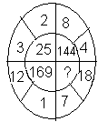
56.

A) 625 B) 25
C) 125 D) 156
DIRECTIONS: - (Q.No.57 & 58). Pick out the odd from the alternatives given

57. A) Ear B) Lung C) Eye D) Heart

58. A) Circle B) Cube D) Ellipse D) Sphere

59. Ranjini wrote a sequence using the following steps
Step 1 She chose 5 as first term
Step 2 She obtained successive terms by subtracting ¹/₅ from
preceding terms
The first six terms in the sequence are
A) 5, ⁴/₅, ³/₅, ²/₅, ¹/₅ B) 5, ²⁴/₅, ²³/₅, ²²/₅, ²¹/₅, 4
C) 5, 4, 3, 2, 1, 0 D) ²⁵/₅, ²⁴/₄, ²³/₃, ²²/₂, ²¹/₁, 0
60. Anil introduces Prashant, “He is the husband of the grand daughter of the father of my father”.
How is Prashant related to Anil?
A) Brother B) Son
C) Brother -in- law D) Son-in-law
61. Suresh walks 10m towards North. He then turns right and walk 10m. He again turns right
and walks 5m. Then he turns left and walks. In which direction is he walking?
A) East B) West
C) North D) South

62. What is the total number of triangles in the figure?

A) 6 B) 7
C) 8 D) 9

63. P is taller than Q, R is taller S and T and T is shorter than Q. Then shortest person among all is
A) P B) Q
C) R D) S
64. If ½ + ¼ = x and ½ - ¼ = y then x ÷ y =?
A) 3 B) ¼
C) ½ D) 0
65. Ina magic pond the number of flowers become double than previous day. One fourth of the
pond is filled with lotus in 12 days. How many more days are required to fill the pond
completely with lotus?
A) 24 B) 12 days
C) 6 days D) 2 days
66. In certain code GIRL is coded as IKTN. How WOMAN is coded in that code
A) YQOCP B) XPNBO
C) YOQPC D) VNLZM
67. In a row of 40persons, Rajan’s rank is 16 from left. What is his rank from the right end?
A) 24 B) 25
C) 26 D) 27
68. ELEPHANT is coded as 79745618. How THANE is coded.
A) 85917 B) 75617
C) 84691 D) 85617
69. In certain code, ‘CONVENTIONAL’ is written as ‘NOCNEVOITLAN’. How is NTHRONEMENT written in that code?

A) TNEROHEMNTNE B) TNEORHMENTNE
B) NTEROHEMNNTE D) TNEROHEMNNTE

70. Find the missing number in the circle.
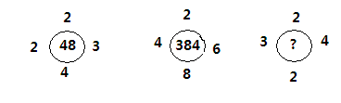

A) 44 B) 46
C) 48 D) 42

DIRECTION: (Q. No. 71 to 74) Given below are letters A to Z. Under each capital letter a small letter is written which is to used as a code for the capital letters.

A | B | C | D | E | F | G | H | I | J | K | L | M | N | O | P | Q | R | S | T | U | V | W | X | Y | Z
j | n | l | r | i | x | a | v | e | S | o | y | d | q | m | t | g | u | c | z | w | h | p | k | b | f

In each of the following questions (71 to 74) a group of six letters is given and its code equivalent is given in one of the columns A, B, C, or D. Study the groups of letters given in each questions and with the help of the code given above, choose the code equivalent from amongst A, B, C or D as your answer.
A | B | C | D
uhmvrj | nywgea | kcgsor | vezuiv
nyweqa | tzeigi | tiqawe | kegoqr
upfrvg | wqsjbl | bilpyq | wsqjbl
veziyu | upfurg | nywgca | kcsgor
biqppu | uhmvjr | upfvra | blipoq

71. HITREH
72. YCEWKN
73. BLUQSG
74. RWZHDG

DIRECTIONS: (Q. No.75 to 79). The first figure relates to the second figure and likewise third figure
relates to the fourth figure. Your task is find out the fourth figure
from A, B, C, or D

75

76

77

78

79
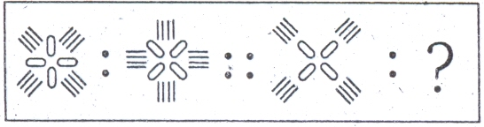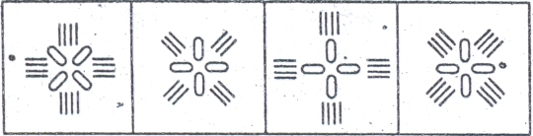
1 2 3 4 A B C D

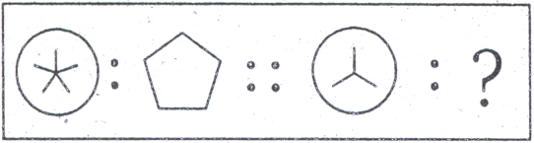
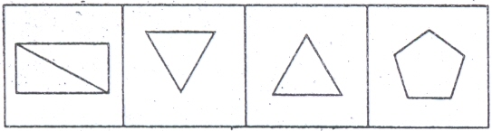
1 2 3 4 A B C D

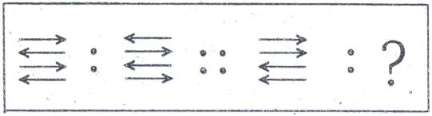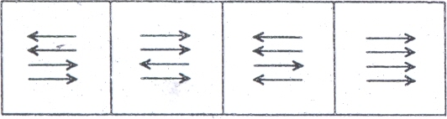
1 2 3 4 A B C D

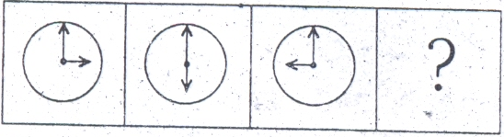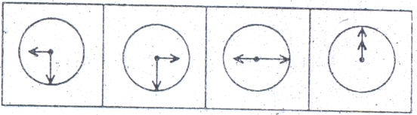
1 2 3 4 A B C D

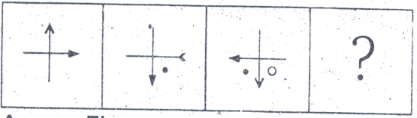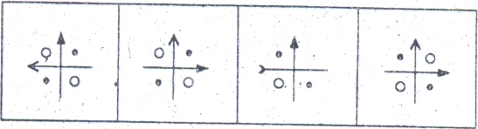

1 2 3 4 A B C D

80. The Bhopal Gas tragedy was caused by which of the following gases
A) Methyl chloride B) Methyl Iso Cyanide
B) Methyl Iso Cynate D) Methyl Cynate

81. The state has the largest area:
A) Uttar Pardesh B) Maharashtra
C) Madya Pradesh D) Rajastan

82. Which was the first news paper in India:
A) Culcutta Chronicle B) Madras News
C) Bengal Gazette D) Mysore Patrika
83. Minimum age required for election as Vice president in India
A) 25 Years B) 30 Years
C) 35 Years D) 40 Years
84. The Vindya - Satpura mountains run west to east parallel to the
A) Narmada Valley B) Western Ghats
C) Malwa Plateau D) Tapti Valley
85. The head quarter of OPEC is:
A) Lyons B) Vienna
C). Geneva D) Brussels
86. The main characteristic of Mansabdari System was that:
A) It was the base of civil and military administration.
B) It was a system to give honour to reputed people
C) It was the system for making the military personals
D) None of these.
87. The quickest and easiest way to locate a particular word or phrase in a document is to use
the command
A) Replace B) Find
C) Lookup D) Search
88. The internet allows you to:
A) Send electronic mail B) Connect to server all around the world
C) View Web pages D) All of the above
89. The blinking symbol on the computer screen is called the
A) Mouse B) Hand
C) Light D) Cursor
90. To prepare a presentation/slide show which application is commonly used
A) Paint B) Power Point
C) Fire fox D) Word
91. Which is the National game of India?
A) Hockey B) Cricket
C) Football C) Basket Ball

92. The Olympic flag is made up of white silk and contain five intertwined rings. From left to right the
rings are blue, yellow, black, green and red, these rings are meant to five different continents.
Which ring (Colour) represent Asian continent
A) Yellow B) Red
C) Green D) Black
93. Who has been selected for the Rajiv Gandhi Khel Ratna award recently?
A) Gagan Narang B) Sania Nehwal
B) Surinder Kaur D) None of these
94 What is the of Gold Medal tally of India in XIX Commonwealth Games.
A) 38 B) 40
C) 39 D) 47
95. What is the total number of players in a Hockey team?
A) 11 B) 9
C) 10 D) 7
96. Who was the founder of city of Agra?
A) Firuz Tughlaq B) Muhammad -bin – Tughlaq
C) Alauddin Kilji C) Sikander Lodi
97. Name the person who invited Babur to invade India.
A) Mahmud Lodi B) Bhara Mal of Amber
C) Rana Sanga of Mewar D)None of these
98. Who among the following was defeated by Ahammad Sah Abdali in the
third battle of Panipat.
A) Marathas B) Sikhs
C) Rajaputs D)Jats
99. Which one of the forests is mostly used for gathering?
A) Tundra B) Wet tropical
C) Dry areas D) Hot humid region.
100. Which country has a less than 1% of population growth rate.
A) China B) Iran
C) Japan D) Indonesia

SPACE FOR ROUGH WORK

