**NATIONAL TEACHERS COUNCIL**

**ALL INDIA TALENT SEARCH EXAMINATION**

**MODEL QUESTION PAPER**

|  |
| --- |
| **AITSE 0510** |

**CLASS V**

**Duration: 11/2 hours Maximum Marks: 100**

General Instructions to Candidates

1. This question paper contains 100 multiple choice questions each of one mark.

2. The question paper is divided into two sections **A** and **B**

3. Section **A** is **S**cholastic **A**bility Test(**SAT)**, contains 50 questions. This section covers Science, Mathematics and Social Science.

4. Section **B** is **M**ental **A**bility **T**est **(MAT),** **C**omputer **A**warenessand **G**eneral **K**nowledge**,** contains 50 questions.

5. There will be no negative marks for wrong answer.

6. A separate answer sheet is provided for answering the questions. Each question should be answered by **darkening** the appropriate circle (A, B, C, or D) with a **blue or black ball pen**.

7. Answer recorded once in the answer sheet cannot be altered.

8. All rough works should be done only in the space provided for **rough work** in this question paper.

9. Calculator is not permitted in the examination hall.

10. Candidate should write his / her name in the space provided for the purpose.

|  |  |  |  |  |  |  |  |  |  |  |  |  |  |  |  |  |  |  |  |
| --- | --- | --- | --- | --- | --- | --- | --- | --- | --- | --- | --- | --- | --- | --- | --- | --- | --- | --- | --- |
| Name |  |  |  |  |  |  |  |  |  |  |  |  |  |  |  |  |  |  |  |

|  |
| --- |
| **SECTION A** |

1. A device used to measure atmospheric pressure

A) Hydrometer B) Barometer

C) Lactometer D) Thermometer

2. The normal range of haemoglobin in our blood

A) 12 to 16 gm/dl B) 8 to 12 gm/dl

C) 10 to 12 gm/dl D) 6 to 10gm/dl

3. Which one of the following diseases is not spread by mosquitoes?

A) Malaria B) Dengue

C) Chikungunya D) Typhoid

4. An animal without external ear

A) Tiger B) Human

C) Snake D) Monkey

5. A carnivorous plant

A) Nepenthes B) Cactus

C) Water Lily D) Orchid

6. The prominent bright coloured part of a plant

A) Sepal B) Petal

C) Stamen D) Pistil

7. The largest animal on the planet earth

A) Dolphin B) Elephant

C) Blue Whale D) Giraffe

8. Many flowers bloom in night. The most common colour of such flowers is

A) Black B) White

C) Red D) Yellow

9. The total number of bones in an adult man

A) 196 B) 200

C) 206 D) 212

10. Which one of the following does not dissolve in water?

A) Salt B) Vinegar

C) Kerosene D) Oxygen

11. A communicable disease

A) Anaemia B) AIDS

C) Scurvy D) Night blindness

12. Which one of the following statement is not true?

A) Water vapour is present in the air

B) The change of water to water vapour is called evaporation

C) Water is a colourless liquid

D) Ice sinks in water

13. The full form of LPG

A) Liquefied Petroleum Gas B) Liquefied Petroleum Gas

C) Low Petroleum Gas D) Liquid Propellant Gas

14. The smallest planet of the solar system

A) Mercury B) Pluto

C) Jupiter D) Mars

15. ORS which is used for the treatment of Diarrhoea stands for

A) Oral Recharging Solution B) Oral Reducing Solution

C) Oral Replenishing Solution D) Oral Rehydration Solution

16. Which one is not a petroleum product?

A) Kerosene B) Natural Gas

C) Petroleum Gas D) Petrol

17. Pulses are mainly rich in

A) Carbohydrates B) Fats

C) Protein D) Vitamins

18. The major component of air is

A) Nitrogen B) Oxygen

C) Carbon dioxide D) None of these

19. A desert plant

A) Water Lily B) Rose

C) Cactus D) Pine

20. The shaking of earth is called

A) Tsunami B) Flood

C) Earthquake D) Volcano

21. One thousand less than **641234** is

A) 640234 B) 631234

C) 64100 D) 640123

22. Two lines which never meet each other are called

A) Perpendicular lines B) Parallel lines

C) Intersecting lines D) Converging lines

23. Sum of the place values of 5 in **56255** is

A) 50055 B) 50000

C) 15 D) 55500

24. The time, **quarter past 12 midnight** is

A) 12:15 pm B) 12: 15 am

C) 11: 45 pm D) 11: 45 am

25. The largest four digit number is divided by largest two digit number. The quotient is

A) 11 B) 111

C) 101 D) 100

26. The product of the place values of **7** and **8** in **48673** is.

A) 56 B) 5600

C) 56000 D) 560000

27. A plane figure is made of three line segments. It has three corners. It is a

A) Rectangle B) Square

C) Triangle D) Angle

28. Two tens + 3 ones + 5 hundredths + 6 thousands can be written as

A) 2 X 10 + 3X1 + 0.5 + 0.006 B) 20 + 3 + 0.05 + 0.6

C) 20 + 3 + 0.05 + 0.006 D) 23.56

29. In the following figure measure of one side is missing.

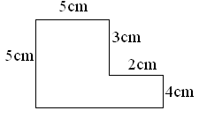

What is the measure of missing side?

A) 10 cm B) 9 cm

C) 5 cm D) 7 cm

30. 8 km 8 m is equal to

A) 8.8 km B) 80.8 km

C) 8.08 km D) 8.008 km

31. Rani purchased a laptop computer for Rs. 24200 and sold it for Rs. 23950. What is her loss?

A) Rs. 1250 B) Rs. 250

C) Rs. 750 D) Rs. 200

32. The smallest four digit number that can be formed by using 8, 0, 1, 4 is

A) 1048 B) 0148

C) 8410 D) 1084

33. The measure of an obtuse angle is always

A) 1200 B) 900

C) Greater than 900 D) Less than 900

34. L C M of 5, 10 and 15 is

A) 15 B) 20

C) 30 D) 60

35. A and B are two squares. The perimeter of B is twice that of A. If the area of A is 25cm2, then the area of B is

A) 50 cm2 B) 10.0 cm2

C) 12.5 cm2 D) None of these

36. If is equal to **0.2** then

+ + + is

A) 3.2 B) 0.8

C) 1.6 D) 4

37. Find the perimeter of the following figure.

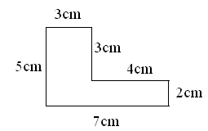

A) 24cm B) 24cm

C) 21cm D) 21cm2

38. The sum of 2 3/8 and 3 10/16 is

A) 5 **13/10** B) 6

C) **77/16** D) 7

39. If a family of **4** requires **38kg** of cereals in a month, how much cereal will be required

for a family of **5**?

A) 47.5kg B) 47kg

C) 43kg D) 42.5kg

40. If **3/7** of a number is **300**, what is the number?

A) 600 B) 660

C) 700 D) 720

41. The region around South Pole is known as.

A) Arctic B) Equator

B) Antarctic D) Capricorn

42. Flora is the:

A) Animal life of a region B) Plant life of a region

C) Study of Physics D) Study of Oceanography

43. Bauxite is an ore of:

A) Iron B) Lead

C) Aluminum D) Magnesium

44. Land of rising sun is:

A) Vietnam B) Australia

C) Japan D) China

45. Indian Ocean is:

A) The largest B) Second largest

C) Third largest D) None of these

46. Shantivan is associated with:

A) Gandhiji B) Jawaharlal Nehru

C) Rajiv Gandhi D) Lalbahadur Sastri

47. Children’s day is celebrated every year on:

A) 14th November B) 15th November

C) 14th December D) 15th December

48. The head of our country:

A) President B) Prime minister

C) Military General D) None of these

49. The famous slogan “Do or die” inspired millions of Indian people during the freedom struggle, this slogan is associated with famous:

A) Quit India Movement B) Salt Satygraha

C) Non Co operation movement D) Civil Disobedience movement.

50.

|  |
| --- |
| **SECTION B** |

**DIRECTION:** - (QNo.51 to 59). In each of these questions some number or letter is missing.

Find out the correct answer:-

51. **0, 1, 3, 6, 10, 15, __**

A) 21 B) 20

C) 22 D) 23

52. **½, ¼, 1/8, 1/16, 1/32 ,**__

A) 1/60 B) 1/36

C) 1/64 D) 1/96

53. **1536, 384, 96, 24 __**

A) 6 B) 8

C) 12 D) 16

54. **U, O, I, __ , A**

A) C B) E

C) F D) H

55. **AB, DE, HI, MN, ­­__ .**

A) OP B) PQ

C) RS D) ST

56. If **P = 64 + 36** and **Q = 124 – 26**, then **P – Q** = ?

A) 0 B) 2

C) 10 D) 36

57. In a class there are **45 students**. If one more boy joins in the class, the number of boys and girls become equal. What is the present strength of boys in the class?

A) 25 B) 24

C) 23 D) 22

58. **3 X 6 ÷ 9 + 9 – 5 = ?**

A) 13 B) 6

C) 10 D) 5

59. If **÷** means **X** , **+** means **-**, **X** means **+** and **–** means **÷**, then

**5 ÷ 8 – 2 + 10 = ?**

A) 4 B) 8

C) 10 D) 12

**DIRECTION:** - (QNo.60 & 61):**-** Odd one out.

60. A) 6 B) 12 C) 44 D) 48

61. A) Circle B) Square C) Rectangle D) Triangle

62. Ankit is facing towards North. He turns left and walks 5m and then turns right.

In which directions he is walking?

A) South B) West

C) East D) North

63. Which one of the following has only one surface?

A) Cube B) Cuboid

D) Sphere D) Cylinder

64. Which one of the following cannot be a mobile phone number?

A) 0943645715 B) 9635468790

C) 9483641831 D) 09876543213

65. If x X x X x X x X x = 32 and x X x X x = 8 then the possible value of x is

A) 4 B) 6

C) 2 D) 1

**DIRECTION:** - (Q. NO. 66 to 68) Complete the series:

66. A, E, I, M, Q …?

A) T B) V

C) U D) W

67. A, E, I, O ….?

A) J B) U

C) K D) C

68. ABC, BCD, CDE, ….?

A) DEF B) EFG

C) CEF D) DEC

**DIRECTION:** - (Q. No. 69 to 75) Three of the following four are alike in certain way and so form a group which is the one that does not belong to that group:

69. A). Thiruvanandapuram B) Hyderabad C). Delhi D) Lucknow

70. A) Bhagavat Gita B) Bible C) Koran D) Iliad

71. A) Father B) Mother C) Sister D) Grand Mother

72. A) Gandhiji B) Bhagat Singh C) Subhash Chandra Bose D) Tipu Sultan

73.

A) B) C) D)

74

A) B) C) D)

75

A) B) C) D)

**DIRECTION:** - (Q. No. 76 & 77) Raju has a banner which includes the following alphabets

A B K R M T N I D H P E S

With the help of above letters he made the names of the following states, but he made one mistakes in each group. Your task is to find the name of the state which he made by using alphabets other than mentioned in banner.

76. A) ANDHRAPRADESH B) KARNATAKA C) KERALA D) BIHAR

77. A) MAHARASHTRA B) ASSAM C) MAHARASHTRA D) MANIPUR

78. The symbol of WWF is:

A) Tiger B) Giant Panda

C) Lion D) Elephant

79. Who is known as ‘The prince of Mathematics’?

A) Euclid B) Carl Frederic Gauss

C) Pythagoras D) Charles Babage

**DIRECTION:** - **(Q. No. 80 to 83) Identify the personalities**

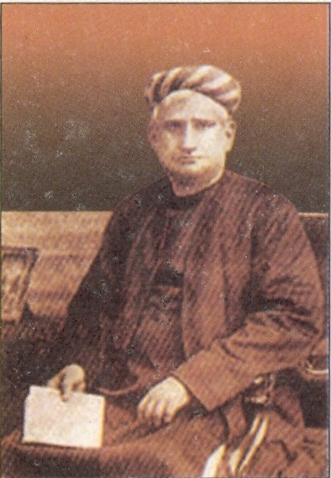

A) Bankim Chandra Chattarjee

B) Motilal Nehru

C) C. Rajagopalachari

D) None of these

80)

A) Bhagat Singh

B) Lala Lajpat Rai

C) Mangal Pandey

D) Subash Chandra Bose

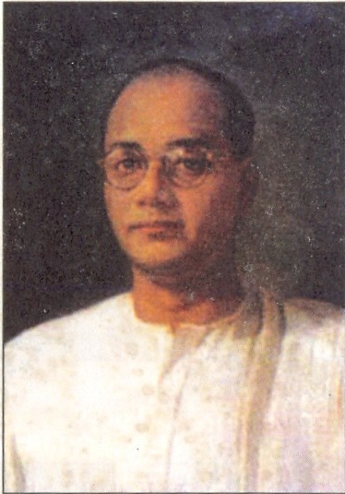

81

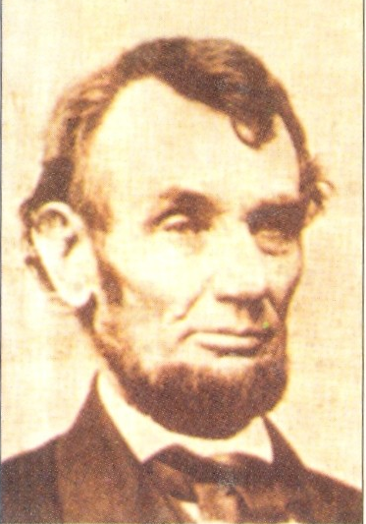

A) Abraham Lincoln

B) George Washington

C) Roosevelt

D) Woodrow Wilson

82

A) Bankim Chandra Chattarjee

B) Motilal Nehru

C) C. Rajendra Prasad

D) Rabindra Nath Tagore

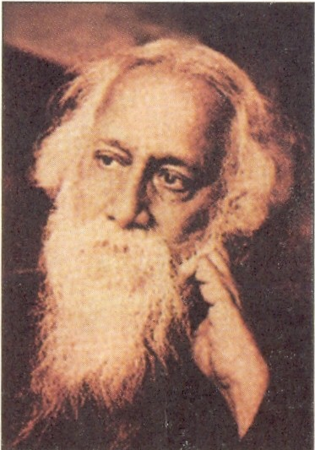

83

84. Who is the captain of Indian Cricket team?

A) Mahendar Singh Dhoni B) Sachin Tendulkar

C) Virendar Sewag D) Anil Kumble

85. What is the duration of a football match?

A) 90 minutes B) 95 minutes

C) 60 minutes D) 120 minutes

86. How many playing members required in a hockey team?

A) 10 B) 9

C) 11 D) 12

87. Which on of the following is not a permanent member of UN Security Council?

A) France B) Italy

C) USA D) Italy

88. Name the king who invaded Delhi and plundered the ‘Kohinoor Diamond’

A) Nadir Shah B) Firuz Shah

C) Mohammad Ghori D) Mohammad Gazni

89. Who is the father of Indian constitution?

A) Dr. B R Ambedkar B) Rajendra Prasad

C) Jawaharlal Nehru C) Sardar Patel

90. An ‘Automatic Teller Machine’ (ATM) represents:

A) An online Banking System B) A fast Internet System

C) A voice recognition system D) None of these

91. The collection of numbers, alphabets, or some facts and numbers are called

A) Information B) Data

C) Values D) Numbers

92. First electronic computer was:

A) ENIAC B) EDSAC

C) Intel Pentium D) Apple

93. Which one of the following is not an input device?

A) OMR B) Joystick

B) Monitor D) Mouse

94. What is the expansion of WWW?

A) World Wide Web B) World Watch Web

C) World Wild Web D) None of these

95. What are the two epics of India

A) Rig-Veda, Bhagavat Gita B) Vedas, Upanishads

B) Ramayana and Mahabharata D) Ramayana and Bhagavat Gita

96. Who was the first prime minister of India?  
 A) Jawaharlal Nehru B) Rajendra Prasad

C) Sardar Patel D) V P Menon

97. Adolph Hitler was the ruler of which country?

A) Germany B) France

C) Italy D) Poland

98. Golden Temple situated in:

A) Jammu and Kashmir B) Assam

C) Delhi D) Himachal Pradesh

99. Which state of India is often called the heart of India?

A) West Bengal C) Uttar Pradesh

C) Madhya Pradesh D) Karnataka

100. Every year Teachers Day celebrated on

A) 5th October B) 5th November

C) 5th August D) 5th September

**SPACE FOR ROUGH WORK**