AITSE 0412

NATIONAL TEACHERS COUNCIL
ALL INDIA TALENT SEARCH EXAMINATION: 2012

CLASS IV

Duration: 90 Maximum Marks: 70
General Instructions to Candidates
1. This question paper contains 70 multiple choice questions each of one mark.
2 The question paper is divided into two sections, A and B
3. Section A is Scholastic Aptitude Test (SAT), contains 40 questions. This section covers Environmental Science and Mathematics.
4. Section B is Mental Ability Test (MAT), Computer Awareness and General Knowledge, contains 30 questions.
5. There will be no negative marks for wrong answer.
6. A separate answer sheet is provided for answering the questions. Each question should be answered by darkening the appropriate circle (A, B, C, or D) with a blue or black ball pen.
7. Answer recorded once in the answer sheet cannot be altered.
8. All rough works should be done only in the space provided for rough work in this question paper.
9. Calculator is not permitted in the examination hall.
10. Candidate should write his / her name in the space provided for the purpose.
Name

SECTION A

1. A device used to measure human body temperature
A) Laboratory thermometer B) Clinical thermometer
C) Barometer D) Mercuric thermometer
2. Air is a mixture of different gases. Which one of the following is NOT a correct?
A) Air is a homogeneous mixture B) Air is highly compressible
C) Air exert pressure D) Air is not a matter
3. The imaginary line on the globe that divides the earth into Northern hemisphere and Southern hemisphere.
A) Longitudes B) Latitudes
C) Equator D) Greenwich meridian
4. Infectious diseases spread from an infected person to healthy person through various ways. Which one of the following is NOT an infectious disease?
A) Beriberi B) Typhoid C) AIDS D) Dengue
5. The best and most economical way to ensure adequate and balanced vitamin intake is to
A) Eat between meal snacks B) Eat high protein diet
C) Eat a well balanced diet D) Take a vitamin supplement
6. The organ system that provide shape and support our body
A ) Circulatory system B) Nervous system
C) Muscular system D) Skeleton system
7. All birds have tails. The tail of a bird helps it to
A) Fly fast B) Change direction C) Fly high D) Fly slow
8. Fertilizers are used in agricultural field to ensure the productivity. Which of the following component of air is used for making fertilizers?
A) Nitrogen B) Oxygen
C) Carbon dioxide D) Water vapour

9. People prefer cotton clothes in summer. This is because cotton
A) Good conductor of heat B) Absorb sweat better
C) Does not absorb sweat D) Easy to wash
10. Km. Arya observed an object X and made following correct observations:-
It has definite volume; It has definite shape; It occupies space; It does not flow.

The object X is
A) Mercury B) Water vapour C) Salt solution D) Iron nail
11. An X-ray diagnosis is very much important in case of
A) Dog bite B) Fever C) Fracture D) Burns
12. LPG is a common fuel. The full form of LPG is
A) Liquefied Petroleum Gas B) Liquid Petroleum Gas
C) Light Petroleum Gas D) Liquefied Propellant Gas
13. Which one of the following gas helps us from harmful ultraviolet radiations?
A) Oxygen B) Ozone C) Carbon dioxide D) Nitrogen
14. Which one of the following statement is NOT correct?
A) Respiration requires air B) Burning of wood requires air
C) Flying of aeroplane requires air D) Digestion of food requires air
15. A student prepared salt solution by adding 20 gram of salt in 100ml of water. He noticed that the volume of water did not change. The reason is
A) The salt particles evaporated up on stirring
B) The water particles evaporated upon stirring
C) The salt particles occupied the empty space in water
D) The salt particles do not have any volume
16. Select the odd one:-
A) Cabbage B) Tomato C) Mango D) Apple

17. Heart : Circulatory system : : Kidney : …………………
A) Nervous system B) Respiratory system C) Excretory system D) Muscular system

18. Carefully observe the diagram given below:- Terrestrial animals
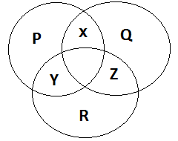
Which one of the following X can be?
A) Fish B) Birds Aquatic animal
C) Star fish D) Frog Aerial Animal

19. Green plants can prepare their own food in presence of sunlight. Which one of the following is known as food factories of a plant?
A) Stem B) Flower C) Leaves D) Roots
20. Identify the correct one from the following
A) Friction produces heat B) Friction increases the speed of a moving object
C) Friction is produced due to heat D) Friction removes heat
21. The numeral for Seventy two thousand fifteen is
A) 72050 B) 7215 C) 72015 D) 72150
22. The product of place values of 4 and 3 in 73742 is
A) 120000 B) 12000 C) 1200 D) 12
23. $\frac{1}{3}$ + $\frac{1}{3}$ + $\frac{1}{3}$ + $\frac{1}{3}$ + $\frac{1}{3}$ +$\frac{1}{3}$ is equal to
A) 6$\frac{1}{3}$ B) 6 x $\frac{1}{3}$ C) 6 + $\frac{1}{3}$ D) $\frac{6}{18}$
24. Which of the following is arranged in ascending order?
A) 72784, 72754, 72745, 72475 B) 72732, 72784, 72754, 72745
C) 72745, 72475, 72784, 72754 D) 72475, 72745, 72754, 72784
25. 7 thousand + 12 hundred +72 tens + 5ones is equal to
A) 8925 B) 72725 C) 712725 D) 8275

26. 200 cm = ……………Km
A) 2 B) 0.2 C) 0.002 D) 0.0002
27. A foot ball is an example of a sphere. How many surfaces does it have?
A) 4 B) 0 C) 2 D) 1
28. Arun wants to buy a toy car which costs Rs. 120. At present he has Rs.30 and he saves Rs.10 per week. After how many will he be able to buy the Toy car?
A) 10 B) 9 C) 12 D) 6
29. In a clock the minute hand and hour hand make an angle of 180⁰. What is the possible time shown by the clock?
A) 12 O’ clock B) 3 O’ clock C) 6 O’clock D) 9 O’ clock
30. Time quarter past 10pm is
A) 1015hrs. B) 2215hrs. C) 0945hrs. D) 2015hrs.
31. A line segment joining two points on a circle and passing through its centre is called
A) Diameter B) Radius C) Arch D) Semicircle
32. Which number represents the shaded portion of the figure?
A) 0.5 B) 4
C) 0.6 D) 0.4
33. A school library has 1975 books. On Monday 186 books were issued to primary class students and on Wednesday 263 books were issued to secondary class students. How many books are remaining in the library?
A) 1526 B) 1789 C) 1712 D) 2424
34. How many squares in the table given below should be shaded to represent half of half?
A) 16
B) 10
C) 5
D) 20

35. (100 x1) + (50 x 1) + (5 x 1) is equal to
A) 151 B) 151 C) 153 D) 155
36. If represents 12 and represents 8, then
+ is equal to
A) 108 B) 100
C) 20 D) 10
37. The expanded form of 74806 is
(A) 70000 + 4000 + 80 + 6 B) 70000 + 4000 + 800 + 6
(C) 700000 + 4000 + 800 + 6 D) 70000 + 4000 + 8000 + 6
38. The following table gives the price list of a cool bar. Name the items having highest and lowest price.
Items | Ice-cream | Apple juice | Orange Juice | Lemon Juice | Fruit Salad
Cost | Rs. 10 | Rs. 16 | Rs. 14 | Rs. 6 | Rs. 18

A) Apple Juice & Lemon Juice B) Fruit Salad & Orange Juice
C) Ice-Cream & Fruit Salad D) Fruit Salad & Lemon Juice
39. $\frac{13}{4}$ is a number between
A) 2 and 3 B) 3 and 4
C) 4 and 5 D) 12 and 13
40. Class IV of a school has 42 students. They divided into 3 equal groups for a discussion. How many members are there in each group?
A) 39 B) 12
C) 14 D) none of these

SECTION B

41. Identify the folder on Desktop which is used by the computer for storing the deleted information.
A) B) C) D)
42. The shortcut for UNDO command is
A) Ctrl + C B) Ctrl + V C) Ctrl + Z D) Ctrl + Y
43. Which one of the following shows fill with colour
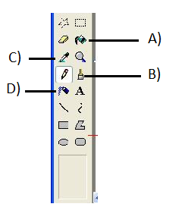.
44. Which one of the following key cannot work independently? It always work in combination with other keys
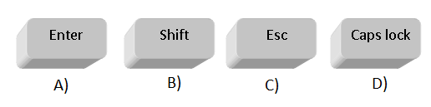
45. Which part of CPU performs all the calculations?
A) Control Unit B) Input Unit
C) Memory D) Arithmetic and logical Unit

46. Identify this classical art form
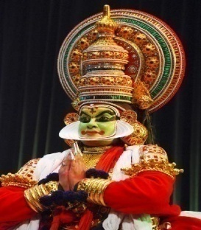
A) Kuchpudi
B) Mohniyatam
C) Kathakali
D) Bihu

47. Identify the name of Indian state by reading following passage:
This state attained its statehood on 20th February 1987. It is situated in the North-Eastern part of India with 83743 sq. kms area and has a long international border with Bhutan to the west (160 km), China to the north and north-east (1,080 km) and Myanmar to the east (440 km). It stretches from snow-capped mountains in the north to the plains of Brahmaputra valley in the south.

A) Assam B) Meghalaya C) Tripura D) Arunachal Pradesh
48. This sisters are belonging to which country?
A) America B) Britain
C) France D) South Africa
49. The action of this cricket umpire indicates:
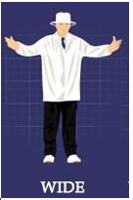
A) No Ball B) Four Runs
C) Wide Ball D) Player Out
50. The planet with shortest day is:
A) Pluto B) Venus
C) Saturn D) Mercury

51. Which one of the following diagram shows the proper structure of Executive in India?
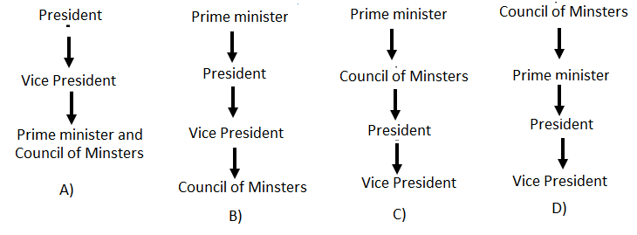
52. Who among the following is an Indian chess player?
A) Viswanathan Anand B) Gary Kasparov
C) I M Vijayan D) Mahesh Bhoopati
53. Who was the first Prime Minister of India?
A) Jawaharlal Nehru B) C Raja Goplachri
C) Rajendra Prasad D) B R Ambedkar

54. Replace question mark?
X
C
?
B
Z
A
E
W
D

A) W B) Y C) X D) V

55. Replace the question mark.
1
9
8
7
20
18
38
?
30
39
2
3
5
3
1
12
18
15
14
12
A) 36
B) 26
C) 23
D) 20

8
8
6
6
3

56. How many cubes are there in the following picture?
A) 23
B) 24
C) 25
D) 26

57. How many circles are there in the following picture?
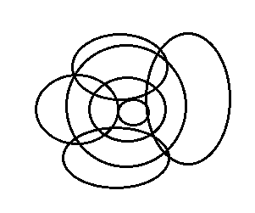
A) 7 B) 9
C) 8 D) 10
Direction for question No 58 to 60:- Find the odd one out
58. A) Chennai B) Mumbai C) Bhubaneswar D) Chandigarh
59. A) Asia B) Africa C) Greenland D) Australia
60. A) Ganga B) Yamuna C) Kaveri D) Indus
61. From the given alternative of words, select the word which cannot be formed using the letters of the given word:
Word: CHEMISTRY
A) CHEMIST B) TRY
C) MISTER D) MASTER
62. How many triangles are there in following picture?
A) 6 B) 5
C) 7 D) 8
Direction for question No 63 to 65:- Complete the series:
63. ABC EFG JKL PQR ?
A) TUV B) WXY C) UVW D) XYZ
64. 4 9 16 25 36 ?
A) 64 B) 49 C) 50 D) 61
65. M31 N41 O51 P61 ?
A) Q 17 B) Q71 C) Q31 D) R71
66. This is the official emblem of:
A) Bharat Scout and Guide
B) Indian Army
C) CRPF
D) BSF

67. The term ‘White Revolution’ closely associated with:
A) Agriculture B) Milk Production
C) Egg D) Fish
(Direction for Questions 68 to 70): Study the following table carefully to answer the questions that follow:
Name of school | Number of boys | Number of girls | Total
A | 256 | 564 | 820
B | 769 | 765 | 1534
C | 342 | 953 | 1295
D | 678 | 321 | 999
E | 987 | 658 | 1645
68. Which school has highest number of girl students?
A) School D B) School B C) school A D) School C
69. Name the schools are having more number of girls than boys?
A) School A and School C B) School A and School B
C) School A and School D D) School B and School C
70. How many Schools are having total number of children more than 1000?
A) 1 B) 2 C) 3 D0 4
Space for Rough Works

