AITSE 0312

NATIONAL TEACHERS COUNCIL
ALL INDIA TALENT SEARCH EXAMINATION: 2012
CLASS III

Duration: 90 Minutes Maximum Marks: 70
General Instructions to Candidates
1. This question paper contains 70 multiple choice questions each of one mark.
2 The question paper is divided into two sections, A and B.
3. Section A is Scholastic Aptitude Test (SAT), contains 40 questions. This section covers Environmental Science and Mathematics.
4. Section B is Mental Ability Test (MAT), Computer Awareness and General Knowledge, contains 30 questions.
5. There will be no negative marks for wrong answer.
6. A separate answer sheet is provided for answering the questions. Each question should be answered by darkening the appropriate circle (A, B, C, or D) with a blue or black ball pen.
7. Answer recorded once in the answer sheet cannot be altered.
8. All rough works should be done only in the space provided for rough work in this question paper.
9. Calculator is not permitted in the examination hall.
10. Candidate should write his / her name in the space provided for the purpose.

Name

SECTION A

1. The smallest planet of the solar system
A) Mercury B) Pluto C) Venus D) Mars
2. Green plants can prepare their own food in presence of sunlight. The raw material used by plants for this process
A) Oxygen & Water B) Oxygen & Carbon dioxide
C) Carbon dioxide & Water D) Water & Fertilizers
3. The largest terrestrial animals
A) Blue whale B) Elephant C) Ostrich. D) None of these
4. We can see the complete bright disc of the moon on a full moon day and no moon on a new moon day. On which day the moon comes in between the sun and the earth
A) New moon day B) Full moon day C) Both (A) & (B) D) None of these
5. Miss Kaveri adds lots of green leaves and vegetables in their food. She will grow
A) Fat & round B) Strong & muscular
C) Healthy & disease free D) All of these
6. Food which is a rich source of Vitamin A is
A) Apricot B) Broccoli C) Bread D) Liver
7. We use different devices to measure different physical quantities. The device lactometer is used to measure
A) Purity of milk B) Earthquake C) Temperature D) Humidity of air
8. A world famous Indian Agricultural Scientist
A) S. Chandrasekhar B) C. V. Raman C) J. C. Bose D) M. S. Swaminathan
9. The proper knowledge of first aid helps to save the life of people at the time of accident. What first aid would you give for burn injury?
A) Pulls away the burnt clothes from the body
B) Pour cold water on the burnt part of the body
C) Use ointment or lotion on the burnt part
D) Break or prick blisters on the burnt part

10. Which of the following method makes food more nutritious?
A) Sprouting B) Fermentation C) Salting D) Baking
11. An animal that has spines to defend from its enemies
A) Platypus B) Tortoise C) Chameleon D) Porcupine
12. Identify the one which is classified wrongly
Options | Plant Product | Animal Product
A | Cotton | Silk
B | Jute | Leather
C | Wool | Paper
D | Rubber | Honey

13. Cactus is a desert plant. To minimize loss of water it does not have leaves. The stem is green and waxy and prepares food for the plant. This shows that
A) Wax is obtained from Cactus B) Plant modifies according to habitat
C) Habitat change according to plant D) Cactus is insectivorous in nature
14. The roots of plants have various functions. Which among the following is not a function of the roots?
A) Production of food B) Storage of food C) Support D) Absorption of water
15. Which one of the following is NOT a food chain?
A) Grass Grass hopper Frog Snake
B) Fly Frog Snake Eagle
C) Plant Rabbit Tiger
D) Egg Larva Pupa Butterfly
16. In the night sky stars appear to move from east to west, because
A) Earth revolves from west to east
B) Earth revolves from east to west
C) Stars revolves around the earth from east to west
D) Stars revolves around the earth from west to east

17. Carefully observe the flow chart given below:-
P R
WATER VAPOUR
WATER
ICE
Q S
Which one of the following is true for P, Q, R and S?
A) P & Q are heating, R & S are cooling B) P & S are heating, Q & R are cooling
C) P & R are heating, Q & S are cooling D) P & R are cooling, Q & S are heating
18. The animals, cow, goat and sheep are similar because, they are
A) Herbivorous B) Carnivorous C) Insectivorous D) Omnivorous
19. Which of the following organ help to purify blood in our body?
A) Lungs B) Heart C) Kidney D) Liver
20. Which is NOT a sense organ?
A) Eye B) Tongue C) Skin D) Hand.
21. How many months in a year have 30 days?
A) 8 B) 7 C) 5 D) 4
22. The difference between smallest four digit number and largest two digit number is
A) 901 B) 999 C) 99 D) 1
23. How many times minute hand moves round the clock in a day?
A) 60 B) 3600 C) 24 D) 120
24. Identify the missing number in the following:
509 = 5 x 100 + x 10 + 9 x 1
A) 1 B) 0 C) 9 D) 50
25. Janani has 22 marbles with her. How many more marbles are required to make it 50?
A) 72 B) 30 C) 28 D) None of these
26. 5 hundreds + 16 tens + 2 one is equal to
A) 662 B) 516 C) 562 D) 212

27. A closed figure made up of three line segments of equal length
A) Rectangle B) Square C) Circle D) Triangle
28. The place value of 8 in 78945 is
A) Eighty thousand B) Eight thousand
C) Eight hundred D) Eight thousand nine hundred
29. Write the fraction representing the shaded portion in the figure:
A) $\frac{3}{12}$ B) $\frac{3}{9}$
C) $\frac{3}{4}$ D) None of these
30. Suresh purchased 12 eggs for Rs. 48. What is the cost of 2 eggs?
A) Rs. 4 B) Rs. 8 C) Rs. 4.8 D) Rs 12
31. The sum of two numbers is 1000 and their difference is 998. The numbers are
A) 1000 & 998 B) 998 and 999 C) 999 and 1 D) None of these
32. Find the number that makes the given equation true.
?
÷ 9 = 12
A) 18 B) 63 C) 81 D) 108
33. If represents 5 and represents 4, then
+ is equal to
A) 9 B) 40 C) 20 D) 81
34. The expanded form of 12701 is
A) 10000 + 2000 +700 +10 + 1 B) 10000 + 1000 + 100 +10 + 1
C) 10000 + 2000 +700 +0+ 1 D) 10000 + 2000 +100 +0 + 1
35. Sahil has 12 red , 7 blue and 5 green pens. What fraction of the pens is red?
A) $\frac{1}{2}$ B) $\frac{12}{7}$ C)$\frac{12}{5}$ D) $\frac{7}{12}$

36. The smallest five digit number that can be formed with digits 4, 7, 9 and 3 is
A) 3497 B) 3749 C) 3479 D) 9743
37. The sum of 23 hundreds and 53 tens is equal to
A) 2 thousand + 8 hundred + 30 tens B) 76 hundreds
C) 2 thousand + 56 hundred D) 2 thousand + 8 hundred + 3 tens
38. The difference between three-fourth and half is
A) Half B) One-fourth C) Two –fourth D) One-eighth
39. 14 + (6 + 18) = ( 14 + -------) + 18
A) 6 B) 18 C) 14 D) 0
40. Which is not the same as 5 X 6?
A) 6 + 6 + 6 + 6 +6 +6 B) (4+2) x 5
C) 6 + 5 D) (3 +2) x 6
SECTION B

41. Which one of the following is not an input device?
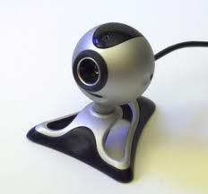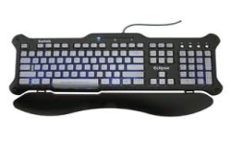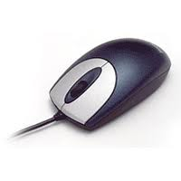
A) B) C) D)
42. Which one of the following tool is used for erasing a picture in paint?
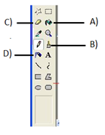

43. What is the function of an Enter Key?
A) To move next line B) To give space
C) To type capital letters D) To type symbols
44. Identify the icon on Desktop which is used to brows Internet.
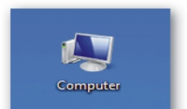
A) B) C) D)
45. Which one of the following program disturbs the normal function of a computer?
A) Games B) Virus C) Arithmetical D) Painting
46. Which one of the following is not correctly matched?
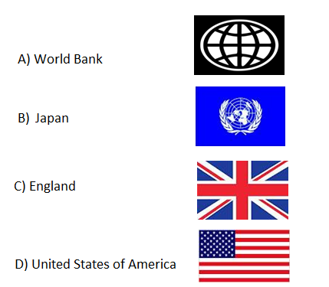
47. Who among the following was not our Prime Minister?
A) Narasimha Rao B) L K Advani
C) Jawaharlal Nehru D) Manmohan Singh
48. Which one of the following is not a Union Territory of India?
A) Goa B) Andaman and Nicobar
C) Lakshadweep D) Chandigarh

49. Which is the smallest country in the world?
A) Nauru B) Peru
C) Israel D) Vatican City
50. Who is the present president of India?
A) Prathiba Patil B) A K Antony
C) Manmohan Saingh D) Pranab Mukharjee
51. Identify this great ruler of Mysore.
A) Hyder Ali
B) Tipu Sultan
C) Shivaji
D) aurangazeb
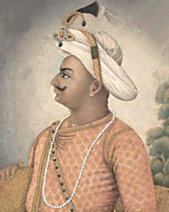

52. What is the importance of Vasco - da - Gama in Indian history?
A) He is the first European reached to India
B) He discovered new sea route to India
C) He established trade with India
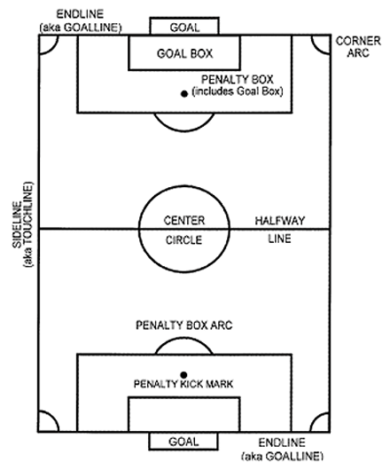
D) He attacked India
53. Which game is associated with the following ground?
A) Football
B) Basketball
C) Volleyball
D) Cricket

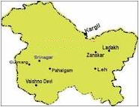
54. Identify this state of India.
A) Madhya Pradesh
B) Jammu and Kashmir
C) Uttar Pradesh
D) Gujarat

55. Name the largest sea in the world.
A) China sea B) Caspian sea
C) Arabian Sea D) Mediterranean Sea
56. Find the odd one out:
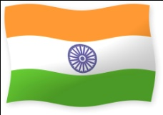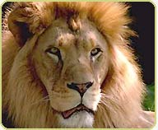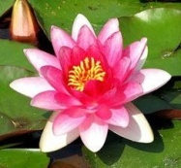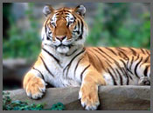
A) B) C) D)
57. Find the odd one out:

A) B) C) D)

58. Find the odd one out
A) B) C) D)

59. Find the odd one out:
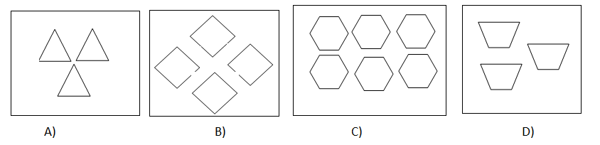

60) Find the odd one out:
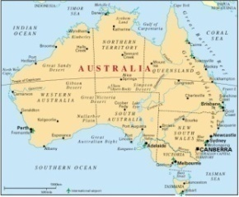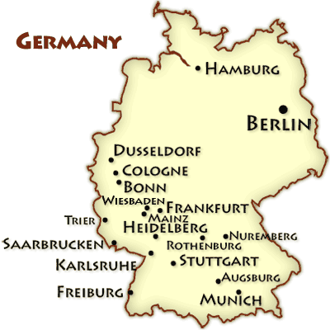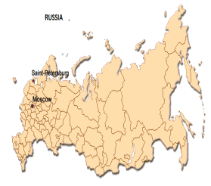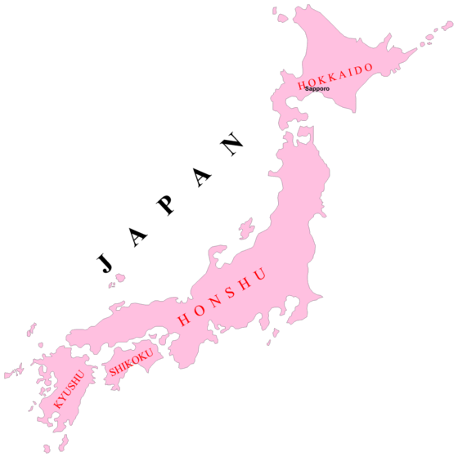
A) B) C) D)

61. Replace the question mark:
?
25
9
16
4
1

A) 50 B) 75 C) 36 D) 49
62. Replace the question mark:
2
1
1
2

4
5
1
3
3
?
5
12

A) 14 B) 15 C) 16 D) 17
63. Replace the question mark: A) 72
18
?
5
13
52
4
3
12
36
B)82
C)90
D)80

64. Replace the question mark:
?
I
E
G
C
A

A) J B) K C) L D) M

65. Replace the question mark:
?
Q
L
H
E
C

A) S B) T C) W D) X

66. 33 + 33 + 33 + 33 + 33 = ------ X 33
A) 5 B) 3
C) 4 D) 2
67. When a number passes through a box, a different number comes out. If 2 goes in 4 comes out, if 3 goes in 9 comes out, if 4 goes in 16 comes out. If 5 go in, which number will be coming out?
A) 25 B) 15
C) 50 D) None of these.
68. In a certain code CLASS III is written as III SSALC. How is CLASS II written in that code?
A) II CLASS B) II SSCLA
C) II ALCSS D) II SSALC
69. Raju walks 50m towards north and turns his right and walks. Now which direction he is facing?
A) East B) West
C) North D) South
70. Which one of the following player is associated with badminton?
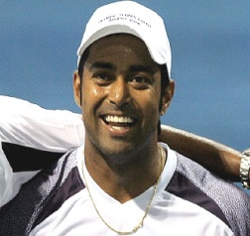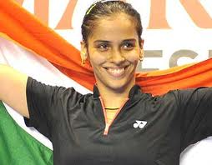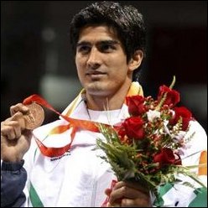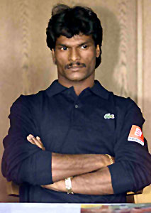
A) B) C) D)
Space for Rough Works

