***International Young***

***Mathematicians’ Convention (IYMC)***

**2012 Individual Contest –Senior level**

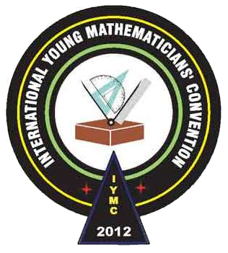

1. If  and  are perfect squares, where *x* and *y* are positive integers, what is the smallest value of *x* + *y*?
2. Determine  if *x* and *y* are real numbers that satisfy  and .
3. A password consists of four distinct digits such that their sum is 19 and such that exactly two of these digits are primes. For example 0397 is a possible password. How many possible passwords are there?
4. For any positive integer *n*, we define *n* as the product of the integers from 1 to *n*, and call it the factorial of *n*. Also 0 is defined as 1. Some numbers are equal to the sum of the factorials of their digits. For example 40585=4+0+5+8+5. Find such a number with three digits.



1. All six faces of a cube are completely painted. It is cut into 64 identical cubes. One of these cubes is chosen at random and rolled. Find the probability that none of the five faces showing is painted.
2. Solve the equation , where all square roots are taken to be positive.
3. In the figure, *BC*>*AC*, *AE*=*EB*, *CH*⊥*AB*, ∠*ACF*=∠*FCB* and ∠*HCF*=∠*FCE*. Find the measure of ∠*ACB*, in degrees.

*A*

*H*

*F*

*E*

*B*

*C*

1. How many ordered triple (*x*, *y*, *z*) of integers satisfy *xyz* = 2012?