Time：60 minutes

Instructions:

* Do not turn to the first page until you are told to do so.
* Remember to write down your team name in the space indicated on every page.
* There are 6 problems in the Team Contest, arranged in increasing order of difficulty. Each question is printed on a separate sheet of paper. Each problem is worth 40 points and complete solutions of all problems are required for full credits. Partial credits may be awarded. In case the spaces provided in each problem are not enough, you may continue your work at the back page of the paper.
* The three team members are allowed 10 minutes to discuss and distribute the problems among themselves. Each student must attempt at least one problem. Each will then have 50 minutes to write the solutions of their allotted problem independently with no further discussion or exchange of problems.
* No calculator or calculating device or electronic devices are allowed.
* Answer must be in pencil or in blue or black ball point pen.
* All papers shall be collected at the end of this test.

|  |  |
| --- | --- |
| *Team Code* |  |

**For Juries Use Only**

|  |  |  |  |  |  |  |  |
| --- | --- | --- | --- | --- | --- | --- | --- |
| No. | **1** | **2** | **3** | **4** | **5** | **6** | **Total** |
| Score |  |  |  |  |  |  |  |
| Sign by Jury |  |  |  |  |  |  |
| Score |  |  |  |  |  |  |  |
| Sign by Jury |  |  |  |  |  |  |

1. A simple tune consists of the following 12 notes in the order:

C, E, E, E, G, G, D, F, F, A, B, B

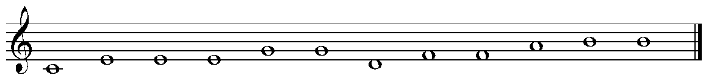

How many different tunes can be made with the same 12 notes?

|  |  |
| --- | --- |
| *ANSWER:* | tunes |

1. Any two adjacent dots in the diagram are 1 unit from each other. A path consists of horizontal and vertical segments between the dots joined end to end. How many paths from point A to point B are there with length 10 units?

*B*

*A*

|  |  |
| --- | --- |
| *ANSWER:* | paths |

1. In the figure , *ABCD* is a quadrilateral. If *AP*=*BP*, *CR*=*DR* and ∠*OEF*=∠*OFE*, prove that *AC*=*BD*.

*A*

*F*

*E*

*D*

*C*

*B*

*R*

*P*

*O*

1. How many different ordered triples  of positive integers satisfy  and 

|  |  |
| --- | --- |
| *ANSWER:* |  |

1. In the figure, *AB=BC* and ∠*B* = 90°. If *D* is a point inside △*ABC* such that

*BD*= *CD* and ∠*ACD* = 30°. What is the measure of ∠*ADB* , in degree?

*D*

*A*

*C*

*B*

30°

|  |  |
| --- | --- |
| *ANSWER:* |  |

°

1. If , what is the value of ?

|  |  |
| --- | --- |
| *ANSWER:* |  |