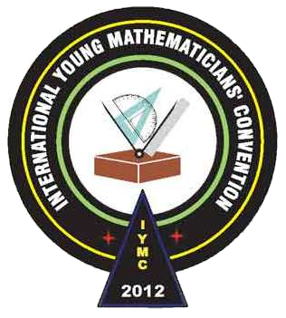
International Young
Mathematicians’ Convention (IYMC)
2012 Individual Contest –Junior level

- A watch with an hour hand and a minute hand shows the time as 3:28. How many minutes later will the angle between the two hands be equal to 120°?
- In the figure below, lines AB, DE and CF are perpendicular to line BD.
If AB = 30 and DE = 20, find the length of CF.
A
F
E
D
C
B

- When 40! is expanded in base 10, what is the tenth digit from the right?
(We define n as the product of the integers from 1 to n.)
- On a street, the houses are all on one side. They are numbered consecutively from 1 to 99. There is a value of x such that 3 times the sum of the numbers of the houses preceding the house numbered x is equal to the sum of the numbers of the houses following it. Find the value of x.
- The total weight of several stones is 500 kilograms. The lightest ten stones weigh 200 kilograms. The heaviest six stones weigh 145 kilograms. The weights of stones are pairwise different and are not necessary integers. Find the number of stones.
- Find the number of 10-digit numbers such that each of them is formed by using each of the digits 0 to 9 once, with no digit smaller than both neighbours.
- A positive integer is said to be curious if it is the smallest of all positive integers with the same sum of digits. If all the curious numbers are arranged in ascending order, what is the 100th number?

F
D
E
A
C
B

60°
30°
20°
50°
- In triangle ABC, AB = AC. D is a point on AC and E is a point on AB. BD and CE intersect at F. If ∠DBC = 50°, ∠ABD = 30°, ∠DCE = 20° and ∠ECB = 60°, what is the measure of ∠CED, in degree?

