HTNO
MLR15

Code No: A10305
MLR INSTITUTE OF TECHNOLOGY
(An Autonomous Institution)
B.Tech I Year II Semester Examinations, June 2016

ENGINEERING DRAWING
(IT & Aero)

Time: 3 Hours Max.Marks:75

1.Construct an ellipse when its major axis is 90mm and minor axis is 55mm using
concentric circles method.
(OR)

2.Draw an epicycloid of rolling circle 40mm (2r), which rolls outside another circle (base
circle) of 150mm diameter (2R) for one revolution. Draw a tangent and normal at any
point on the curve.

3.A line BC, 80mm long, is inclined at 45⁰ to the HP and 30⁰ to the VP. Its end B is in the
HP and 40mm in front of the VP. Draw its projections.

(OR)

4. A line CD, 90mm long, measures 72mm in front view and 65mm in top view. Draw the
two views of the line if it fully lies in the first quadrant. Find the true inclinations of the
line. Point C lies at a distance 20mm from the reference planes.

5. A semicircular plane of 60 mm diameter is inclined to the VP at 30⁰. Its straight edge is in
the VP and inclined to the HP at 45⁰. Draw its views.

(OR)

6. A square pyramid base 35 mm side and axis 80 mm long has a triangular face in the HP
and the vertical plane containing the axis makes an angle of 45⁰ with the VP. Draw its
projections.
7. A square prism of side of base 40 mm and axis 80 mm long, is resting on its base on HP
such that, a rectangular face of it is parallel to VP. Draw the development of the prism.

(OR)

8. A cone of base 50 mm diameter and height 65 mm rests with its base on HP. A section
plane perpendicular to VP and inclined at 30⁰ to HP bisects the axis of the cone. Draw the
development of the lateral surface of the truncated cone.

9. Draw the three possible ways of representing the isometric projection of a hexagonal
prism, side of base 25 mm and height 60 mm.
(OR)

10. Draw three views of the blocks shown pictorially in figure.1 according to first
angle projection.
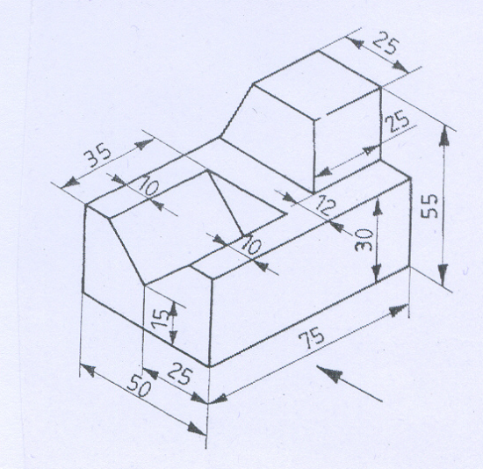

Fig.1

*****

