KTSE (Kutchi Talent Search Examination) – 2015
(Nanji Monji Dedhia Charitable Trust)

Name: _____________________ ID No.: _______

SET A
Instructions

- The exam duration is 120 minutes ( 2 hours)
- The exam is of 100 marks

- There are 80questions in two sections for a total of 100 marks
  - SECTION 1: 1 marks each (60 questions adding up to 60 marks)
  - SECTION 2: 2 marks each (20 questions adding upto 40 marks)
  - There is NO negative marking

- The rough work should be done on separate paper provided.

- Answer Sheet
- All questions are multiple choice. With a black pen, fill the correct answer in the answer sheet separately provided.
- At the top, put down your name and the ID (registration) number
- There are two sets. Set A and Set B. The order of questions are different in each. Please ensure that you correctly fill in circle A or B depending on which question paper you get. It is important to fill this right so that the computer checks against the right answer keys.
- Fill in the ID number at the right also. Make sure that the ID number fields are filled properly (one in each column and not all in one column), and also written in the boxes above. Your ID number is the registration number given to you by KTSE

- Results
  - The results will be announced by Thursday, 11th June
  - Marks for everyone by ID number will be put up on the KTSE website, www.ktse.in The correct answer list will also be put up
  - Only the top 40 will called for the next interview round, that will be held on Saturday, 13th June
  - Please do NOT call. Check the website. Only the top 40 will get email and/or SMS informing about interview time

ALL THE BEST !!

SECTION 1

ALL QUESTIONS IN THIS SECTION ARE OF 1 MARKS

Q (1 mark)A bat and a ball cost Rs. 110 in total. The bat costs Rs. 100 more than the ball. How much does the ball cost?

A: Rs. 5 B: Rs. 10 C: Rs. 15 D: Rs. 20 E: Rs. 1

Q (1 mark)A paper is folded as shown below and two holes are punched into it. When the paper is opened, how will it look?
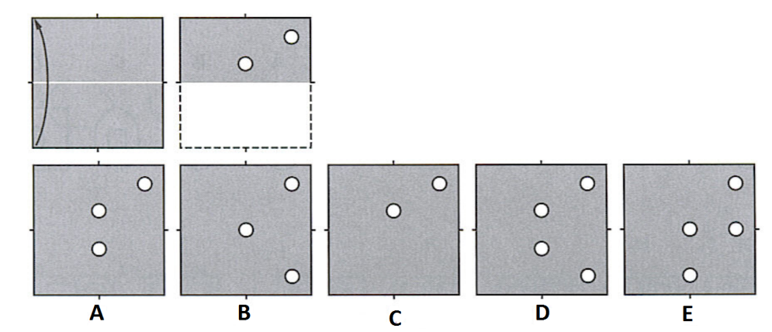
A: A B: B C: C D: D E: E

Q (1 mark) Of the five figures marked “A” to “E”, which is different from the rest?
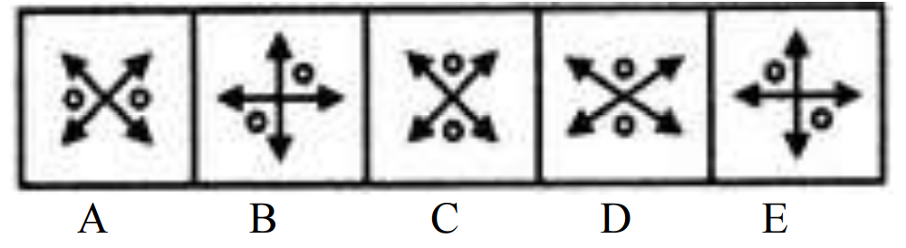
A: A B: B C: C D: D E: E

Q (1 mark) How many 8’s are there in the following sequence which are immediately preceded by 6 but not immediately followed by 5?

6, 8, 5, 7, 8, 5, 4, 3, 6, 8, 1, 9, 8, 5, 4, 6, 8, 2, 9, 6, 8, 1, 3, 6, 8, 5, 3, 6

A: 1 B: 2 C: 3 D: 4 E: 5

Q (1 mark) Which number replaces the ‘?’ in the matrix below?
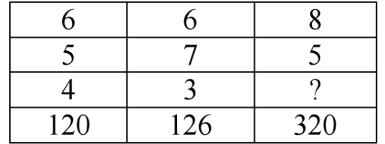

A: 2 B: 6 C: 9 D: 8 E: 4

Q (1 mark) If 20% of a is b, then b% of 20 is equal to-

A: 2% of a B: 4% of a C: 6% of a D: 50% of a
E: 60% of a

Q (1 mark) 10 years ago the age of a father was 3 times that of his son. 10 years later father’s age willbe 2 times that of the son. The ages of father and son today are in the ratio of-

A: 8:5 B: 6:4 C: 9:5 D: 7:3 E: 2:1

Q (1 mark)The following letter group series has been formed following a particular logical rule-
ABC, ZYX, DEF, WVU, ………
The correct letter group that continues the series is-
A: HIJ B: GHI C: IJK D: TSR E: QRS

Q (1 mark)½ divided by 0.05 is

A: 0.0005 B: 1 C: 10 D: 100 E: 0.025

Q (1 mark) A pie is cut so that one piece, which is one quarter of the pie, is twice as large as
each of the other pieces. Into how many total pieces is the pie cut?

A: 3 B: 4 C: 6 D: 7 E: 8

Q (1 mark) INCITE means the same as

A: short B: delay C: place D: provoke E: quote

Q (1 mark) The average between a two digit number and the number obtained by interchanging the digits is 9. What is the difference between the two digits of the number?

A: 8 B: 2 C: 5 D: 18/11 E: Cannot be determined

Q (1 mark) The probability that a man will be alive for 50 years is 3/5 and the probability that his wife will be alive for 50 years is 2/3. Find the probability that, out of the couple, only the man will be alive for 50 years ?

A: 2/5 B: 1/5 C: 3/5 D: 4/5 E: Cannot be determined

Q (1 mark) The average age of students of an adult school is 40 years. 120 new students whoseaverage age is 32 years joined the school. As a result the average age is decreased by 4 years. Find the total number of students of the school after joining of the new students.

A: 1200 B: 120 C: 360 D: 240 E: 160

Q (1 mark) A man owns 2/3 of a market research business. He sells 3/4 of his shares for
Rs.75000. What is the total value of the business?

A: 150000 B: 13000 C: 240000 D: 34000 E:120000

Q (1 mark) I have trouble ________.

A: to remember my password B: to remembering my password
C: remember my password D: remembering my password E: to remember password

Q (1 mark) A papaya tree was planted 2 years ago. It increases at the rate of 20% every year. If at present, the height of the tree is 540 cm, what was it when the tree was planted?

A: 432 cm B: 375 cm C: 400 cm D: 324 cm E: 385.7

Q (1 mark) 'A' is twice as good a workman as 'B' and together they finish a piece of work in 18 days. In how many days will 'A' alone finish the work?

A: 27 B: 26 C: 25 D: 24 E: 22

Q (1 mark) Daal is now being sold at Rs. 20 a kg. During last month, its rate was Rs.16 per kg. By how much percent should a family reduce its consumption so as to keep their expenditure fixed?

A: 12 % B: 4% C: 20% D: 40% E: 25%

Q (1 mark) As Horse is related to Jockey, so is Car related to

A: Mechanic B: Chauffeur C: Steering D: Brake E: Passenger

Q (1 mark) How many points will be on the face opposite to the face which contains 2 points?
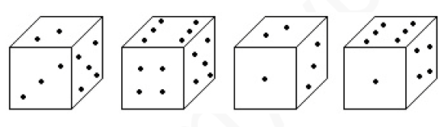

A: 1 B: 5 C: 4 D: 6 E: 3

Q (1 mark) Which figure comes next in the series ?
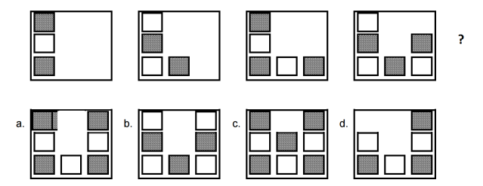

A: a B: b C: c D: d E: none of the above

Q (1 mark) What is the missing number in the following series?
5 7 11 17 ? 35

A: 20 B: 22 C: 25 D: 28 E: 30

Q (1 mark) Find the missing number.

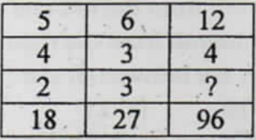

A: 1 B: 2 C: 4 D: 6 E: 8

Q (1 mark) Identify the correct 3-D figure from the answer
figures, which has the elevation as given in the problem figure on the left.

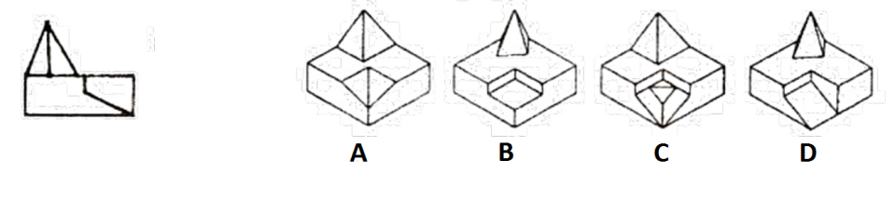
A: A B: B C: C D: D E: None of the above

Q (1 mark) The 3-D problem figure on the left shows the view of an object. Identify the correct elevation as seen from the direction of the arrow.
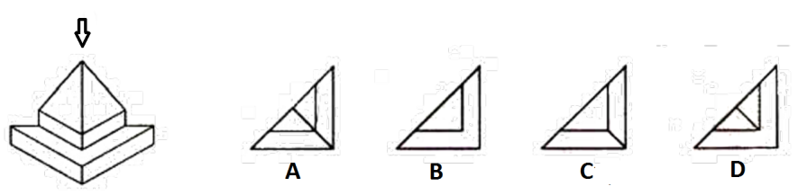
A: A B: B C: C D: D E: none of the above

Q (1 mark) Find out the total number of surfaces of the objectgiven below.
A: 10 B: 11 C: 12 D: 13 E: 14

Q (1 mark) What is the mirror image of the drawing on the left ?

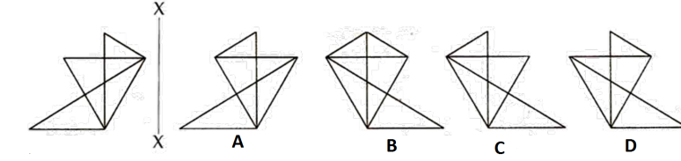

A: A B: B C: C D: D E: All of the them are mirror images

Q (1 mark) Identify the correct "top view" of the given object amongst the answer figures.
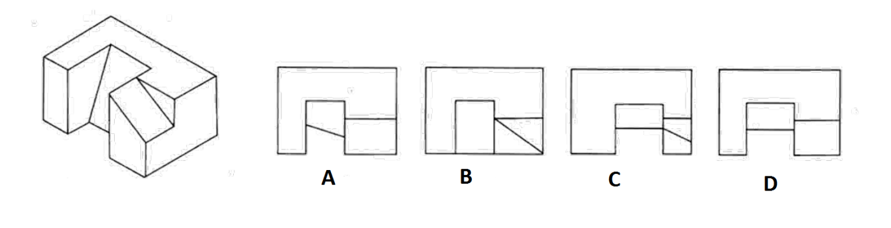
A: A B: B C: C D: D E: All of the above are possible

Q (1 mark) The diagram below presents the route followed by an ant looking for food. On this route the ant walked a specific distance and then turned right. Every time the ant turned right it walked 2 meters less than the previous time. On the last part of the route the ant walked one meter before stopping. What was the total distance it walked?

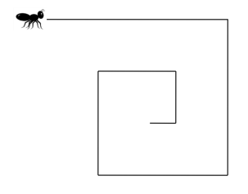
A: 30 m B: 49 m C: 18 m D: 24 m E: 42 m

Q (1 mark) Find the first number in the series

? 19 23 29 31

A: 13 B: 14 C: 15 D: 16 E: 17

Q (1 mark) Which of the Answer Figures fits in the missing space in the Question Figure?
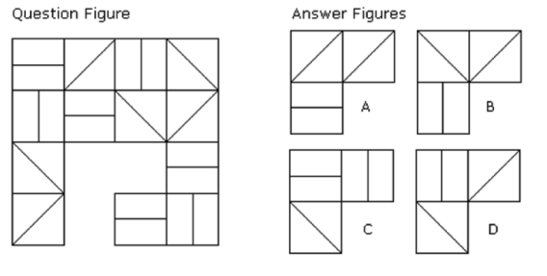
A: A B: B C: C D: D E: none of the above

Q (1 mark) Which of the patterns when folded will make the cube shown?
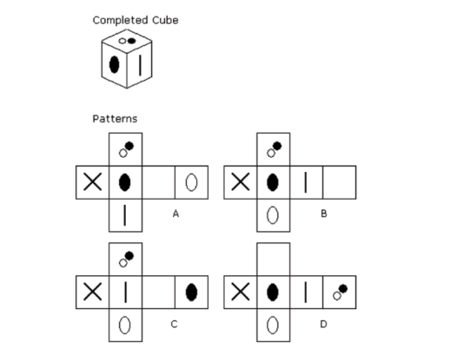

A: A B: B C: C D: D E: All the patterns

Q (1 mark) Which set follows all the rules given below?
- Odd numbers are always above the line
- Most of the numbers below the line are less than 12
- Numbers between 4 and 8, not including 4 and 8, are never below the line
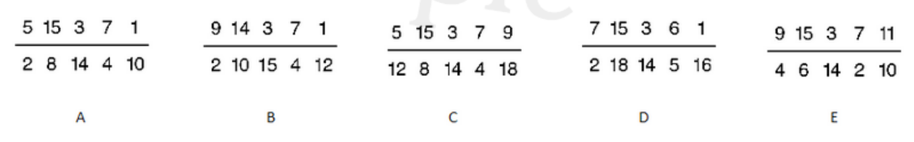
A: A B: B C: C D: D E: E

Q (1 mark) Radha moves towards South-east for a distance of 7 km, then she moves towards West and travels a distance of 14m. From here, she moves, towards North-west, a distance of 7 m and finally she moves a distance of 4 m towards East and stands at that point. How far is the starting point from where she stands?

A: 3 m B: 4 m C: 8 m D: 10 m E: 11 m

Q (1 mark) In a certain office, 1/3 of the workers are women, 1/2 of the women are married and 1/3 of the married women have children. If 3/4 th of the men are married and 2/3 rd of the married men have children, what part of workers are without children?

A: 5/18 B: 11/18 C: 4/9 D: 17/18 E: 17/36

Q (1 mark) A, P, R, X, S and Z are sitting in a row. S and Z are in the centre. A and P are at the ends. R is sitting to the left of A. Who is to the right of P?

A: P B: A C: X D: S E: Z

Q (1 mark) You have to take the given two statements to be true even if they seem to be at variance from commonly known facts.

Statements: Some dogs are bats. Some bats are cats.

From these 2 facts, which of the following conclusions necessarily follow ?
1. Some dogs are cats.
2. Some cats are dogs

A. Only (2) conclusion follows
B. Both (1) and (2) follow
C. Either (1) or (2) follows
D. Only (1) conclusion follows
E. Neither (1) nor (2) follows

A: A B: B C: C D: D E: E

Q (1mark) Which figure completes the pattern ?
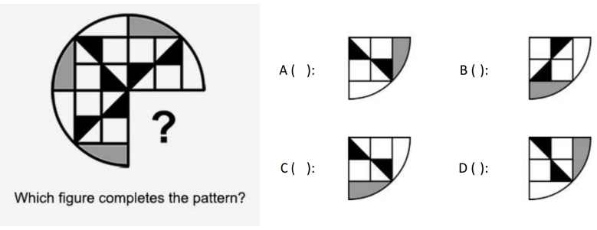

A: A B: B C: C D: D E: none of the above

Q (1 mark)Which one of the figures can be formed by rotating the figure below?
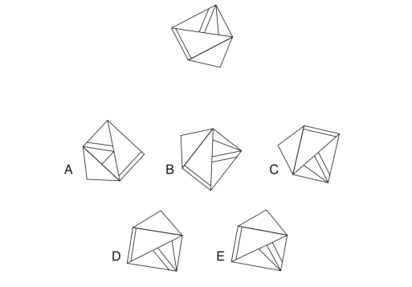

A:A B: B C: C D: D E: E

Q (1 mark)A bag of potatoes weighs 50 kgs divided by half of its weight.How much does the bag of potatoes weigh?

A:5 kg B: 10 kg C: 15 kg D: 20 kg E: 25 kg

Q (1 mark)HILT is to LMPY as DENS is to ????

A:MENS B: HIRW C: GHRX D: HIRX E: GHIR

Q (1 mark)Out of 384 guests at a conference, a quarter took their coffee with sugar only, 5/8 took it with both milk and sugar, one out of every 16 guests took it with milk only and the rest took it black with neither milk nor sugar. How many guests took it black with neither milk nor sugar?

A: 24 B: 26 C: 36 D: 38 E: 40

Q (1 mark)Which is the odd one out ?
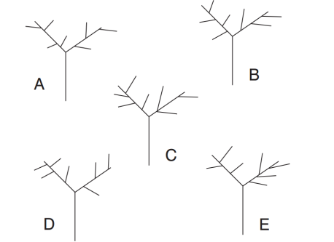

A:A B: B C: C D: D E: E

Q (1 mark)How tall is a sapling that is 3 feet shorter than a fence that isfour times the height of the sapling?

A:7 ft B: 4 ft C: 1 ft D: 6 ft E: 3.5 ft

Q (1 mark)Complete the equation by correctly identifying the missingpart of the calculation from the list of options below.
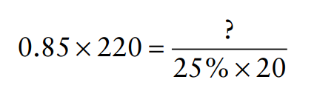

A:1090 - 145 B: 935 C: 85 + 29X29 D: 31x31 - 28 E: 945

Q (1 mark)Which hexagon should replace the question mark?
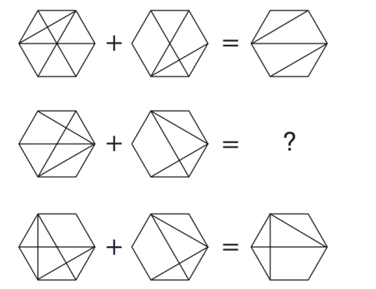

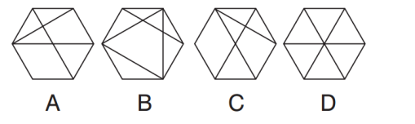

A:A B: B C: C D: D E: none of the above

Q (1 mark)Given the following information
1)A occurs only if either B or C occurs
2)B occurs only if both D and E occurs
3)F occurs only if C does not occur
4)G occurs only if both A and F occur

Which of the options below are true ?

A) B and C do not occur together
B) G does not occur if D does not occur
C) A occurs whenever F occurs
D) F never occurs
E) C occurs if F does not occur

A:A B: B C: C D: D E: E

Q (1 mark)In what ratio must rice at Rs 9.30 per Kg be mixed with rice at Rs 10.80 per Kg so that the mixture be worth Rs 10 per Kg?

A:6:5 B: 6:1 C: 3:7 D: 8:7 E: 3:4

Q (1 mark)By walking at 3/4thof his usual speed, a man reaches office 20 minutes later than usual. What is his usual time?

A:100 min B: 90 min C: 80 min D: 70 min E: 60 min

Q (1 mark)Choose the most logical order of sentences from among the given choices to construct a coherent paragraph

1) Thus begins the search for relief: painkillers, ice, yoga, herbs, even surgery
2) Most computer users develop disorders because they ignore warnings like tingling fingers, a numb hand or a sore shoulder
3) They keep pointing and dragging until tendons chafe and scar tissue forms, along with bad habits that are almost impossible to change
4) But cures are elusive, because repetitive stress injuries present a bag of ills that often defy easy diagnosis.

A:1234 B: 2413 C: 2143 D: 2314 E: 1342

Q (1 mark)Find the odd one out

A. twigs: nest

B. wood: furniture

C. picture: pottery

D. gold: ornaments

E. paper: book

A:A B: B C: C D: D E: E

Q (1 mark) 'A' can do piece of work in 30 days while 'B' alone can do it in 40 days. In how many days can 'A' and 'B' working together do it?

A: 17 1/7 B: 15 2/3 C: 15 2/7 D: 17 2/7 E: 35

Q (1 mark)Five boys were climbing a hill. J was following H. R was just ahead of G. K
was between G & H. They were climbing up in a column. Who was second?

A:J B: H C: R D: G E: K

Q (1 mark)Which of the following is larger than 3/5?

A: 1/2 B: 39/50 C: 7/25 D: 3/10 E: 59/100

Q (1 mark)A rectangular plate with length 8 inches, breadth 11 inches and thickness 2 inches is available. What is the length of the circular rod with diameter 8 inches and equal to the volume of the rectangular plate?

A:2 inches B: 7 inches C: 3.5 inches D: 9 inches E: 7.5 inches

Q (1 mark)If the time at this moment is 9 P.M., what will be the time 23999999992 hours later?

A:10 pm B: 1 pm C: 5 pm D: 12 pm E: 11 pm

Q (1 mark)I drove 60 km at 30 kmph and then an additional 60 km at 50 kmph. Compute myaverage speed over the entire 120 km

A: 32.5 kmph B: 34 kmph C: 35 kmph D: 37.5 kmph
E: 40 kmph

Q (1 mark)An investortrading through a stock broker, that charges Rs.10 for each transaction, bought 200 shares of Index Tile Corporation at Rs. 50 per share. The stock quickly increased in value by 50%, but then lost 40% of its value. The investor then sold the stock. How much money did the investor gain or lose?

A:gained Rs. 990 B: gained Rs. 980 C: lost Rs. 1010 D: lost Rs. 1020 E: no gain no loss

Q (1 mark)A high speed electric train is travelling Southwest at 100 kilometres per hour. The wind is blowing Westward at 60 kilometres per hour. In what direction will the smoke from the engine blow?

A:Southwest at 70 kmph B: South at 70 kmph C: between southwest and west at 50 kmph D: south at 50 kmph E: No smoke will blow

SECTION 2

ALL QUESTIONS IN THIS SECTION ARE OF 2 MARKS

Q (2 marks)In the multiplication shown below, ‘A’ and ‘B’ are two different single digit numbers, each being more than 0 but less than 9.

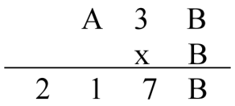
The numerical difference between ‘A’ and ‘B’ is

A: 1 B: 2 C: 3 D: 6 E: 8

Q (2 marks) 'A $ B' means A is the father of B; 'A # B' means A is the sister of B; 'A * B' means A is the daughter of B and 'A @ B' means A is the brother of B. Which of the following indicates that M is the wife of Q?

A:M$Q@R*T B: Q@R*T#M C: Q#R*T@M D: Q$R@T*M
E: Q#R*T*M

Q (2 marks)Six persons named A, B, C, D, E and F live in an apartment in Mangalore and by profession they are Engineer, Housewife, Journalist, Lawyer, Photographer and Waiter but not necessarily in that order. The six people include two married couples. Further
I. A is married and his wife is a Housewife by profession.
II. B is a Lawyer, who is married to the Photographer sister of A.
III. D is the brother of C.
IV. C is not a Housewife by profession.
V. The Waiter is going to get married to his girlfriend in Puttur shortly.
VI. E, a Journalist, is unmarried and has taken a vow to never get married.

Who is the Engineer?

A: A B: C C: D D: F E: Cannot be determined

Q (2 marks)Naga was born in the year 19n. ‘n’ is a two digit number. In the year 2014 he completed ‘n’ yearsof his age. The sum of the two digits of ‘n’ is

A:10 B: 18 C: 12 D: 7 E: 9

Q (2 marks)Akbar keeps running on a circular track with a uniform speed such that he completes one round every 40 seconds. On the same circular track, Basha keeps running, but in the direction opposite to Akbar, with such uniform speed, that Akbar meets him every 15 seconds. The time taken by Basha to complete each round of the circular track is-

A:15 secs B: 24 seconds C: 32 seconds D: 55 seconds
E: 1 minute 10 seconds

Q (2 marks)A person has 4 notes, a Rs. 10 note, a Rs. 100 note, a Rs. 500 note and a Rs 1000note. What is the number of different sums ofmoney the person can form (using one or more notes at a time)?

A:16 B: 15 C: 12 D: 11 E: 14

Q (2 marks)There is a cube whose dimensions are 4 x 3 x 3 cm. All sides are painted yellow. Now the cube is cut into small cubes of side 1 cm.How many small cubes will have no face coloured?

A:1 B: 2 C: 4 D: 8 E: 12

Q (2 marks) Which of the Complete Shapes can be made from the Components below ?
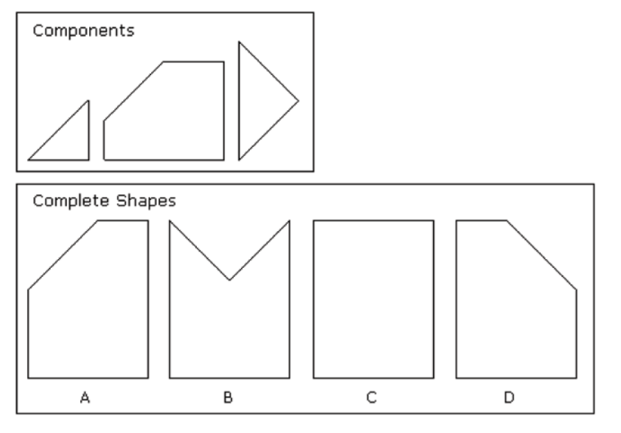
A: A B: B C: C D: D E: none of the shapes are possible

Q (2 marks)
100, 99.8, 99.2, ? , 92, 75.8
What number should replace the question mark?

A: 97.4 B: 96.8 C: 95.4 D: 94.4 E: 91.1

Q (2 marks)Each three digit number in group I matches to one three letter word in group II, (and each letter in the word corresponds to a number in the three digit number). What number does TIE refer to ?

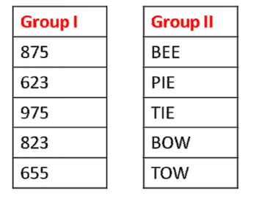

A:655 B: 875 C: 623 D: 975 E: 823

Q (2 marks)If every alternative letter starting from 'b' of the English alphabet is written insmall letters, and rest all are written in capital letters, how will the month “ September” be written ?

A:SeptEMbEr B: SEpTeMBEr C: SeptembeR D: SepteMber E: None of the above

Q (2 marks)The total age of some 7 years old and some 5 years old children is 60 years. If I have to select a team from these children such that their total age is 48 years, In how many ways can it be done?

A: 1 B: 2 C: 3 D: 4 E: 5

Q (2 marks)In a set of three numbers, the average of first two numbers is 2, the average of the last two numbers is 3, and the average of the first and the last numbers is 4. What is the average of the three numbers?

A: 2 B: 3 C: 4 D: 9 E: 12

Q (2 marks)If a train 110 m long passes a telegraph pole in 3 seconds, then the time taken by it to cross a railway platform 165 m long, is

A:3 sec B: 4.5 sec C: 6 sec D: 7.5 sec E: 9 sec

Q (2 marks) 'A' and 'B' can do a piece of work in 30 days, while 'B' and 'C' can do the same work in 24 days and 'C' and 'A' in 20 day. They all work together for 10 days, after which 'B' and 'C' leave. How many days more will 'A' take to finish the work?

A: 18 days B: 19 days C: 20 days D: 21 days E: 22 days

Q (2 marks)A man bought a toy horse and a toy cart. If he sold the horse at 10 % loss and the cart at 20 % gain, he would not lose anything; but if he sold the horse at 5% loss and the cart at 5% gain, he would lose Rs. 10 in the bargain. The amount paid by him for the horse and the cart respectively were

A:Rs. 200 , Rs. 100 B: Rs 250, Rs. 150 C: Rs. 300, Rs. 150
D: Rs. 380, Rs. 160 E: Rs 400, Rs 200

Q (2 marks)David passed one sixth of his life in childhood, one twelfth in youth, and one
seventh more as a bachelor; five years after his marriage a son was born who died
four years before his father at half his final age. How old is David?

A:72 years B: 74 years C: 78 years D: 80 years
E: 84 years

Q (2marks) The functions M and S transform the input shapes in a certain way. You need to use the diagram to determine what effect each of these functions has. Apply them to the input shape in the question to arrive at the correct output.

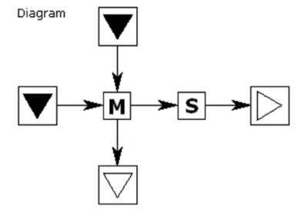

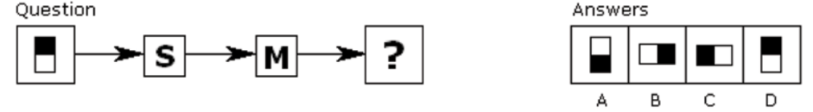

A: A B: B C: C D: D E: None of the above

Q (2 marks)At a party, everyone shook hands with everybody else. There were 66 handshakes. How many people were at the party?

A:33 B: 32 C: 10 D: 11 E: 12

Q (2 marks)All students in the physics class also study mathematics. Half of those who study literature also study mathematics. Half of the students in the mathematics class study physics. Thirty students study literature and twenty study physics. Nobody who studies literature studies physics. How many students in the mathematics class study neither physics nor literature?

A:1 B: 5 C: 10 D: 15 E: 20

