KTSE (Kutchi Talent Search Examination) – 2014
(Nanji Monji Dedhia Charitable Trust)

Name: _____________________ ID No.: _______

SET A

Instructions

- The exam duration is 120 minutes ( 2 hours)
- The exam is of 100 marks

- There are 80 questions in two sections for a total of 100 marks
  - SECTION 1: 1 marks each (60 questions adding up to 60 marks)
  - SECTION 2: 2 marks each (20 questions adding upto 40 marks)
  - There is NO negative marking

- The rough work should be done on separate paper provided.

- Most questions are multiple choice. With a black pen, fill the correct answer in the answer sheet separately provided.

Results
- Marks for everyone (including the answer key) will be published on www.ktse.in by Thursday, 12th June. Do not call to find out the marks, check on the site
- Only the top 40 will get an email/SMS call for interview by Thursday
- The interview will be held on Friday or Saturday, 14th June at Seepz, Andheri (address will be sent)
- 80% weightage will be given to the marks in the aptitude test and 20% for the interview
- The top 20 will be informed by Saturday evening by email/SMS/phone
- The award function will be held on Sunday, 15th June for the 20 scholars and their parents
- The award ad will come in Patrika the following week

ALL THE BEST !!
SECTION 1

ALL QUESTIONS IN THIS SECTION ARE OF 1 MARKS

Q (1 mark)If the image given below is reflected in a pool of water which of the options shall it resemble ?
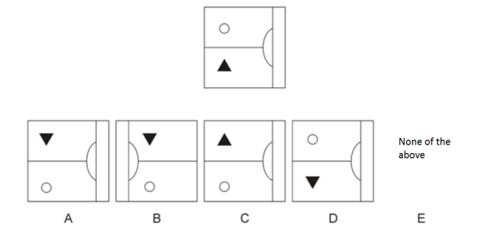

A:A B:B C:C D:D E:E

Q (1 mark)On folding the paper given below into the shape of a cube (like a dice) which letter would lie opposite E?
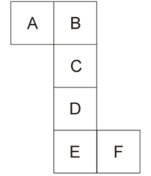
A: A B: B C: C D: D E: E

Q (1 mark)The below five figures are in a logical series. Out of the options A, B, C, D and E what comes next in the series?
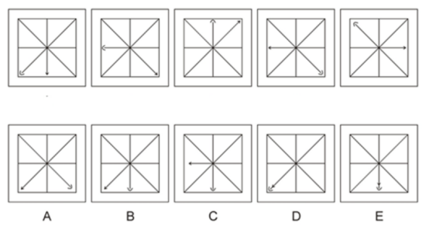
A: A B: B C: C D: D E: E

Q (1 mark)If in a certain code MERGER has been coded as NGUKJX, in that language what will be the code for STRATEGY ?

A: TVUEYLNH B: TVUEYLNF C: TVUEYKMF D: TVUEYKNF
E: TVUEYKNG

Q (1 mark)Find the next term in the series below?

2, 8, 24, 60, 136, 292, ?

A: 608 B: 610 C: 612 D: 614 E: 616

Q (1 mark)What will be the middle digit of the 2nd highest number after the positions of the first and third digits in each of the below numbers is reversed?

138 429 568 222 483 ?

A: 3 B: 2 C: 6 D: 8 E: 1

Q (1 mark)The average of 40 numbers is zero. Of them, at the most, how many can be greater than zero ?
A: 0 B: 1 C: 39 D: 20 E: 21

Q (1 mark)The age of John 21 years from now will be half that of Parson at that time. Currently the ratio of John’s age to Parson’s age is 5:17. What was the age of Parson 2 years ago ?

A: 15 B: 49 C: 13 D: 36 E: 11

Q (1 mark)A game is played between 2 players and one player is declared as winner. Only the winners from first round are played in second round. Only the winners from second round are played in third round and so on. If 8 rounds are played to declare only one player as winner, how many players are played in first round?

A: 256 B: 512 C: 64 D: 128 E: 32

Q (1 mark)A and B are shooters and having their exam. A and B fall short of the qualifying mark by 10 and 2 shots respectively. If each of them fired at least one shot and even by adding their total score together, they fall short of the qualifying mark, what is the qualifying mark ?

A: 10 B: 11 C: 12 D: 13 E: 14

Q (1 mark)A man wants to sell his scooter. There are two offers, one at Rs. 12,000 cash and the other at a credit of Rs. 13,000 to be paid after 8 months. Interest on money in the market at 18% per annum. Which is the better offer ?

A: Rs. 12000 in cash B: Rs. 13000 in credit C: Both are equal D: Impossible to calculate

Q (1 mark)In an election between two candidates, one got 55% of the total valid votes. 20% of the total votes were invalid. If the total number of votes was 7500, what was the number of valid votes that the other candidate got?

A: 2400 B: 2600 C: 2700 D: 2800 E: 2950

Q (1 mark)A trader mixes 26 kg of rice at Rs. 20 per kg with 30 kg of rice of other variety at Rs. 36 per kg and sells the mixture at Rs. 30 per kg. His profit percent is ?

A: 5% B: 5.5% C: 6% D: 6.5% E: No profit no loss

Q (1 mark)Ayesha's father was 38 years of age when she was born while her mother was 36 years old when her brother four years younger to her was born. What is the difference between the ages of her parents?

A: 2 yrs B: 4 yrs C: 6 yrs D: 8 yrs E: 1 yr

Q (1 mark)A wheel that has 6 cogs is meshed with a larger wheel of 14 cogs. When the smaller wheel has made 21 revolutions, then the number of revolutions made by the larger wheel is: ?

A: 9 B: 49 C: 12 D: 4 E: 8

Q (1 mark)A box of 150 packets consists of 1kg packets and 2kg packets. Total weight of box is 264kg. How many 2kg packets are there ?

A: 150 B: 246 C: 114 D: 36 E: 28

Q (1 mark)A batsman's average in his first 50 innings was 50. After the 51st innings his average was 51. How many runs did he make in the 51st innings ?

A: 50 B: 51 C: 52 D: 84 E: 101

Q (1 mark)If DDMUQZM is coded as CENTRAL then RBDJK can be coded as ----- ?

A: CENTRAL B: QCEIL C: RSEIT D: WESTERN
E: UNEXT

Q (1 mark)What number should be added to each term of the ratio 17 : 24 so that it becomes equal to 1 : 2 ?

A: +12 B: -6 C: +8 D: -10 E: +1

Q (1 mark)If the radius of a circle is increased by 20% then the area is increased by ?

A: 44% B: 104% C: 144% D: 40% E: 4%

Q (1 mark)A father is three times as old as his son. After fifteen years the father will be twice as old as his son's age at that time. Hence the father's present age is ?

A: 36 B: 45 C: 38 D: 42 E: 60

Q (1 mark)A racehorse starts chasing a wild pony 3 hours after the pony bolts the stable. The pony runs through 7 villages, jumps 3 streams and crosses four 10 meter roads. The racehorse finally catches up with the pony after four hours. By the time the sun had set and the moon was up in the sky for 4 hours. If the average speed of the racehorse is 63kmph then average speed of the wild pony is ____ kmph ?

A: 24 kmph B: 20 kmph C: 32 kmph D: 36 kmph E: 42 kmph

Q (1 mark)30 teams enter a hockey tournament. A team is out of the tournament if it loses 2 games. What is the maximum number of games to be played to decide one winner ?

A: 60 B: 59 C: 61 D: 30 E: 34

Q (1 mark)A cube of 3x3x3 is painted from all the 6 faces. If I cut the cube in 27 equal cubes of 1x1x1 then how many cubes will be painted on exactly 2 faces ?

A: 27 B: 9 C: 12 D: 8 E: 17

Q (1 mark)In a box of one dozen eggs, the ratio of broken eggs to unbroken eggs could be any of the following EXCEPT?

A: 1:4 B: 1:3 C: 1:2 D: 1:1 E: 2:1

Q (1 mark)A train starts full of passengers. At the first station, it drops one-third of the passengers and takes 280 more. At the second station, it drops one-half of the new total and takes 12 more. On arriving at the third station, it is found to have 248 passengers. Find the number of passengers in the beginning ?

A: 240 B: 248 C: 258 D: 260 E: 288

Q (1 mark) A family consists of two grandparents, two parents and three grandchildren. The average age of the grandparents is 67 years, that of the parents is 34 years and that of the grandchildren is 5 years. What is the average age of the family in years?

A: 31 B: 32 C: 33 D: 34 E: 36.5

Q (1 mark)A two-digit number is such that the product of the digits is 8. When 18 is added to the number, then the digits are reversed. The number is ?

A: 18 B: 81 C: 24 D: 42 E: 28

Q (1 mark)There are five different houses. P, Q, R, S, T in a row. P is to the immediate right of Q. T is between S and R. P is to the immediate left of S. Which of the house is in the middle ?

A: P B: Q C: R D: S E: T

Q (1 mark)What is most accurately true for F in the diagram below ?
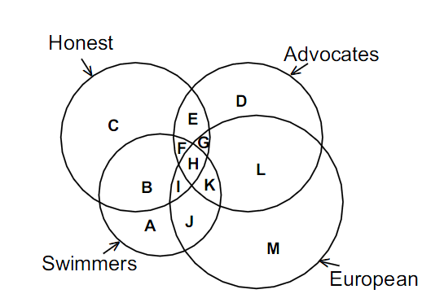
A: All honest european swimmers B: All honest advocates who are swimmers also
C: All non-european dishonest advocates who are swimmers
D: All non-european advocates who are honest swimmers
E: all honest european swimming advocates

Q (1 mark)Radha is wife of Mohan. She has three sons (in order of age) - Suresh, Rakesh and Satish. Bimla is only daughter of Radha. She is youngest. Name of the brother's wives are Sudha, Savita and Sita respectively. Mr Raghunath is husband of Bimla. Suresh has two daughters, Kamla and Sarla. He has a son Deepak. Rakesh has three sons named Sohan, Ramu and Kewal. Satish has one son (Shrikant) and one daughter (Shobha). Bimla has also one son (Sagar) and one daughter (Sarika)

Bimla is Kamla's ------?

A: sister B: aunt C: mother D: niece E: grandmother

Q (1 mark)Six sides of a cube are coloured in the following manner.
If Blue and Orange are opposite and Red is on the top, which colour will be at the bottom??
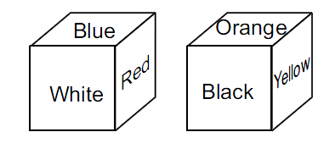
A: Blue B: Orange C: White D: Yellow E: Black

Q (1 mark)'A' ranks fifth in a class. B is eight from the last. If C is sixth after A
and just in the middle of A and B. How many students are there in the class??

A: 21 B: 22 C: 23 D: 24 E: 25

Q (1 mark)What figure comes next in the series ?

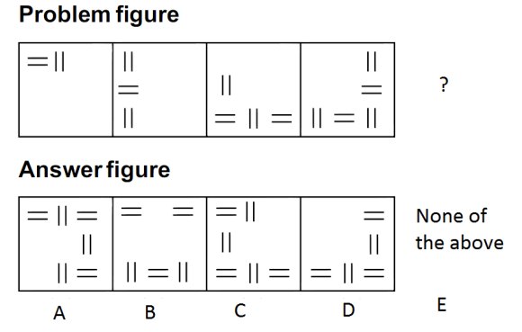
A: A B: B C: C D: D E: E

Q (1 mark)Below are different objects placed on a weighing balance to get a perfect balanceWhich object replaces the '?' ?
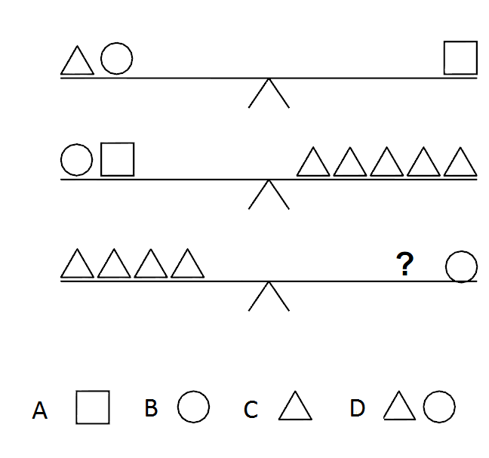
A: A B: B C: C D: D E: none of the above

Q (1 mark)P, Q, R, S are four statements such
that
If P is true, then Q is true
If Q is true, then R is true
If S is true then at least one of Q and R is false.
Then which of the following is correct?

A: If P is true then S is false B: If S is false both Q and R are true
C: If at least one of Q and R is false then S is false D: If Q is true then S is true.
E: All the above statements are true

Q (1 mark)A monkey climbs 10 meters at the beginning of each hour and rests for
a while during which he slips back 5 meters. He again starts climbing at the beginning of next hour. If he starts climbing at 8 am, at what time will he first touch the flag at 50 meters from the ground?

A: 4 pm B: 4:30 pm C: 5 pm D: 6 pm E: 7 pm

Q (1 mark)Which figure completes the design below ?

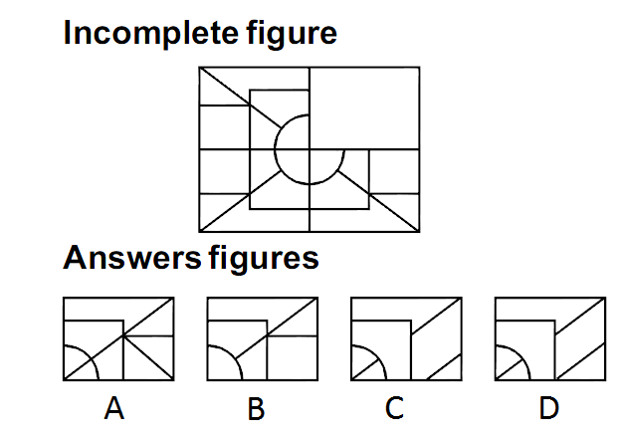

A: A B: B C: C D: D E: None of the above

Q (1 mark)Ram walks 20 meters in front towards east and then 15 meters to the right. Then every time turning to his left, he walks 5, 30 and 25 meters respectively. How far is he from his starting point and in which direction? ?

A: 5 meters, South B: 10 meters, North C: 15 meters, North
D: 20 meters, East E: 10 meters, South

Q (1 mark)B, the son of A was married to C, whose sister D was married to E, the brother of B. How D is related to A ?

A:Sister B: Sister-in-law C: Cousin D: Daughter
E: Daughter-in-law

Q (1 mark)Eight students A, B, C, D, E, F, G and H are going to college in two cars and following are conditions -
There are four students in each car.
A is in the same car in which D is sitting but H is not in the same car.
B and C are not in the car in which D is sitting.
F is sitting with A and E.
Four students sitting in the same car are:?

A: A, B, G, H B: B, D, F, G C: B, C, G, H D: A, C, D, E
E: A, B, C, D

Q (1 mark)Which one of the following diagram best indicate the relationship among Tennis fans, Cricket Players and students ?
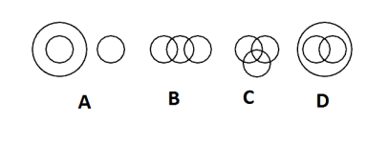
A: A B: B C: C D: D E: none of the above

Q (1 mark)Total motor vehicle accidents in UK are what times of that in Germany ?
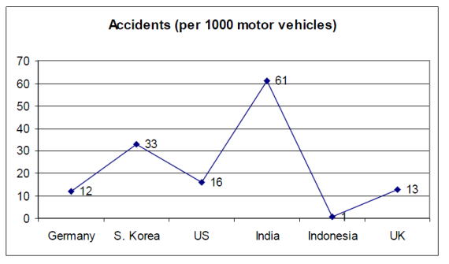

A: 8.33% B: 108.33% C: 10% D: 110% E: Data is inadequate

Q (1 mark)One evening before sunset Sumit and Mohit were talking to each other face to face. If Mohit’s shadow was exactly to his right side, what direction was Sumit facing?
A: North B: South C: East D: West E: Data not adequate

Q (1 mark)Choose the right option to fill in the blanks.
We must prevent endangered wild animal species from becoming………in order
that our future generation may……the great diversity of animal life

A: rare, escape B: outdated, know
C: volatile, notice D: extinct, enjoy E: finished, remember

Q (1 mark)Statement: In states showing greater economic progress, law and order is seen to be better. Which of the two conclusions can be drawn?
Conclusion 1: States with low incidence of crime will always be economically progressive
Conclusion 2: There is no relation between economic progress and the law and order situation.

A. only conclusion 1 can be drawn but not conclusion 2
B. only conclusion 2 can be drawn but not conclusion 1
C. only conclusion 1 can be drawn and sometimes conclusion 2 can be drawn
D. both the conclusion can be drawn
E. none of the conclusion can be drawn

A: A B: B C: C D: D E: E

Q (1 mark)Amar earns more money than does Ajay. But since Aditya earns more money than does Abhay, it follows that Amar earns more money than does Abhay. Which one of the following, when introduced into the argument does not make the argument above logically correct?
A. Ajay and Aditya earn same amount of money
b. Ajay earns more money than Abhay
c. Ajay earns more money than Aditya
D. Aditya earns more money than Amar
E. Ajay earns the same money as Aditya

A: A B: B C: C D: D E: E

Q (1 mark)
Statement 1: A says I am brother of B
Statement 2: B says I am not brother of A
In light of the above what can be concluded about the statements?
A. If statement1 is correct then statement 2 cannot be correct.
B. If statement 2 is correct then statement 1 cannot be correct
C. Both the statements can be correct
D. Both the statements have to be false
E. No co-relation can be drawn from two statements

A: A B: B C: C D: D E: E

Q (1 mark)The Reserve Bank of India has taken the risk …????…....is slowly moving up.
Arrange the following sentences in order to fit into the blank (????) above
P- as measured by wholesale price Index
Q- by allowing a large flow of funds
R- when the annual rate of inflation
S- into the economy at a time

A: PRQS B: QSRP C: RSPQ D: SQPR
E: PQRS

Q (1 mark)Choose the pair of words that has the same relationship as ?

Water: Swim

A: Graze:Grass B: Plan:Implement C: Flood:Damage
D: Ground:Play E: Clouds:Rain

Q (1 mark)At what degrees angle are the hands of a clock when it is half past 8 ?

A: 75 B: 65 C: 90 D: 60 E: 80

Q (1 mark)Examine the following statements
1. None but the rich can afford to travel by air
2. Some of those who travel by air become sick
3 Some of those who become sick require treatment

Which of the following conclusions can be drawn from the above statements

A: All the rich persons travel by air B: Those who travel by air become sick
C: All the rich persons become sick D: All of those who travel by air are rich
E: If you are sick and you travel by air, then your sickness will become worse

Q (1 mark)In a garrison, there was food for 1000 soldiers for one month. After 10 days, 1000 more soldiers joined the garrison. How long after this would the soldiers be able to carry on with the remaining food?

A: 25 days B: 10 days C: 15 days D: 17.5 days E: 20 days

Q (1 mark)Consider the following figures 1, 2, 3 and 4:

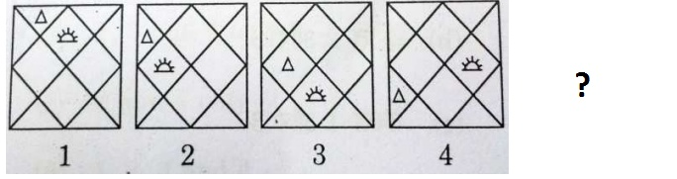
What figure comes next in the series

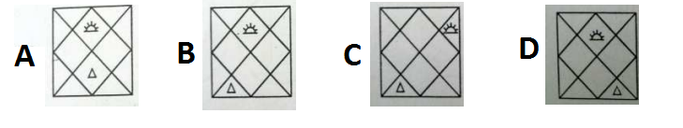

A: A B: B C: C D: D E: None of the above

Q (1 mark)A Village having a population of 4000 requires 150 litres of water per head per day. It has a tank measuring 20m x 15m x 6m. The water of this tank will last for ?

A: 3 days B: 13 days C: 30 days D: 300 days E: 31 days

Q (1 mark)Five people A, B, C, D and E, are seated about a round table. Every chair is spaced equidistant from adjacent chairs. C is seated next to A, A is seated two seats from D, and B is not seated next to A.

Which of the following must be true?
(I) D is seated next to B (II) E is seated next to A.

A: I only B: II only C: Both I and II D: Neither I nor II E: None of the above

Q (1 mark)Examine the following three figures in which the numbers follow a specific pattern:
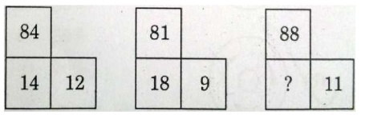
The missing number (?) in the third figure above is ...?

A: 7 B: 8 C: 16 D: 22 E: 44

Q (1 mark)The drawings on the left shows a sheet of paper which is being folded. The dashed lines represent the whole sheet, and each drawing represents a single fold. The black square shows where a hole was punched. The figure on the right shows the naming convention of the holes. Where do the holes appear when the sheet is unfolded ?
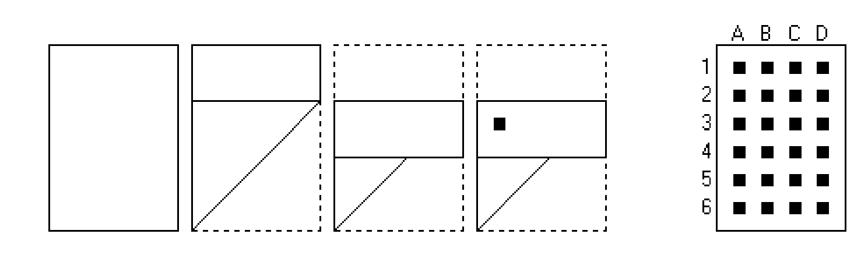

A: 3A,5A,5D B: 3A,2A C: 3A,5A,3D D: 3A,5A,6D
E: 3A,2A,6D

Q (1 mark) ?
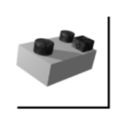
If the block above is rotated in space, which of the following is possible ?
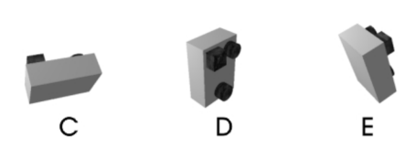

A: A B: B C: C D: D E: E

Q (1 mark) What is the sum of only the odd numbers in the following sequence ?

A: 31 B: 36 C: 34 D: 33 E:35

SECTION 2

ALL QUESTIONS IN THIS SECTION ARE OF 2 MARKS

Q (2 marks)Two bowls are taken, one contains water and second contains tea. Both of them are of equal amount. One spoon of water is taken from 1st bowl and is added to the second bowl and mixed well. Then a spoon of mixture is taken from second bowl and added to the 1st bowl. Which statement will hold good for the above?
A:The water in the 1st bowl is equal to the tea in the 2nd bowl B: The water in the 1st bowl is greater than the tea in the 2nd bowl C: The water in the 1st bowl is less than the tea in the 2nd bowl D:The tea in the first bowl is greater than the water in the second bowl
E: The tea in the 1st bowl is less than the tea in the 2nd bowl

Q (2 marks) A certain shade of gray paint is obtained by mixing 3 parts of white paint with 5 parts of black paint. If 2 gallons of the mixture is needed and the individual colors can be purchased only in one-gallon or half- gallon cans, what is the least amount of total paint, in gallons, that must be purchased in order to measure out the portions needed for the mixture?

A: 2 B: 3 C: 3 1/2 D: 4 E: 4 1/2

Q (2 marks) A lady has gloves in her closet, 25 blue, 7 red, and 9 yellow. The lights are out and it is totally dark. How many gloves must she take out to be absolutely sure that she has a pair of each color ?

A: 6 B: 36 C: 25 D: 8 E: 41

Q (2 marks) Anand finishes a work in 7 days, Bittu finishes the same job in 8 days and Chandu in 6 days. They take turns to finish the work. Anand on the first day, Bittu on the second and Chandu on the third day and then Anand again and so on. On which day will the work get over ?

A: 6th day B: 7th day C: 8th day D: 9th day E: 21st day

Q (2 marks) My flight took off at 2am from a place at 18N 10E and landed after a flight of 10 hrs at a place with coordinates 36N70W. What is the local time when my plane landed ?

A: 12 noon B: 5:20 am C: 2:40 pm D: 6:40 am E: 8 am

Q (2 marks) There is a circular pizza with negligible thickness that is cut into 'x' pieces by 4 straight line cuts. What is the maximum and minimum value of 'x' respectively ??

A: 11,5 B: 10, 6 C: 12,6 D: 11,8 E: 10,8

Q (2 marks) From a group of six boys M,N,O,P,Q,R and five girls G,H,I,J,K a team of six is to be selected .Some of the criteria of selection are as follows:
M and J go together
O cannot be placed with N
I cannot go with J
N and H go together
P and Q have to be together
K and R go together?

A: GMRPQ B: OPQRK C: HNOPQ D: KRMNP E: NPQRK

Q (2 marks) What number will replace the question mark in the following sequence

49, 15, 51, 216, 1100, ? , 46452

A: 6430 B: 6500 C: 6630 D: 6600 E: 6695

Q (2 marks) If a pipe can fill the tank within 6 hrs. But due to leak it takes 30 min more. Now if the tank is full then how much time will it take to empty the tank thought the leak ?

A: 69 hrs B: 78 hrs C: 56 hrs D: 72 hrs E: 12 hrs

Q (2 marks) Find average speed if a man travels from one point to the other at the speed of 24kmph and returns to original point at a speed 36kmph ?

A: 24 kmph B: 30 kmph C: 14.4 kmph D: 28.8 kmph E: 32 kmph

Q (2 marks) If the current selling price is doubled, the profit amount triples. Find the current profit percent.?

A: 66.66% B: 50% C: 100% D: 150% E: 33.33%

Q (2 marks) Six bells commence ringing together and ring at intervals of 2, 4, 6, 8 10 and 12 seconds respectively. All of them start with the first ring at 0th second. In 30 minutes, how many times do they ring together ?

A: 15 B: 16 C: 17 D: 18 E: 20

Q (2 marks) A can contains a mixture of two liquids A and B is the ratio 7 : 5. When 9 litres of mixture are drawn off and the can is filled with B, the ratio of A and B becomes 7 : 9. How many litres of liquid A was contained by the can initially ?

A: 10 B: 11 C: 20 D: 21 E: 28

Q (2 marks) Find the odd man out 396, 462, 572, 427, 671, 264 ?

A: 396 B: 462 C: 572 D: 427 E: 671

Q (2 marks) Seats for Mathematics, Physics and Biology in a school are in the ratio 5 : 7 : 8. There is a proposal to increase these seats by 40%, 50% and 75% respectively. What will be the ratio of increased seats ?

A: 2:3:4 B: 6:7:8 C: 4:5:7.5 D: 9:12:15.5 E: 6:8:9

Q (2 marks) If in a certain code 'facing problems with health' is coded as 'mlp hlt ngi snk' 'rise with every challenge' is coded as 'snk rtv lne riy', 'facing challenge each day' is coded as 'ngi riy nop hus'. 'health problems on rise' is coded as 'hlt sa rtv mlp' then whose code can be 'riy snk mlp'?

A: with health day B: challenge with health C: facing every challenge D: problems every day E: rise with challenge

Q (2 marks)
(a) P×Q means Q is mother of P;
(b) P+Q means P is father of Q;
(c) P–Q means P is brother of Q;
(d) P÷Q means Q is sister of P.
Which of the following means 'M is niece of T' ?

A: M÷D+T×R B: T–D+R÷M C: T×D+R÷M D: D÷M+R–T E:D÷M+R XT

Q (2 marks) Choose the alternative which will be formed after folding the fig (X) into a cube.?
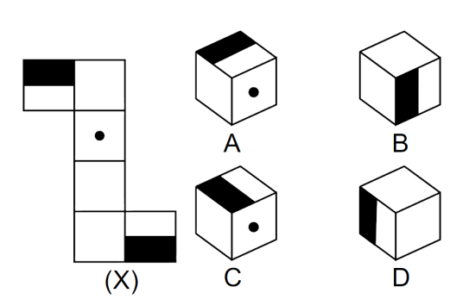

A: A & B only B: B & C only C: B & D only D: C & D only
E: A, B, C and D

Q (2 marks) The students of a school have an option to study only Hindi, only Sanskrit or a composite subject Hindi and Sanskrit. Out of the 175 students in the school, boys and girls are in the ratio of 3 : 4 respectively. 40% of boys have opted for only Hindi. 44% of the students have opted for only Sanskrit. Out of the total number of girls 32% have opted for the composite subject. The number of boys who opted for only Sanskrit and that for composite subject are in the ratio of 2 : 1 respectively. What is the ratio between the number of boys who have opted for only Hindi and the number of girls who have opted for the composite subject

A: 15:16 B: 10:7 C: 10:9 D: 11:12 E: 1:2

Q (2 marks) Seven men, A, B, C, D, E, F and G are standing in a queue in that order (with A in front). Each one is wearing a cap of a different colour like violet, indigo, blue, green, yellow, orange and red. D is able to see in front of him green and blue, but not violet. E can see violet and yellow, but not red. G can see caps of all colours other than orange. If E is wearing an indigo coloured cap, then the colour of the cap worn by F is?

A: blue B: violet C: red D: orange E: yellow

