**KTSE (Kutchi Talent Search Examination) – 2013**

**(Nanji Monji Dedhia Charitable Trust)**

**Name: _____________________ ID No.: _______**

**SET A**

**Instructions**

* The 100 mark exam duration is **100 minutes ( 1 hour and 40 minutes)**
* **IMPORTANT : Please put your Hall Ticket number, Name, and Set Identification on the answer sheet**
* There are **81 questions** in two sections for a total of 100 marks
  + SECTION 1: **1 marks** each (62 questions adding up to **62** marks)
  + SECTION 2: **2 marks** each (19 questions adding up to **38** marks)
  + There is NO negative marking
* The rough work should be done on separate paper provided.
* Most questions are multiple choice. **With a pen, fill the correct answer in the answer sheet separately provided.**
* Since some students might see visual questions for the first time, here is an example of a visual question

Example of Visual question:Fill in the white square with the figure that most logically fits in from the four figures (a,b,c,d)

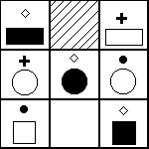 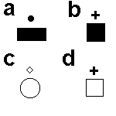

Answer:

The correct answer is **(d)** since each row has a diamond, plus sign and dark circle on top of each figure. The blank square should have a plus sign on top of it. Also, each row has two white and one dark figures. The blank square should have a white figure. Hence the white square with the plus on top of it is the correct answer

**ALL THE BEST !!**

# SECTION 1

# ALL QUESTIONS IN THIS SECTION ARE OF 1 MARKS

**Q** (1 mark)

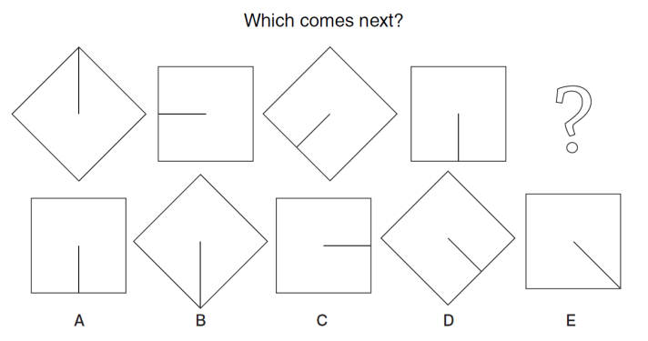

A: A B: B C: C D: D E: E

**Q** (1 mark) Salman, Chirag, Lokesh, Tahir and Sandeep travel extensively on business. Four of them have visas for China. All, apart from Chirag and Tahir, have visas for Russia. Chirag’s only visa is for Pakistan, although only Salman and Sandeep do not have a visa for Pakistan.

How many visas does the group have between them?

A: 7 B: 8 C: 9 D: 10 E: 11

**Q** (1 mark) In a ‘knockout’ cricket competition with 5 teams, Chennai SuperKings are beaten by Rajasthan Royals. Pune Warriors beat Chennai SuperKings. Chennai SuperKings and Rajasthan Royals are beaten by Delhi Daredevils. Pune Warriors are beaten by Rajasthan Royals and Delhi Daredevils. Who emerges as the champions ?

A: Delhi Daredevils B: Rajasthan Royals C: Pune Warriors  
D:Chennai SuperKings E: Not possible to decide

**Q** (1 mark) When the driving wheel 1 turns, which wheel will turn the fastest ?

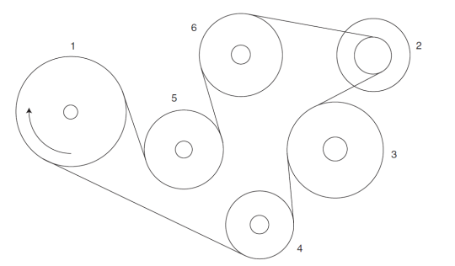

A: 2 B: 3 C: 4 D: 5 E: 6

**Q** (1 mark) If an item cost Rs. 126 when discounted to 60% of its original price, what

was the original price?

A: Rs. 75.60 B: Rs. 201.60 C: Rs. 176.40 D: Rs. 210 E: Rs. 315

**Q** (1 mark) Fill in the blank.

Pipelines can _____ water or oil over great distances.

A: roll B: pull C: push D: carry E: lift

**Q** (1 mark) Which pattern can be folded to make the cube shown ?

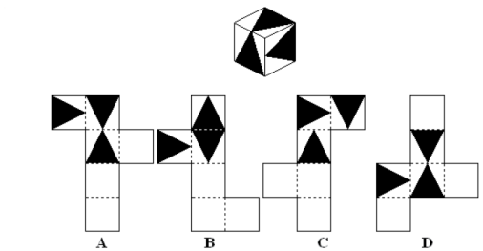

A: A B: B C: C D: D E: None of the above

**Q** (1 mark) Which figure is identical to the first ?

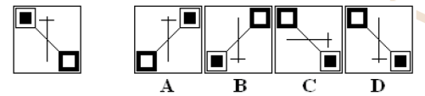

A: A B: B C: C D: D E: None of the above

**Q** (1 mark) It was 3:10 by Sohail's watch when he left home to go to the post office.

While at the post office he corrected his watch by setting it forward from 3:35 to 3:44. It was 4:04 by his watch when he returned home. How many minutes was he away?

A: 45 B:50 C: 55 D: 63 E: 85

**Q** (1 mark) Fill in the missing box.

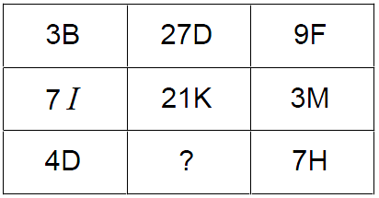

A: 11E B: 28F C: 28E D: 48F E: 11F

**Q** (1 mark) A group of 1200 persons consisting of captains and soldiers are traveling in a train. For every 15 soldiers there is one captain. The number of captains in the group is:

A: 75 B: 80 C: 85 D: 90 E: 100

**Q** (1 mark) At the end of a banquet 10 people shake hands with each other. How many handshakes will there be in total?

A: 100 B: 20 C: 50 D: 11 E: 45

**Q** (1 mark) Which day is two days after the day four days before the day immediately following the day two days before Saturday?

A: Sunday B: Monday C: Tuesday D: Wednesday   
E: Thursday

**Q** (1 mark) The sequence of numbers below follow a certain logic. Fill in the missing number

2 12 30 ? 90 132

A: 48 B: 50 C: 54 D: 56 E: 63

**Q** (1 mark) Which letter will come at place "4" on the circle

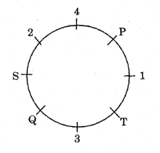

A: R B: S C: T D: V E: W

**Q** (1 mark) The alphabets below follow a pattern based on some logic.   
Which group of letters will come in place of the question marks ?

a?baab?aabba?bbaabb?

A: abba B: bbaa C: baba D: abab E: bbab

**Q** (1 mark) The sequence of numbers below follow a certain logic. Complete the series

5, 11, 24, 51, 106, ?

A: 214 B: 219 C: 218 D: 216 E: 217

**Q** (1 mark) How many triangles (overlapping triangles should also be counted) are there in the figure below?

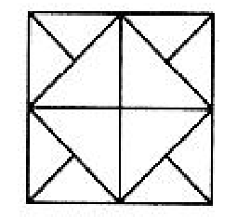

A: 16 B: 12 C: 20 D: 22 E: 18

**Q** (1 mark) A cube, on whose faces, letters have been written, is shown below in different positions. Find the missing letter.



A: S B: D C: M D: Y E: W

**Q** (1 mark) Sheila is hosting a party at her house. All guests are going to be seated in chairs around a large perfectly circular table at a distance of 3 meter from each of its adjacent chairs. All the guests arrive at a separate time and each guest takes a chair to the immediate left of the last guest who arrived. If Rani who was the sixth guest to arrive is sitting diametrically opposite to Sunita who was the fourteenth guest to arrive, how many people were sitting at the round table ?

A: 15 B: 16 C: 17 D: 18 E: 20

**Q** (1 mark) Pointing to his son’s portrait, a man said to a woman, “His mother is the only daughter of your mother”. How was the woman related to the man ?

A: Mother B: Sister C: Aunt D: Wife E: Daughter

**Q** (1 mark) Village Chimur is 20 km to the North of village Rewa. Village Rewa is 18 km to the west of village Rahate. Village Angne is 12 km to the West of Chimur. If Sanjay starts from village Rahate and goes to village Angne, in which direction is he from his starting point ?

A: North B: NorthWest C: South D:SouthEast E:SouthWest

**Q** (1 mark) A man is facing North-West. He turns 90 degrees in the clockwise direction, then 180 degrees in the anticlockwise direction and then another 90 degrees in the same direction. Which direction is he facing now ?

A: South B: SouthWest C: West D: SouthEast E:North

**Q** (1 mark) Two buses start from the opposite points of a main road, 150 km apart. The first bus runs for 25 km and takes a turn right and runs for 15 km. It then turns left and runs for another 25 km and then takes the shortest direction to the main road, and reaches the main road. In the meantime, due to a minor breakdown, the other bus has run only 35 kms along the main road. What would be the distance between the two buses at this point ?

A: 75 km B: 80 km C: 65 km D: 70 km E: 125 km

**Q** (1 mark) Boat is related to Oar in the same way as Bicycle is related to

A: Road B: Wheel C: Seat D: Paddle E: Bell

**Q** (1 mark) Which of the following diagrams correctly represents the relationship among Smokers, Beedi smokers, and Cancer patients

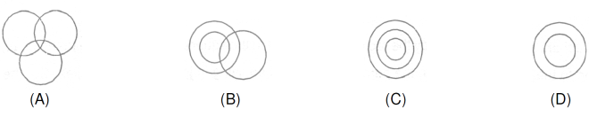

A: A B: B C: C D: D E: Impossible to decide

**Q** (1 mark) In the following diagram three classes of population are represented by three figures. The triangle represents the school teachers, the square represents the married persons and the circle represents the persons living in joint families.



School teachers who are married but do not live in joint families are represented by ?

A: A B: B C: C D: D E: E

**Q** (1 mark) If the seventh day of month is three days earlier than Friday, what day will it be on the nineteenth day of the month ?

A: Sunday B: Monday C: Tuesday D: Wednesday E: Thursday

**Q** (1 mark) A dice has been thrown four times and produces following result

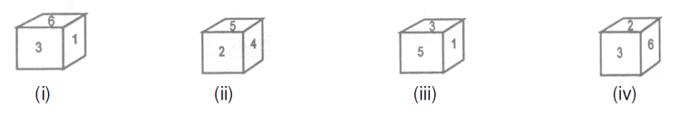

Which number is there on the dice opposite to the number 3 ?

A: 4 B: 5 C: 6 D: 2 E: 1

**Q** (1 mark) What is the mirror image of the figure X ?

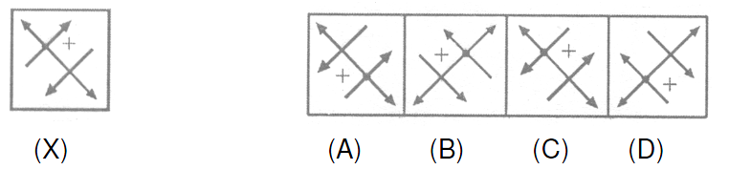

A:A B: B C:C D:D E:None of the above

**Q** (1 mark) Nitin was counting down from 32, and calling out the numbers. Sumit was counting upwards the numbers starting from 1, and he was calling out only the odd numbers. What common number will they call out at the same time, if they were calling out at the same speed ?

A: 19 B: 21 C: 22 D: 23 E: They will never call out same number

**Q** (1 mark) Anil and Sunil are ranked seventh and eleventh respectively from the top in a class of 31 students. What will be their respective ranks from the bottom in the class ?

A: 20th and 21st B: 24th and 20th C: 25th and 21st   
D: 26th and 22nd E: 7th and 11th

**Q** (1 mark) A man in a restaurant ordered gulab jamuns in a weird pattern every day for five days. After eating a certain amount of gulab jamuns on the first day, he ate five more gulab jamuns than the previous day every successive day. How many gulab jamuns had he eaten on the fourth day, if he had consumed 80 gulab jamuns during the five days ?

A: 6 B: 21 C: 8 D: 27 E: 14

**Q** (1 mark) The gardeners at Rani Laxmibai Chowk want to plant a total of 45 white and pink flowers in one flower bed. In another flower bed, they want to plan 120 flowers. In this bed, they want two times the number of white flowers and three times the number of pink flowers as in the first bed. How many white flowers should the gardeners buy together ?

A: 15 B: 20 C: 25 D: 30 E: 35

**Q** (1 mark) Ravi has a piece of cardboard of dimensions 19 cm X 17 cm. He cuts off a square of side 4 cm at each corner and folds the cardboard to make an open box. What is the volume that the box can encompass neglecting the thickness of the cardboard ?

A: 1292 cc B: 684 cc C: 792 cc D: 424 cc E: 396 cc

**Q** (1 mark) Shyam travelled by a train that was 3 km long. The train travelled at 3 km/min. There was a tunnel in it's way through which the train needed to pass. The tunnel was also 3km long. How long will it take the train to pass through the tunnel completely ?

A: 0.5 min B: 1 min C: 1.5 min D: 2 min E: 2.5 min

**Q** (1 mark) In a certain system of barter, 2 cows are worth 5 dogs, and 9 dogs are worth 2 horses. Then five horses are worth how many cows ?

A: 9 B: 8 C: 7 D: 6 E: 4

**Q** (1 mark) Rose syrup and milk were mixed in the ratio 1:6 to produce a 42 litre solution. Later 9 litres of rose syrup were added to the solution. What is the ratio of rose syrup to milk in the new solution ?

A: 5:12 B: 36:15 C: 1:6 D: 10:6 E: 36:42

**Q** (1 mark) Raju, the grocer uses a faulty weighing machine that shows 1 kg for every 800 grams. Despite this, he charged 15% more than the cost price per kg on the weight measured on the weighing scale. Find his profit percentage ?

A: 15% B: 35% C: 43.75% D: 47.25% E: 50%

**Q** (1 mark) The sum of ages of 5 children born at intervals of 3 years each is 50 years. What is the age of youngest child ?

A: 7 yrs B: 6 yrs C: 5 yrs D: 4 yrs E: 3 yrs

**Q** (1 mark) A sheet has been folded in the manner as shown in X and Y, and then punched as in Z below. How will the sheet look when it is unfolded ?

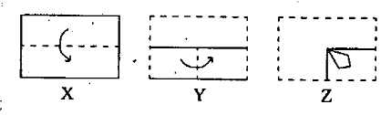

A: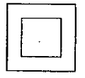 B:  C: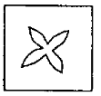 D: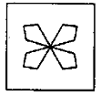   
E: None of above

**Q** (1 mark) In the figure below, what number represents graduate, hard working, rural people who are not honest

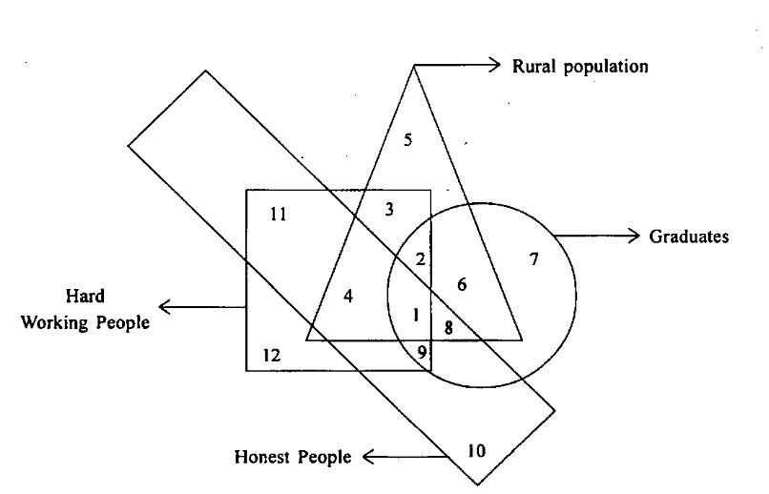

A: 5 B: 3 C: 2 D: 1 E: 9

**Q** (1 mark) The alphabets below follow a pattern based on some logic.   
Which are the next two letters in the following series

M B I N B I O B I __ __

A: L M B: P B C: T U D: XY E: M I

**Q** (1 mark) A dress in a store is first discounted by 20% from it's original price. As it does not sell, the owner puts it up for clearance by putting another 25% discount on the discounted price. What is the total discount from the original price

A: 40% B: 42.5% C: 45% D: 47.5% E: 60%

**Q** (1 mark) In a cage, there are rabbits and parrots. The number of heads are 28 and feet are 72. Find the number of parrots ?

A: 8 B:20 C: 24 D: 32 E: 44

**Q** (1 mark) What is the next number in the series

1, 5, 13, 29, 61, 125, ?

A: 255 B: 254 C: 249 D: 252 E: 253

**Q** (1 mark) Jack is taller than Peter, and Bill is shorter than Jack. Which of the following statement would be most accurate?

A: Bill is taller than Peter B: Bill is shorter than Peter C: Bill is as tall as Peter  
D: Not enough information to decide

**Q** (1 mark) John’s mother sent him to the store to get 9 large cans of peaches. John could

only carry 2 cans at a time. How many trips to the store did John have to make to get the cans home ?

A: 4 B: 4.5 C: 5 D: 5.5 E: 6

**Q** (1 mark) There are six books A, B, C, D, E and F. B, C and E have blue covers while the rest have red covers. D and F are new books while the rest are old books. A, C and D are law reports while the rest are of physics. Which two are old physics books and have blue

covers ?

A: B & F B: B & C C: B & E D: E & F E: E & C

**Q** (1 mark) Shyam is taller than Raja . Umesh is taller than Raja but shorter than Ganesh. Vikas is taller than Shyam but shorter than Umesh. Who is the second shortest person ?

A: Shyam B: Raja C: Umesh D: Ganesh E: Vikas

**Q** (1 mark) Which is the odd one out ?

A: inch B: metre C: litre D: foot E: yard

**Q** (1 mark) Ram started his journey at 9.00 a.m. at 8 km/hour. Hamid started from the same spot in the same direction at 9.30 a.m. at 10 km/hour. Hamid overtakes Ram at :

A: 10 am B: 10:30 am C: 11 am D: 11:30 am E: 12 noon

**Q** (1 mark) A can do a piece of work in 12 days and B can do it in 10 days and A, B and C together in 5 days. C alone can do it in how many days.

A: 17 days B: 27 days C: 30 days D: 45 days E: 60 days

**Q** (1 mark) P is 300 kms eastward of O and Q is 400 kms north of O. R is exactly in the middle of Q and P. The distance between Q and R is :

A: 300 km B: 200 km C: 250 km D: 250√2 km E: 700√2 km

**Q** (1 mark) Which figure comes next ?

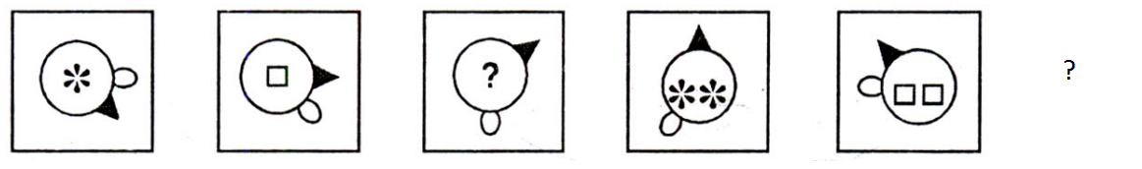

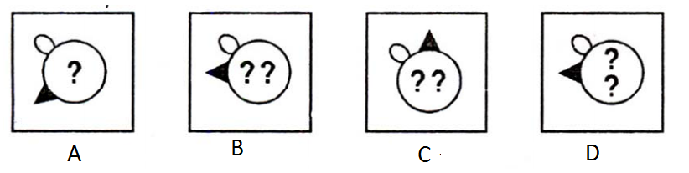

A:A B: B C:C D:D E:None of the above

**Q** (1 mark)

If 27 * 3 = 243

5 * 4 = 80

Then what is the value of 3 * 7 ?

A: 23 B: 63 C:84 D: 124 E: 147

**Q** (1 mark) A paper is folded along the dotted lines in the sequence X, Y,Z, and then cuts are made as shown in Z. When the paper is unfolded, what will it look like ?

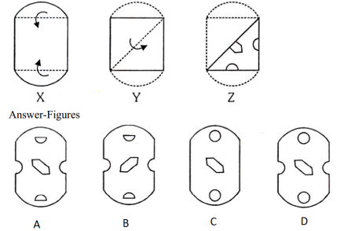

A: A B: B C: C D:D E:Not possible to decide

**Q** (1 mark) X, Y, Z and P are sitting around a circular table and discussing their trades.

(1) X sits opposite to cook (2) Y sits right to the barber

(3) the washerman is on the left of the tailor (4) P sits opposite Z

(5) Z is to the left of the cook

Who is sitting to the right of the cook ?

A: Z the Barber B: Z the Tailor C: X the Tailor

D: P the Washerman E: Z the Washerman

**Q** (1 mark) : In the following questions there is some relationship between the two figures on the left of (::), and the same relationship exists between the two terms on the right, of which one is missing. Find the missing one.

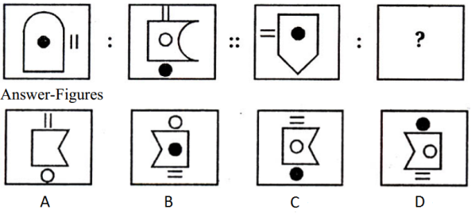

A: A B: B C: C D: D E: None of the above

**Q** (1 mark) In the following questions there is some relationship between the two figure on the left of (::), the same relationship exists between the two terms on the right, of which one is missing. Find the missing one

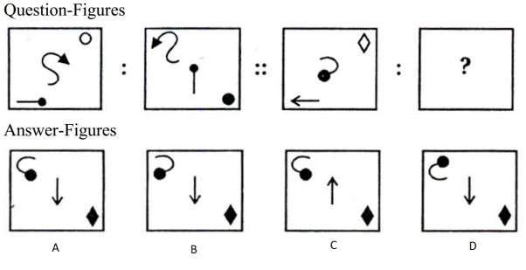

A: A B: B C: C D: D E:None of the above

**Q** (1 mark) Below four figures are given. One of these figures does not fit with the rest of the figures. Which is the odd one out ?

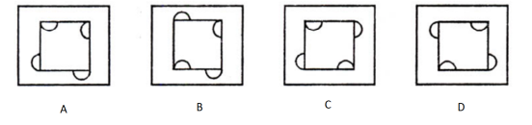

A: A B: B C: C D: D E: None of the above

**Q** (1 mark) Take 1000 and add 40 to it. Now add another 1000. Now add 30. Add another 1000. Now add 20. Now add another 1000. Now add 10. What is the total?

A:4000 B: 4100 C: 4200 D: 5000 E: 5400

# SECTION 2

# ALL QUESTIONS IN THIS SECTION ARE OF 2 MARKS

**Q** (2 marks) In a jar there are 100 balls of ten different colours. There are ten balls of each colour (violet, red, blue, green, yellow, orange, red, black, white and silver). What is the least number of balls that Melanie needs to pick from the jar to be sure that she has selected at least 5 black balls?

A: 5 B: 6 C: 50 D: 91 E: 95

**Q** (2 marks) Different businesses occupy a three-storey building. The Architect is on

the top floor, whilst the Estate Agent is on the floor below the Travel Agent. The Accountant is on the floor above the Publisher, as is the Estate Agent. The Travel Agent is on the same floor as the Car Rental Company. On the floor between the Publisher and the Car Rental Company is a Detective Agency. Which business is on the same floor as the Accountant?

A: Travel Agent and Car Rental B: Publisher C: Estate Agent & Detective D: Travel Agent & Estate Agent E: Travel Agent & Detective

**Q** (2 marks) If COURAGE is coded as RECGOAU, how is ADVENTURE coded in that code?

A: RTEADVNUE B: URTANDEVE C: ERAUDTVNE   
D: ERUTNEVDA E: NEARDUVTE

**Q** (2 marks) If X φ Y means X is the wife of Y, X $ Y means X is the son of Y and X ψ Y means X is the sister of Y, which of the following would mean that A is the daughter of B?

A: A$CψDφB B: AφC$DψB C: AψCφD$B D: AψC$DφB   
E: CψDφA$B

**Q** (2 marks) A book seller has to arrange five magazines on his newsstand from left to right. The five magazines are America Daily, Music and More, Science, Readers Digest and Sports Illustrated. America Daily and Science cannot be placed next to each other as they are published by competing publishers. The Sports illustrated and the Readers Digest must always be next to each other as there is a special discount if both the magazines are bought together. It is known that the Music and More Magazine is not kept next to the Readers Digest. If the Sports Illustrated is kept second from left and America Daily is kept second from right then which magazine is kept on the extreme right?

A: Music and More B: Readers Digest C: Science D: Sports Illustrated   
E: American Daily

**Q** (2 marks) Which group of shapes can be assembled to make the shape shown ?

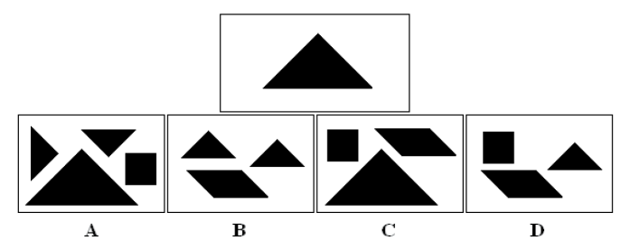

A: A B: B C: C D: D E: None of the above

**Q** (2 marks) Five friends A, B, C, D and E went on a summer vacation to five

cities namely Chennai, Kolkata, Delhi, Bangalore and Hyderabad, with each choosing a different modes of transport – bus, train, aeroplane, car or boat from Mumbai. C went to Bangalore by car and B went to Kolkata by air. D travelled by boat whereas E went by train. Between Mumbai, Delhi and Chennai there is no bus service. The person who went to Delhi did not use boat to travel. How did D travel and where did he go?

A: By train to Delhi B: By bus to Hyderabad C: By bus to Delhi  
D: By boat to Chennai E: By boat to Hyderabad

**Q** (2 marks) The below given diagram is of a normal clock. If the time is turned back by 14 hours and 47 minutes where would be the hour hand(smaller arrow) and the minute hand (larger arrow) be pointing

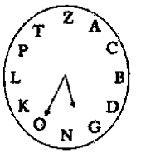

A: The hour hand would be pointing somewhere between D and G and the minute hand would be pointing somewhere between L and P   
B: The hour hand would be pointing somewhere between C and B and the minute hand would be pointing somewhere between N and O   
C: The hour hand would be pointing somewhere between C and B and the minute hand would be pointing somewhere between L and P   
D: The hour hand would be pointing somewhere between D and B and the minute would be pointing somewhere between T and Z

E: The hour hand would be at B and the minute hand at P

**Q** (2 marks) Which diagram below represents best the relationship between

Females, Mothers, Cooks

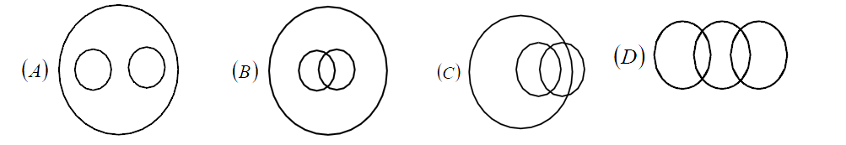

A: A B: B C: C D: D E: None of the above

**Q** (2 marks)

(i) In a class of boys and girls, Amar’s rank is 12th and Meeta’s rank is 8th.

(ii) Amar’s rank among the boys is 6th and Meeta’s rank among girls is 3rd.

(iii) In the class Meeta’s rank is 52th from the other end.

(iv) From the other end, Amar’s rank among the boys is 26th

How many boys are there between Amar and Meeta ?

A: 1 B:2 C:3 D:4 E:None of the above

**Q** (2 marks) There are 70 clerks working with M/s. Jha Lal Khanna & Co. chartered accountant, of which 30 are female.

I. 30 clerks are married.

II. 24 clerks are above 25 years of age

III. 19 married clerks are above 25 years of age ; among them 7 are males.

IV. 12 males are above 25 years of age

V. 15 males are married

How many of these unmarried girls are above 25 ?

A: 12 B: 15 C: 3 D: 4 E:0

**Q** (2 marks) If A + D > C + E, C + D = 2B and B + E > C + D, it necessarily follows that

A: A + B > 2D B: B + D > C + E C: A + D > B + E   
D: A + D > B + C E: A + B = C + D

**Q** (2 marks) P.S. Drona scored an average of 45 runs in the first 6 matches. If the first match is not counted and the seventh match is counted, then the average score goes up to 60 runs. If his score in the first match was 40 runs, find his score in the seventh match ?

A: 50 B: 65 C: 105 D: 130 E: 170

**Q** (2 marks) At what time between 9 and 10 will the hands of a clock be in the straight line, but not together ?

A: 16 minutes past 9 B: 16 4/11 minutes past 9 C: 16 6/11 minutes past 9   
D: 16 9/11 minutes past 9 E: 17 1/11 minutes past 9

**Q** (2 marks) Shreya loves talking on her cell. She talks on an average 25 minutes on a weekday, from Monday to Friday, and around 45 minutes on weekends. If she has refilled the talktime on the first of a month, which is a Thursday, so that she can speak for 600 minutes, what is the day on which she would need to go for a refill ?

A: 17th B: 18th C: 19th D: 20th E: 21st

**Q** (2 marks) A 3 digit number and a 2 digit number are multiplied together to get a 5 digit number. What is the value of digit "B"

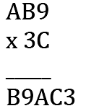

A: 2 B: 3 C: 7 D: 1 E: 4

**Q** (2 marks) Six friends A, B, C, D, E and F are seated in a circle facing centre. If F is between A and D, C is between E and B, E is ***not*** between D and C, and D is 2nd to the left of C; which one of the following is the position of D ?

A: 2nd to the right of A B: Immediately to the right of B   
C: 3rd to the left of B D: 4th to the right of A E: 2nd to the right of B

**Q** (2 marks) Pipe P fills an empty tank in 30 minutes when used alone. Pipe Q does the same in 50 minutes. Chandni decided to use both the pipes simultaneously. After some time, "T", she closes P, and continues with Q only until the tank gets filled. What is the time T, so that the tank gets filled in 35 minutes from the beginning.

A: 4.375 mins B: 6 mins C: 9 mins D: 12 mins E: 15 mins

**Q** (2 marks) A solid cube is painted red on two adjacent sides, black on the sides opposite to the red sides and green on the remaining sides. It is cut into sixty four smaller cubes of equal size. How many cubes have one side green and the adjacent side black or red?

A: 8 B: 16 C: 20 D: 24 E: 32